Sign Up Form

<html>

<head>

<title>Register</title>

</head>

<body>

<h1 align="center"> Register </h1>

<fieldset align=”center”>

<form method="post" action="login.html">

<label>User Name: </label>

<input type="text" name="Name"><br>

<label> Email: </label>

<input type="Email" name="Email"><br>

<label>Password: </label>

<input type="Password" name="Password"><br>

<label>Confirm Password: </label>

<input type="Password" name="Confirm Password"><br><br>

<input type="button" name="Sign Up" value="Sign Up"><br>

<h4> Have an Account?<a href="login.html">login Here </a></h4>

</form>

</fieldset>

</body>

</html>

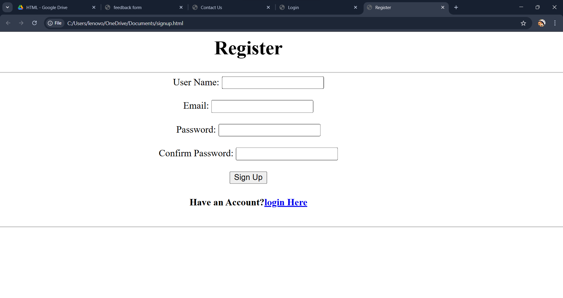

Login Form

<html>

<head>

<title> Login </title>

</head>

<body>

<h1 align="center"> Login </h1>

<fieldset align="center">

<form method="get" action="menu.html" >

<label>Email: </label>

<input type="Email" name="Email"><br><br>

<label>Password: </label>

<input type="Password" name="Password"><br><br>

<input type="button" name="Sign In" value="Sign In">

<h4>Forgot <span>Email/Password</span>?</h4>

<h4> Don't have an account?<a href="signup.html">Sign up </a></h4>

</form>

</fieldset>

</body>

</html>

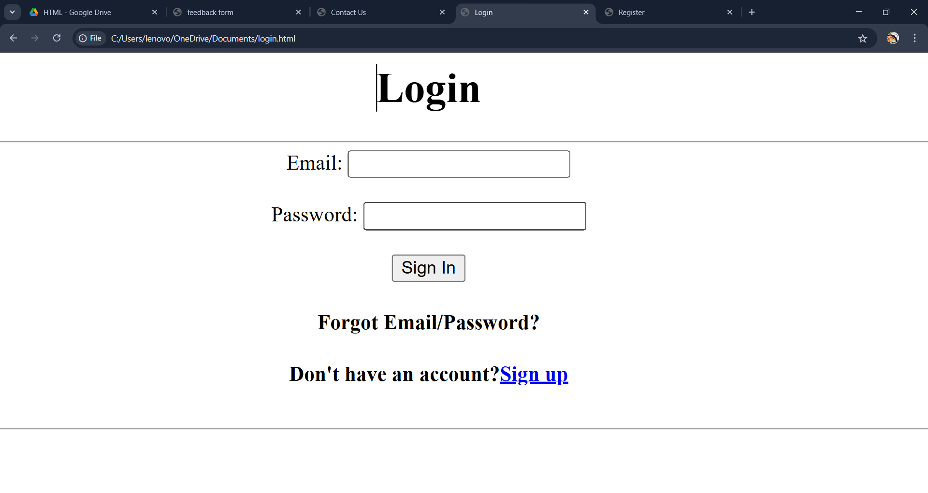

Contact Us Form

<html>

<head>

<title> Contact Us </title>

</head>

<body>

<h1 align="center"> Contact us</h1>

<fieldset align="center">

<form method="post" action="Contact Us">

<label>First Name:</label><br>

<input type="text" name="First Name"><br>

<label>Last Name:</label><br>

<input type="text" name="First Name"><br>

<label>Email:</label><br>

<input type="Email" name="Email"><br>

<label>Phone Number:</label><br>

<input type="Contact" name="Contact"><br>

<label>What do you have in mind?</label><br>

<textarea name="What do you have in mind"></textarea>

</form>

<a href="https://www.instagram.com/accounts/login/?hl=en">

<img src="C:\Users\lenovo\OneDrive\Desktop\insta.jpeg" width="50px" height="50px">

</a>

<a href="https://www.facebook.com/login/">

<img src="C:\Users\lenovo\OneDrive\Desktop\fb.png" width="45px" height="45px">

</a><br><br>

<input type="submit" name="input" value="submit">

</fieldset>

</html>

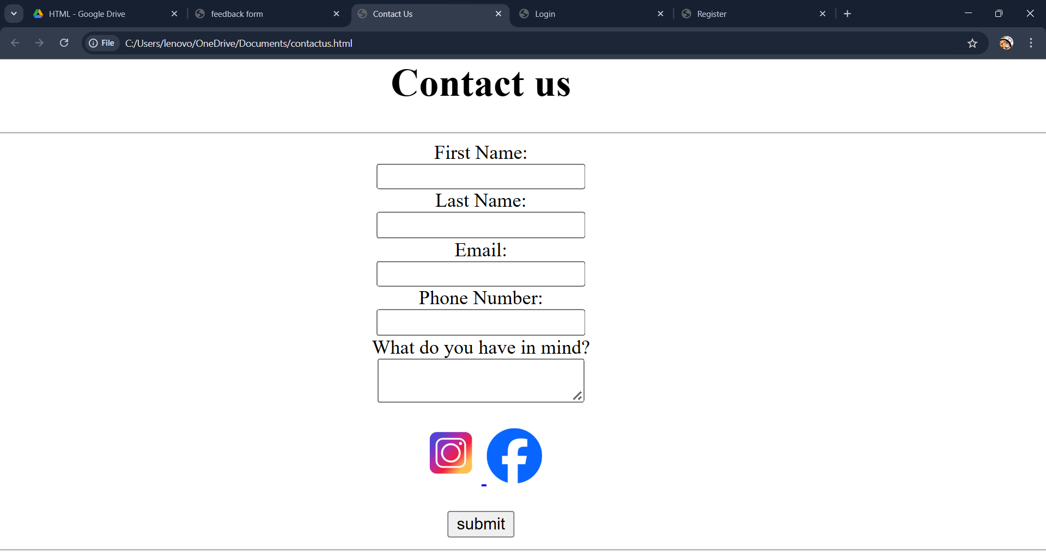

Feedback Form

+<html>

<head>

<title>feedback form</title>

</head>

<body>

<fieldset align=”center”>

<h1 align="center"> product feedback form with rules </h1>

<p>please rate the following aspects:</p>

<label> 1) Rate your overall satisfaction with the product</label><br>

Very Good: <input type="radio" name="satisfaction" value="very good">

Good: <input type="radio" name=" satisfaction" value="good">

Fair: <input type="radio" name="satisfaction" value="Fair">

Poor: <input type="radio" name="satisfaction" value="Poor">

Very Poor: <input type="radio" name="satisfaction" value="very poor"><br><br>

<label> 2) How easy was it to use the product?</label><br>

Very Good: <input type="radio" name="use" value="very good">

Good: <input type="radio" name=" use" value="good">

Fair: <input type="radio" name="use" value="Fair">

Poor: <input type="radio" name="use" value="Poor">

Very Poor: <input type="radio" name="use" value="very poor"><br><br>

<label> 3) How would you rate the performance of the product?</label><br>

Very Good: <input type="radio" name="performance" value="very good">

Good: <input type="radio" name="performance" value="good">

Fair: <input type="radio" name="performance" value="Fair">

Poor: <input type="radio" name="performance" value="Poor">

Very Poor: <input type="radio" name="performance" value="very poor"><br><br>

<label>Did you encounter any usability issues?</label><br>

Yes:<input type="radio" name="usability" value="Yes">

No:<input type="radio" name="usability" value="No"><br><br>

<label>were there any missing features that you expected?</label><br>

Yes:<input type="radio" name="missing" value="Yes">

No:<input type="radio" name="missing" value="No"><br><br>

<label>Did you experience any performance ussues?</label><br>

Yes:<input type="radio" name="performance" value="Yes">

No:<input type="radio" name="performance" value="No">

<h2> Thank you for taking the time to complete this <br> feedback form</h2>

<input type="button" name="submit" value="submit">

</fieldset>

</body>

</html>

