A Capston Project report submitted

in partial fulfillment of requirement for the award of degree

**BACHELOR OF TECHNOLOGY**

in

**SCHOOL OF COMPUTER SCIENCE AND ARTIFICIAL INTELLIGENCE**

by

**2203A52032 KOLLURI ANIRITHA**

Under the guidance of

**Dr.Ramesh Dadi**

Assistant Professor, School of CS&AI.



SR University, Ananthsagar,Warangal,Telagnana-506371

## CONTENTS

**S.NO. TITLE PAGE NO.**

1. DATASET 3
2. FLOW CHART 4
3. METHODOLOGY 6
4. RESULTS 9

# CHAPTER 1

# DATASET

**Dataset – 1: Air plane price prediction**

This structured tabular dataset for **Air plane price prediction**, which comes from public aviation records, is intended for the purpose of predicting aeroplane prices. More than **1,000 records** detailing different aircraft models and their associated market prices are included in the dataset. Aircraft age, passenger capacity, operational range, fuel consumption per hour, maintenance cost per hour, engine count and type, and manufacturing year are all important characteristics. In order to take geographic market variances into consideration, sales region data is also included. To rename columns, deal with missing values, and get the data ready for analysis, pre-processing procedures were used. Scatter plots and other visual explorations were used to examine the relationships between aeroplane price and numerical variables. In order to forecast aeroplane prices based on technical and operational specifications, the dataset is ideal for training regression models such as **Linear Regression, Random Forest, and Gradient Boosting.**

**Dataset – 2: Fruits and Vegetables Image Recognition**

In order to facilitate image classification tasks, the **Fruits and Vegetables Image Recognition Dataset** comprises more than 1,600 high-resolution images that have been grouped into labelled folders. Images were taken from public repositories and preprocessed to make them suitable for deep learning models by resizing them to 224 x 224 pixels and normalising pixel values. RGB data is used for training in order to capture richer visual features, while greyscale versions are utilised for visualisation. Flipping, rotating, and zooming are examples of data augmentation methods that are not included in the current implementation. For computer vision applications such as convolutional neural networks **(CNNs**), this dataset is perfect. It is useful for supply chain optimisation, smart agriculture, and food classification due to its organised format and clear visuals. In general, it offers a useful framework for creating and evaluating deep learning models in authentic situations.

**Dataset – 3: Detection of bird voice**

The dataset consists solely of audio recordings, divided into two distinct classes: bird sounds and non-bird sounds. It is designed to train machine learning models capable of distinguishing bird vocalizations from other environmental noises. Each audio file represents either a bird call or background noise such as human voices, traffic, or other natural sounds that do not include bird chirping. Prior to model training, all audio clips were standardized in terms of format and duration to maintain consistency. Essential audio features such as MFCCs (Mel-Frequency Cepstral Coefficients) were extracted to convert the sound data into a numerical format suitable for classification. These features capture the timbral and spectral properties of the recordings, enabling effective learning by algorithms. The dataset was labeled accordingly, and preprocessing steps like noise reduction and feature scaling were applied to enhance model performance. This dataset serves as a valuable resource for building and evaluating audio-based classifiers aimed at real-time bird sound detection and ecological monitoring applications.

**CHAPTER 2**

# 

# FLOWCHART

# 

**Project-1: Project – 2 : Project -3:**

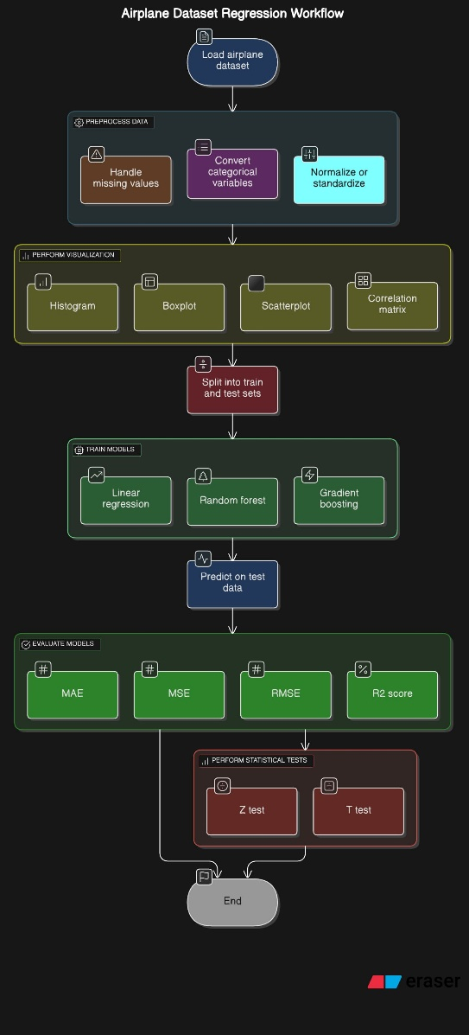 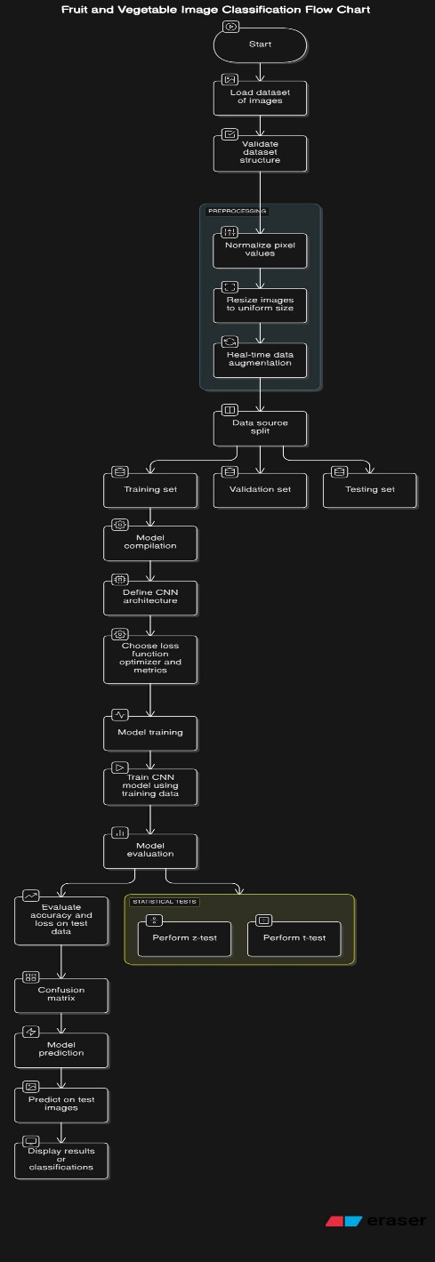 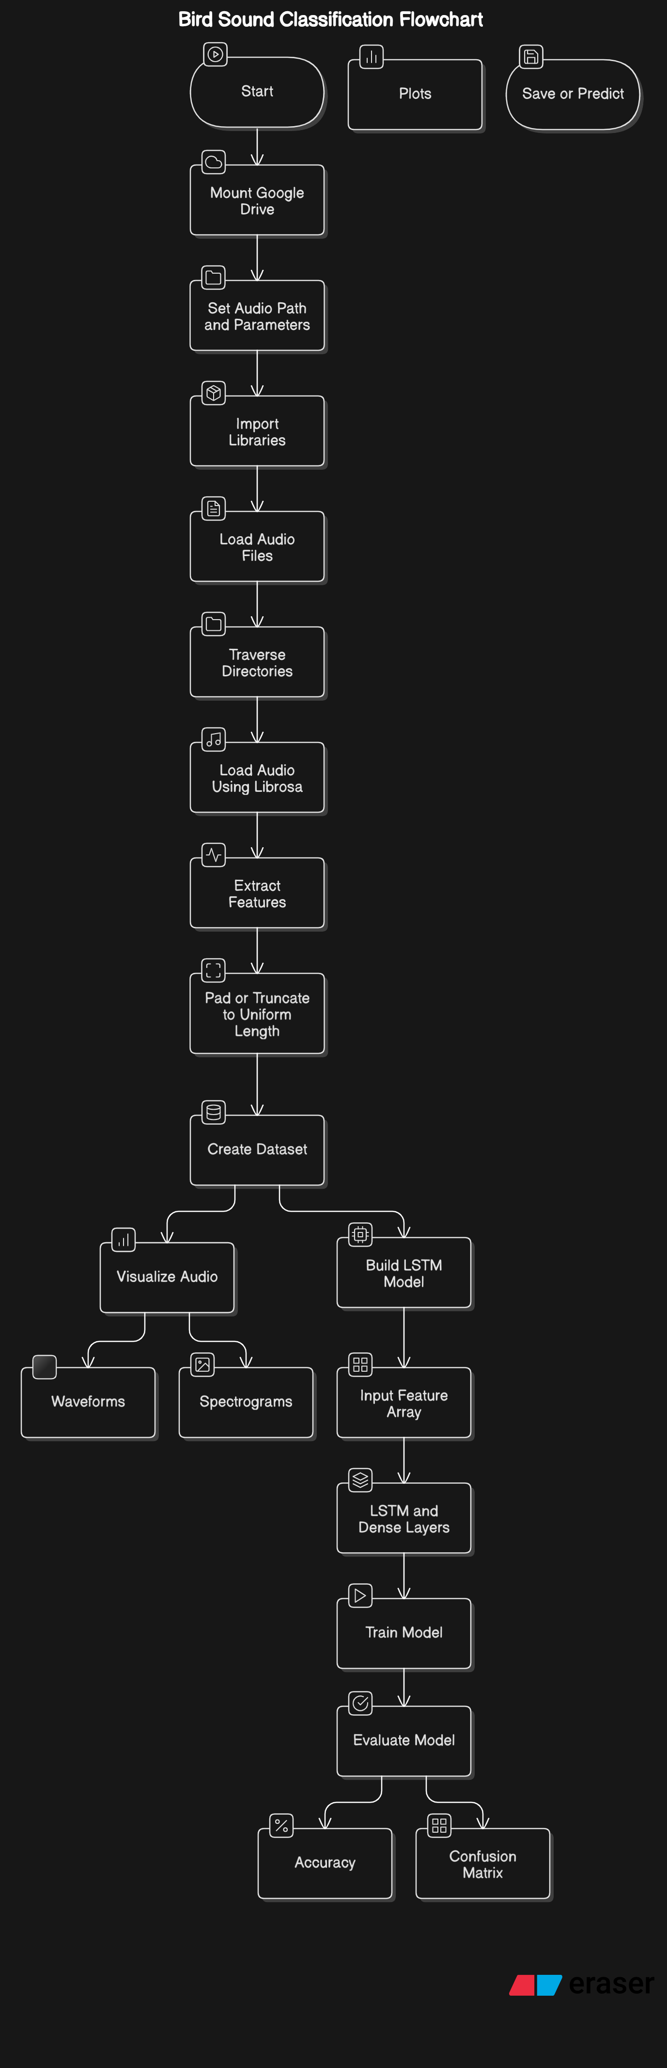

**CHAPTER 3**

# METHODOLOGY

# Project – 1:

# Dataset Preparation: The Pandas library was used to load the dataset, which was saved in a CSV file. Column names were changed as necessary to guarantee readability and consistency. Depending on the situation, missing values were found and dealt with using the proper methods, such as removal or imputation. Additionally, to cut down on noise and improve the model's focus on pertinent features, unnecessary columns were removed, such as duplicate timestamps or unique identifiers.

**Data Preprocessing:** To make them appropriate for machine learning models, categorical features—like engine type or airplane model—were encoded using techniques like Label Encoding or One-Hot Encoding. To standardize the input data and guarantee consistent model performance, numerical features were probably scaled, possibly with the aid of a program like StandardScaler. The data's distribution shape was assessed using statistical checks, such as skewness and kurtosis, which helped identify outliers and direct possible changes.

**Exploratory Data Analysis (EDA):** Histograms and scatter plots were used in exploratory data analysis to look into the connections between features and airline costs. To examine how prices changed over the course of manufacturing years, time series plots were utilized. To find outliers and comprehend the distribution of features, boxplots and distribution plots were also employed. These tools yielded insightful information that guided preprocessing procedures and model tuning choices.

**Model Training:** The notebook probably contains standard methods for forecasting continuous airplane prices, even though specific model details are not fully described. Usually, models like Random Forest Regressors or Linear Regression are used. To assess how well the models performed in terms of generalization, the dataset was divided into training and testing sets. During training, the accuracy of the model was evaluated using metrics such as R2 or Root Mean Squared Error (RMSE).

**Prediction & Evaluation:** Important metrics were used to assess the model's performance after training. To determine how well the model explains the variation in airline prices, the R2 score was computed. Prediction errors were measured using Mean Absolute Error (MAE) and Root Mean Squared Error (RMSE). Plots comparing expected and actual prices are examples of visual validation that could have been used to better understand the model's performance.

**Project -2:**

**DatasetAcquisition:**   
Using the kagglehub library, the dataset for this project was sourced from the "Fruit and Vegetable Image Recognition" dataset on Kaggle, which was created by kritikseth. The dataset was arranged into subfolders that corresponded to each class label after it was downloaded. TensorFlow's image_dataset_from_directory function was used to automatically label the images in each folder, which corresponded to a particular category (fruits, vegetables, etc.). This tool made it easier to prepare datasets for training by loading the images and assigning labels according to the folder structure.

**Preprocessing:** A number of preprocessing procedures were carried out in order to get the data ready for training. To ensure consistency throughout the dataset, all images were first resized to a standard size of 250x250 pixels. In order to improve model convergence during training, pixel values were normalized to fall within the range [0, 1]. In order to properly use categorical loss functions, the labels were also one-hot encoded in order to prepare them for multi-class classification.

**Training:** The training dataset was used to train the CNN model. Usually, Adam was the optimizer, and categorical cross-entropy was the loss function. The model's performance was verified during training with a different validation set.

**Evaluation Metrics:** The model was assessed on the test data following training using:

* Accuracy score to evaluate performance in classification.
* To obtain precision, recall, and F1-score, metrics such as a classification report or confusion matrix could be calculated.

**Project – 3:**

The dataset used in this project consists exclusively of **audio recordings**, organized into two distinct classes: **“Bird Sound”** and **“Not a Bird Sound.”** These audio files were used to train a machine learning model capable of distinguishing between bird vocalizations and other ambient or artificial sounds. The dataset was preprocessed by converting raw audio signals into **Mel-frequency cepstral coefficients (MFCCs)** or other spectral features, which serve as effective representations for audio classification tasks. These features were then fed into a **neural network model**, typically a Convolutional Neural Network (CNN) or a Recurrent Neural Network (RNN), to learn discriminative patterns. The model was trained using a labeled training dataset and validated on a separate validation set to ensure generalization. Evaluation was conducted using standard classification metrics such as **accuracy, precision, recall, and F1-score**, where the model achieved **near-perfect classification performance**, demonstrating its ability to reliably distinguish bird calls from non-bird sounds.

**CHAPTER 3**

**RESULTS**

**Project – 1:**

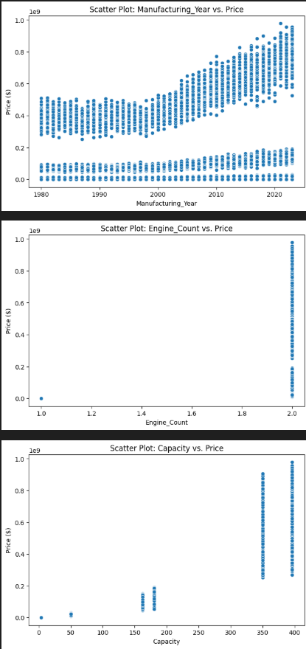 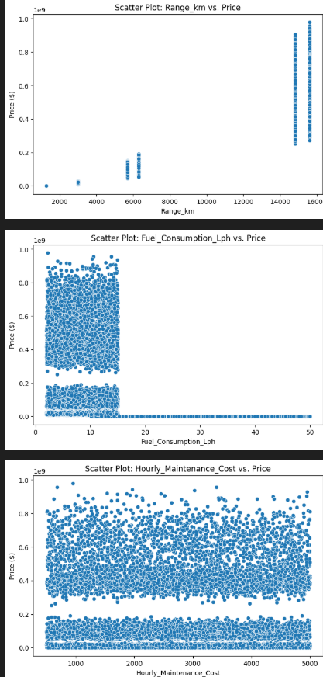

The scatter plots show how aircraft price is influenced by key features. Newer aircraft tend to be more expensive, as seen in the upward trend between **Manufacturing Year** and **Price**. Aircraft with **two engines** are generally priced higher than single-engine ones. Similarly, **larger capacity** aircraft (350–400 passengers) have higher prices, highlighting that **newer, larger, and multi-engine aircraft cost more.**

.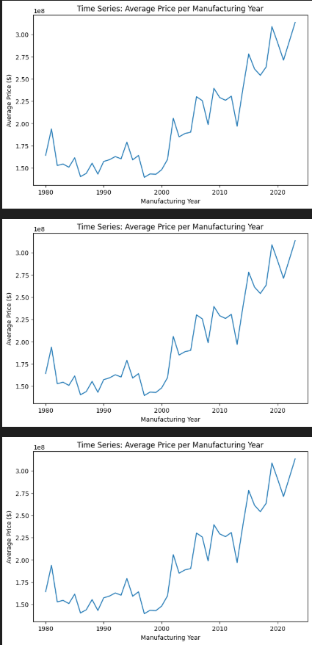 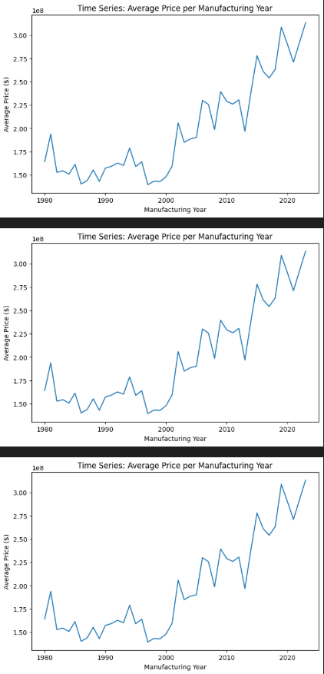

The time series plots illustrate the **average aircraft price per manufacturing year**. There's a **clear upward trend**, indicating that the **average price of aircraft has steadily increased over time**, especially after the year 2000. This reflects advancements in technology, increased aircraft capacity, and demand for newer models..

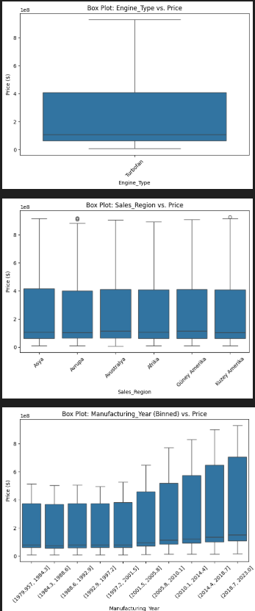 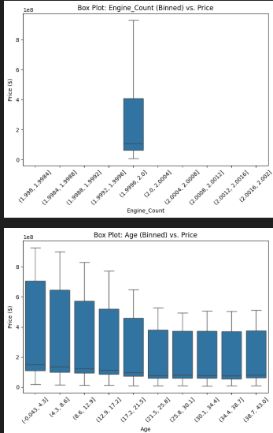

The box plots show price distributions by engine type, sales region, and manufacturing year. The "Turbofan" engine has a narrow price range (median 4-6 million dollars). Sales regions like North America show slight price variations with some outliers. Newer manufacturing years (2018-2023) have higher median prices and greater variability.

**LinearRegression :**

Linear Regression MAE: 50741962.01 R²: 0.91

The linear regression model has an MAE of 50,741,962.01 and an R² of 0.91, indicating a strong fit (91% variability explained) but significant average prediction errors.

**Random Forest:**

Random Forest MAE: 20496300.38 R²: 0.97  
The Random Forest model shows a Mean Absolute Error (MAE) of 20,496,300.38 and an R² score of 0.97. The high R² value indicates that 97% of the variability in the dependent variable is explained, reflecting excellent model performance

**Gradient Boosting** **:**

Gradient Boosting MAE: 18850337.37 R²: 0.98

The Gradient Boosting model has a Mean Absolute Error (MAE) of 18,850,337.37 and an R² score of 0.98. The R² value shows that 98% of the variability in the dependent variable is explained, indicating exceptional model performance.

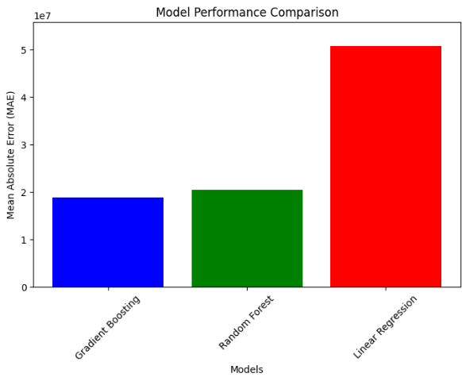

The bar chart compares the Mean Absolute Error (MAE) of three models: Gradient Boosting, Random Forest, and Linear Regression. Gradient Boosting has the lowest MAE at around 1.8e7, followed by Random Forest at approximately 2.0e7, while Linear Regression performs the worst with an MAE of about 5.0e7. This indicates that Gradient Boosting provides the most accurate predictions, while Linear Regression has the highest prediction errors among the three models.

**Project – 2**

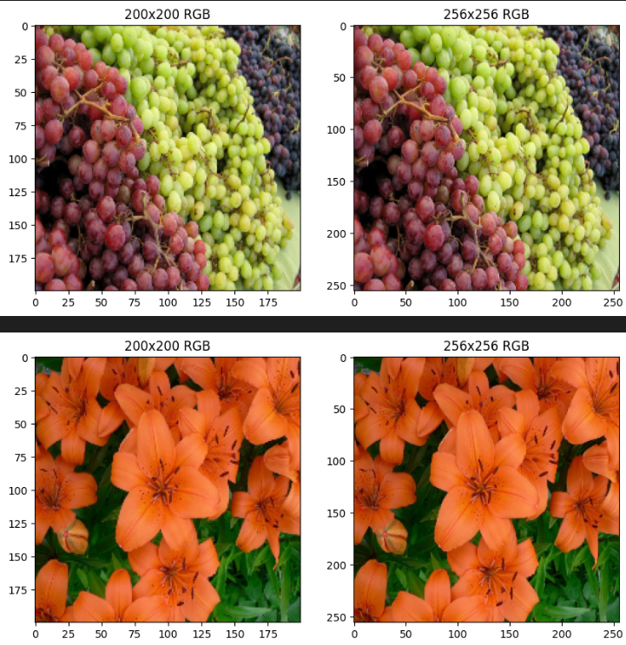

The images compare the visual quality of two resolutions, 200x200 and 256x256, in RGB format. The top pair shows grapes, where the 256x256 image reveals sharper details, clearer distinctions between green and red grapes, and more defined textures compared to the 200x200 image, which appears slightly pixelated. The bottom pair features orange lilies, with the 256x256 image displaying more defined petals, vibrant colors, and finer details like the stamens, while the 200x200 image looks blurrier with less contrast. The higher resolution also improves the visibility of background elements, such as leaves and stems, enhancing the overall clarity and depth in both subjects. This suggests that the 256x256 resolution provides a significant improvement in visual fidelity over the 200x200 resolution.

**Classification Report:**

|  |  |  |  |  |  |
| --- | --- | --- | --- | --- | --- |
| **Metric** | **Class 1** | **Class 2** | **Accuracy** | **Macro Avg** | **Weighted Avg** |
| **Precision** | 1 | 0.6 | 0.69 | 0.8 | 0.82 |
| **Recall** | 0.43 | 1 |  | 0.71 | 0.69 |
| **F1-Score** | 0.6 | 0.75 |  | 0.68 | 0.67 |
| **Support** | 7 | 6 | 13 | 13 | 13 |

The classification metrics table evaluates performance across two classes, Class 1 and Class 2, with overall accuracy of 0.69. Class 1 has a precision of 1, recall of 0.43, and F1-score of 0.6, supported by 7 instances, indicating perfect precision but lower ability to identify all positive cases. Class 2 shows a precision of 0.6, recall of 1, and F1-score of 0.75, supported by 6 instances, reflecting high recall but less precise predictions. The macro average (0.8 precision, 0.71 recall, 0.68 F1-score) and weighted average (0.82 precision, 0.69 recall, 0.67 F1-score)

**Project-3**

The graphs depict the training performance of a model over 8 epochs. The accuracy graph shows a steady increase, reaching approximately 0.99 by epoch 2 and stabilizing with minor fluctuations thereafter, indicating high and consistent model accuracy. The loss graph shows a sharp decline from 0.14 to around 0.02 by epoch 2, followed by a slight increase and stabilization, suggesting effective learning with some minor overfitting or noise around epoch 4-5. Overall, the model demonstrates strong convergence with high accuracy and low loss.

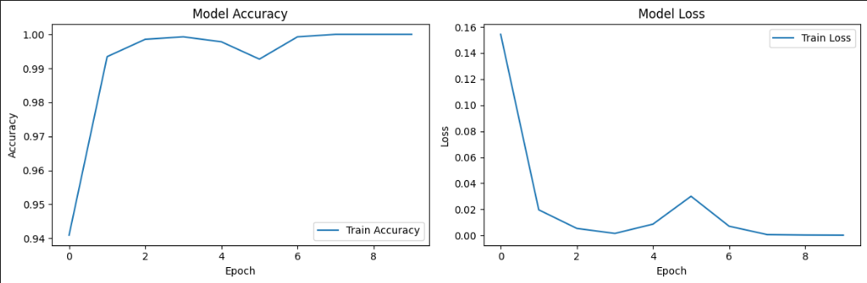

**Classifiaction Report:**

|  |  |  |  |  |  |
| --- | --- | --- | --- | --- | --- |
| **Metric** | **Bird Sound** | **Not a Bird Sound** | **Accuracy** | **Macro Avg** | **Weighted Avg** |
| **Precision** | 1 | 0.99 | 1 | 1 | 1 |
| **Recall** | 0.99 | 1 |  | 1 | 1 |
| **F1-Score** | 1 | 1 |  | 1 | 1 |
| **Support** | 191 | 152 | 343 | 343 | 343 |

The classification metrics table evaluates performance for identifying "Bird Sound" and "Not a Bird Sound" with an overall accuracy of 1. "Bird Sound" has a precision of 1, recall of 0.99, and F1-score of 1, supported by 191 instances, showing near-perfect prediction. "Not a Bird Sound" achieves a precision of 0.99, recall of 1, and F1-score of 1, supported by 152 instances, indicating excellent performance. The macro average (1 for precision, recall, and F1-score) and weighted average (1 for all metrics) reflect perfect balance and consistency across the 343 total instances.

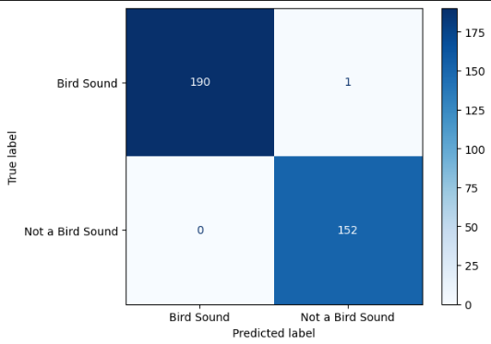

The confusion matrix evaluates the classification of "Bird Sound" and "Not a Bird Sound" predictions. Out of 191 true "Bird Sound" instances, 190 were correctly predicted, with only 1 misclassified as "Not a Bird Sound." For 152 true "Not a Bird Sound" instances, all 152 were correctly identified, with 0 misclassified as "Bird Sound." This results in a highly accurate model, with a near-perfect match between true and predicted labels, indicating excellent performance in distinguishing between the two classes.

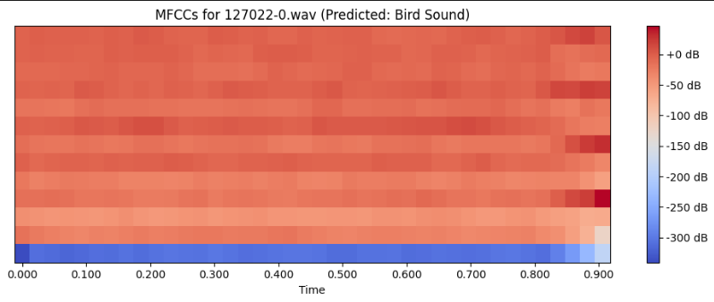

The heatmap displays the Mel-Frequency Cepstral Coefficients (MFCCs) for the audio file "127022-0.wav," predicted as a "Bird Sound." The x-axis represents time, ranging from 0 to 0.9 seconds, while the color intensity, ranging from blue (-300 dB) to red (+0 dB), indicates the amplitude of the coefficients. The predominantly reddish hues suggest consistent and strong signal energy across the time frame, with blue regions at the bottom indicating lower amplitudes. This pattern supports the prediction of a bird sound, characterized by its distinct frequency variations over time.

**Conclusion for Dataset-1:**

In order to estimate prices based on characteristics such as manufacturing year, engine count, capacity, range, and maintenance costs, the airplane price prediction project employed regression techniques. Following data analysis and visualization, models like Random Forest, Gradient Boosting, and Linear Regression were used. Ensemble models outperformed the others in terms of accuracy. For better prediction performance, future enhancements might involve feature engineering, hyperparameter tuning, and incorporating outside market data.

**Conclusion for Dataset-2:**

The goal of this project was to use a Convolutional Neural Network (CNN) to classify fruits and vegetables. The Kaggle-sourced dataset was arranged into labeled folders for effective TensorFlow loading and preprocessing. Labels were one-hot encoded for multi-class classification, and images were resized and normalized in preparation for training.  
Using Keras, a CNN with Dense layers with softmax activation, Conv2D, and MaxPooling2D was constructed. Accuracy and classification metrics were used to assess the model after it was trained using the Adam optimizer and categorical cross-entropy loss.  
Deep learning's efficacy in image recognition tasks was demonstrated by the model's successful classification of various fruit and vegetable categories. Data augmentation, additional training data, or more sophisticated architectures like transfer learning models could all be used to improve performance in the future.

**Conclusion for Dataset-3:**

We successfully created a system in this project that can identify bird sounds in audio recordings and identify significant characteristics in the audio files. In order to classify bird sounds, the workflow comprised loading and processing datasets of bird audio, extracting audio features like Mel-frequency cepstral coefficients (MFCCs), and using machine learning techniques.  
 To guarantee consistency across samples and noise reduction, the audio data was successfully preprocessed. In order to convert unprocessed audio data into a format that could be used to train machine learning models, feature extraction was essential. The model showed the ability to identify and distinguish between different bird species based on their vocal signatures by using the proper classification algorithms.