**Big Data-Data Visualization Project**

**Group -7**

**Report**

* **Dataset:**

Ebola dataset is downloaded from ebola.data.org

1. It’s a monthly statistics updated every month by WHO in the year 2015 from june- december. We got different sheets of data for every month.
2. The other dataset has data information

* Technolgies used:

1. We used R programming language to visualize 1st data set . Following packages are used for the same

googleVis , shiny.

**Steps to run visualization in your local**

1. Install R
2. Open console and run the following lines to import the packages
3. Place all the files in the folder(UI.r,server.r,all the data files in your folder)
4. Set the work dir to folder where all the above files are places

#This will install the required packages in your local

Setwd(“path”)# example path will be some thing like c:/bigdataproj)

Install.packages(“googleVis”)

Install.packages(“shiny”)

require(shiny)

require(googleVis)

runApp()

Screenshot to this:

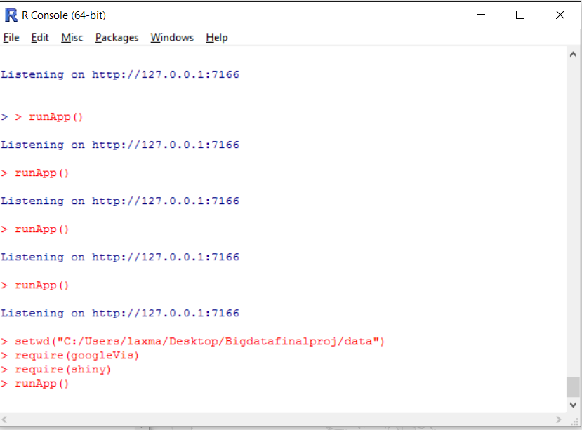

Once the app is executed your browser will open with the visualization which will look like the below picture

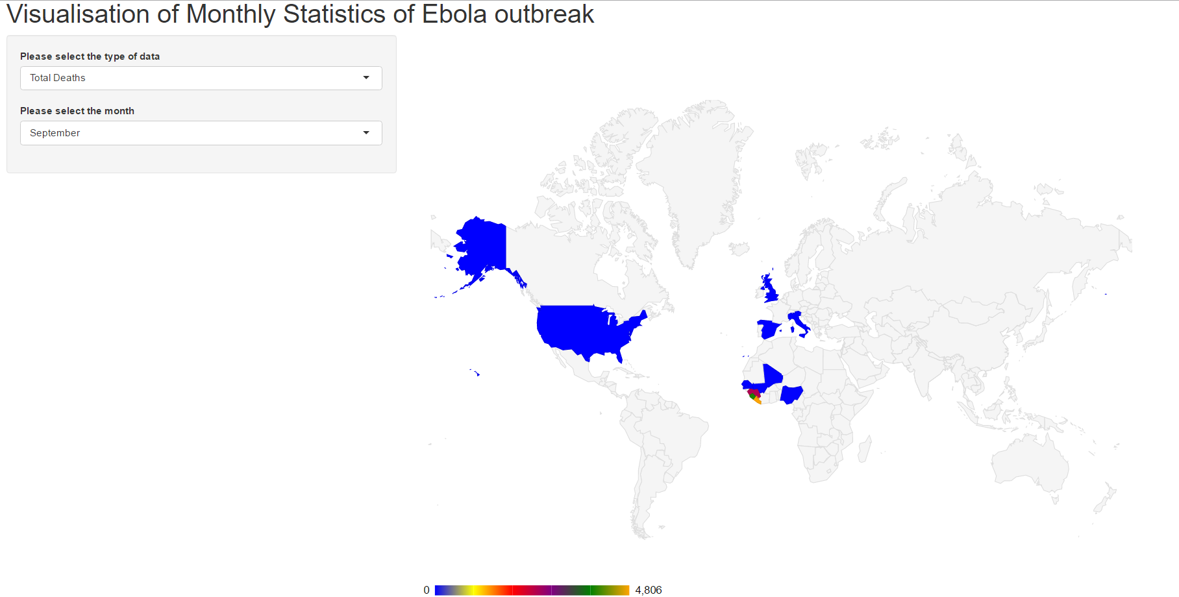

It has 2 dropdowns

1. The first one is the type of the data that is being retrieved from the dataset. It retrieves the total number of deaths from the particular months (for ex:june) data set and plots it on the respective country.
2. The second one is the total number of cases from each month.
3. Hovering the the visualization would display the number of cases and number of deaths in that particular colored area

**More screenshots for the visualization**

