We have used R to do the trust assessment. There are various packages that needs to be installed before running our code. Follow the following steps executing the code.

1. Install the following packages in your local. To do so run the code given below

***Install.packages(‘twitteR’)***

***Install.packages(‘plyr’)***

***Install.packages (‘ggplot2’)***

***Install.packages(‘wordcloud’)***

***Install.packages(‘RColorBrewer’)***

***Install.packages(‘tm’)***

***Install.packages(‘rstem’)***

Place sentiment_0.2.tar.gz file placed in the package in any local folder then execute the following lines of code.

**Install.packages( ‘PATH_TO_FILE’,repos = NULL,type=”source”)**

For example : install.packages(“C:/sentiment_0.2.tar.gz”,repos = NULL,type=”source”)

2. Once the installation are successful. Place the Sentiment_analysis.R (All the functions are placed in the file) file in any local location then execute the following steps

***setwd(PATH TO FOLDER WHERE THE FILE EXISTS IN THE LOCAL)***

***source(‘Sentiment_analysis.R’)***

For example : 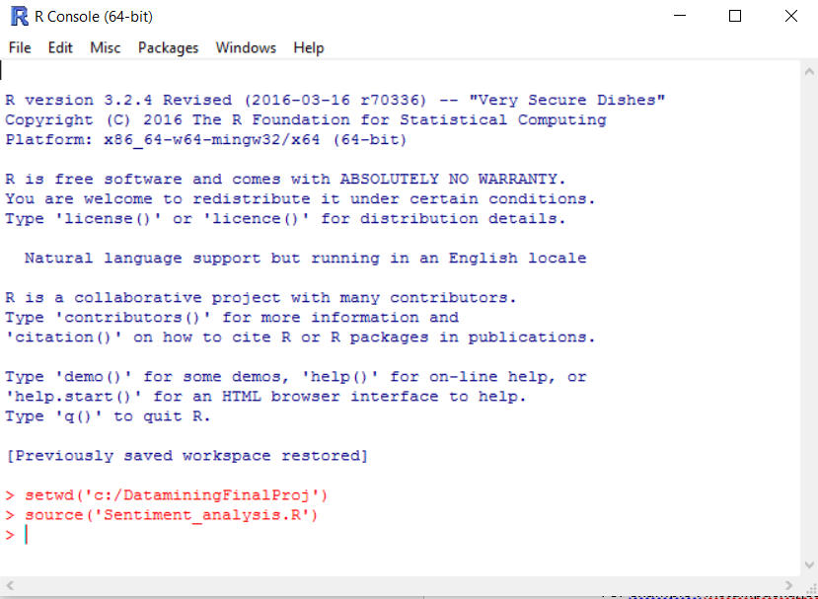

3. Call the sentiment analysis function in the file with the name of the ecommerce site and enter. It will take about 2minutes to get the live tweeter data to local and apply the algorithm and show the visualization. Execute the following command for each eccomerce site. We use #Amazon because usually reviews are tweeted with hashtag

**> sentimentAnalysis(“#Amazon”)**

**Select 1 after this step**

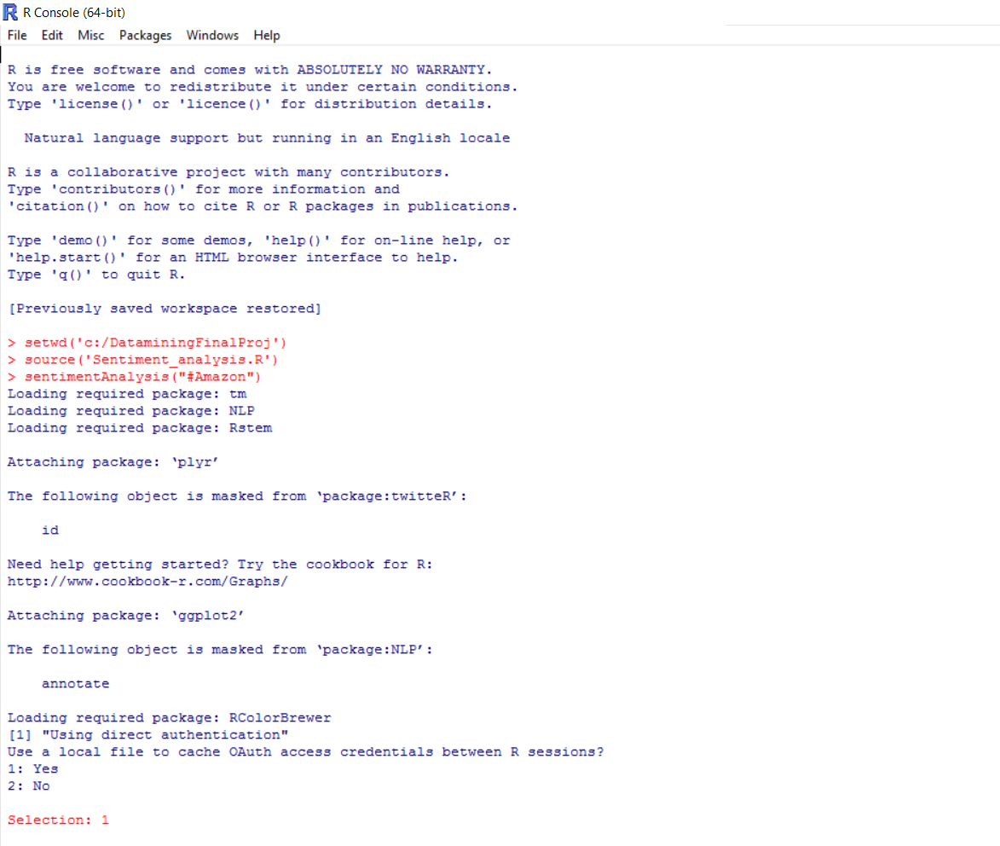

4. We get the output visualization for Amazon in 2 windows 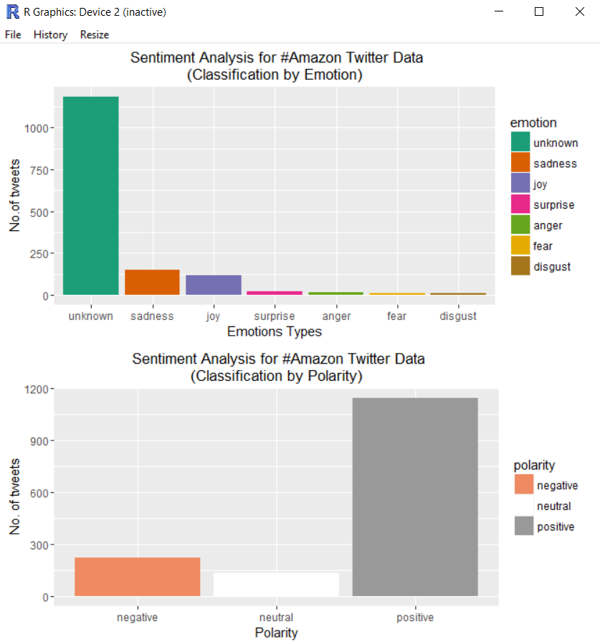

Wordcloud for various emotions

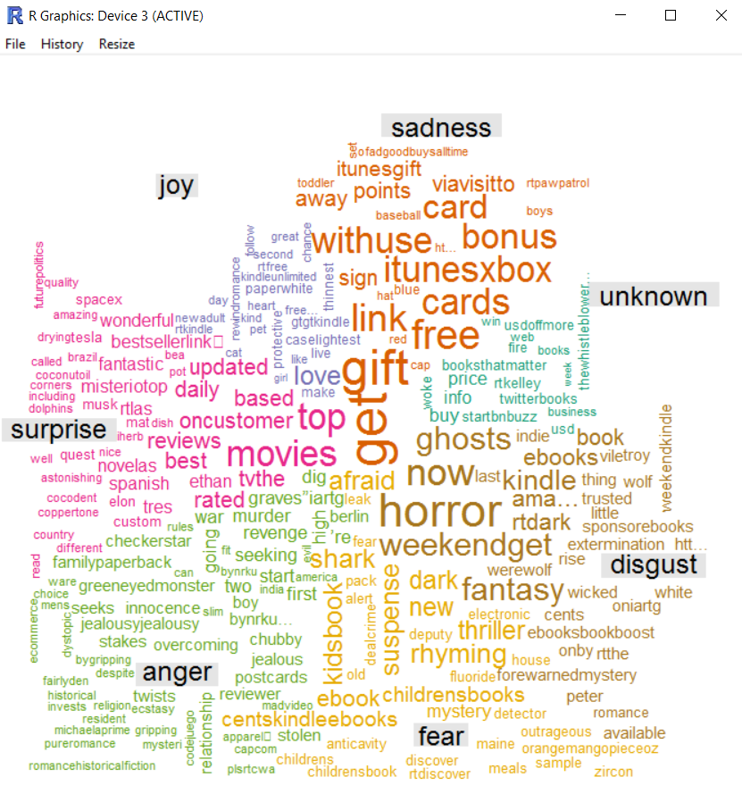

5. Repeat step 3 for any other ecommerce websites.

**> sentimentAnalysis(“#Walmart”)**

**> sentimentAnalysis(“#ebay”)**

**EBAY WORD CLOUD AND SENTIMENT ANALYSIS**

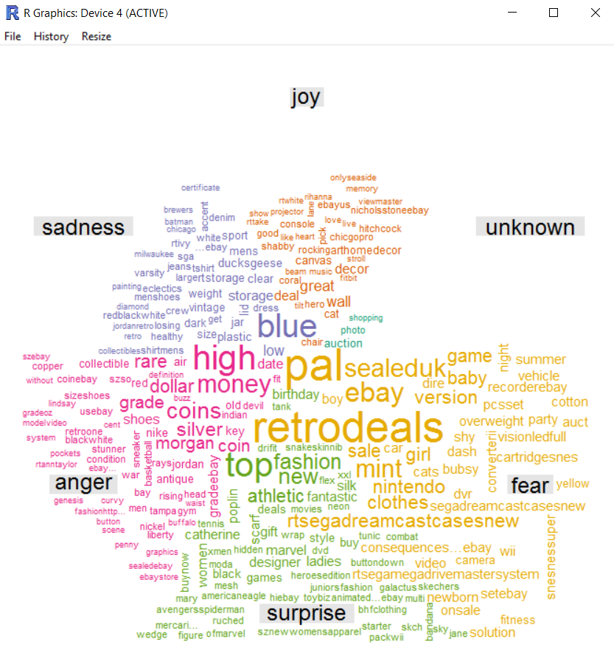

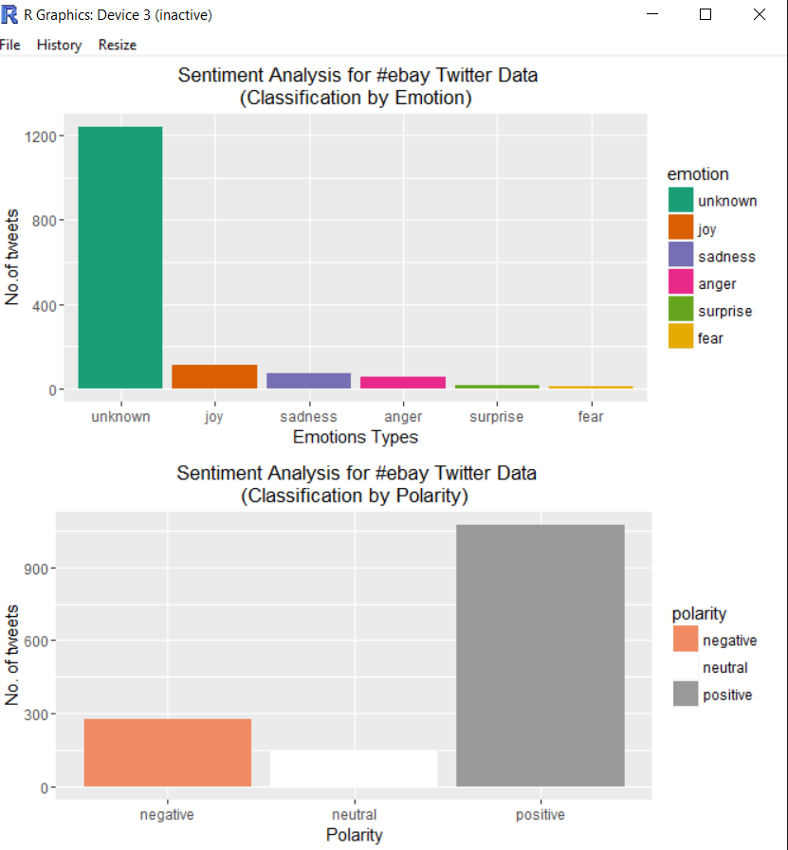

**Walmart word cloud and sentiment analysis**

