create database supplier155;

use supplier155;

create table Supplier(

sid int primary key,

sname varchar(20) ,

city varchar(20));

desc Supplier;

create table Parts(

pid int primary key,

pname varchar(20),

color varchar(20) );

desc Parts;

create table Catalog(

sid int,

pid int,

cost int,

foreign key(sid) references Supplier(sid),

foreign key(pid) references Parts(pid));

desc Catalog;

insert into Supplier values (10001, 'Acme Widget','Bangalore');

insert into Supplier values (10002, 'Johns','Kolkata');

insert into Supplier values (10003, 'Vimal','Mumbai');

insert into Supplier values (10004, 'Reliance','Delhi');

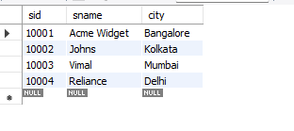

insert into Parts values (20001, 'Book','Red');

insert into Parts values (20002, 'Pen','Red');

insert into Parts values (20003, 'Pencil','Green');

insert into Parts values (20004, 'Mobile','Green');

insert into Parts values (20005, 'Charger','Black');

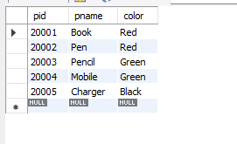

insert into Catalog values (10001, 20001 , 10);

insert into Catalog values (10001, 20002 , 10);

insert into Catalog values (10001, 20003 , 30);

insert into Catalog values (10001, 20004 , 10);

insert into Catalog values (10001, 20005 , 10);

insert into Catalog values (10002, 20001 , 10);

insert into Catalog values (10002, 20002 , 20);

insert into Catalog values (10003, 20003 , 30);

insert into Catalog values (10004, 20003 , 40);

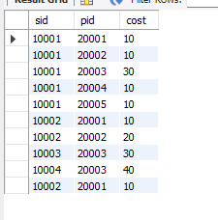

SELECT \* FROM Supplier;

SELECT \* FROM Parts;

SELECT \* FROM Catalog;

select distinct p.pname

from Parts p, Catalog c

where p.pid = c.pid;

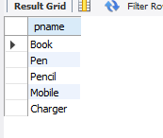

select distinct s.sname

from Catalog c , Supplier s where c.sid = s.sid and

NOT EXISTS(select p.pid from Parts p

where NOT EXISTS(select c1.sid from Catalog c1

where c1.sid=c.sid and c1.pid =c.pid));

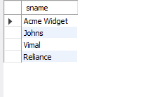

select distinct s.sname

from Catalog C, Supplier s

where C.sid=s.sid and

NOT EXISTS (select P.pid from Parts P

where P.color="Red" and NOT EXISTS (select C1.sid from Catalog C1

where C1.sid = C.sid and C1.pid = P.pid and P.color="Red"));

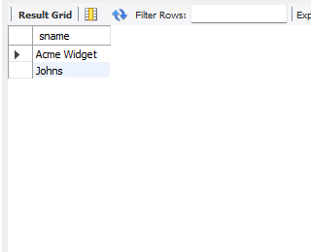

select p.pname

from Parts p, Catalog c, Supplier s

where p.pid=c.pid and c.sid=s.sid and s.sname="Acme Widget"

and NOT EXISTS (select \* from Catalog c1, Supplier s1

where p.pid=c1.pid and c1.sid=s1.sid and

s1.sname != "Acme Widget");

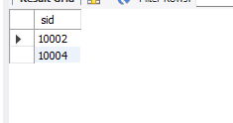

select distinct C.sid from Catalog C

where C.cost > (select AVG(C1.cost)

from Catalog C1 where C1.pid = C.pid);



select P.pid, S.sname

from Parts P, Supplier S, Catalog C

where C.pid = P.pid and

C.sid = S.sid and

C.cost = (select max(C1.cost)

from Catalog C1

where C1.pid = P.pid);

