Technical Report: Deep Learning for an 11-year-old
Topic: Weights, Bias, and Activation Functions
Assignment: A03 ITAI 2376 Deep Learning for an 11-year-old
Course: ITAI 2376 Deep Learning Artificial Intelligence
Institution: Houston City College
Date: February 2, 2026
Team Name: Team 1
Team Members: DeMarcus Crump, Chloe Tu, Matthew Choo, Franck eric Kolontchang toheu

THE NEURAL NETWORK SQUAD - A Deep Learning Adventure
Website Link (Interactive Web Comic): https://neural-network-squad.netlify.app/

1. Introduction
This report explains artificial neurons. The neuron is the most important piece of Deep Learning. You can think of a neuron like a tiny building block for a computer brain. It copies how our own human brains work to solve problems. It takes information from the outside world. It decides if that information is important. Then it gives us an answer. Our goal is to explain this complex idea (Bias, Weight and Activation Function) so that an 11-year-old student can understand it easily.

2. Activities Performed
The team worked together to make this topic more fun. Demarcus created a creative storybook to tell a story about neurons. The rest of the team split up the difficult technical topics. We each researched one specific part of the neuron to explain it better. We looked at the three main stages: Weighting, Biasing, and Activation.

3. Research Findings and Analysis
3.1 Background
The main goal for this assignment (A03) was to pick a hard topic in AI. We had to teach it to a younger student. We chose the artificial neuron because it is the start of everything in Deep Learning.

3.2 Key Features
Our research focused on three big words: Bias, Weight, and Activation Function. These sound hard, but they are actually simple tools the computer uses. We wanted to turn these math terms into easy ideas. We compared them to things an 11-year-old sees every day, like video games or volume knobs.

5. The Computational Flow
A neuron works like a factory line. It follows a strict list of steps to get an answer.
The execution of a single neuron follows a strict sequential pipeline:
- Input Ingestion: The neuron catches data, like catching a ball.
- Weighted Sum: It multiplies the data by a number called the Weight.
- Bias Addition: It adds an extra number called the Bias to the total.
- Activation: The Activation Function looks at the number and makes a final decision.
- Output: The neuron sends its answer to the next neuron in the line.

6. Real-World Applications
To make this real for a student, we used a cartoonish storybook. This helps kids see how math actually works in real life. It shows that these numbers are not just on a page. They help computers do things like play games or recognize cats in photos.

7. Core Components
This section breaks down the three parts of the neuron we researched. We simplified the math into plain English.

7.1. Weights (The Importance Factor) - Researched by Franck
You can think of Weights like the volume of knobs on a radio or a mixing board. These are special numbers that the computer learns over time to help it make better decisions.
- What they do Weights work by multiplying the input number by a specific value. They act like coefficients in a math equation to decide how strong a signal should be. This process helps the neuron figure out which information matters the most.
- High Weight A high weight turns the volume all the way up. It amplifies the input signal and tells the neuron that this specific piece of information is very important to the final answer.
- Low Weight A low weight turns the volume down. It dampens the signal, so it becomes quiet. This tells the neuron that this information is not very important and should be mostly ignored.
- Negative Weight A negative weight is like a special button that flips the meaning of the message. It inverts the relationship between the input and the output. For example, if the input is positive, a negative weight turns it into a negative signal.

7.2. Bias (The Activation Offset) - Researched by Chloe
Bias acts like a helpful teammate for the neuron. It is a learnable parameter that is completely independent of the input data coming in.
- What it does Bias add an extra number to the total calculation after the weight has done its multiplication work. It shifts the activation function to the left or to the right to help the model find the best answer.
- The Job You can think of Bias as a "head start" in a race or a threshold. It allows the neuron to fire and do its job even if the starting input is zero or very low.
- Why we need it Without bias, the computer might get stuck at the starting line (0,0). Bias ensures the model can fit data that does not pass perfectly through the center of origin. It gives the neuron the flexibility it needs to solve harder problems.

7.3. Activation Functions (Non-Linearity) - Researched by Matthew
The Activation Function is the final decision-maker. It looks at the information and determines the final output of the neuron.
- What it does This function introduces something called "non-linearity". This means it can change straight lines into complex curves. This allows neural networks to learn difficult patterns rather than just simple, straight relationships.
- Sigmoid This function squashes the output, so it fits between 0 and 1. It is very useful for questions that need a probability answer, like "Is this a cat? Yes or no".
- Tanh (Hyperbolic Tangent) This function is like Sigmoid, but it is zero-centered. Its range goes from -1 to 1. It is great for modeling inputs that have strong negative, neutral, or strong positive states.
- ReLU (Rectified Linear Unit) This is the most common function used in modern deep learning. It uses simple logic: if the number is positive, let it pass; if it is negative, stop it. By blocking negative signals and setting them to zero, it makes the computer much more efficient and faster at learning.

8. Conclusion: What was Learned
We learned a lot about Weight, Bias, and Activation Functions. We learned that a single neuron has three stages. One neuron can solve simple problems. But Deep Learning uses millions of these neurons stacked in layers. By adjusting Weights and Biases, the computer can learn to do amazing things. This includes recognizing faces or understanding language.

9. Media Gallery
To help explain these complex ideas to an 11-year-old audience, our team created a visual learning hub on the web.
The Neural Network Squad Website (Interactive Web Comic)
Description: This website hosts the creative materials we developed for this project. It serves as a colorful, interactive guide where students can see the concepts of Weights, Bias, and Activation Functions in action.
The "Neural Network" Storybook
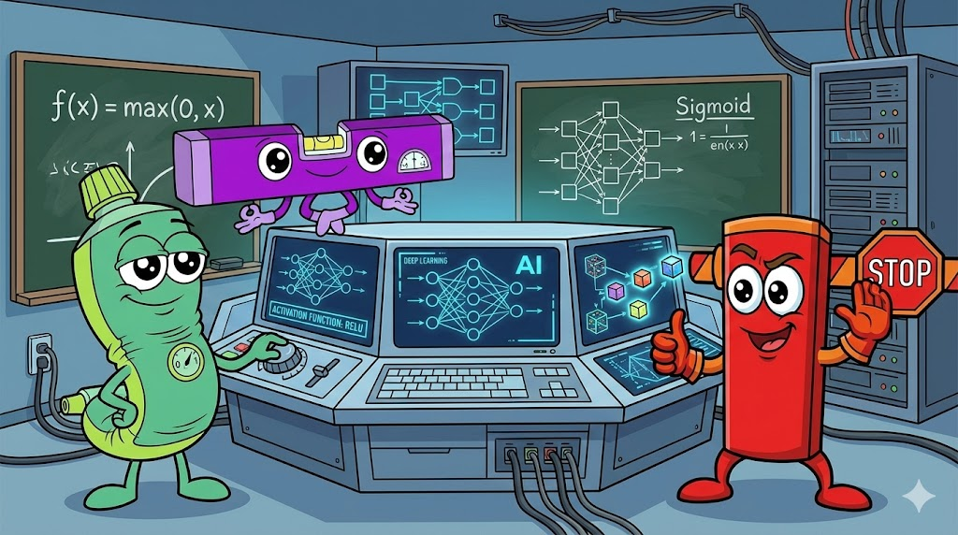
Format: Digital Slideshow / Cartoon Storybook
Content: We converted technical research into a cartoonish storybook to make it relatable. The story follows characters that represent the different parts of a neuron, showing how they work together to solve problems. This visual approach helps bridge the gap between complex math and simple understanding.
9. References
- Baheti, Pragati. “12 Types of Neural Networks Activation Functions: How to Choose?” Www.v7labs.com, 8 Mar. 2022, www.v7labs.com/blog/neural-networks-activation-functions. Accessed 29 Jan. 2026.
- Luna, Javier Canales. “A Beginner’s Guide to the Rectified Linear Unit (ReLU).” Datacamp.com, DataCamp, 28 Jan. 2025, www.datacamp.com/blog/rectified-linear-unit-relu. Accessed 29 Jan. 2026.
- Luca, Gabriele De. “Baeldung.” Baeldung on Computer Science, 20 July 2020, www.baeldung.com/cs/neural-networks-bias. Accessed 29 Jan. 2026.
- GeeksforGeeks. “Effect of Bias in Neural Network.” GeeksforGeeks, 25 Sept. 2018, www.geeksforgeeks.org/deep-learning/effect-of-bias-in-neural-network/. Accessed 2 Feb. 2026.
- Turing. “Importance of Neural Network Bias and How to Add It.” Www.turing.com, www.turing.com/kb/necessity-of-bias-in-neural-networks. Accessed 29 Jan. 2026.
- Ali, Moez. “Introduction to Activation Functions in Neural Networks.” Datacamp.com, DataCamp, 9 Nov. 2023, www.datacamp.com/tutorial/introduction-to-activation-functions-in-neural-networks. Accessed 29 Jan. 2026.
- “Neural Networks: Activation Functions.” Google for Developers, 2024, https://developers.google.com/machine-learning/crash-course/neural-networks/activation-functions. Accessed 29 Jan. 2026.
- GeeksforGeeks. “Weights and Bias in Neural Networks.” GeeksforGeeks, 11 Oct. 2023, www.geeksforgeeks.org/deep-learning/the-role-of-weights-and-bias-in-neural-networks/. Accessed 29 Jan. 2026.

