**Voice Tech in the Multiverse: Alien Encounter**

**World Analysis**

In the Alien Encounter universe, the primary challenge is designing voice technology that can bridge communication between vastly different species with unknown vocal anatomies, acoustic environments, and languages. The first contact setting involves an extraterrestrial environment where atmospheric composition, gravity, and ambient noise levels differ significantly from Earth, affecting sound propagation and recording quality. For example, a denser atmosphere might cause slower sound transmission, while lower gravity could influence vocal cord vibration patterns for both humans and aliens. The vocal anatomy of alien species is unpredictable; some may communicate using ultrasonic frequencies, infrasound, or entirely different modalities like bioluminescent signals or electromagnetic pulses. Furthermore, the noise environment could include alien natural sounds such as electromagnetic storms or biological hums, which complicate the isolation of speech signals. User characteristics range from humans needing advanced translation aids to aliens unfamiliar with human speech patterns, necessitating highly adaptable voice tech that can handle multiple vocal forms and auditory capabilities. The system must also consider non-verbal cues or alternate communication methods native to extraterrestrials to ensure robust understanding.

**Technical Solutions Design**

To address these challenges, the voice technology employs a custom preprocessing pipeline that begins with adaptive acoustic sensing capable of capturing a wide frequency range, from subsonic to ultrasonic bands, and filtering out non-speech environmental noise through dynamic noise suppression algorithms. Unlike standard MFCC (Mel-Frequency Cepstral Coefficients), which assumes human vocal tract frequency ranges, the feature extraction method leverages a more flexible spectral analysis, such as wavelet transforms, to capture diverse signal patterns. Acoustic modeling incorporates machine learning models trained on multi-species vocal datasets simulated with generative adversarial networks (GANs) to generalize across unknown vocal anatomies. Automatic Speech Recognition (ASR) is designed as a multi-modal system combining audio, visual (e.g., lip movement or bioluminescent signals), and contextual environmental cues, improving accuracy in ambiguous settings. Text-to-Speech (TTS) synthesis adapts by generating voice outputs modulated to the recipient’s perceptual abilities, possibly converting human speech into alien sound forms or visual signals. The entire system is built to learn and evolve during interaction, refining its models in real-time to improve translation accuracy and naturalness.

**Demo Scenario**

In the demo, a human scientist on an alien planet attempts first contact with a mysterious extraterrestrial species using the Universal Translator device. The story starts with the scientist greeting the alien with a simple phrase, “Hello, friend,” transmitted through the translator. The alien responds with unfamiliar sounds and flashes of colored lights. The device processes the signals, analyzes vocal and visual data, and presents a synthesized English translation. Suddenly, a solar storm causes interference, scrambling the signal and causing the device to misinterpret the alien’s words, leading to a humorous misunderstanding where the alien is thought to be asking for a dance battle instead of peace talks. The scientist panics but quickly activates the system’s noise-resilient adaptive mode, which recalibrates the signal filters and cross-checks with environmental sensors. The translator then restores accurate communication, allowing the conversation to continue smoothly. The comic strip illustrates the interaction panels, showing the technical details such as signal filtering, multi-modal analysis, and adaptive learning annotations alongside the dialogue, highlighting how the technology handles the acoustic and environmental complexity.

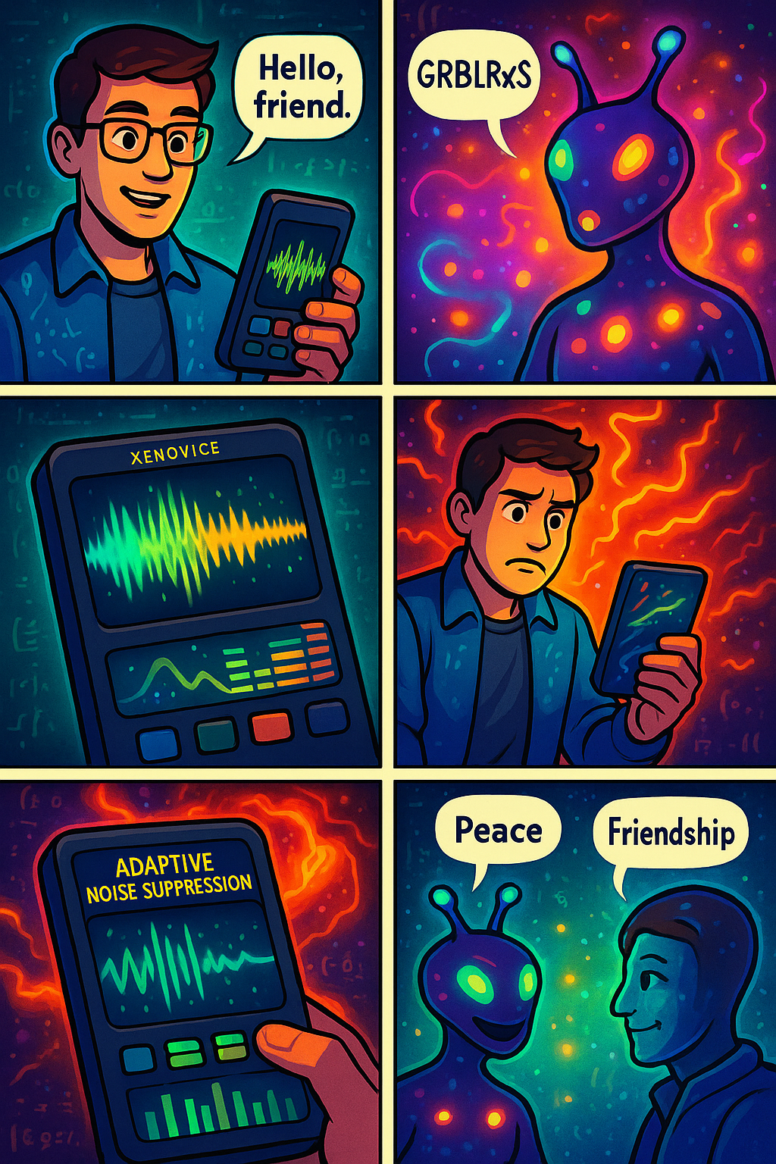

**Executive Pitch**

Introducing “Xenovoice”, the first Universal Translator engineered for seamless interspecies communication across the cosmos. Xenovoice harnesses advanced multi-modal acoustic sensing, adaptive noise suppression, and machine learning acoustic models designed to interpret and synthesize alien vocal patterns alongside human speech. Its unique wavelet-based feature extraction transcends Earth-bound audio assumptions, enabling real-time translation of unknown languages and non-standard communication modes. Marketed as “Breaking Barriers, Bridging Worlds,” Xenovoice offers unmatched versatility and robustness compared to conventional voice tech limited to human acoustic ranges. Its competitive edge lies in the dynamic learning capability, environmental adaptability, and multi-sensory integration, making it the essential tool for explorers, diplomats, and scientists facing the unknown. With Xenovoice, first contact is not just possible, it’s guaranteed to be meaningful.

**Villain’s Countermeasure: “Signal Phantom”**

The antagonist, known as the Signal Phantom, deploys a disruptive technology called the Echo Scrambler, which mimics the ambient noise patterns of the alien environment. This device injects synthetic interference that confuses the Xenovoice system’s adaptive filters by dynamically shifting acoustic signatures and mimicking alien speech patterns. It overwhelms the system’s learning model by flooding it with contradictory data, forcing misclassifications during critical diplomatic exchanges. For example, a peaceful alien greeting may be mistranslated as a threat, sowing discord. The countermeasure challenges Xenovoice to detect adversarial audio patterns and differentiate genuine speech from mimicry using anomaly detection and audio fingerprinting.

**Theme Song**

**Title**: “Voices Beyond the Stars”

(Verse 1)

Through static storms and cosmic sound,

We reach for words where none are found,

In clicks and tones, and glowing light,

We chase a voice through endless night.

(Chorus)

Speak to me in pulses and beams,

In sonic codes and dreaming streams,

Let every phrase we synthesize

Bridge the stars, and break the lies.

(Verse 2)

Your echo's strange, your vowels don't bend,

My TTS can’t comprehend,

Yet with each glitch and garbled line,

We learn, adapt, and realign.

This theme song showcases the difficulty of synthesizing natural, emotional voices across unfamiliar phonetic structures, especially when tonal nuances, pitch dynamics, and timing vary across species.

**New Acoustic Feature: Quantum Harmonic Drift (QHD)**

Quantum Harmonic Drift (QHD) measures the microscopic phase fluctuations in sound waves caused by gravitational field variations in alien environments. Since alien planets may distort sound propagation through quantum-level atmospheric effects, QHD provides a measurement of these temporal anomalies. Unlike standard features like pitch or formants, QHD captures “drift signatures” that reveal how gravitational distortions subtly affect resonance, helping the ASR system localize the source species and environmental context. It becomes a crucial feature in distinguishing overlapping or layered alien voices in complex multidimensional soundscapes.