**8.24**

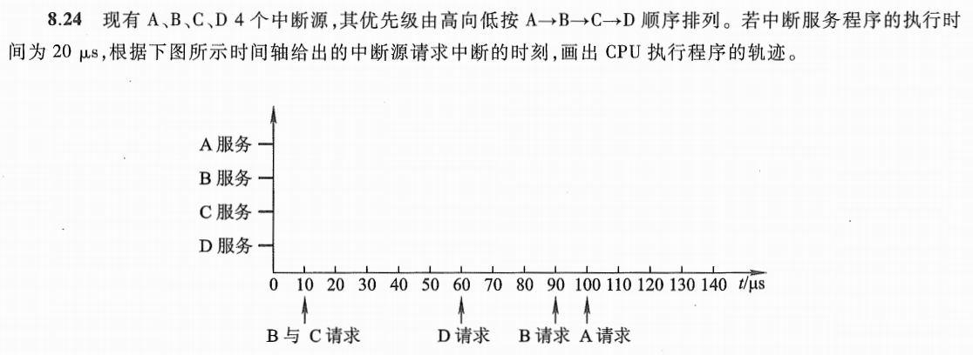

CPU的运行轨迹如图：

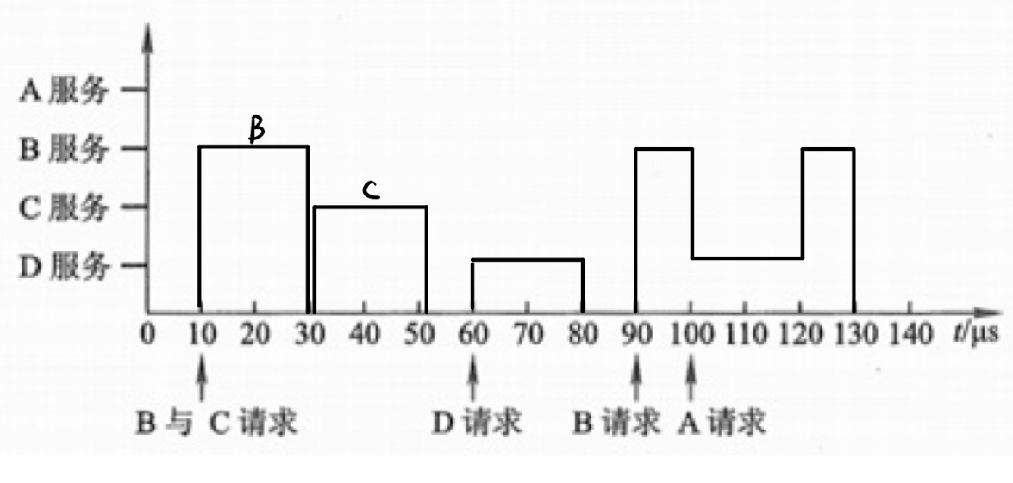

**8.25**

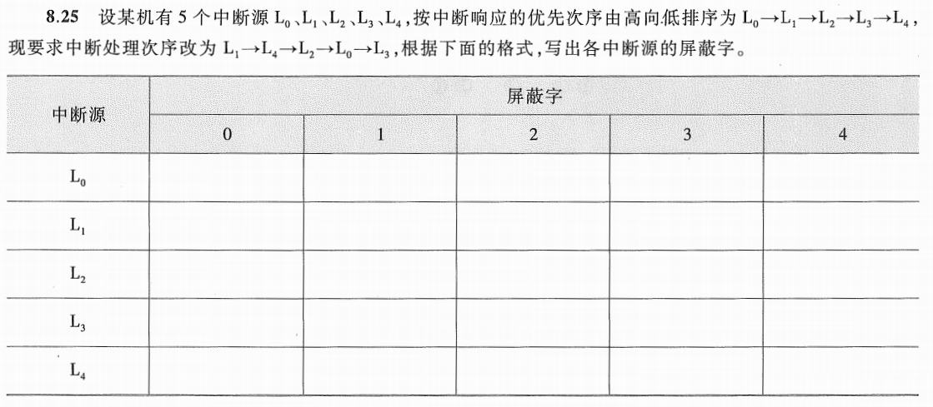

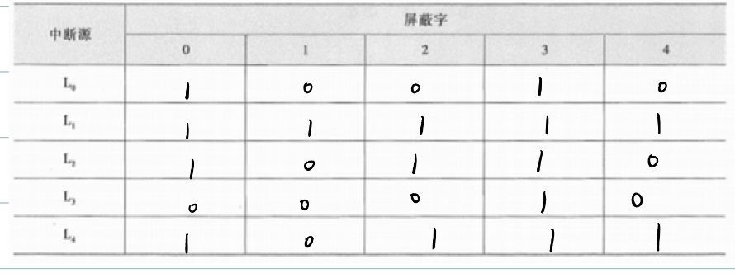

**8.26**



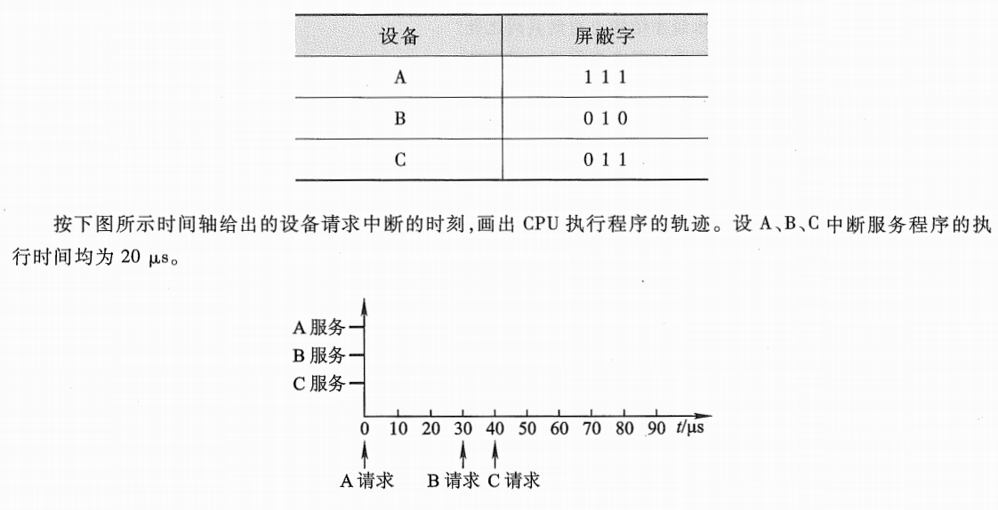

改变后的优先级为A>C>B

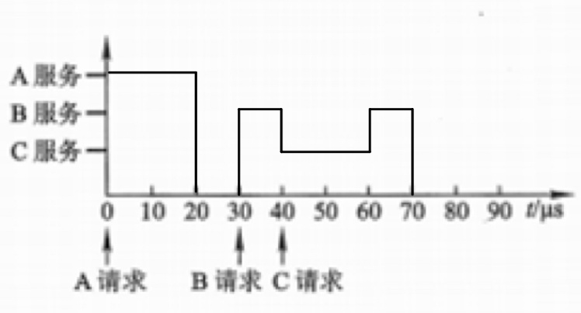

**8.27**

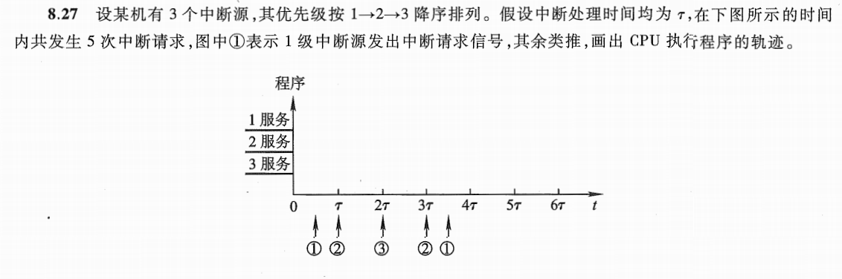

CPU的运行轨迹如图：

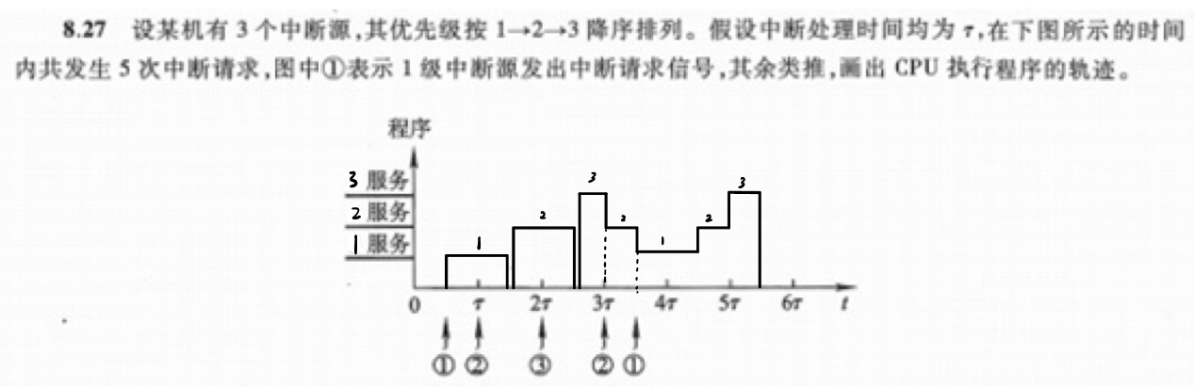

**8.28**

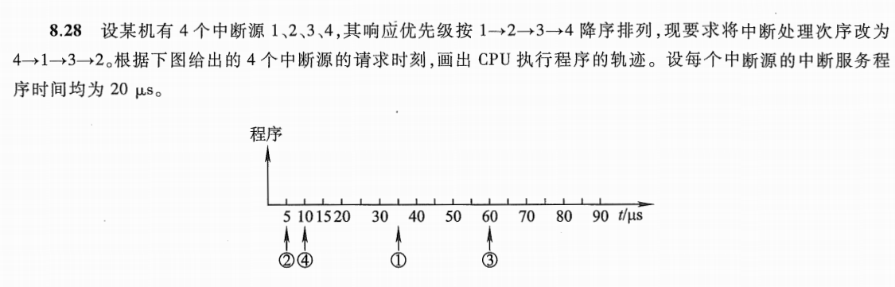

重新设计屏蔽字

|  |  |  |  |  |
| --- | --- | --- | --- | --- |
| 中断源 | 屏蔽字 | | | |
| 1 | 2 | 3 | 4 |
| 1 | 1 | 1 | 1 | 0 |
| 2 | 0 | 1 | 1 | 0 |
| 3 | 0 | 0 | 1 | 0 |
| 4 | 1 | 1 | 1 | 1 |

CPU的运行轨迹如图：

