Don’t Worry, Bar Happy

Research Document

IT-Capstone Project

Getting the most out of your dollar is a basic capitalistic instinct. This especially rings true with going out and having a drink on the town. Bars tend to keep their specials secretive or only have their happy hours written down on a table placard inside of the bar. Also we found many bars don’t have an efficient presence on Facebook and even less have an actual web address. This can cause confusion and inconvenience customers as the only way they can find out specials, happy hours, and conveniences is by taking time to visit each bar.

Our goal as a group is to create a website/web app that will act as a tool to enable consumers to find nearby bars that have specials, happy hours, and amenities that fit their interests. At their computers or on their mobiles they will be able to see what nearby bars offer without having to call or visit them. If they are interested in late night happy hours they can find those bars or if they are only interested in bars that have pool tables they can find those bars. Our project is designed to save time and money for the consumer and can also provide these establishments with unique ways to attract clientele.

**Database**

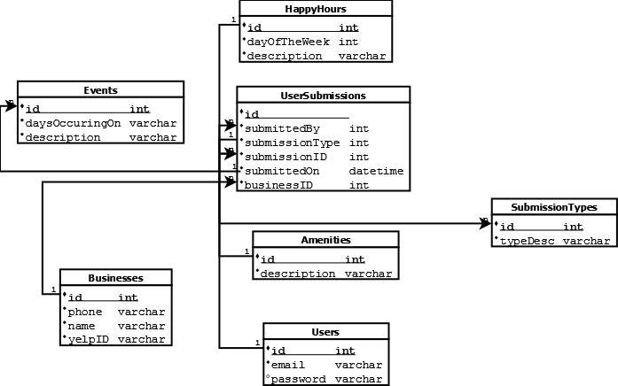

We will be using a database to store information about the bars. We plan on using the Yelp API to populate our database based on zip. However we will rely on ourselves and our users to supply information on the happy hours, specials, and features of the individual bar. This is because that information is not explicitly provided by Yelp.

We will have a web form that will be able to get information on bars from the users so if there isn’t a bar or the happy hour isn’t filled out then they will have the chance to contribute to the website and submit that. We are still trying to figure out exactly how we will vet the information provided and if it will have to have moderator approval or not.

**GUI**

We will start out our website with a basic splash page that has a simple field for the user to input their zip code. We want to make this initial page simple and minimalistic because our target consumers are 18 - 35 and possess web savvy. From there when the user input their zip code a database will populate bars that have specials and/or happy hours.

**Language**

We will be using a variety of programming languages to create our project. Chiefly HTML, CSS, JavaScript, and also PHP.

**Target Population**

Our target population is men and women in the under 35 age group. (<http://www.sbdcnet.org/small-business-research-reports/bar-business-2012> Citation Needed) They spend the most on going out to drink at bars and restaurants and therefore would find the most use out of an app that helps them get more for their money. We have no target ethnicity since we find the differences to be a non-factor in ethnically homogenous area like Eau Claire.