Intro to Natural Language Processing
Assignment – 3
Name: Lakshmipathi Balaji
Roll No: 2021114007
2.1 Theory
1. Explain negative sampling. How do we approximate the word2vec training computation using this technique?

In word2vec training, negative sampling is a method for approximating the computation required to train the model. Word embeddings, which are vector representations of words that capture their meanings and interactions with other words, are what word2vec aims to teach users. The Continuous Bag of Words (CBOW) model trains on a huge corpus of text by either predicting a target word given its context or, in the case of other models, predicting the context given a target word (in the case of the Skip-gram model).

The model is trained using the softmax method, which determines the likelihood that each word in the vocabulary would be the appropriate output given the input context, in normal word2vec. An alternative to softmax that produces decent results is negative sampling. It allows us to approximate the computation required to train the model. Negative sampling only samples a limited number of "negative" words (words that are not in the context). For a given context it takes different a random word from the whole vocabulary. Note that going by emperical frequencies or uniform frequency for all the words doesn’t give good results. A optimal way presented in Mikolov paper is to go by chance of emperical frequency raised to the power of 3/4th.

After getting the positive and negative samples the model is trained for the target word with positive sample and not target word with negative sample hence efficiently finding embeddings of words.

Source/ Reference: https://www.youtube.com/watch?v=4PXILCmVK4Q

2. Explain the concept of semantic similarity and how it is measured using word embeddings. Describe at least two techniques for measuring semantic similarity using word embeddings.
The degree to which two words or phrases have similar meanings is referred to as semantic similarity. In many natural language processing applications, including text categorization, information retrieval, and machine translation, measuring semantic similarity is crucial. Word embeddings, which are dense vector representations of words that capture their semantic and syntactic links, may be used to calculate semantic similarity.

Using word embeddings, there are numerous methods for calculating semantic similarity. Cosine similarity, which calculates the cosine of the angle between two vectors, is one widely used method. The dot product of the two vectors divided by the product of their magnitudes is the formula for calculating the cosine similarity between two word embeddings.The final value falls between -1 and 1, with -1 denoting full dissimilarity and 1 denoting complete similarity.

Word mover's distance (WMD), a distance metric that calculates the smallest distance needed to transfer the words from one phrase to another, is a different method for gauging semantic similarity. In this method, the WMD between each pair of word embeddings represents the semantic similarity between two phrases. The total semantic similarity of the two sentences may be captured by WMD, which takes into consideration the semantic links between words and their relative distances.

2.2 Implementation
The code submitted contains the implementation of both SVD word to vec model and the cbow model with negative sampling.

2.3Analysis
Hyperparameter tuning in Cbow -
Here are a few experiments made during tuning the hyperparameters -
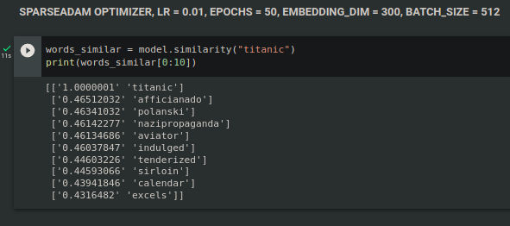

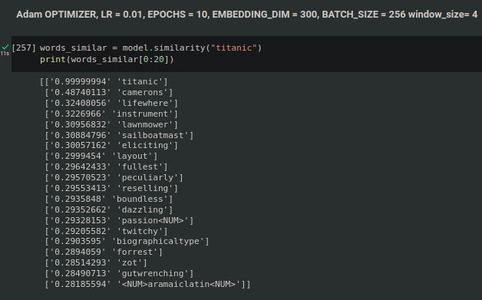

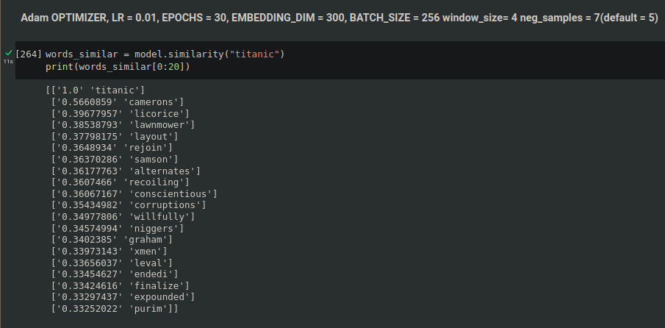
Reason for unrelated outputs even after increasing epochs is because of higher learning rate. The descent had already crossed the minima 24th epoch.
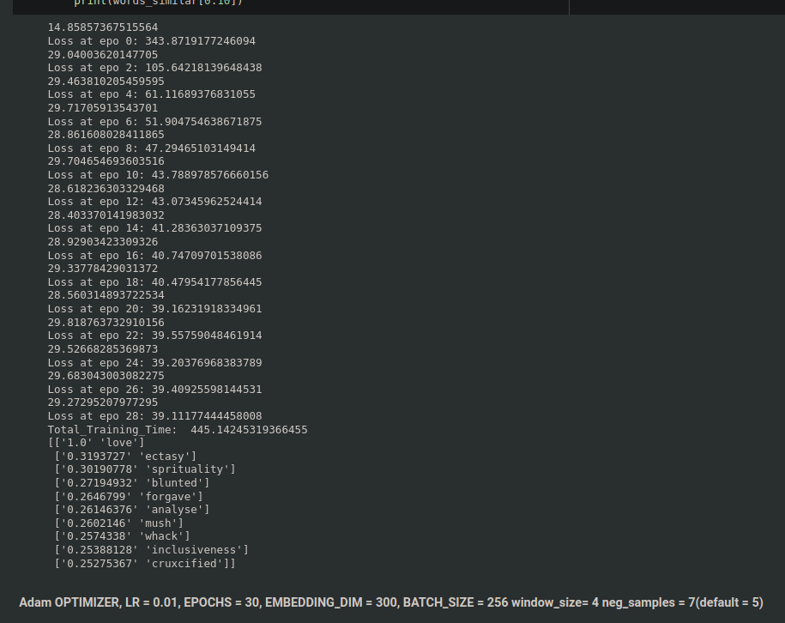
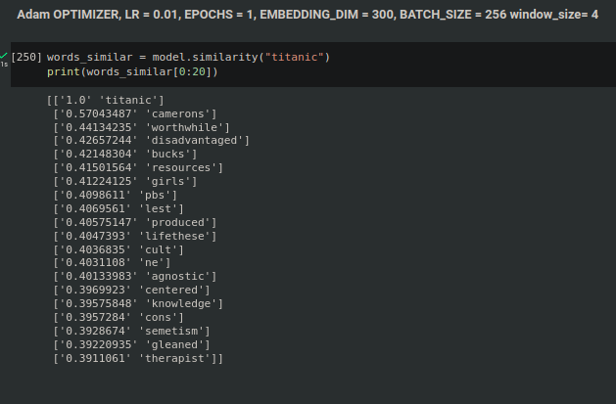
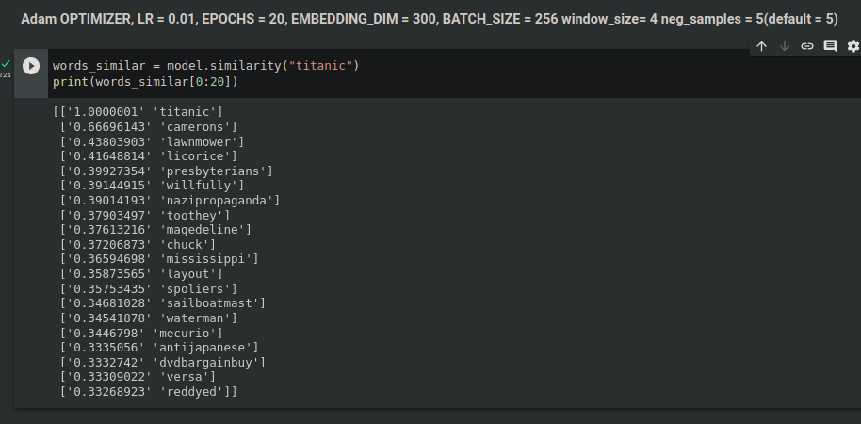
So finally a model with 20 epochs is found to perform better and continued for further functionalities.

PLOTS:

SVD
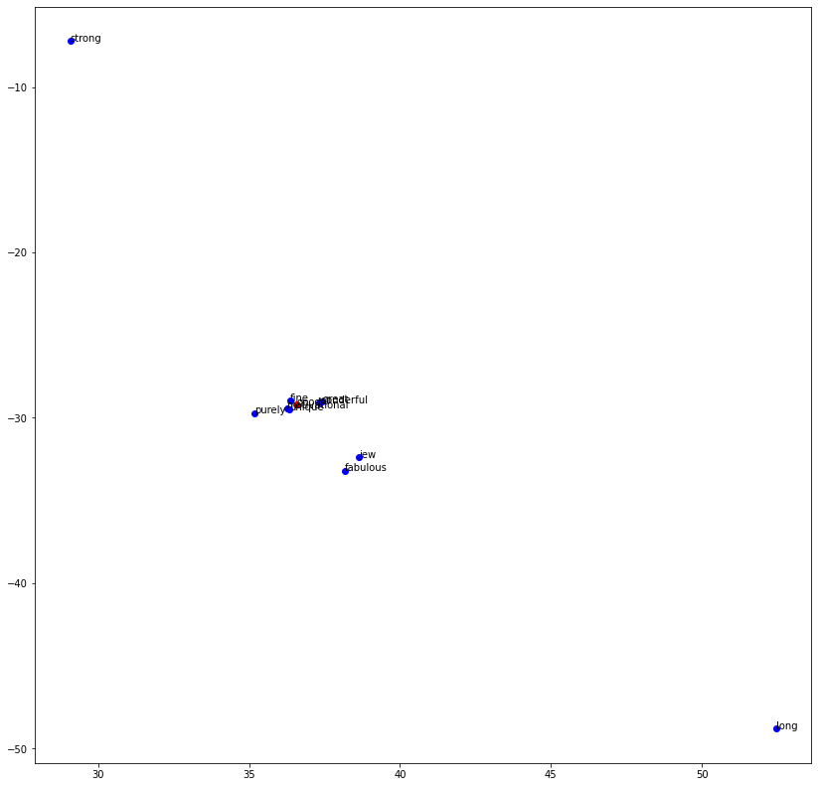

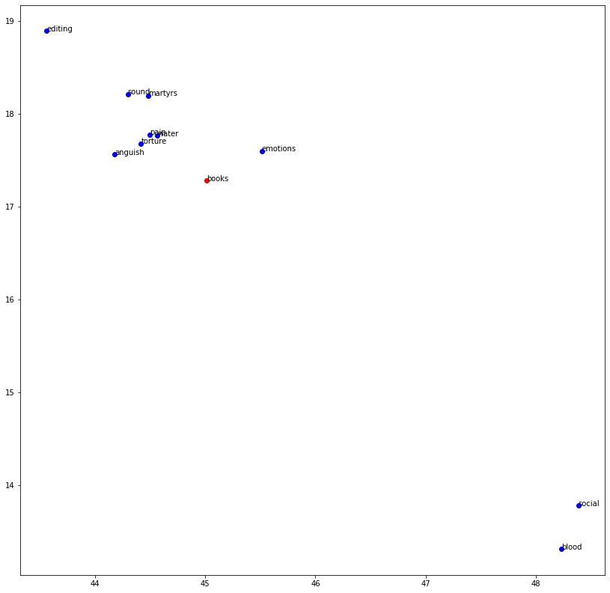

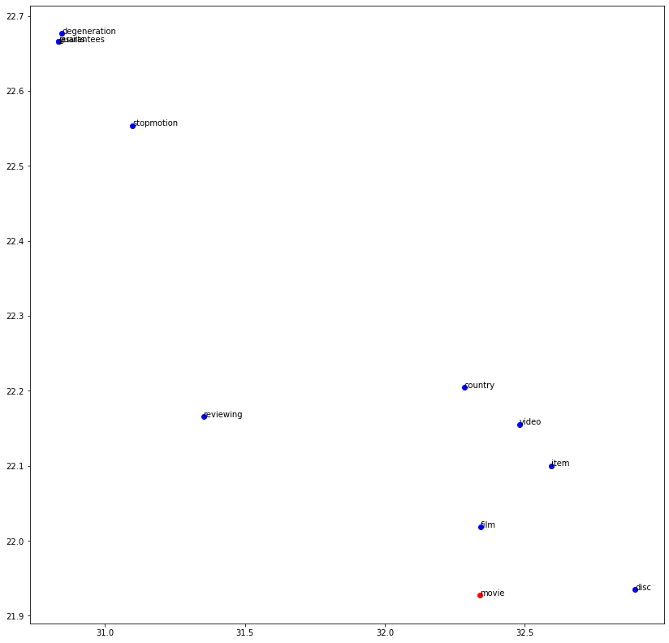

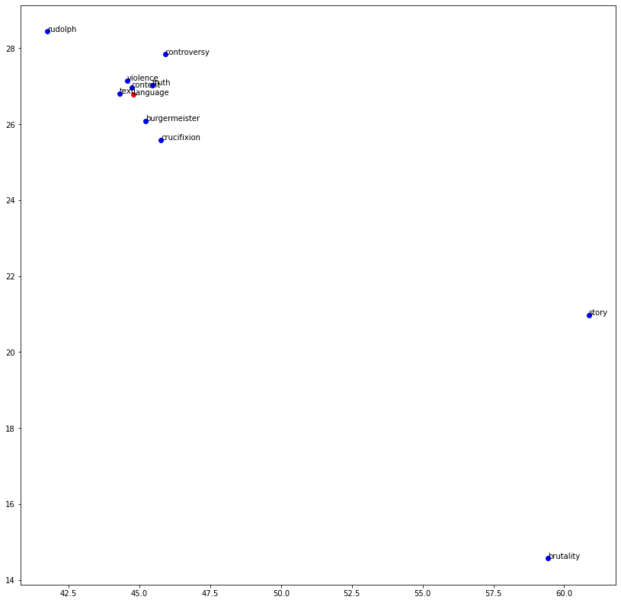

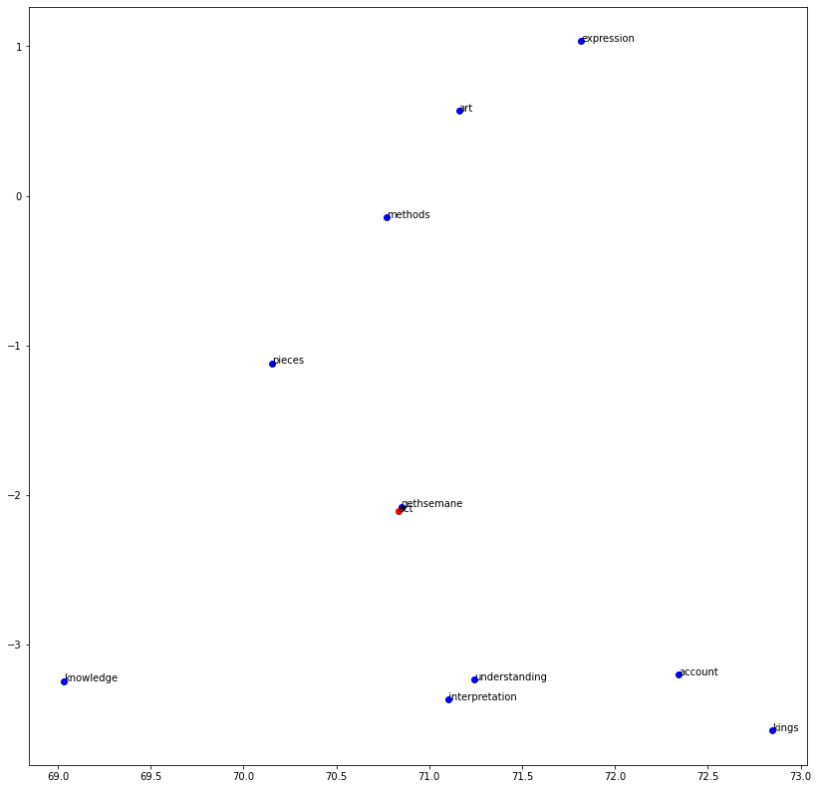

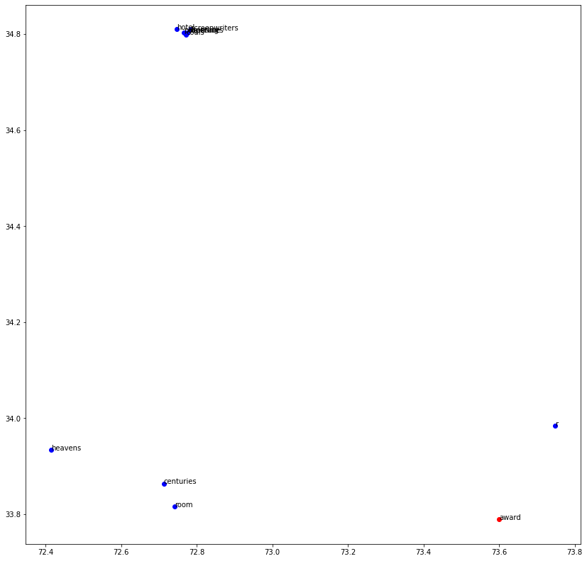

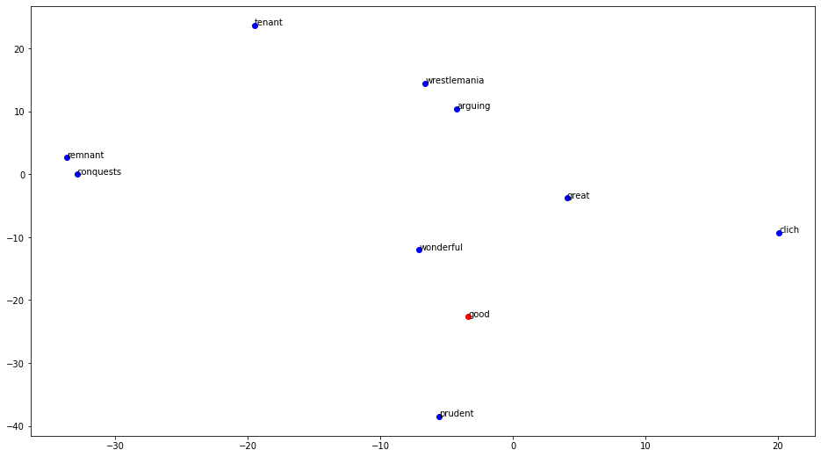
CBOW

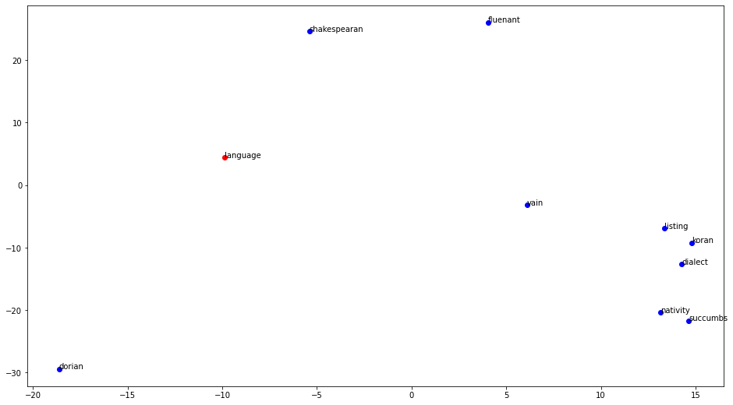

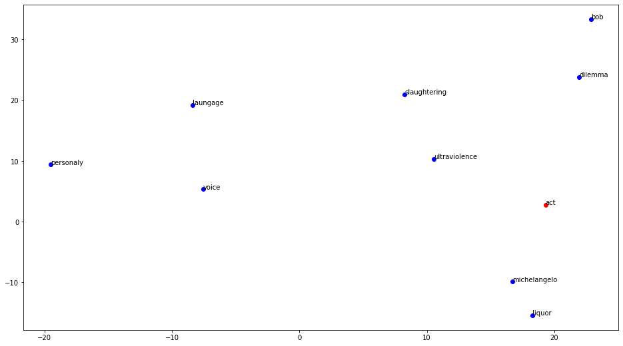
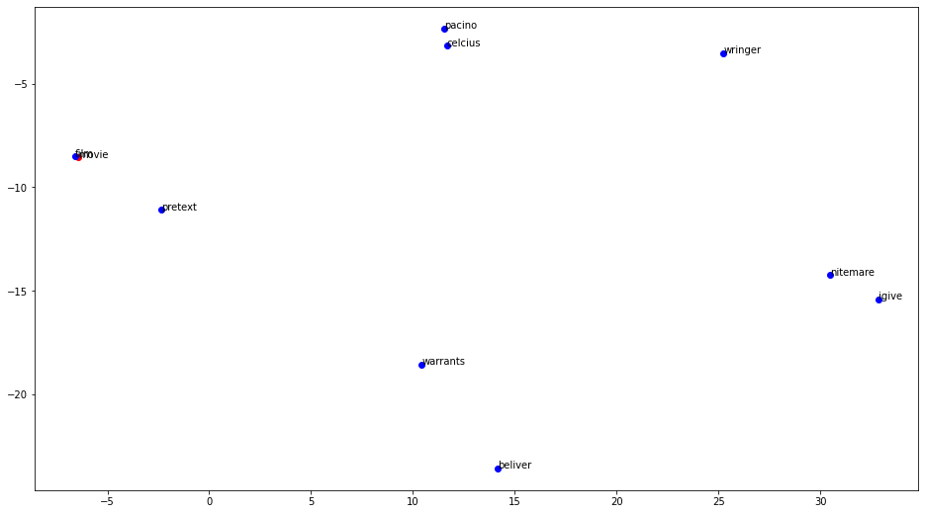

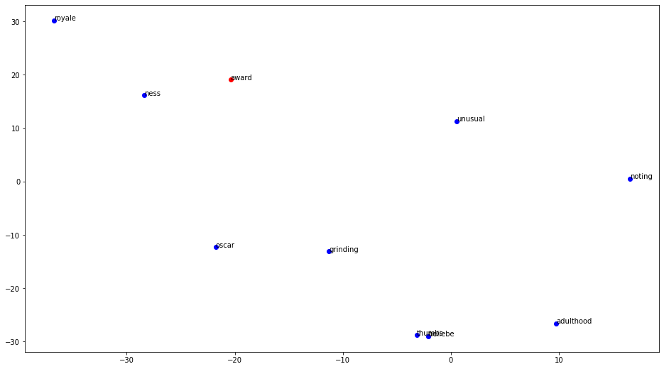

Cbow
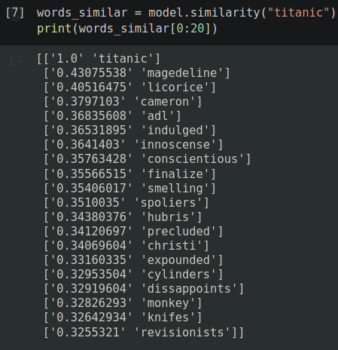

The nearest words according to google-news-300:
('colossal', 0.5896502137184143)
('gargantuan', 0.5718227028846741)
('titanic proportions', 0.5610266923’)
('titantic', 0.5592556595802307)
('monumental', 0.5530510544776917)
('monstrous', 0.5457675457000732)
('epic_proportions', 0.543700397014’)
('gigantic', 0.5176911950111389)
('mighty', 0.5088781118392944)
('epic', 0.600616455078125)

SVD
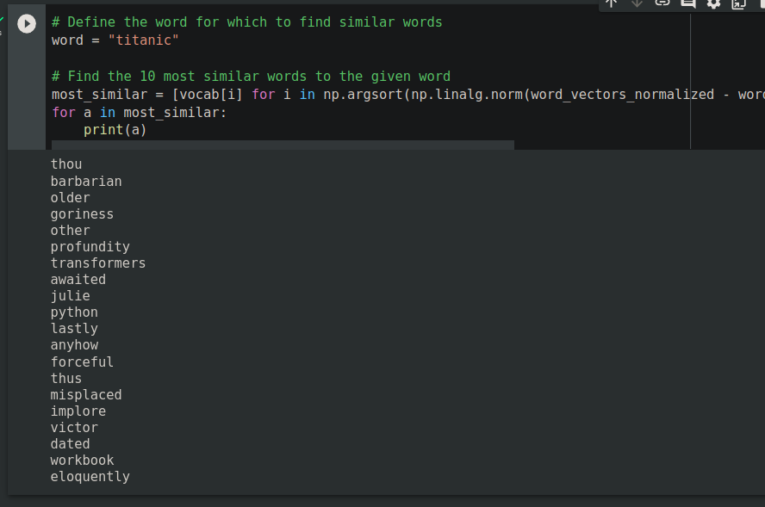

Observation:
Cbow with negative samplings out performs svd.

