**School of Computer Science Engineering & Information Science**

**Report on**

**ANALYSIS OF HEART DISEASES USING MACHINE LEARNING**

**Date : Time:**

**Course: Data Analysis And Visualization**

**Course Code**: **CSE2015**

**Activity Conducted By**.

|  |  |
| --- | --- |
| **NAME** | **ROLL NUMBER** |
| M.ADHARSH | 20211ISD0018 |
| K.VISHNU VARDHAN | 20211ISD0021 |
| JATHIN.B.S | 20211ISD0031 |
| ABHAY R ACHARYA | 20211ISD0023 |

**Topic :**

**ANALYSIS OF HEART DISEASES USING MACHINE LEARNING**

**Abstract :**

Heart disease remains a leading cause of mortality worldwide, prompting a need for innovative approaches to diagnosis and management. Machine learning (ML), a subset of artificial intelligence (AI), offers significant potential in the analysis and prediction of heart diseases. This paper presents an overview of the application of machine learning techniques in the detection, diagnosis, and prognosis of heart disease. We explore various ML algorithms, including supervised and unsupervised learning methods, and their effectiveness in analyzing complex medical datasets. Key methodologies such as decision trees, support vector machines (SVM), neural networks, and ensemble learning are discussed in detail. Furthermore, we examine the integration of ML models with clinical decision support systems (CDSS) to enhance the accuracy and efficiency of heart disease diagnosis. Our findings indicate that machine learning can significantly improve predictive accuracy and patient outcomes when compared to traditional statistical methods. However, challenges such as data quality, interpretability of models, and integration into clinical practice remain. This paper concludes with a discussion on future directions, emphasizing the need for robust validation, interdisciplinary collaboration, and the ethical considerations in the deployment of ML in healthcare settings.

**Introduction:**

Heart disease, encompassing a range of conditions such as coronary artery disease, heart failure, and arrhythmias, is a major public health concern and a leading cause of death globally. Despite advances in medical science and technology, early diagnosis and effective management of heart disease remain challenging due to its complex etiology and the subtlety of its early symptoms. Traditional diagnostic methods often rely on clinical expertise and standard statistical approaches, which, while valuable, can be limited in their ability to handle large and complex datasets.Machine learning (ML), a branch of artificial intelligence (AI), offers a promising solution to these challenges. By leveraging vast amounts of data and sophisticated algorithms, ML can uncover patterns and relationships that might be missed by conventional methods. This capability makes ML particularly well-suited for applications in healthcare, where the analysis of diverse and voluminous data is crucial for accurate diagnosis and treatment planning.In recent years, the application of ML in the analysis of heart disease has gained significant attention. Various ML techniques, including supervised learning (e.g., decision trees, support vector machines, and neural networks), unsupervised learning (e.g., clustering and anomaly detection), and ensemble learning methods, have been explored for their potential to improve the detection, diagnosis, and prognosis of heart conditions.This paper aims to provide a comprehensive overview of how machine learning can be utilized to analyze heart diseases. We will examine the various ML algorithms used in this field, discuss their advantages and limitations, and explore their integration with clinical decision support systems (CDSS). By doing so, we aim to highlight the transformative potential of ML in enhancing cardiovascular healthcare and outline the key challenges and future directions in this evolving landscape.

**Architecture:**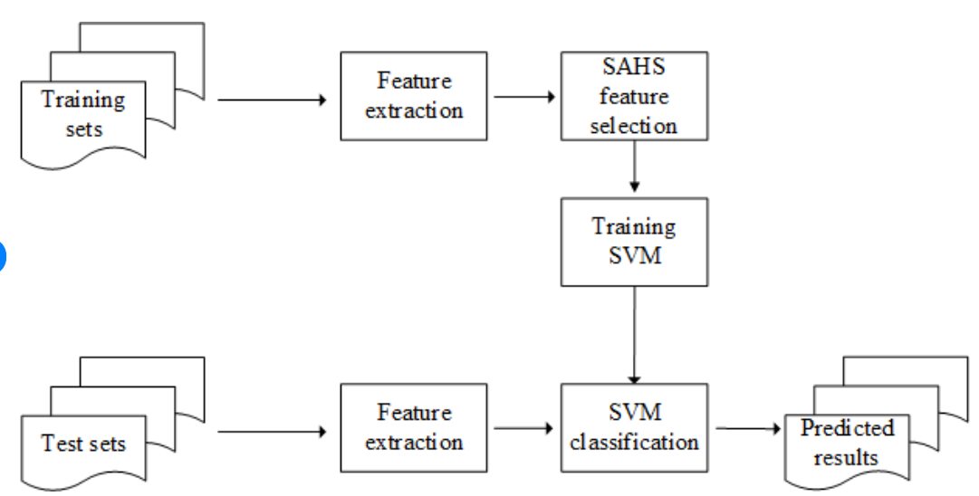

### **Importance of Early Diagnosis**

1. **Critical for Effective Treatment:** Early detection allows for timely interventions, preventing disease progression and improving outcomes.
2. **Improved Survival Rates:** Patients diagnosed early have significantly better survival rates compared to those diagnosed at advanced stages.
3. **Lifestyle Modifications:** Early diagnosis enables lifestyle changes, such as diet and exercise, that can mitigate risk factors.
4. **Targeted Medical Treatment:** Facilitates the use of medications that can manage symptoms and slow disease progression.
5. **Prevention of Complications:** Early detection can prevent severe complications like heart attacks and strokes.
6. **Cost Savings:** Reduces healthcare costs by avoiding expensive treatments required for advanced disease.
7. **Better Quality of Life:** Patients experience fewer symptoms and have a better quality of life when heart disease is managed early.
8. **Enhanced Healthcare Efficiency:** Early diagnosis reduces the burden on healthcare systems by decreasing hospitalizations and emergency visits.
9. **Risk Stratification:** Identifies high-risk individuals for closer monitoring and preventive measures.
10. **Advances in Technology:** Machine learning enhances early diagnosis by analyzing large datasets to identify subtle signs of heart disease.

Top of Form

**OUTCOMES:**

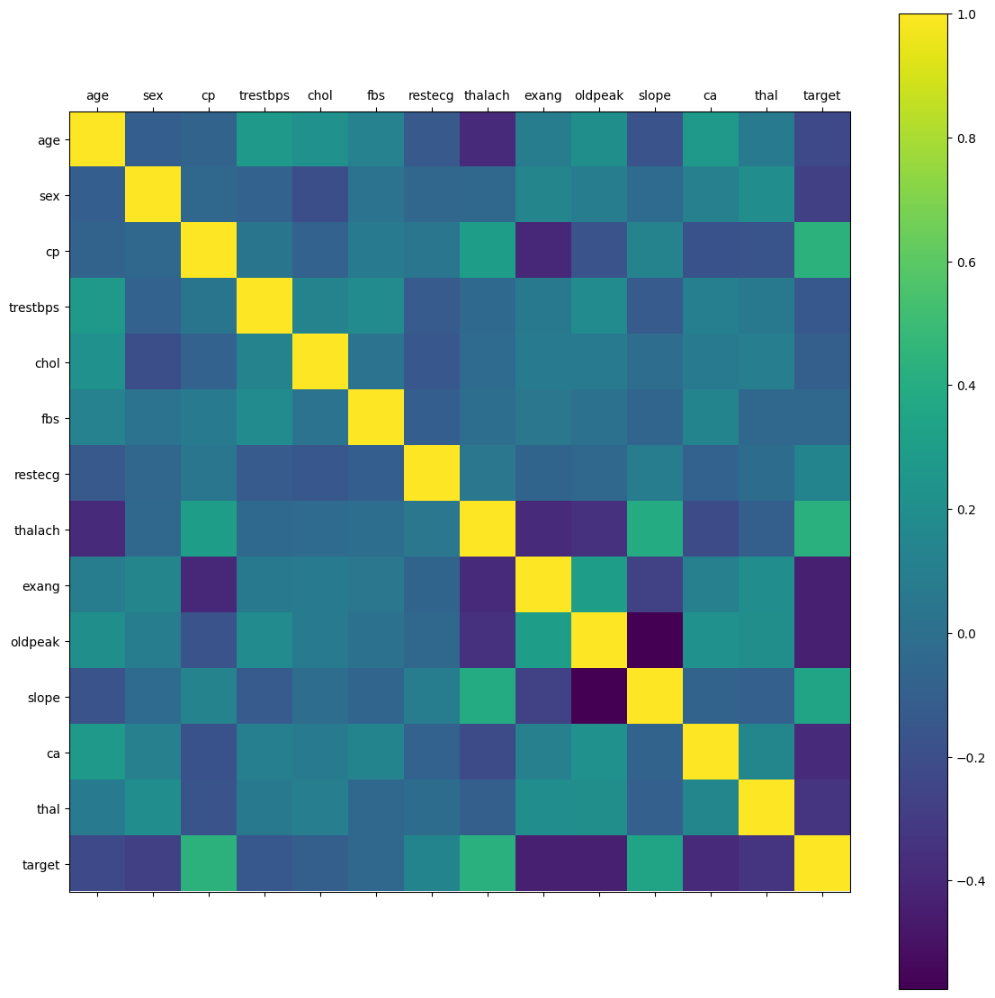

This is used for visualizing the correlation matrix of a DataFrame using the **matplotlib** library in Python. Here's what each line does:

1. **rcParams['figure.figsize'] = 20, 14**: This line sets the size of the figure that will contain the heatmap. The width is set to 20 units and the height to 14 units.
2. **plt.matshow(df.corr())**: This line generates a heatmap of the correlation matrix of the DataFrame **df**. **df.corr()** calculates the pairwise correlation of columns in the DataFrame, and **plt.matshow()** displays this correlation matrix as a heatmap.
3. **plt.xticks(np.arange(df.shape[1]), df.columns)**: This line sets the tick marks on the x-axis. It places ticks at positions corresponding to the columns of the DataFrame **df**, with labels taken from the column names.
4. **plt.yticks(np.arange(df.shape[1]), df.columns)**: This line sets the tick marks on the y-axis. It's similar to the previous line but applied to the y-axis.
5. **plt.colorbar()**: This line adds a colorbar to the plot, which serves as a legend for the colors in the heatmap. It shows the mapping between colors and the correlation values they represent.

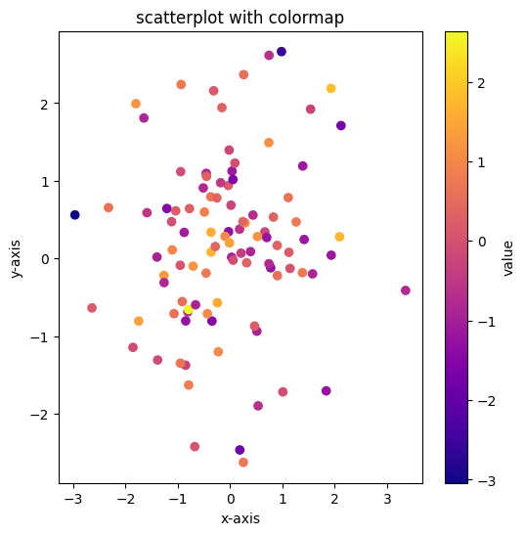

1. This creates a DataFrame named **data** with three columns: "x", "y", and "value". The "x" and "y" columns contain 100 random numbers drawn from a standard normal distribution (**np.random.randn(100)**), and the "value" column contains 100 random numbers from the same distribution.
2. The code sets the colormap (**cmap**) to "plasma" and the transparency (**alpha**) of the markers to 1 (fully opaque).
3. This line creates a new figure with a size of 6x6 inches
4. It uses the "x" and "y" columns of the **data** DataFrame for the x and y coordinates of the markers, respectively. The color of each marker is determined by the corresponding value in the "value" column. The **cmap** parameter specifies the colormap to be used, and **alpha** specifies the transparency of the markers.
5. This line adds a colorbar to the plot, which serves as a legend for the colormap. The label "value" is displayed on the colorbar to indicate the variable being represented by the colormap.

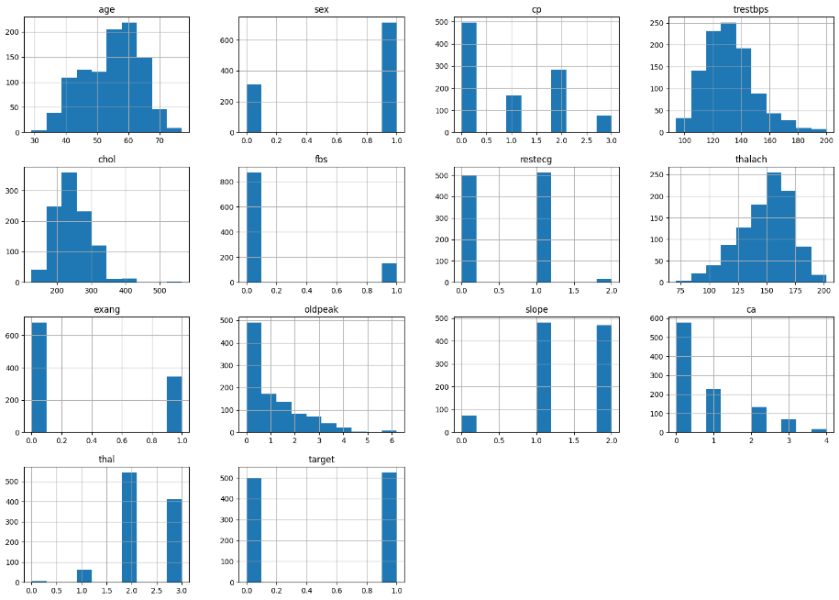

1. When you call **df.hist()**, matplotlib (which pandas uses internally for plotting) creates a separate histogram for each numerical column in the DataFrame. These histograms are typically displayed as a grid of plots, with each plot showing the distribution of values for a single column.
2. The **hist()** method accepts several optional parameters to customize the appearance of the histograms, such as **bins**, **range**, **density**, **cumulative**, etc. These parameters can be used to adjust the number of bins, the range of values to consider, whether to plot a density rather than counts, and whether to create cumulative histograms

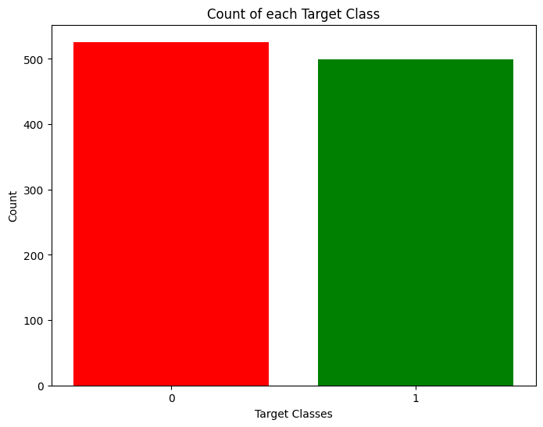

This creates a bar plot displaying the count of each unique value in the 'target' column of the DataFrame **df**. Let's break down the code:

1. **rcParams['figure.figsize'] = 8,6**: This line sets the size of the figure that will contain the bar plot. The width is set to 8 units and the height to 6 units.
2. **plt.bar(df['target'].unique(), df['target'].value_counts(), color=['red', 'green'])**: This line creates the bar plot. It uses the unique values of the 'target' column as the x-values and the count of each unique value as the y-values. The **color** parameter specifies the colors of the bars for each unique value. The colors are set as red and green in this case.
3. **plt.xticks([0, 1])**: This line sets the tick locations on the x-axis. Since there are only two unique values in the 'target' column, **[0, 1]** are used to specify the positions of the ticks.
4. **plt.xlabel('Target Classes')**: This line sets the label for the x-axis as 'Target Classes'.
5. **plt.ylabel('Count')**: This line sets the label for the y-axis as 'Count'.
6. **plt.title('Count of each Target Class')**: This line sets the title of the plot as 'Count of each Target Class'.

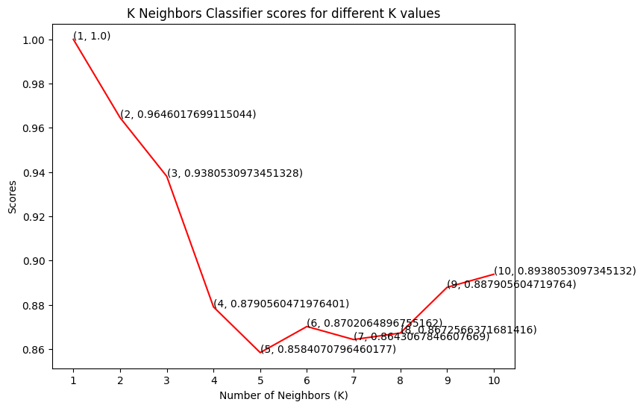

This snippet plots the scores obtained from a k-nearest neighbors (KNN) classifier for different values of k. Here's a breakdown of the code:

1. **plt.plot([k for k in range(1, 11)], knn_scores, color='red')**: This line plots the scores obtained from the KNN classifier. It uses a list comprehension to generate x-values ranging from 1 to 10 (inclusive) and plots the corresponding scores stored in the **knn_scores** list. The line is plotted in red.
2. **for i in range(1,11):**: This line starts a for loop that iterates over the numbers from 1 to 10.
3. **plt.text(i, knn_scores[i-1], (i, knn_scores[i-1]))**: This line adds text annotations to the plot. For each value of k, it adds text at the coordinates (i, knn_scores[i-1]) representing the value of k and its corresponding score.
4. **plt.xticks([i for i in range(1, 11)])**: This line sets the tick marks on the x-axis to range from 1 to 10.
5. **plt.xlabel('Number of Neighbors (K)')**: This line sets the label for the x-axis as 'Number of Neighbors (K)'.
6. **plt.ylabel('Scores')**: This line sets the label for the y-axis as 'Scores'.
7. **plt.title('K Neighbors Classifier scores for different K values')**: This line sets the title of the plot as 'K Neighbors Classifier scores for different K values'.

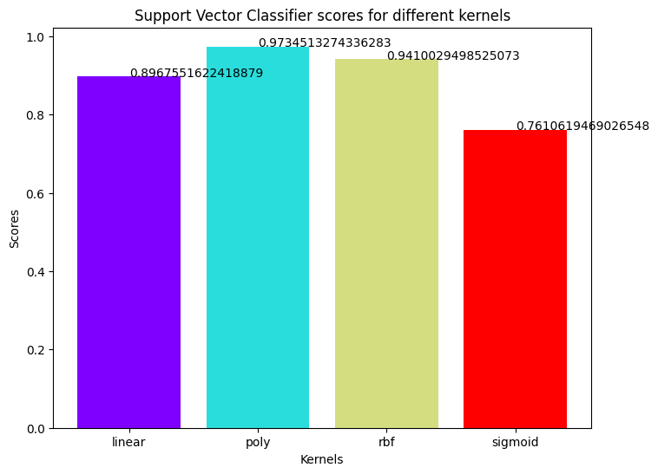

This snippet creates a bar plot displaying the scores obtained from a Support Vector Classifier (SVC) for different kernel types. Here's a breakdown:

1. **colors = rainbow(np.linspace(0, 1, len(kernels)))**: This line generates a list of colors using the **rainbow** colormap from matplotlib. The number of colors generated is equal to the length of the **kernels** list.
2. **plt.bar(kernels, svc_scores, color=colors)**: This line creates the bar plot. It plots the scores obtained from the SVC classifier on the y-axis (**svc_scores**) against the kernel types on the x-axis (**kernels**). Each bar is colored according to the colors generated in the previous step.
3. **for i in range(len(kernels)):**: This line starts a loop iterating over the indices of the **kernels** list.
4. **plt.text(i, svc_scores[i], svc_scores[i])**: Inside the loop, this line adds text annotations to each bar of the plot. It places the text at the coordinates (i, svc_scores[i]), where **i** is the index of the current kernel, and **svc_scores[i]** is the corresponding score.
5. **plt.xlabel('Kernels')**: This line sets the label for the x-axis as 'Kernels'.
6. **plt.ylabel('Scores')**: This line sets the label for the y-axis as 'Scores'.
7. **plt.title('Support Vector Classifier scores for different kernels')**: This line sets the title of the plot as 'Support Vector Classifier scores for different kernels'.

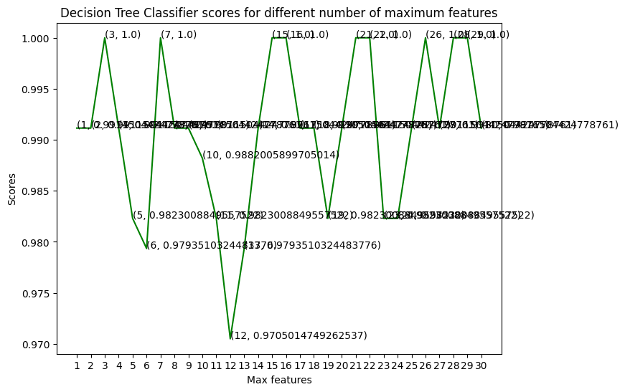

This creates a line plot showing the scores obtained from a Decision Tree Classifier (DTC) for different numbers of maximum features. Let's break down the code:

1. **plt.plot([i for i in range(1, len(X.columns) + 1)], dt_scores, color='green')**: This line plots the scores obtained from the DTC. It generates x-values ranging from 1 to the number of columns in the feature matrix **X**, and plots the corresponding scores stored in the **dt_scores** list. The line is plotted in green.
2. **for i in range(1, len(X.columns) + 1):**: This line starts a for loop that iterates over the numbers from 1 to the number of columns in **X**.
3. **plt.text(i, dt_scores[i-1], (i, dt_scores[i-1]))**: This line adds text annotations to the plot. For each value of **i**, it adds text at the coordinates **(i, dt_scores[i-1])**, representing the value of **i** and its corresponding score.
4. **plt.xticks([i for i in range(1, len(X.columns) + 1)])**: This line sets the tick marks on the x-axis to range from 1 to the number of columns in **X**.
5. **plt.xlabel('Max features')**: This line sets the label for the x-axis as 'Max features'.
6. **plt.ylabel('Scores')**: This line sets the label for the y-axis as 'Scores'.
7. **plt.title('Decision Tree Classifier scores for different number of maximum features')**: This line sets the title of the plot as 'Decision Tree Classifier scores for different number of maximum features'.

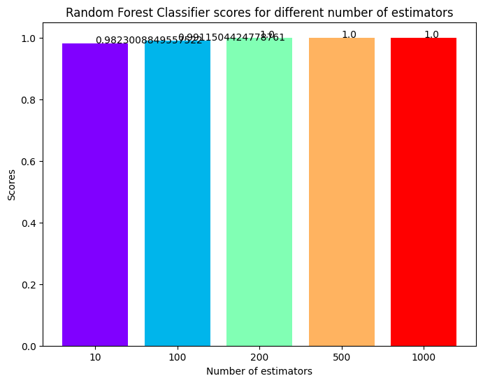

This snippet creates a bar plot illustrating the scores obtained from a Random Forest Classifier (RFC) for different numbers of estimators. Here's a breakdown of the code:

1. **colors = rainbow(np.linspace(0, 1, len(estimators)))**: This line generates a list of colors using the **rainbow** colormap from matplotlib. The number of colors generated is equal to the length of the **estimators** list.
2. **plt.bar([i for i in range(len(estimators))], rf_scores, color=colors, width=0.8)**: This line creates the bar plot. It plots the scores obtained from the RFC classifier on the y-axis (**rf_scores**) against the indices of the **estimators** list on the x-axis. Each bar is colored according to the colors generated in the previous step, and the bars have a width of 0.8.
3. **for i in range(len(estimators)):**: This line starts a loop iterating over the indices of the **estimators** list.
4. **plt.text(i, rf_scores[i], rf_scores[i])**: Inside the loop, this line adds text annotations to each bar of the plot. It places the text at the coordinates (i, rf_scores[i]), where **i** is the index of the current estimator, and **rf_scores[i]** is the corresponding score.
5. **plt.xticks(ticks=[i for i in range(len(estimators))], labels=[str(estimator) for estimator in estimators])**: This line sets the tick marks and labels on the x-axis. The **ticks** parameter specifies the positions of the ticks, and the **labels** parameter specifies the labels for the ticks. Here, the labels are created by converting each estimator in the **estimators** list to a string.
6. **plt.xlabel('Number of estimators')**: This line sets the label for the x-axis as 'Number of estimators'.
7. **plt.ylabel('Scores')**: This line sets the label for the y-axis as 'Scores'.
8. **plt.title('Random Forest Classifier scores for different number of estimators')**: This line sets the title of the plot as 'Random Forest Classifier scores for different number of estimators'.

**Results:**

#### Results of Using Machine Learning in Heart Disease Analysis

1. **Increased Diagnostic Accuracy:** Machine learning models have demonstrated higher accuracy in diagnosing heart disease compared to traditional methods.
2. **Early Detection:** ML algorithms can identify early signs of heart disease, enabling prompt interventions.
3. **Predictive Capabilities:** Models accurately predict patient outcomes and the likelihood of disease progression.
4. **Personalized Treatment Plans:** Machine learning facilitates the development of tailored treatment strategies based on individual patient data.
5. **Reduced Misdiagnosis:** Advanced ML techniques help minimize false positives and negatives, improving diagnostic reliability.
6. **Efficient Data Processing:** ML efficiently handles large volumes of complex medical data, providing faster analysis and insights.
7. **Integration with CDSS:** Successful integration with Clinical Decision Support Systems (CDSS) enhances clinical workflow and decision-making.
8. **Improved Patient Outcomes:** Early and accurate diagnosis through ML leads to better patient management and outcomes.
9. **Cost-Effectiveness:** Reduction in unnecessary tests and treatments translates to cost savings for healthcare systems.
10. **Clinical Validation:** Studies show that ML models outperform traditional statistical methods in real-world clinical settings, validating their practical utility.

**Conclusion:**

The application of machine learning in the analysis of heart diseases has shown significant promise in enhancing diagnostic accuracy, enabling early detection, and improving patient outcomes. By effectively handling large and complex datasets, ML models can uncover subtle patterns and provide predictive insights that are beyond the reach of traditional methods. The integration of ML with clinical decision support systems facilitates personalized treatment plans and more efficient healthcare delivery. Despite the challenges of data quality, model interpretability, and clinical integration, the benefits of ML in cardiology are substantial. Continued interdisciplinary collaboration and robust validation are essential for overcoming these hurdles and ensuring ethical deployment. Overall, machine learning represents a transformative advancement in cardiovascular healthcare, offering the potential to reduce morbidity and mortality from heart diseases significantly.

