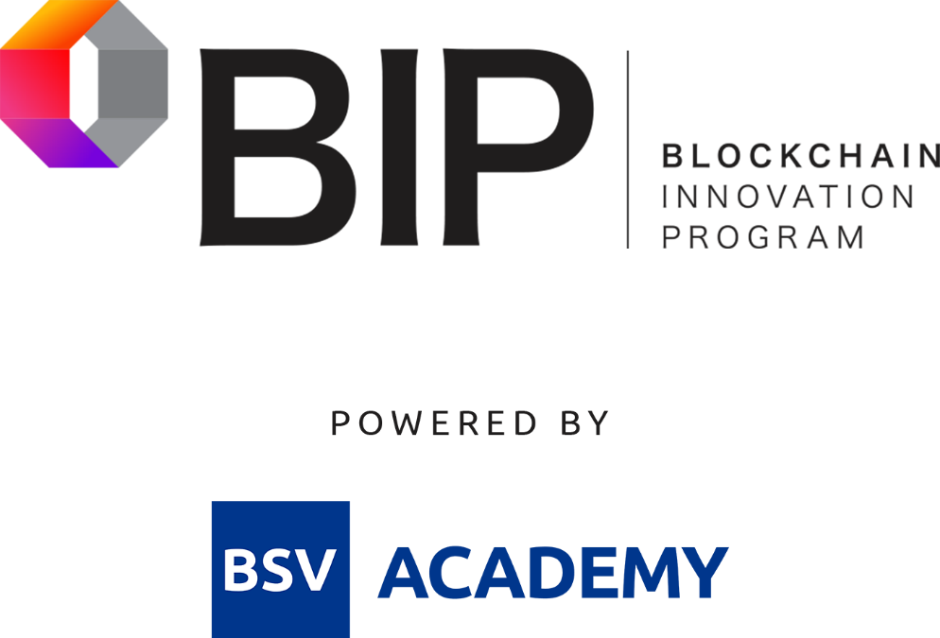

Please note:

There is no tutorial worksheet for week 8. Content will be covered in a live session.

Contact [@Julie Gaudreau](mailto:julie@bitcoinassociation.net) if you have any questions.