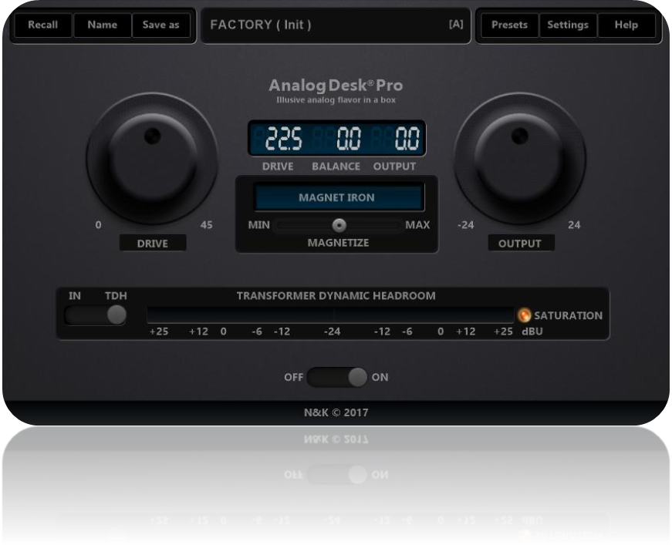

Analog Desk Pro

Illusive analog flavor in a box!

Inspired by the smooth dynamic shaping capabilities of some high-end Transformers & Preamps, this plug-in simulates almost all of the most distinctive and much appreciated sonic effects generated by these devices.
The Concept:
"Analog Desk" emulates the authentic tone of the audio industry’s microphone preamplifiers to your digital audio workstation. Each preamp uses an infinite impulse response (IIR) analog modeling technology to recreate every aspect of the preamp circuit, from mild coloration to full-on saturation and distortion. The "Analog DESK" adds real analog preamp tone to any track or mix, and even create rich-sounding distortion effects.

In Depth:
"Analog DESK" emulates as real as possible all the characteristics of the most distinctive and much appreciated real life hardware transformers like the API, Neve, SSL, Manley, Urei, Avalon Design, DBX, Focusrite, JENSEN and so many other. Aspects like the magnetic core material, the hysteresis magnetic flux, the frequency response, the phase response, the transient response, the Core Loss, the Aliasing resonance, the crosstalk between circuits, the analog noise and humming generating from the power stage de-coupling, the Harmonic Distortion with Even and Odd harmonics coming to your ears as you push further the Drive knob, the increasing THD % with real life time pass temperature and many more other aspects.
At a glance
- Authentic audio transformer simulation including typical LF distortions as well as frequency and load dependent analog circuit effects
- Sophisticated and deep gain riding full of musical character and attitude
- Feedback compression design
- Classic input level driven knob design
- -18dBFS button to adopt the plug-ins internal gain staging to mixing levels at around -18dBFS
- Custom SC filter option to attenuate the SC bass response while slightly boosting the HF spectrum
- Additional one pole (6dB per octave) low band TILT filter adjustable 35Hz
- Additional one pole (6dB per octave) high band TILT filter adjustable 14000Hz
- Switchable Input/TDH metering display
- Variable output trim/gain control from -24/24dB
- Custom algorithms based on a true stateful non-linear saturation models
And many many more….
