Ugrinsky Wind Wall V5 Assembly Manual
  - Assembly and coil experiments for the PLA prototype

1 Purpose and limitations
This manual covers fit coupons, printing, assembly of the seven-stage rotor and comparable coil experiments. Begin with a guarded workshop setup. Actual measurements are required before selecting the winding, magnet retention and charging electronics.
Prototype status. V5 has not been physically validated. CAD checks confirm geometric properties, but do not establish a safe speed, fatigue life, output or suitability for unattended outdoor operation. The fits are not approved interference fits. The side cable outlet and housing are not waterproof.
Electrical limitation. Do not connect the generator directly to a 48-V lead-acid battery. Initial experiments must use only a guarded measurement setup with a defined, appropriately rated load.

Concept image A possible garden fence element with ten Ugrinsky rotors
Feature | V5 nominal value
Rotor stages | 7: 1 base, 5 standard, 1 top
Rotor diameter | 122 mm
Stage pitch and rotor height | 70 × 490 mm
Extended shaft envelope | 555.3 mm; not a final cutting dimension
Printed bodies | 12 from 8 different STL files

Understanding the complete assembly
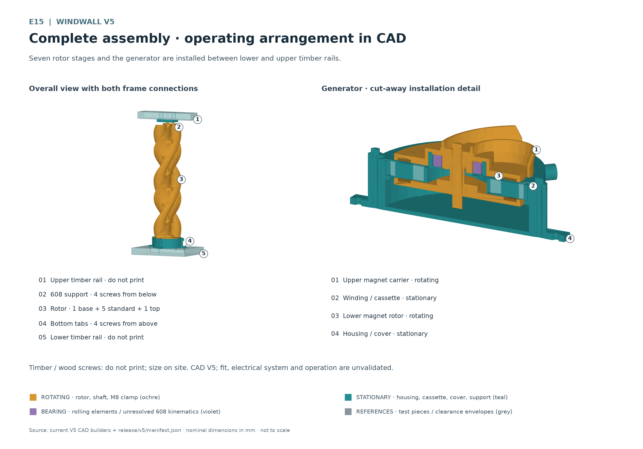
E15 Seven rotor stages and the generator are mounted between the lower and upper timber rails.
Ochre identifies the rotating assembly. Turquoise identifies stationary printed parts. Purple identifies bearing regions; their rolling elements and races move differently. Grey timber, screw and clearance references are not printed parts.
Both magnet carriers rotate together with the shaft, M8 clamping hardware and rotor stack. The coil, cassette, housing, cover and upper support remain stationary. The lower magnet rotor runs inside the housing below the stationary coil.
For reference: chapters 2 and 3 cover printed parts and purchased hardware; 4 and 5 printing and fit coupons; 6 to 9 winding and assembly; 10 and 11 measurement and commissioning; 12 and 13 maintenance, troubleshooting and experiment records.

2 Printed parts and files
Quantities cover one complete rotor, including the generator housing and upper support. The upper magnet carrier is integrated into the base. STL files are in release/v5/stl/ and matching STEP files in release/v5/step/.
Qty | Printed part | STL file | STEP file
1 | Base with upper magnet carrier | base_rotor_module.stl | base_rotor_module.step
5 | Standard module | standard_rotor_module.stl | standard_rotor_module.step
1 | Top module | top_rotor_module.stl | top_rotor_module.step
1 | Lower magnet rotor | lower_magnet_rotor.stl | lower_magnet_rotor.step
1 | Generator housing | generator_housing.stl | generator_housing.step
1 | Coil cassette | coil_cassette.stl | coil_cassette.step
1 | Stationary cover | generator_cover.stl | generator_cover.step
1 | Upper bearing support | top_support.stl | top_support.step

The base, standard, top and lower magnet rotor rotate. The housing, coil cassette, generator cover and upper bearing support are stationary. Release STLs sit on the print bed at Z = 0; this does not mean their printing orientation has been automatically optimised.

Fit coupons and assemblies
Print each of the following coupons once for the initial fit check. Repeat whenever the material, profile or fit dimension changes. Coupon STLs are in release/v5/coupons/ and their STEP files in release/v5/step/.
Qty | Coupon STL file | Coupon STEP file
1 | magnet_pocket_coupon.stl | magnet_pocket_coupon.step
1 | 51105_outer_seat_coupon.stl | 51105_outer_seat_coupon.step
1 | 25mm_pilot_coupon.stl | 25mm_pilot_coupon.step
1 | 608_seat_coupon.stl | 608_seat_coupon.step
1 | coil_cassette_segment_coupon.stl | coil_cassette_segment_coupon.step
1 | bayonet_male.stl | bayonet_male.step
1 | bayonet_female.stl | bayonet_female.step
1 | joint_male.stl | joint_male.step
1 | joint_female.stl | joint_female.step

Assemblies for inspection
release/v5/assembly/rotor_locked.step
release/v5/assembly/generator.step
release/v5/assembly/fence_assembly.step
These STEP assemblies support assembly inspection. The file fence_assembly.step includes the extended shaft for the upper support. Timber and purchased hardware are not exported from assemblies as printable parts.

3 Purchased parts and tools
The table describes the planned prototype. Purchase only after checking against the actual parts. Nominal envelopes do not establish thread engagement, screw-head seating or load capacity.
Qty | Component | Dimensions and selection
1 | M8 threaded rod | Extended shaft for the upper 608; cut only after dry assembly
3 | M8 nuts | Two positively engaged torque nuts and one upper clamping nut
1 | Upper M8 washer | 24 × 2 mm; outside dimension and thickness
36 | Magnets | Two rings of 18 magnets each; project target 10 × 2 mm, verify actual dimensions and retention
1 | Complete 51105 thrust bearing | 25 × 42 × 11 mm
1 | 608 radial bearing | 8 × 22 × 7 mm
4 | M4 cover screws | Check length and head shape against the actual stack; no approved catalogue length
4 | Captive M4 nuts | Hexagonal; fully seat in the housing pockets
4 | Lower timber screws | Timber screw 4 × 30 mm, flat head Ø9; do not print; unverified nominal envelope
4 | Upper timber screws | Timber screw 4 × 40 mm; do not print; V5 nominal envelope

Purchase the 51105 as a complete bearing, including both washers and rolling elements. These are shown separately in the CAD assembly. For the M4 screws, measure actual grip length, nut height, head and floor clearance; the envelope is not a purchasing recommendation for a particular screw length.

Materials for winding and measurement
Prepare enamelled copper wire with an initial diameter of 0.18 mm, insulated leads, suitable soldering and insulating materials, and proven strain relief. Measure any other wire diameters first. Adhesives and potting compounds require compatibility tests with wire enamel, magnet coating and print material.
Required measuring equipment includes callipers, a micrometer, depth gauge, feeler gauges, tachometer, suitable True-RMS multimeter, temperature probe and defined power resistors. For low resistance, account for test-lead resistance or use four-wire measurement. Provide suitable M4 and M8 tools, safety glasses and a nonmagnetic assembly fixture.

4 Preparing to print
Start with PLA and the coupons on the Bambu P2S with a 0.4 mm nozzle. Use the material profile for the PLA actually loaded. Treat a 0.20 mm layer height as an initial slicer setting that still needs verification. Set temperature, cooling, wall lines, infill and supports only after inspecting the coupons and the complete layer preview.
The CAD rotor wall is 2 mm thick. Ensure the slicer produces thin wall regions without gaps. Thickness alone does not establish strength; orientation and layer adhesion also determine actual load capacity.
Part group | Orientation and checks
Magnet and bearing coupons | Pockets upwards; keep elephant foot and support residue away from mating surfaces.
Base | Magnet pockets face down when installed. Compare Z-up and inverted orientations in the slicer; inspect pockets, nut pocket and blade transitions.
Standard and top | Check the exported Z-up orientation; lower lugs and upper latch tracks must remain clear and accessible after printing.
Lower magnet rotor | Magnet pockets upwards; check the rear pocket and bed contact.
Housing | Closed floor on the bed, opening upwards; inspect every mounting tab and screw channel.
Cassette | Support face down, winding space up; key and cable opening free of burrs.
Cover and upper support | Prefer bearing seats upwards if the underside can be supported cleanly; leave no support residue in bearing seats.

Bayonet roofs and undercuts require verified bridging or accessible supports. Do not leave irremovable supports in enclosed latch tracks. Inspect every preview layer before starting; print coupons first, then a real two-stage joint, and only then the complete set.
ASA is a later material stage. After changing material, recheck fits, warping, joining forces, magnet retention and loading. A material change alone does not approve the rotor for weather, heat or continuous operation. Follow the processing and ventilation instructions for the actual filament and printer.

5 Checking fit coupons and bearings
Measure the actual bearings, magnets and nuts before printing. Mark material, profile and orientation on each coupon. A dimensionally suitable coupon must assemble without cracks, misalignment or uncontrolled force; record the choice and transfer it to the design before printing large parts.
Coupon | Release variants
51105 outer seat | 42 / 42.2 / 42.4 mm
51105 locating pilot | 24.6 / 24.8 / 25 mm
608 outer seat | 22 / 22.2 / 22.4 mm
Magnet pockets | 10.8 / 11 / 11.2 mm
Cassette radial clearance | 0.3 / 0.35 / 0.4 mm

For the cassette segment, first cut the male arc free flush with the plate and deburr the cut edge. Then compare it with the seat segments. The coupon checks radial clearance, not the final axial retention by the cover.
Test the bayonet pair and complete joint pair separately. Insert, lock anticlockwise and inspect the latch. The permanent latch may be damaged by reverse rotation or disassembly. Record force, visible cracks, axial play and blade seam; do not release the latch by forcefully turning backwards.

51105 fit and orientation
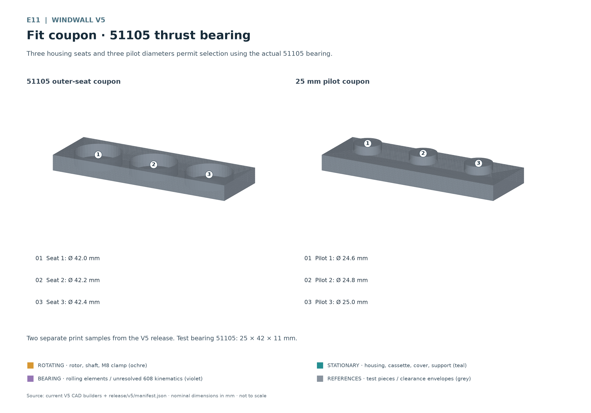
E11 Three housing seats and three pilot diameters allow selection using the actual 51105 bearing.
51105: 25 × 42 × 11 mm. The housing washer remains stationary in the central cover seat. The shaft washer rotates with the base and is aligned by its locating pilot. Raceways face the rolling elements. Identify washers and cage by their actual geometry and manufacturer markings; do not interchange them merely because they look similar.
The 51105 carries the axial rotor load. During fitting, press only on the washer being installed and do not transmit force through the rolling elements. Do not use the bearing as a fitting tool by clamping printed parts against each other.

608 fit and orientation
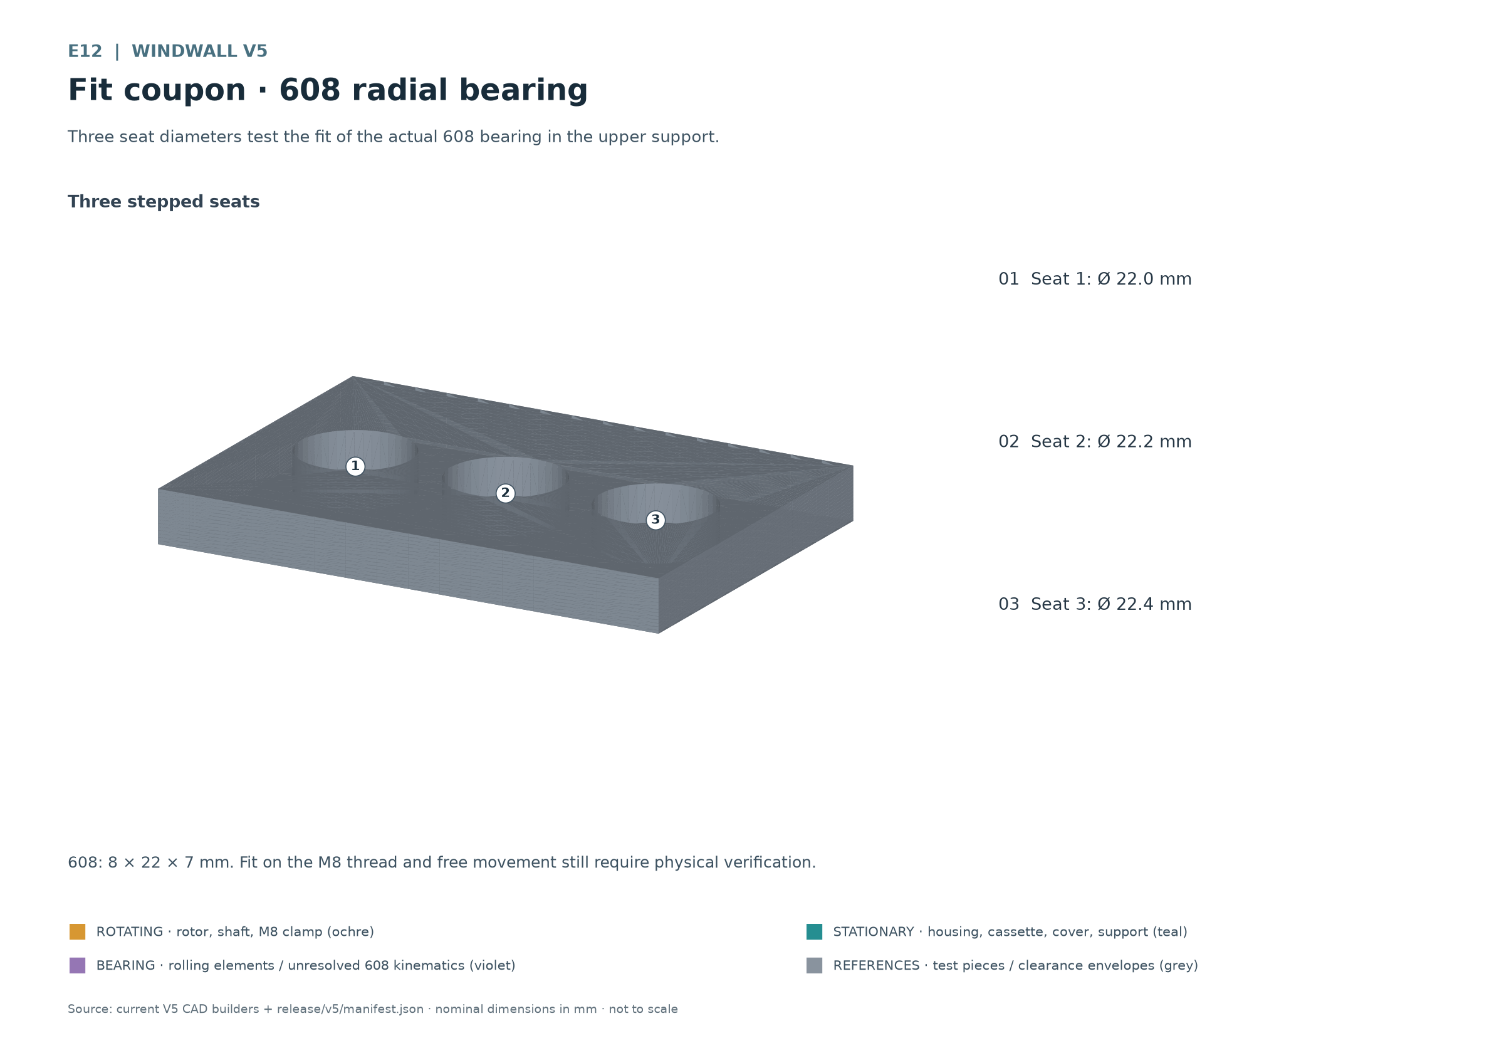
E12 Three seat diameters test the fit of the actual 608 bearing for the upper support.
608: 8 × 22 × 7 mm. The outer ring sits in the stationary upper support; the inner ring guides the rotating M8 shaft. Rolling elements move between the rings. The purple CAD envelope does not resolve this internal motion.
An M8 threaded rod is not a ground bearing journal. Adapt a local running surface only after measurement and controlled machining; recheck diameter, runout, remaining cross-section and secure inner-ring seating. A printed guide sleeve is not specified. The 608 location provides mainly radial guidance; avoid unintended additional axial clamping.

6 Preparing magnets and the test coil
Measure magnet diameter and thickness including coating. The pockets are 11 × 2 mm in diameter and depth; they do not provide a confirmed clamping fit for a magnet with the project dimensions of 10 × 2 mm. Test adhesive, coating and retention on the coupon. Adhesive thickness must not reduce the gap unnoticed.
1. Mark the pole faces. Use a reference magnet and mark the same pole face on every magnet. Recheck polarity before insertion. Wear safety glasses and keep magnets separated with nonmagnetic spacers.
2. Populate the upper ring. The coil-facing poles alternate N S N S around the ring. Mark a fixed pocket as the starting position and record the entire pole sequence.
3. Match the lower ring. At the same angular position, an upper N pole faces a lower S pole; the next pair is reversed. The faces directed towards the coil are decisive. Discs facing the same way on the workbench can show a different correspondence after one is turned over.
4. Check retention. Seat magnets fully and allow the fastening system to cure according to the actual product. Check each ring separately first. Magnet retention remains an independent unresolved check before every rotation test.

Experimental serpentine winding
Route the insulated wire as one continuous serpentine around the 18 rounded guide islands in the stationary cassette. Pass alternately along the inner and outer side of the next guide. Mark start A, end B and one complete path. For this experiment series, one complete circuit around all 18 guides counts as one turn. All test coils must use the same path and winding direction.
First check the path with a few repetitions while turning by hand: contributions from successive active sections should add. Changing the pole sequence, reversing sections or using other wire paths can cancel voltage. Document the actual path with a photograph or sketch; the cassette does not define a fully validated electrical winding.
Wire | Turns | Comparison and measurement
0.18 mm, measure actual wire | 20 | Resistance, winding height, open-circuit voltage and loaded measurement at equal speed
0.18 mm, measure actual wire | 40 | Same path and winding direction as for 20
0.18 mm, measure actual wire | 80 | Install only if the actual winding fits the verified space

Repeat the complete 20, 40 and 80 matrix for every wire diameter measured later. Distinguish conductor diameter from outside diameter including enamel. There is no final turn count and no guaranteed output. Do not confuse available winding space with maximum permissible heat generation.
Keep connection ends outside the active running gaps. Insulate solder joints, provide mechanical strain relief and check continuity and insulation from the rest of the assembly. Measure a removable test coil before permanent potting; potting can change heat removal, repairability, height and fit.

7 Assembling the generator
Work with rotation securely stopped and an assembly fixture that controls attraction between the magnet rings. The housing cup opens upwards. Check nut pockets, shoulder, key and cable route beforehand. Fully insert the four captive M4 nuts before closing.
1. Insert the lower magnet rotor. Insert the M8 torque nut into the bottom-open pocket from below. Insert the lower rotor with shaft and integral spacer sleeve into the cup, magnet faces upwards. The magnet carrier remains inside the housing while the sleeve runs freely through the stationary centre. The nut and shaft end must not touch the closed floor.
2. Insert the coil cassette. Check winding fit and insulation first. Lower the cassette over the shaft, seat it on the housing shoulder and engage the single key in its anti-rotation feature. The side cable openings must align.
3. Install the stationary cover. Route the cable through the side outlet and provide strain relief. Seat the cover flat and insert the four M4 screws into the captive nuts. Tighten evenly and incrementally in a crossing pattern; stop if a gap or deformation appears. The separate outer frame holes remain untouched. No tightening torque has been validated for PLA.
4. Install the 51105. Place the stationary housing washer on the cover seat, then install the rolling elements and rotating shaft washer with the raceways facing each other. Keep the bearing clean; check the base locating pilot against the actual shaft washer.
5. Fit the base. Insert the upper torque nut and lower the base onto the shaft and bearing. Its magnet faces point down towards the coil. The base shoulder bears on the rotating shaft washer. Limit magnetic attraction with the assembly fixture and keep fingers out of the gap.
6. Measure running clearances. Turn the shaft through a complete revolution by hand. Check every angle for contact, cable tension and visible runout. Actual magnet faces, winding and adhesive determine clearances. Continue with the rotor stack only after this check succeeds.

Lower rotor inside the housing
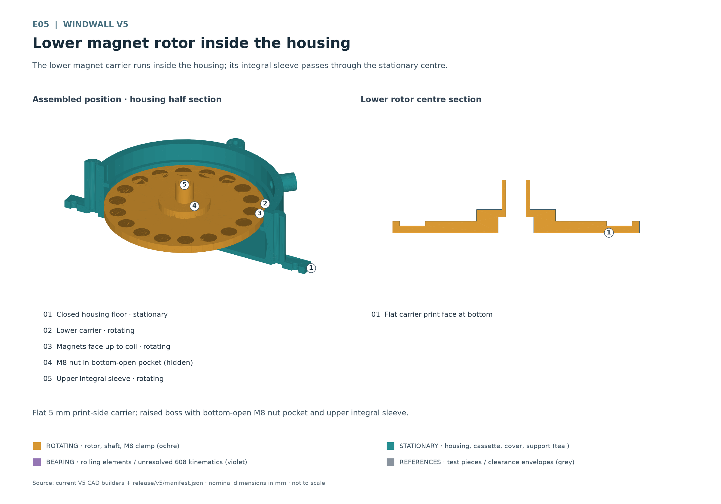
E05 The lower magnet carrier runs inside the housing; its integral sleeve reaches through the stationary centre.
The flat 5 mm carrier print surface rests on the bed. The raised central boss contains the bottom-open M8 nut pocket for torque transmission. The upper integral sleeve rotates with the lower rotor; the stationary coil must not touch it. The CAD sleeve is 12 × 17.85 mm outside diameter by height, with an 8.8 mm M8 passage. Dry-check actual clamping and floor clearance. Physical stiffness, bridge printability, dimensional fit, outdoor use and powered operation remain unvalidated.

Generator installation order
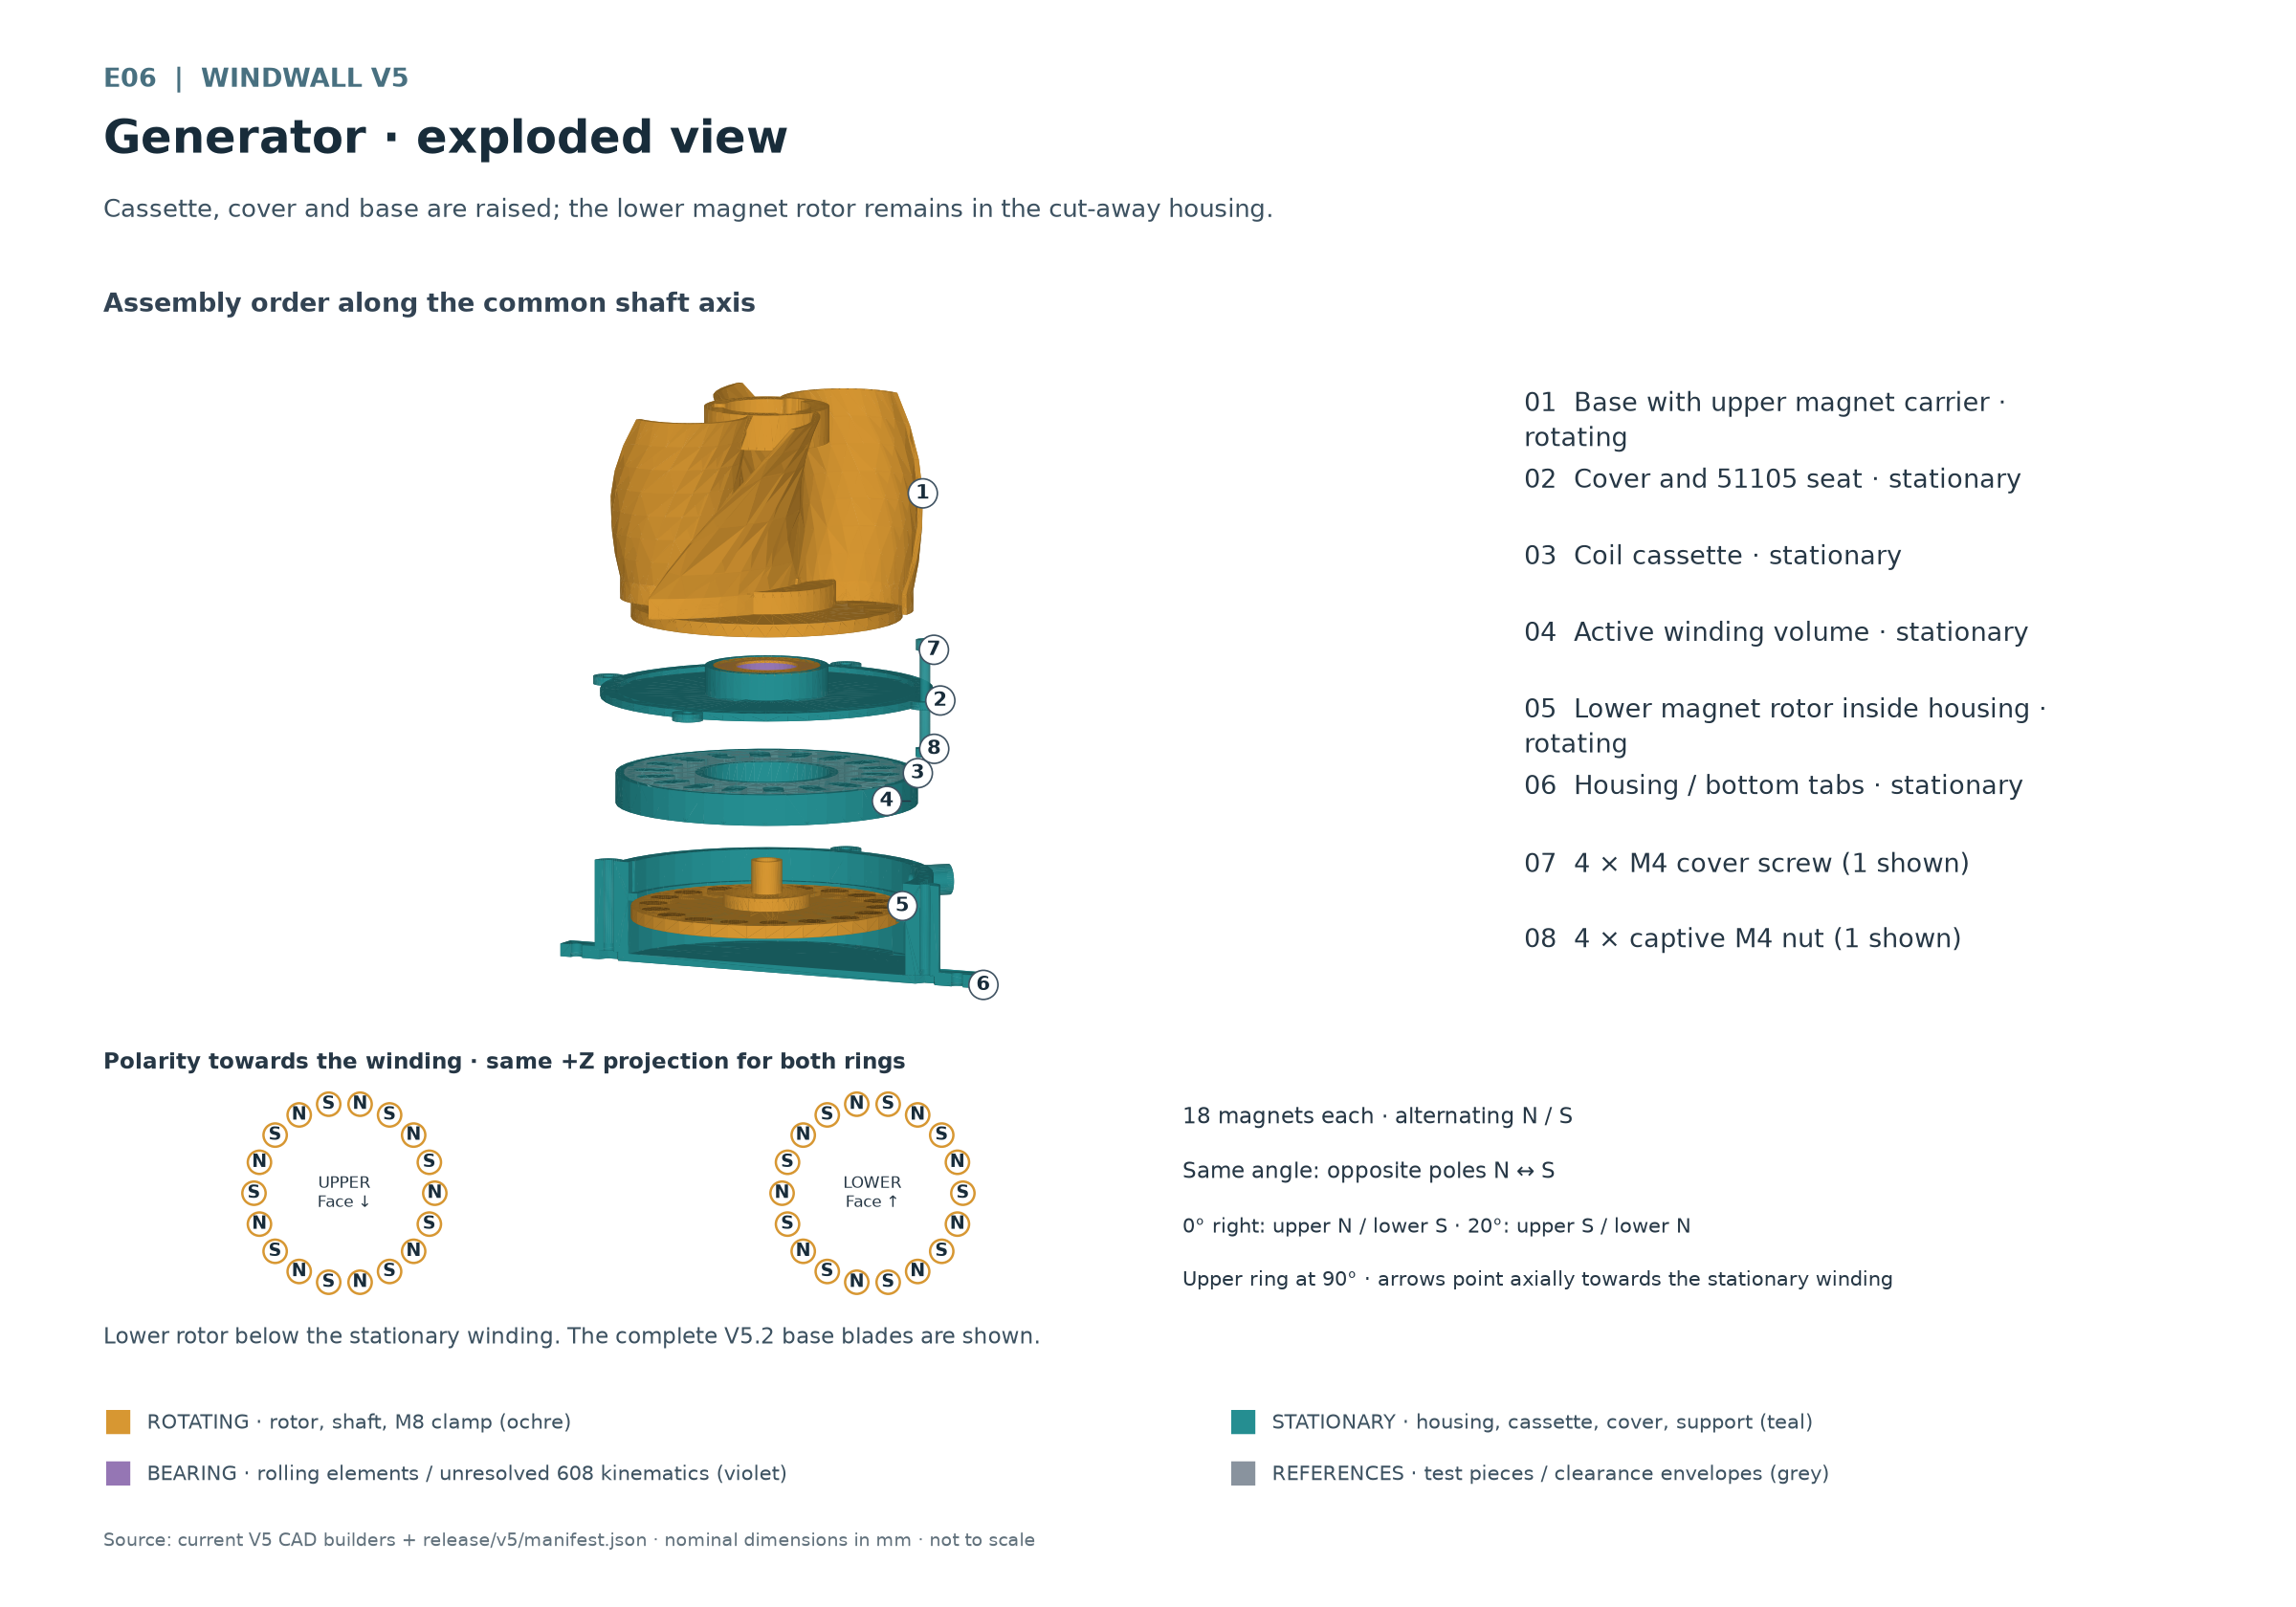
E06 Cassette, cover and base are lifted; the lower magnet rotor remains in the cutaway housing.
The raised parts show access from above. The winding remains stationary between the two rotating magnet carriers. Install the lower magnet rotor before the cassette and cover; once closed, the cup floor provides no assembly access.

Thrust bearing and load path
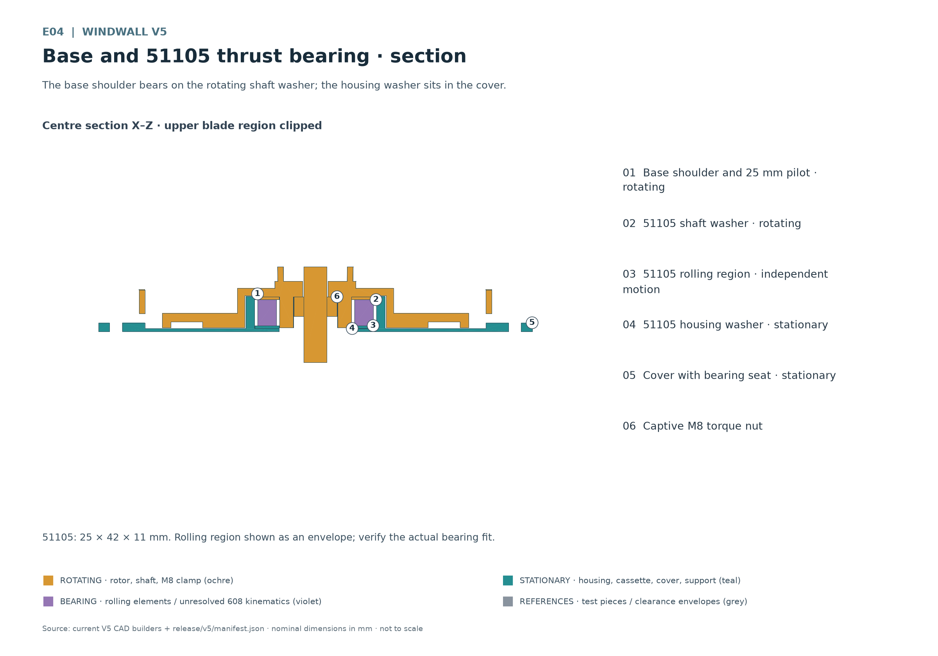
E04 The base shoulder bears on the rotating shaft washer; the housing washer sits in the cover.
Rotor load passes from the base shoulder through the shaft washer, rolling elements and housing washer into the stationary cover, then through the housing to the lower frame. The M8 clamp joins rotating parts; it must not clamp the stationary cover or winding.

Checking both air gaps
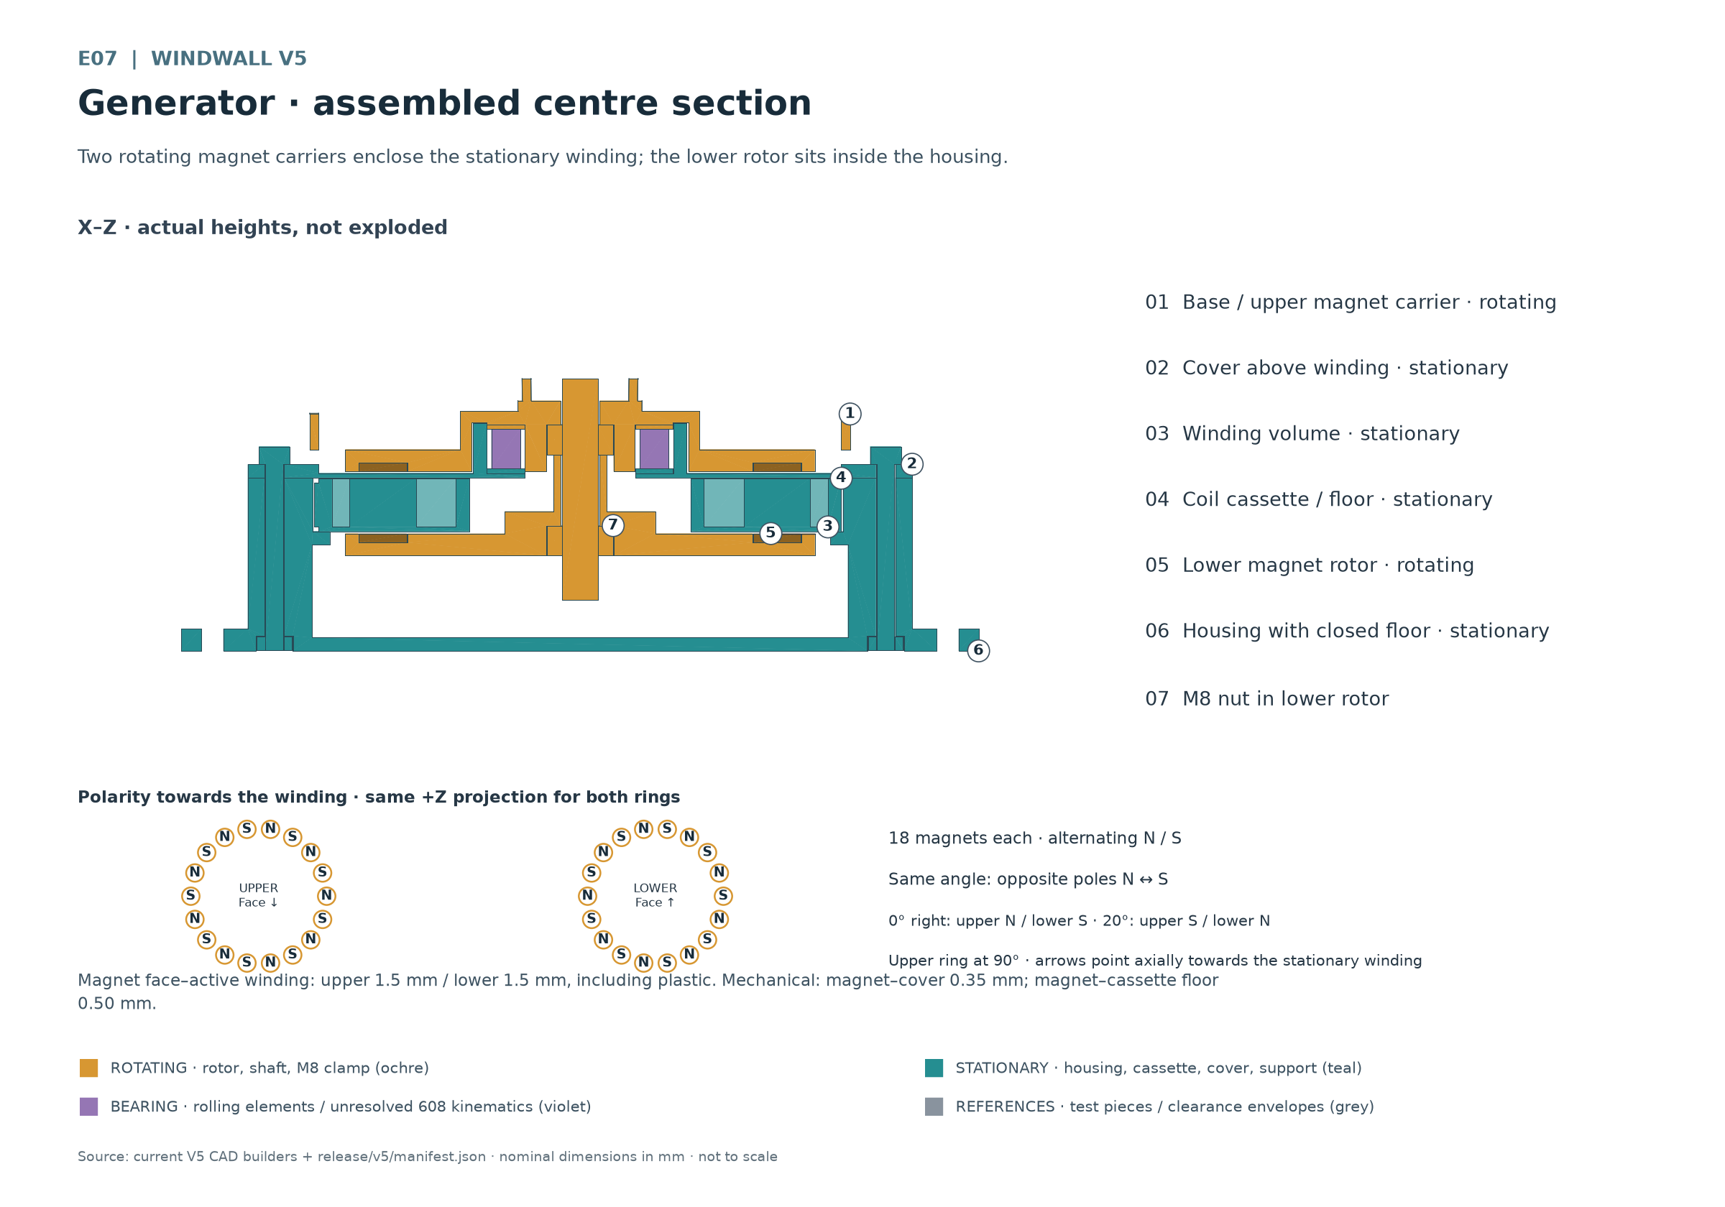
E07 Two rotating magnet carriers surround the stationary winding; the lower rotor sits in the housing.
Nominal distances from the magnet face to the active winding face are 1.5 mm above and 1.5 mm below. Both magnetic distances include the intervening plastic: the cover membrane above and the cassette floor below. They apply only when magnets sit flush with or below their pocket planes. Protrusion, adhesive, winding height, axial offset and runout can reduce the actual minimum distance.
Mechanical clearances are smaller: 0.35 mm above between magnet face and cover membrane, and 0.50 mm below between magnet face and cassette floor. Membrane and cassette floor are each 1.00 mm thick. There is 0.15 mm between cassette top and cover underside for axial retention. Check magnetic distances and mechanical clearances separately.
Measure over a complete hand revolution and check any axial play. A contact-free CAD state does not establish reserve clearance under load. If rubbing occurs, do not grind it in or clear it by increasing speed; locate the cause and correct the assembly.

Securing cassette and cover
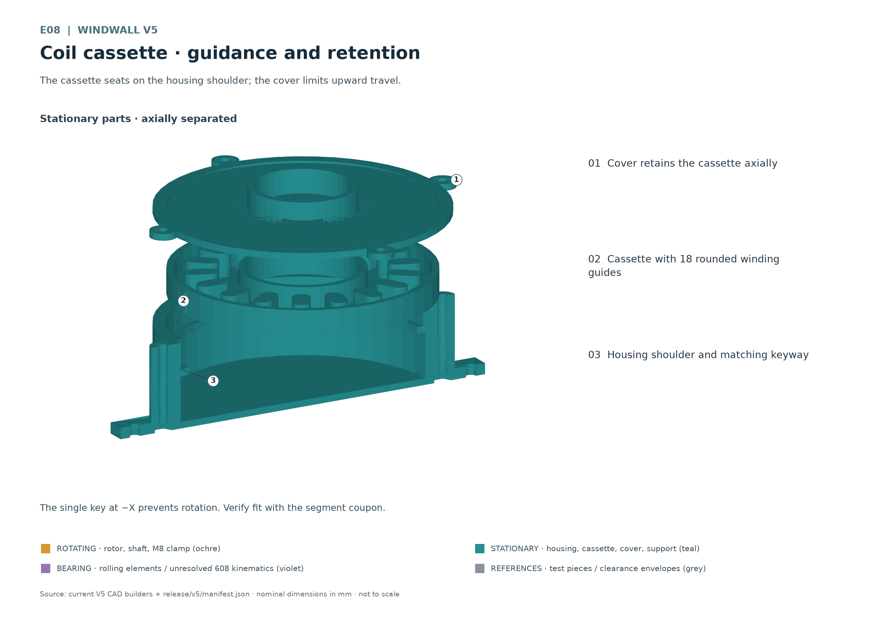
E08 The cassette rests on the housing shoulder; the cover limits upward travel.
The housing shoulder supports the cassette downwards, the locating ring centres it radially and the key prevents rotation. The screwed cover limits upward travel. All four functions must be present during dry assembly; a loosely inserted winding carrier is not ready for operation.

Checking cover screws
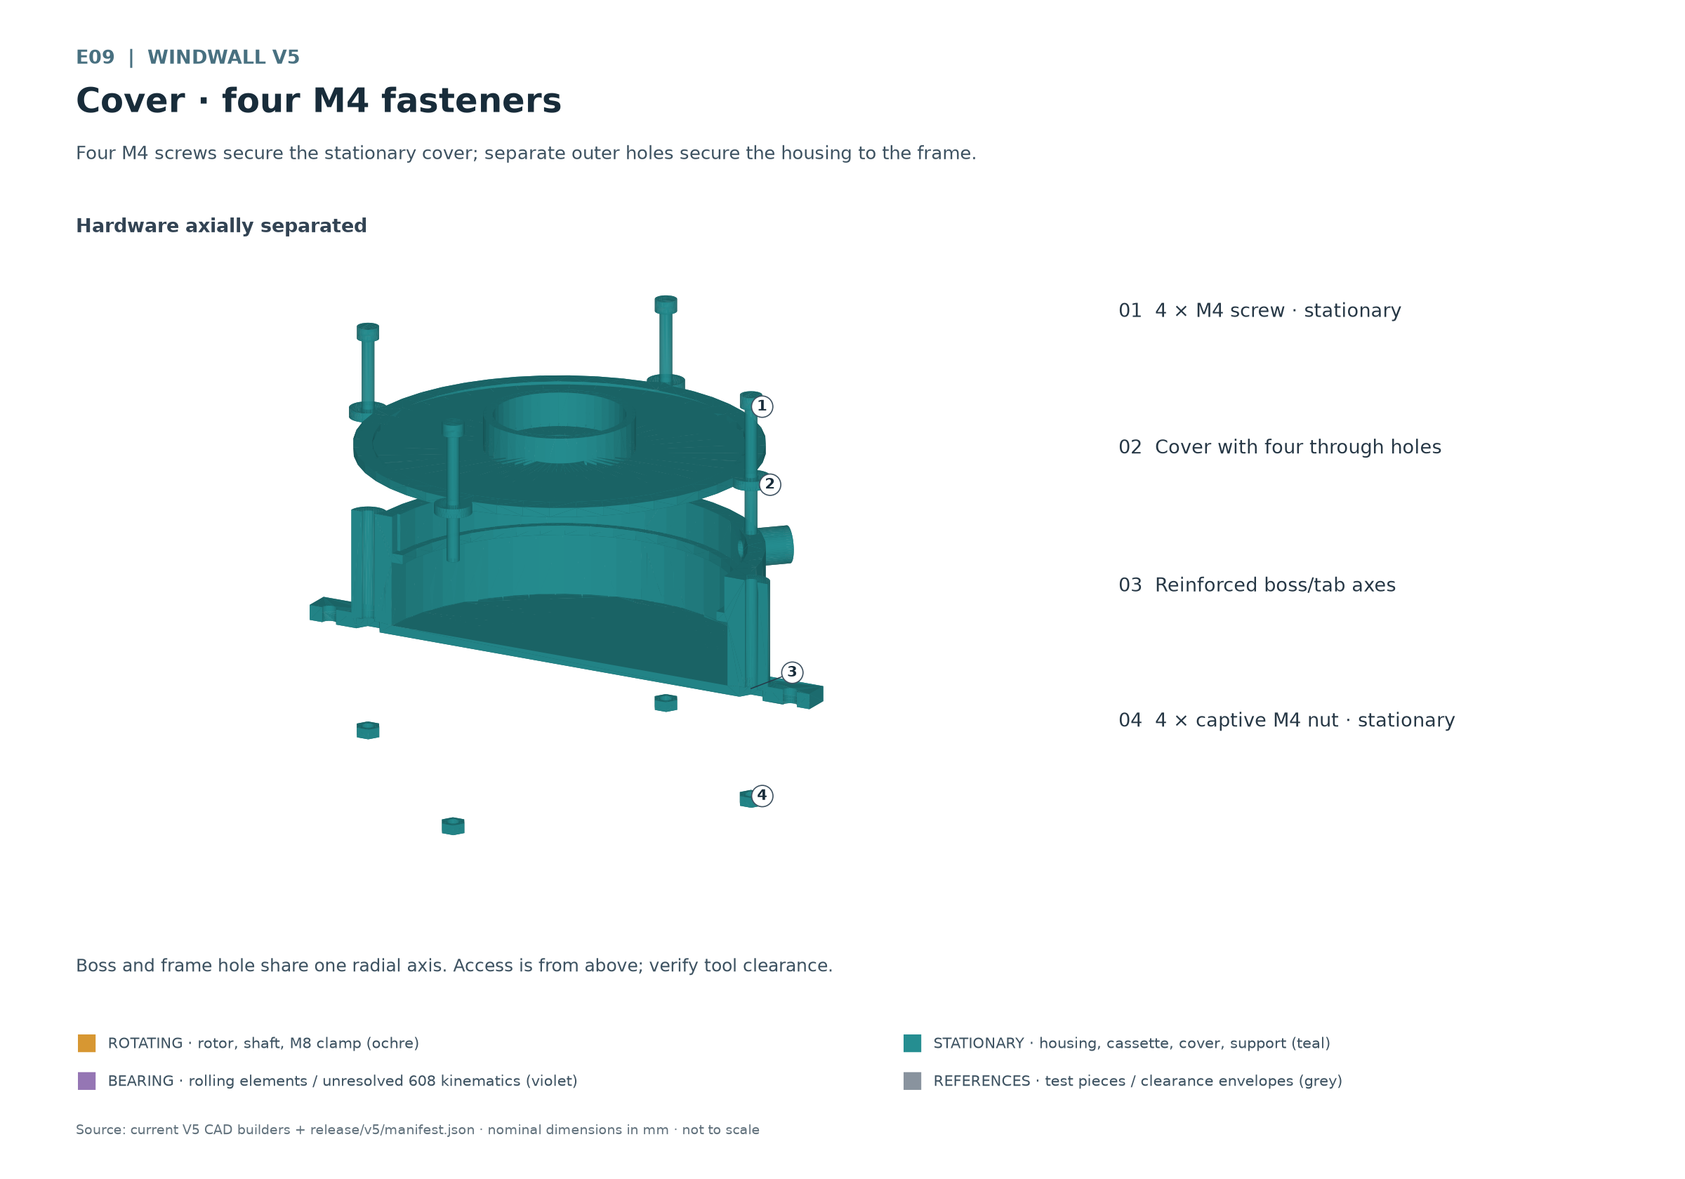
E09 Four M4 screws secure the stationary cover; separate outer holes fasten the housing to the frame.
Four M4 screws and four captive hex nuts connect cover and housing. They share radial axes with the four separate frame holes, and the continuous bosses reinforce the lower tabs. Screw access is from above. After tightening, the cover must sit flat and the shaft must still turn freely.

Routing the side cable
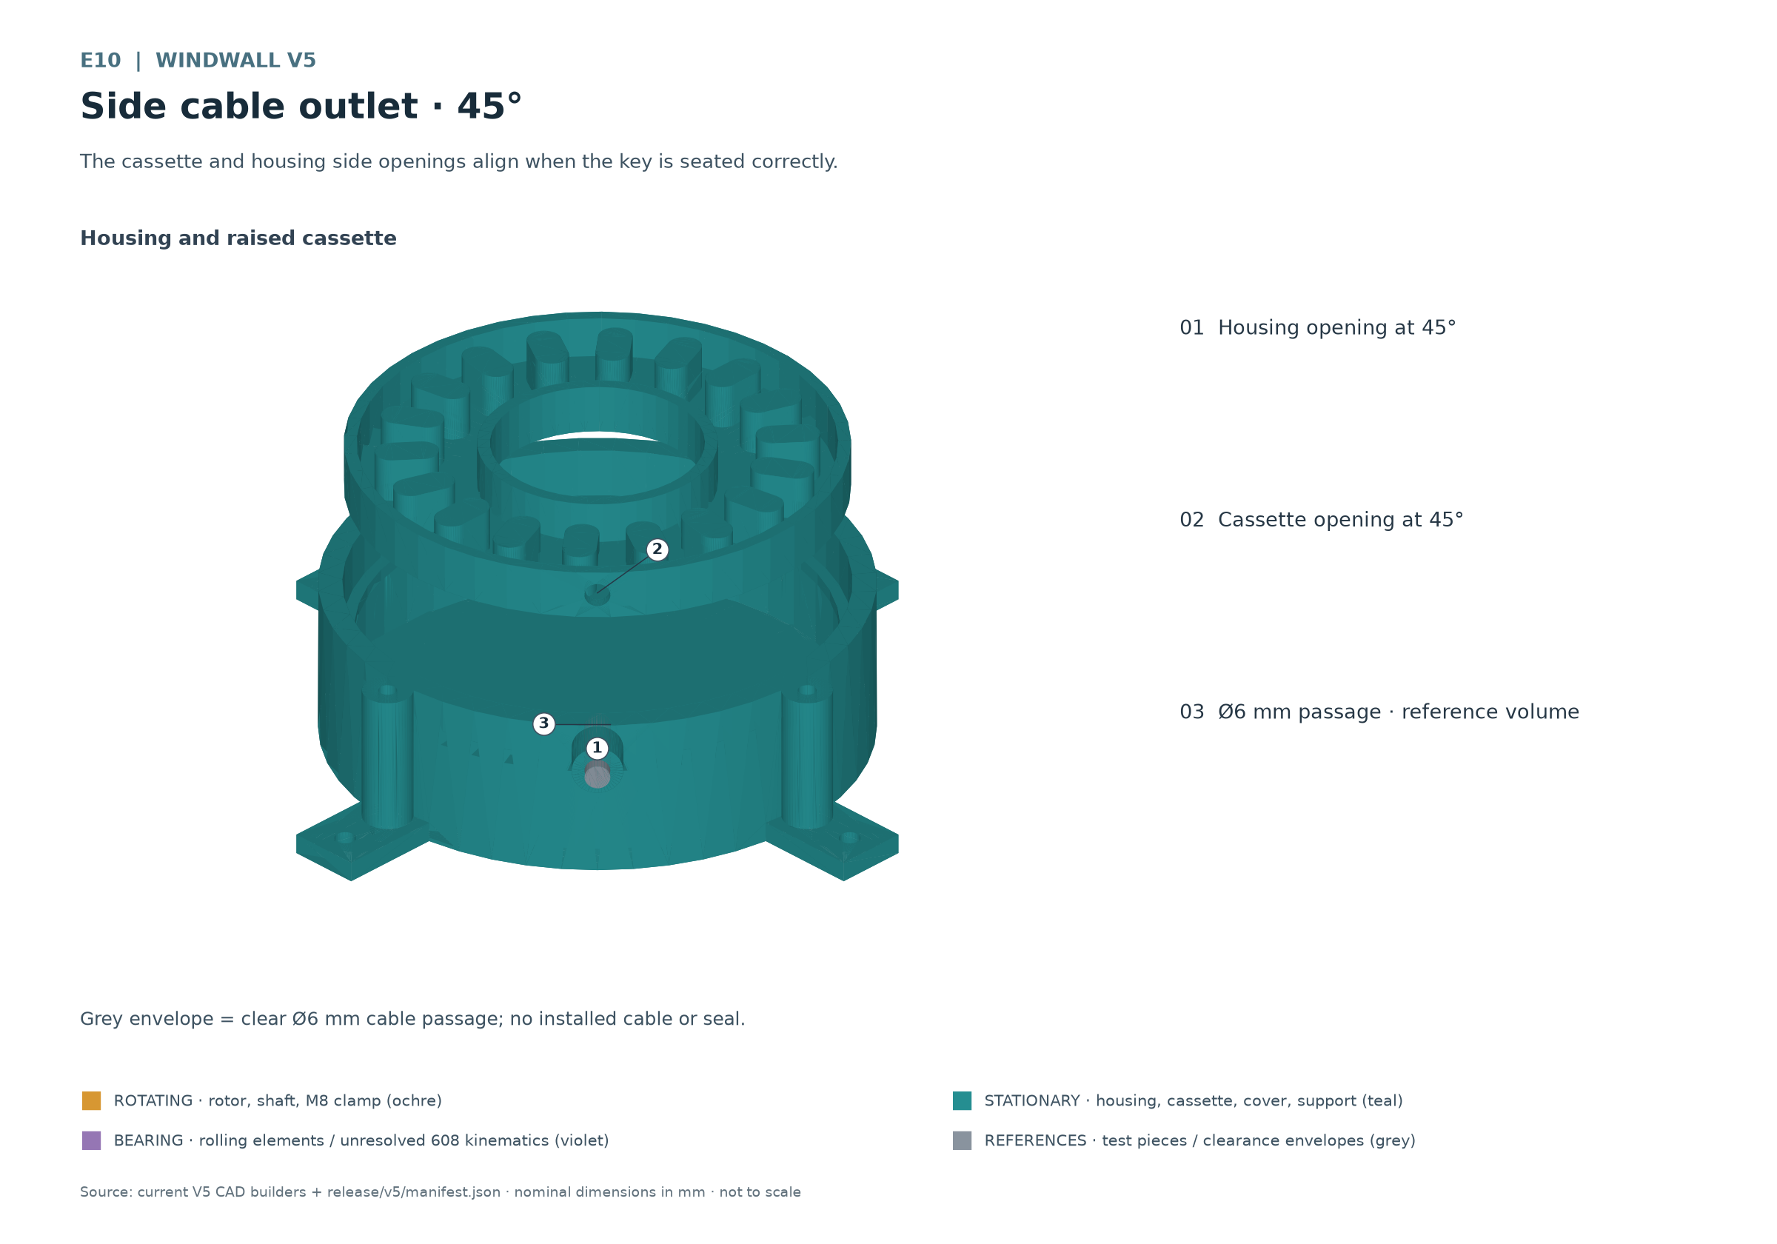
E10 The cassette and housing side openings align when the key is correctly seated.
Route the insulated leads through the aligned side openings. The cable requires actual strain relief and edge protection; the grey envelope only represents the cable passage. It is not an installed gland or seal. The outlet is not waterproof. Keep the free cable entirely outside rotating parts.

8 Assembling the rotor stack
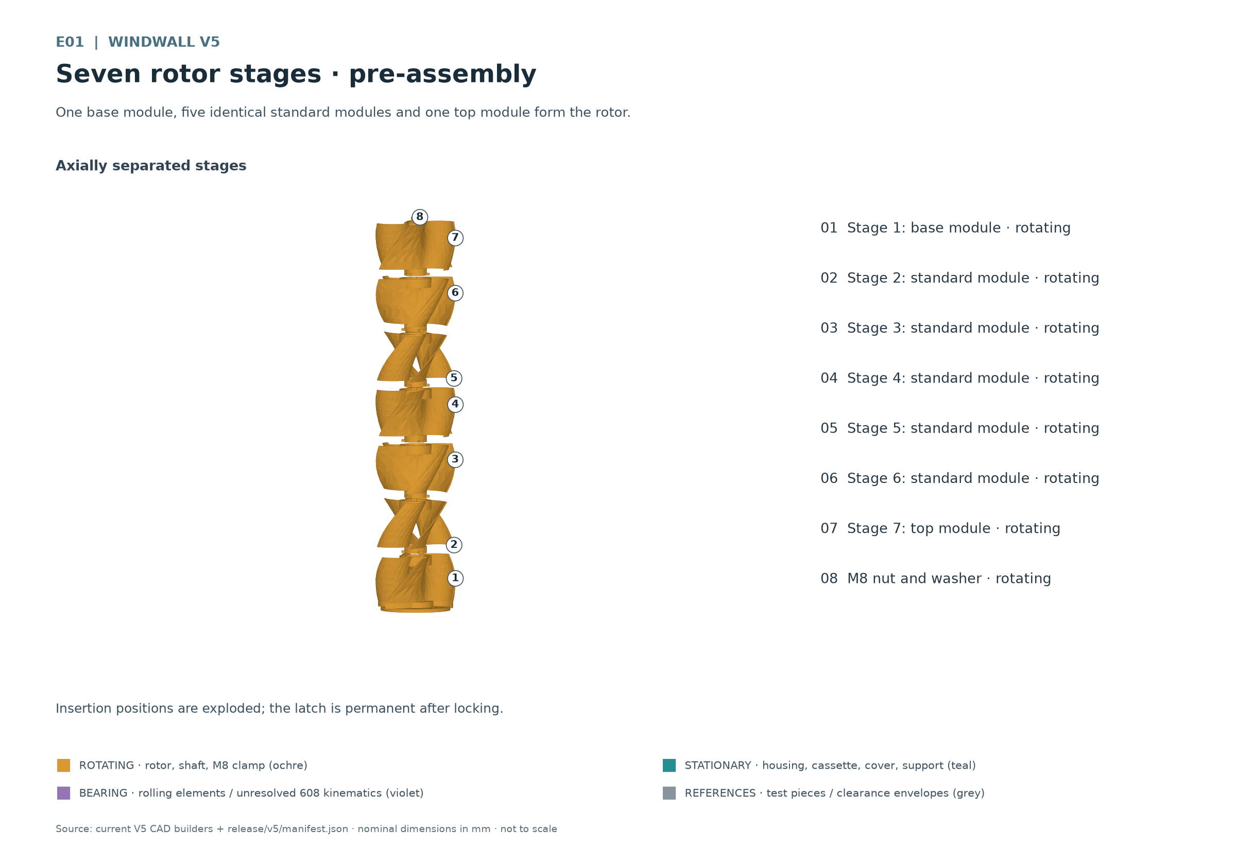
E01 One base module, five identical standard modules and one top module form the rotor.
Fit five identical standard modules above the base already supported by its bearing, followed by the top module. The M8 shaft passes through the open centres and short guide regions. Secure the stack against tipping throughout assembly.
1. Align the insertion position. Align the bayonet lugs and insertion windows for each new stage. The stages have plain flush blade ends. The central bayonet is the sole keyed torque interface.
2. Lock the stage. Viewed from above, lock counterclockwise to the intended stop. The permanent latch must engage. Do not apply excessive torque or use a hammer; if the joint jams, inspect the coupons and mating surfaces.
3. Check the seam. After locking, verify flush blade contact, every lug seat, the latch and axial play at each joint. Stop for visible misalignment or a damaged latch tooth. Add the next section only after this check.
4. Close the upper clamp. Fit the washer and M8 nut on the reinforced top region. Adjust the clamp before installing the upper bearing support. Tightening must not bind the actual bearing motion or blade joints.

Distinguishing the three module types
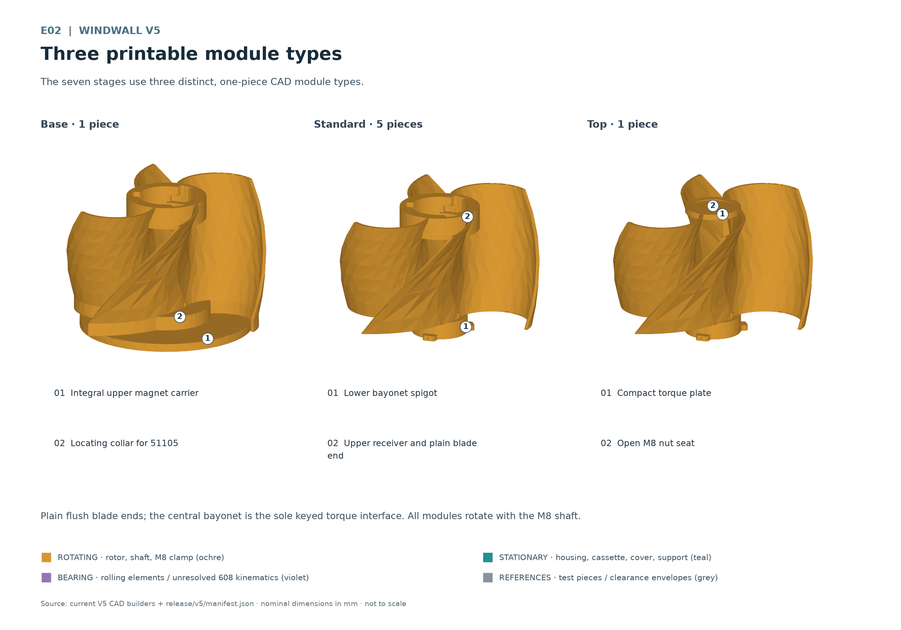
E02 The seven stages use three different single-body CAD module types.
The base includes the upper magnet carrier and 51105 locating pilot. The standard module has the male joint below and the female joint above. The top module completes the stack with a local load-bearing region for the upper M8 clamp. Each of the three types is a single printed body.

Checking bayonet and blade seam
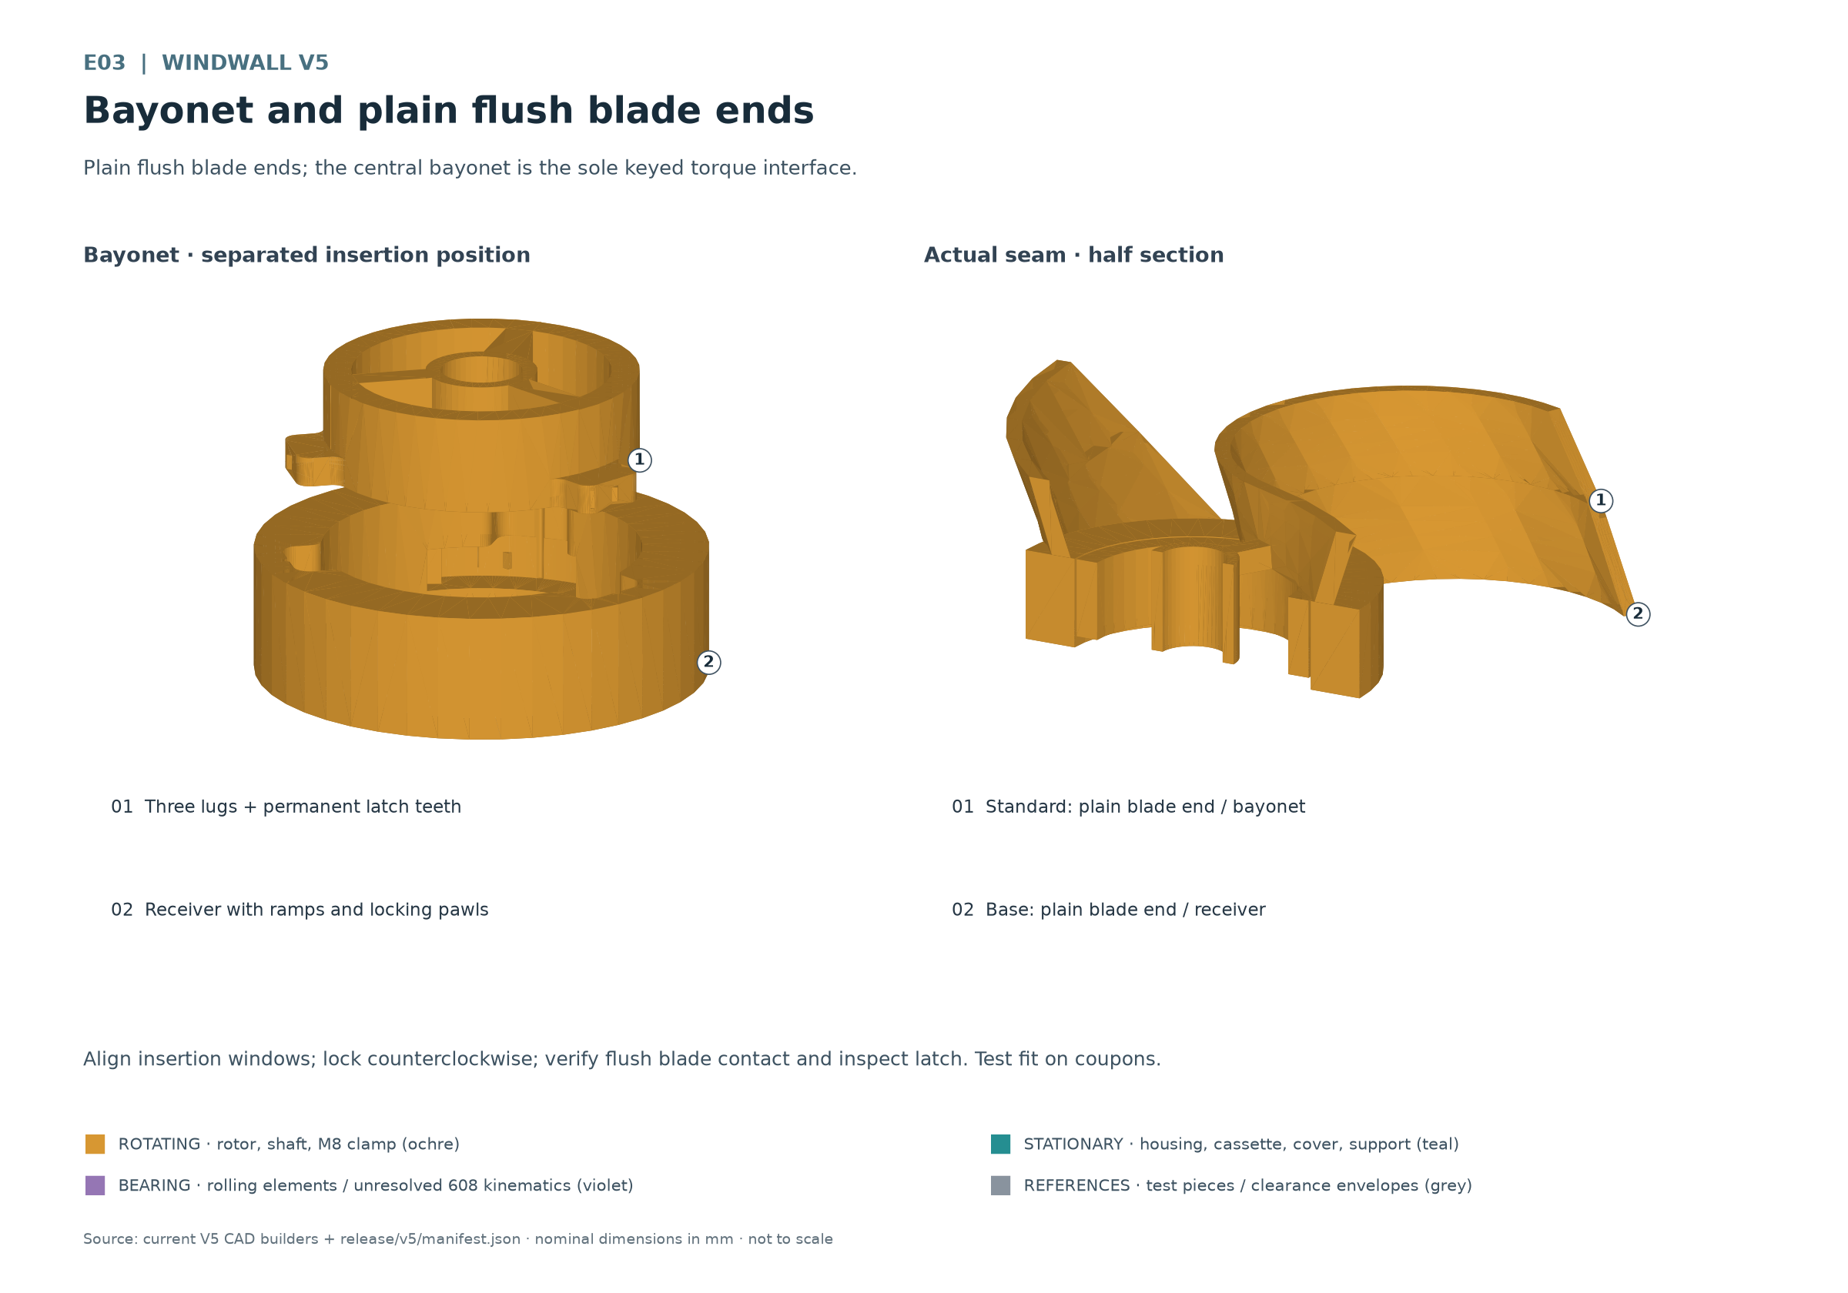
E03 Plain flush blade ends; the central bayonet is the sole keyed torque interface.
The latch is intended as a permanent joint. Plan the rotor stack as one unit; changing the coil should not require separating its six stage joints. Actual elastic insertion and force transmission still require confirmation with coupons and a two-stage assembly.

9 Mounting on the timber frame
Finish adjusting the M8 clamp at the top module and check tool access first. Then guide the extended M8 shaft through the upper bearing location. Frame spacing and rod length must be established by actual dry assembly, including bearings, nuts, clearances and necessary thread engagement.
1. Prepare the lower frame. Provide a flat, load-bearing support. The housing rests on the timber through four floor tabs. Insert the four lower timber screws from top to bottom, outside the rotating interior. Determine pilot drilling, edge distance and screw length for the actual timber.
2. Install the support. Insert the 608 from above into the stationary support's open bearing seat. Attach the support against the upper timber frame using four timber screws from bottom to top. The lower shoulder retains the bearing downwards; the timber closes the seat and retains it upwards.
3. Align the shaft. Align the upper support with the lower bearing axis before finally securing the four screws. The shaft must run through the 608 without lateral constraint. Check clearance to the top module, washer and nut over a complete hand revolution.
4. Check the shaft end. The extended shaft must guide the full width of the inner ring and remain securely engaged even with axial play. Provide space at the upper timber for the shaft end and movement. Do not force the projecting end against the timber frame.
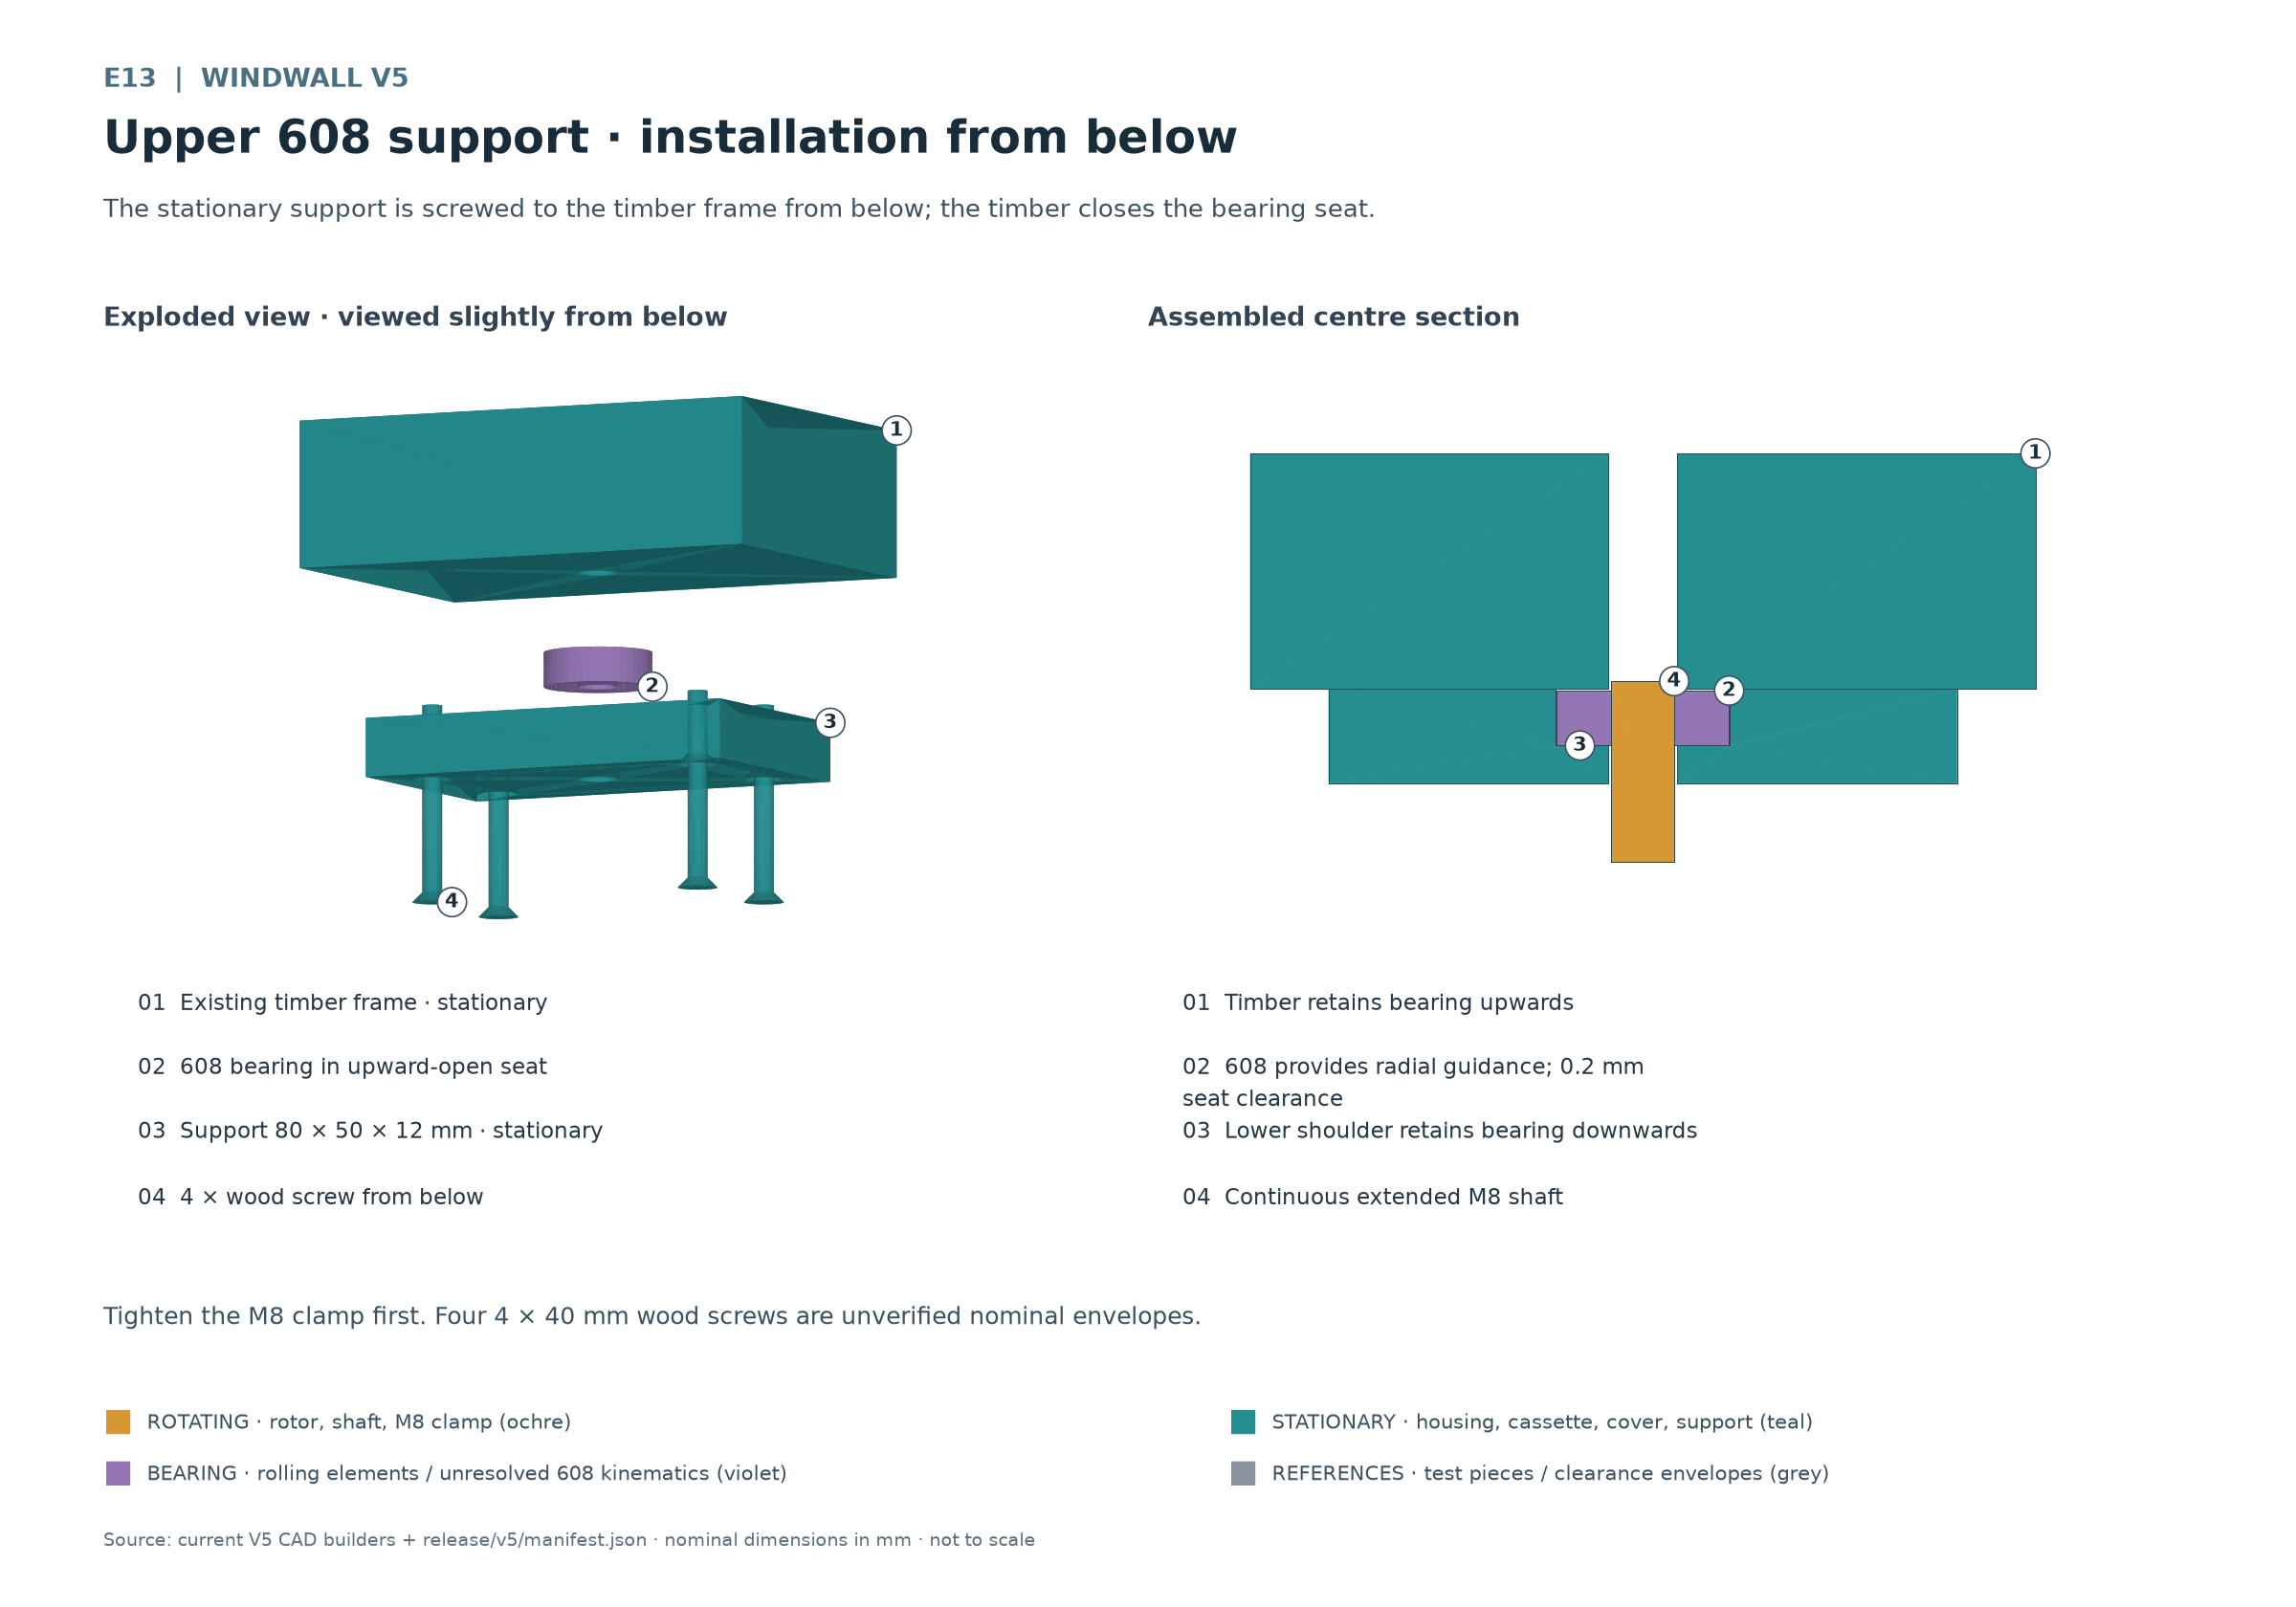
E13 The stationary support screws to the timber frame from below; the timber closes the bearing seat.

Mounting between the timber rails
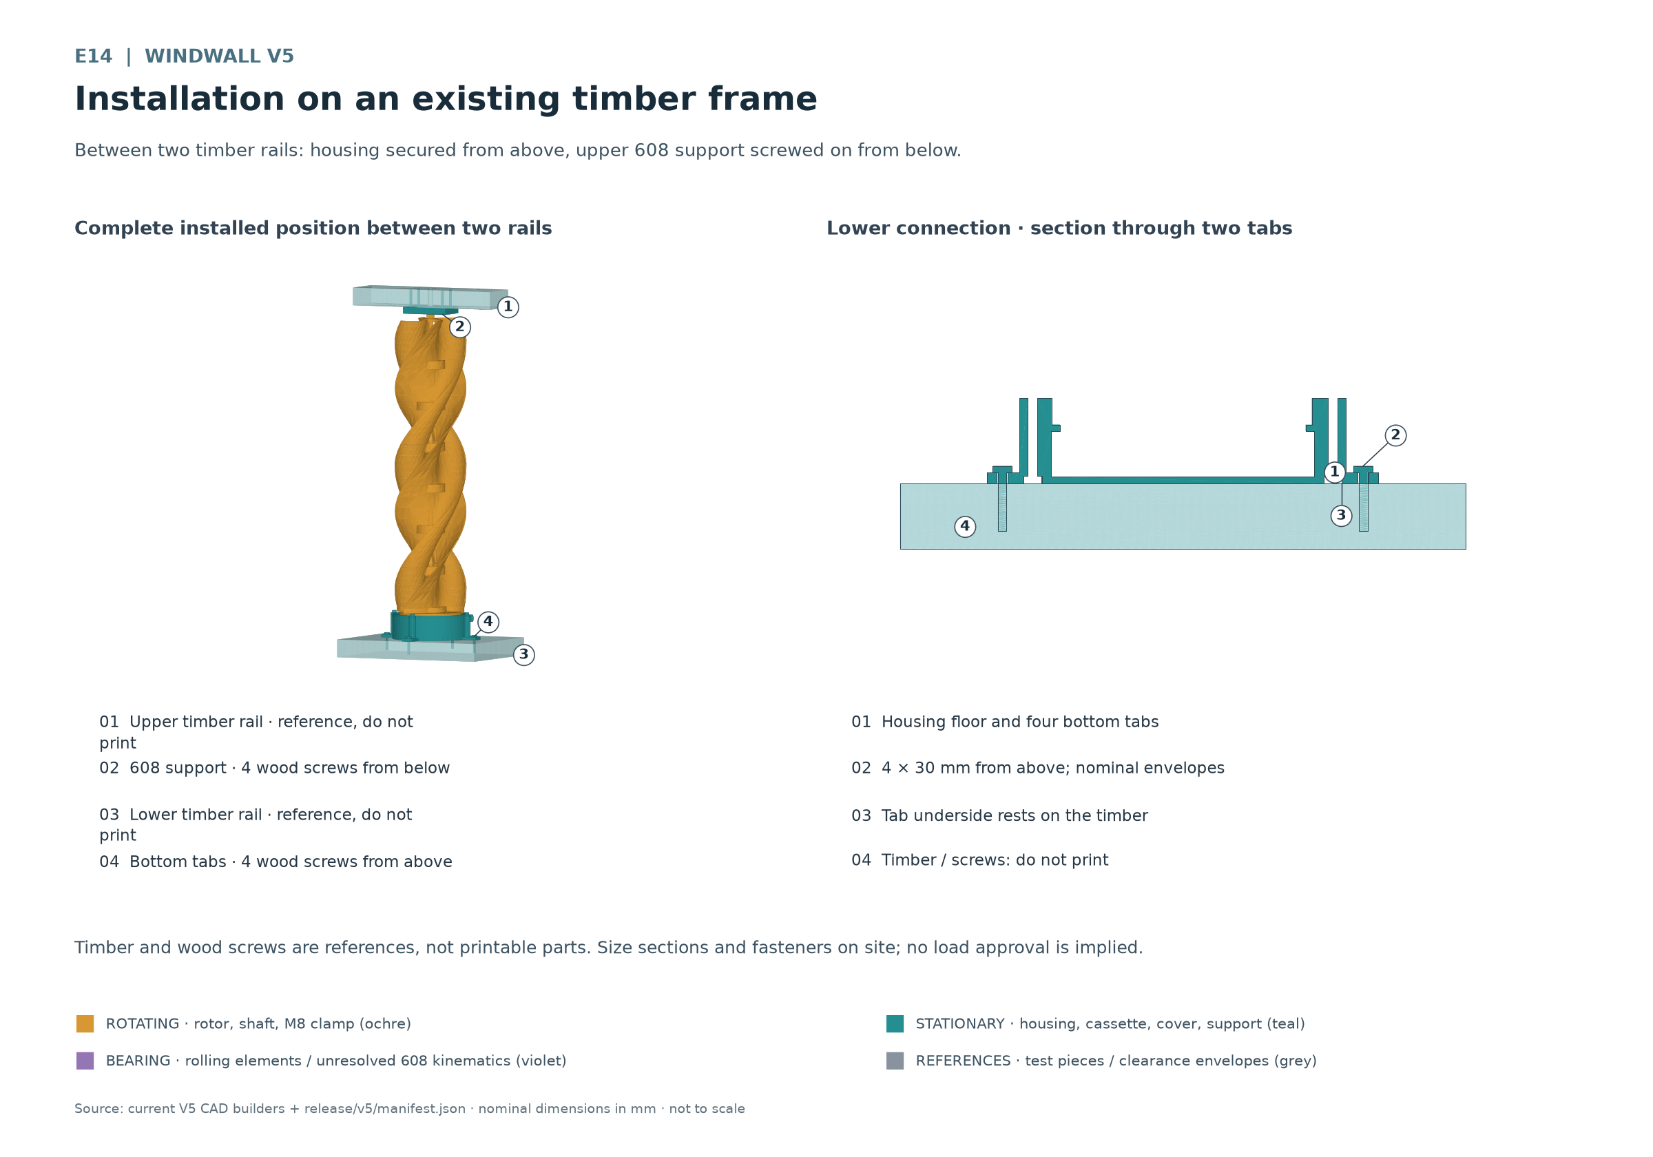
E14 Between two timber rails: housing fastened from above and upper 608 support screwed from below.
The drawing uses unverified screw envelopes of 4 × 30 mm below and 4 × 40 mm above. Timber sections are examples. They do not approve the existing fence or a particular wind load. Design and verify the fixings and timber on site.
The upper bearing support provides radial guidance. The lower 51105 is intended to carry axial load. After fastening, recheck free hand rotation, bearing noise, minimum air gaps and cable clearance. Only then prepare the guarded test stand for measurements.

10 Measuring and comparing coils
Compare each coil at the same recorded speeds and with the same load. The three turn counts form an experimental matrix. A higher open-circuit value alone does not identify the coil that performs usefully under load.
1. Check the coil with the rotor stopped. Record wire diameter, turn count, path, winding height, resistance and ambient temperature. Clearly mark conductor ends A and B. Check insulation from shaft and magnet carriers.
2. Measure open-circuit voltage. Drive slowly and controllably in the guarded setup. Record speed and AC open-circuit voltage simultaneously. Instrument bandwidth must suit the actual waveform. Do not interpret a disconnected measuring contact as low generator output.
3. Connect a defined load. Use only a load that has already been appropriately rated. At the same speed, record voltage, current and temperature. Record load value, measurement duration, surroundings and cable condition. Stop immediately if the winding becomes hot, or if odour, vibration or contact occurs.
4. Compare results. For purely resistive loads, average power can be determined from appropriately measured RMS values. With a rectifier or pulsed current, use suitable DC or true power measurement; do not multiply AC readings without verification.
Measurement | Record for every experiment
Identification | Coil identifier, material, actual conductor diameter, enamelled diameter, turns and wire path
Mechanical data | Magnet pole sequence, magnet protrusion, coil height, minimum upper and lower air gaps
Electrical data | Cold resistance, speed, AC open-circuit voltage, load value, load voltage and load current
Heat and time | Ambient temperature, coil temperature, measurement duration and temperature history
Observation | Starting behaviour, noise, vibration, rubbing, loose parts and reason for stopping

Scaling turn count from open-circuit voltage is at most an initial approximation with unchanged magnetic field and path at the same speed. Resistance, copper fill, space and heating also change. Every derived winding must be tested again as an actual coil.

11 Guarded commissioning
The first rotation test requires confirmed magnet retention, secure frame attachment, closed cassette retention and free hand rotation. Provide shielding against ejected parts and a safe means of stopping. Keep people, hair, clothing and loose objects away from rotation.
1. Check at standstill. Inspect screw witness marks, latches, bearings, cable and both air gaps. Remove foreign objects. Secure electrical test leads before movement.
2. Start slowly. Increase rotation in steps under controlled conditions and observe after every change. No maximum speed has been approved. Do not infer permission for wind, storm or overspeed tests from this manual.
3. Stop on abnormalities. Rubbing, cracks, magnet movement, unusual bearing noise, heating or loose fixings require stopping and investigating the cause. Continue only after correction and another hand-rotation check.

Select charging electronics only after measurements
Do not connect the generator directly to a 48-V lead-acid battery, even experimentally. Nominal voltage and open-circuit readings are insufficient for selecting a charging system. Battery type and charging profile must match the actual manufacturer's requirements.
A future connection design must cover rectification, suitable charge control, reverse-current blocking, cable and short-circuit protection, safe isolation and energy dissipation when the load is absent. Select components using measured voltage, current, heat and fault conditions. Any necessary dump load requires thermal and electrical design. This manual contains no approved circuit diagram for that purpose.
Until then, development remains on the defined measurement setup. Free running in wind, charging, water ingress, UV exposure, frost, continuous load and unattended operation have not been validated.

12 Maintenance and troubleshooting

Removing the coil cassette
1. Stop and support. Mechanically secure the rotor against movement and disconnect electrical leads with power isolated. Support the rotor stack as one unit. Control magnetic forces and weight during removal.
2. Clear access from above. With the stack secured, release the upper bearing support and free the shaft. Hold the lower rotating assembly with a fixture. Unload and lift the base and upper rotor assembly enough to access the 51105 and cover. Release necessary M8 connections at standstill without separating the stage latches.
3. Remove the cover. Set bearing parts aside separately according to orientation. Undo the four cover screws, lift off the cover and release cable strain relief. The separate frame fasteners remain installed; keep the lower magnet rotor secured in the housing.
4. Lift out the cassette upwards. Carefully feed the cable, lift the key out of its groove and remove the cassette upwards over the freed shaft. Do not pull the wire. Verify the actual service path during dry assembly.
5. Reassemble. Assemble in the sequence in chapter 7, realign the upper support and measure all clearances again. Changing the coil can change winding height and air gaps.
Before every experiment session and after transport, material changes or coil changes, inspect cracks, warping, play, screw marks, magnet attachment and insulation. Replace worn or loose parts and repeat the affected fit check.
Observation | Check at standstill
Rotor rubs | Measure magnet protrusion, coil height, both air gaps, the integral rotor sleeve and axial offset.
Bearing is stiff | Check washer orientation, cocked seats, upper shaft alignment and axial binding.
Cassette moves | Inspect shoulder, key, locating ring and flat-seated cover for printing defects.
Low or no voltage | Check speed, wire continuity, solder joints, pole sequence and additive connection of the serpentine path.
Winding gets hot | Check load current, winding resistance, insulation and heat removal; do not run another rotation test until resolved.
Vibration or loose nuts | Check runout, magnet distribution, frame stiffness and M8 clamping; do not try to pass through it by increasing speed.

13 Recording experiments
Keep a separate record for each build variant, including date, material, print profile and release files used. Retain photographs of pole sequence, wire routing and actual assembly. One successful experiment does not approve continuous or outdoor operation.
Check area | Required evidence
Printing and fits | Coupon variant, actual dimensions, joining forces, absence of cracks and material profile
Mechanical assembly | Nut engagement, bearing orientation, shaft length, frame mounting and free hand revolution
Generator | Magnet retention, pole sequence, actual protrusion and minimum air gaps
Coil | Matrix from chapter 6 and measurements from chapter 10 including temperature
Further experiment | Rationale, unresolved points, stopping criteria and necessary corrections

Finding the drawings
ID | File
E01 | E01-rotorstapel.png
E02 | E02-modultypen.png
E03 | E03-bajonett-blattnaht.png
E04 | E04-base-51105-schnitt.png
E05 | E05-unterer-magnetrotor.png
E06 | E06-generator-explosion.png
E07 | E07-generator-schnitt.png
E08 | E08-kassettenrueckhaltung.png
E09 | E09-deckelverschraubung.png
E10 | E10-seitlicher-kabelausgang.png
E11 | E11-51105-passungsprobe.png
E12 | E12-608-passungsprobe.png
E13 | E13-oberer-halter.png
E14 | E14-zaunmontage.png
E15 | E15-gesamtbaugruppe.png

Project status and limits of claims
Release inventory and dimensions: release/v5/manifest.json. Drawings and image descriptions: release/v5/drawings/figures.json. This manual applies to the V5 assembly with stationary generator housing and upper bearing support.
Physical fit, bearing retention, magnet retention, electrical function, strength, fatigue life, overspeed and weather behaviour still require evidence. CAD clearances and closed STL bodies do not replace these experiments. Confirmed measurements are required before the next development step.

