|  |  |  |  |
| --- | --- | --- | --- |
| Course Title: Internet Architecture and Protocols |  | Date: | 21/05/2021 |
|  |  | Session: II |  |
| Faculty’s Name: Aamir Aqeel |  | Max Marks: | 25 |
| Time Allowed: 90 minutes |  | Total Pages: | 1 (including this) |

**INSTRUCTIONS:**

1. All questions are compulsory.
2. There are a total of 5 questions.
3. The paper is closed book.
4. The use of any helping material (books, tables, formulas, etc.) is not allowed.
5. The answer sheet has to be submitted via LMS within the time allowed.

Student’s Name: **Muhammad Yasir** Enroll No: **01-235181-042**

(USE CAPITAL LETTERS)

**Question 1: (5 MARKS)**

What are the “nuts & Bolts” of the internet, please explain with examples.

**Ans:** The nuts and bolts of the internet include communication links, routers, protocols. Communication links vary upon transmission rate.

1. **Communication Links:** Communication links are the physical medium b/w to nodes.

**e.g:** fiber Optics which is most reliable links in internet. While other coper, radio and satellite.

**2.** **Routers:** It is device which used to connect two or more network or sub-networks. Router have two main functionality which are: managing traffic b/w networks and allowing other devices to connect the same network.

**e.**g: The router in our university which are responsible for two functions: 1. To connect the devices and managing the network which are connected to other router.

**3.** **Protocols:** Protocols define rules that how msg can be send or receive.

**e.**g: TCP is Trnasmission Control Protocol, TCP establishes a connection b/w a source and destination, this connection will remain until data transmission finished. It breaks the data into smaller packets, when it arrived to destination it make data to its original form.

**Question 2: (5 MARKS)**

Briefly describe the following terms with reference to Internet Protocols.

1. Datagram **B**. Manual Configuration **C.** DHCP **D.** Header Length
2. **Datagram:** Datagram network is responsible for each time end node wants to send a packet, it put the network with the address of the destination and then pops the packet into the network.
3. **Manual Configuration:** Manual Configuration refers to providing IP address to any devices manually. Suppose providing IP address my laptop manual. In manual configuration you should provide the fields 1. Ip address which will be the unique ip address. 2. Subnet mask and default gateway which is the network.

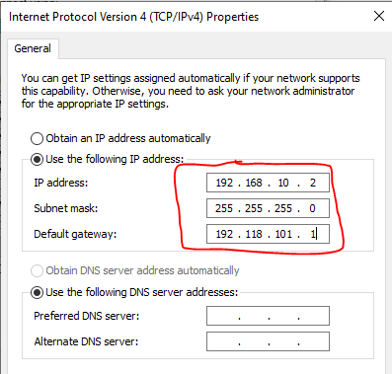

1. **DHCP:** Providing IP address to any devices automatically. This is an option among router which provide an ip address to devices. DHCP provide ip address to any device with a certain time, after that time their lease will be expired.
2. **Header Length:** Header length is a 4-bit in size which shows how many 32-bit words are present in the header.

**Question 3: (5 MARKS)**

Please describe the Network Layer with the Following values when a message is transmitted from Host 1 to Host 2. Please describe the question with a diagram.

**Values:** Host= H1, H2

Router= R1, R2, R3, R4

Physical Layer = ph1

**Ans:** Network layer is the 3rd layer in OSI model. The Internet Protocol is the one of main protocol that used in network layer along with some other protocol which are responsible for routing, testing and encryption.

Suppose H1 and H2 are connected to two different networks suppose H1 is connected to R1 and H2 is connected to R4. To sending msg from H1 to H2 the network layer is responsible for packet routing means the selection of the shortest path to transmit the packet. The sender and receiver’s Ip address are placed in the header by network layer. Firstly the network layer will determine the shortest possible distance for the message sending which called the routing. After that to identify each device on internetwork uniquely it defines an addressing. The network layer put sender and reciever address in the header of packet to identify source and destination.

**Question 4: (5 MARKS)**

What “service model” is used for channel transporting datagrams from sender to receiver? Please explain that channel with examples.

**Ans:** The network layer is used for channel transporting datagram from sender to recever. Suppose H1 and H2 are connected to two different networks suppose H1 is connected to R1 and H2 is connected to R4. To sending msg from H1 to H2 the network layer is responsible for packet routing means the selection of the shortest path to transmit the packet. The sender and receiver’s Ip address are placed in the header by network layer. Firstly the network layer will determine the shortest possible distance for the message sending which called the routing. After that to identify each device on internetwork uniquely it defines an addressing. The network layer put sender and reciever address in the header of packet to identify source and destination.

**Question 5: (5 MARKS)**

Describe the term “VC” and briefly explain the VC Translation table with values.

**Ans:** Virtual Circuit is connection-oriented service in network. It is responsible for the transmission of data b/w two nodes.

Virtual Circuit first set up b/w the two end nodes. Then it send signal from reciver to the sender to know about the connection is established. After that it starts the data transmission and ensure the data transmission for every single packet. It also controls the data congestion suppose h1 is sending data towards h2 so we can say the connection is established b/w h1 and h2, while VC will not establish any other connection until h1 and h2 finished data transmission.

**End of Exam**

**Best of Luck**