**Title:online doctor appointment system**

**Team: Gayatri Sharma**

**komal Dhamankar**

**Introduction**

**Purpose:**

The purposed proect is a smart appointment booking system that provides patients or any user an easy way of booking a doctor's appointment online.This is a web based application that overcomes the issue of managing and booking appointments according to user's choice or demand and save their time as well. The task sometimes become very tedious for compounder or doctor himself to manually alloting appointments for the users as per their availablity.Hence the project offer an effective soltuion where user's can view various booking slots available and select preferred date and time.This system also allows users to cancel their booking anytime.

**Scope:**

The Online Doctor Appointment System manages all the details of Doctor,Appointment,Patient,Booking, Doctor Scheduled and Doctor Fees. The system allows the patient to confirm the booking and cancel their booking anytime and give feedback.

**Definitions:**

ODAS --> Online Doctor Appointment System

SRS --> Software Requirement Specification

GUI---> Graphical User Interface

Portal--> Personalized Website

Stackholder--> The person who will participate in the System. And Onwer of system

Ex. Doctor, Admin , Patient

UML---> Software Engineering Notation for visualising System in the form diagrams

SSL---> Secure Socket Layer used for providing restricted access to application.

BOD---> Board Of Directors (Management).

RDBMS --> Relational Dadabase Management System. CLUSTERS---> Group of independent servers.

**Overview:**

This System provides an easy solution to Patient to take appointment of a Doctor online on their availablity and Doctor can also see the patient request and feedback.

**Additional Information:**

The system work on internet server, so it will be operated by any end user for the booking purpose with secure platform. This system protects the integrity of the Doctor and Patient, provides easy booking and cancellation policies.

**General Description:**

The Online Doctor Appointment application helps to manage Doctor details,Patient details and booking details. The online Appointment system will use the internet as the sole method for taking the appointment based on the available time and date of a doctor.

**Functional Requirement:**

This section provides requirement overview of the system. Various functional modules that can be implemented by the system will be-

**User side functinality**

-->Register and login

--->search doctor

-->Book Appointment

-->FeedBack

-->Cancellation

**Admin side functinality**

-->Add Doctor

-->Remove Doctor

-->View User data

-->Feedback View and Reply

-->Cancellation

**Application Architecture:**

Application = Logic + data

Logic =(UI Logic + Business Logic + DataAccess Logic)

Data =( structured data , Non Structured data)

**Online Application:**

**Web based Application**

deployed on web and accessed by user from anywhere

**Online Doctor Appointment System------Web portal-- used remotely by Patient, Doctors,Admin**

**Logic:**

**UI Logic:**

**Web Pages + HTML controls + Web Components (Angular)**

**Navigation : (UI Routing) HTML Links, Routing mechansim**

**Data Binding : DOM + JSP tags (JSTL) + {{}} ngModel,**

**Event Binding :**  **action handlers**

**HTTP Request:**

**GET:----------------Doget**

**POST:---------------Dopost**

**PUT:**

**DELETE:**

**Client Side UI---------------**-HTML, CSS, javaScript, bootstrap

UI (Client Side UI Framework)

Angular, React, Vue,..........

**Web Logic: ( Server Side processing)**

**Server UI----------------** JSP, servelet, ( classical java web technology)

spring MVC ( to take advantage of MVC design Pattern using ready made framework)

Model, View, Controller

Router

(SOA layer)

Spring Boot api

CRUD REST API

ORM Technique:Hibernate ( ORM)

,JPA

JDBC ( database Connectivity)

**State management**

---------------------------------

Client Side state management---->

cookies, querystring, form collection, hidden variables

local storage, session storage, Web sql,

Server Side state management---->

session, Cache,database

**Business Logic:**

**Java console application will be used to test your business Logic**

**Core Java:**

**will contain**

**1.business query processing**

**2.business operation managment**

**3.Business data manipulation**

**online Doctor Appointment System Modules-**

**1)Admin login- The system in under supervision of admin who manages the booking made and add doctors.**

**2)login/registration-User have to first register themselevs to login into the system.**

**3)Appointment availabilty check- user can check the availability.**

**4)Appointment booking online for date and time-User can book appointment for their required date and time.**

**5) Email on appointment booking-when user is successful in appointment confirmation then confirmed mail sent to user.**

**6)Booking cancellation-User may cancel their booking by login into the system anytime.**

**7)Payment processing-user pay the appointment fees.**

**8)Feedback-The System has a feedback form,where user can provide feedback into the system.**

**Database :**

**Structured Data**

**RDBMS =MySql**

**1)Admin**

**id ,first_name,last_name ,email ,password ,contact_no**

**Primary key --->id**

**2) patients**

**patient_id ,firstname,Lastname,email ,password ,dob ,address ,phone ,gender**

**Primary key ---> patient_id**

**3) doctor_specialization**

**spec_id ,name**

**Primary key ---> spec_id**

**4)doctor**

**doctor_id ,firstname ,lastname ,email ,password,dob ,address ,phone ,gender ,fees,specialization_id**

**Primary key ---> doctor_id**

**Foreign Key---->specialization_id**

**5)doctor_availability**

**id ,doctor_id ,day_in_week ,starting_time ,**

**ending_time ,open_for_day ,minutes_for_patient**

**Primary key ---> id**

**Foreign Key----> doctor_id**

**6)appointments**

**appointment_id ,patient_id ,doctor_id ,appointment_status_id ,starttime ,appointment_date ,**

**Primary key ----> appointment_id**

**Foreign Key ---->patient_id**

**Foreign Key ---->doctor_id**

**Foreign Key --->appointment_status_id**

**7)appointment_status**

**appointment_status_id ,status**

**Primary key ----> appointment_status_id**

**8)feedbacks**

**id int(5) ,appointment_id ,msg**

**Primary key ----> appointment_status_id**

**Foreign Key ----> appointment_id**

**9)payment**

**paymentid ,card_no ,paymentdatetime , amount, appointment_id**

**Primary key ----> paymentid**

**Foreign Key --->appointment_id**

**10)card_type**

**card_no ,expiry_date ,security_code ,cardtype**

**Er-Diagram**

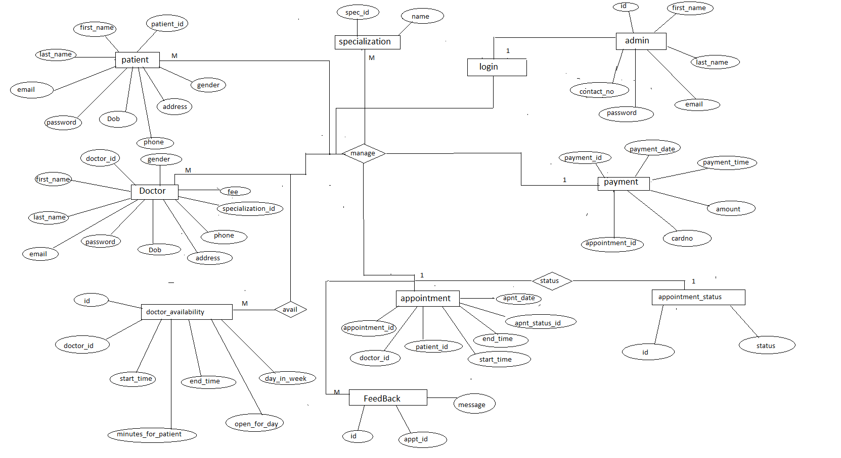

**Use Case Diagram**

