**HTML4 Assignment**

1. **Simple Page with Heading and Paragraph**

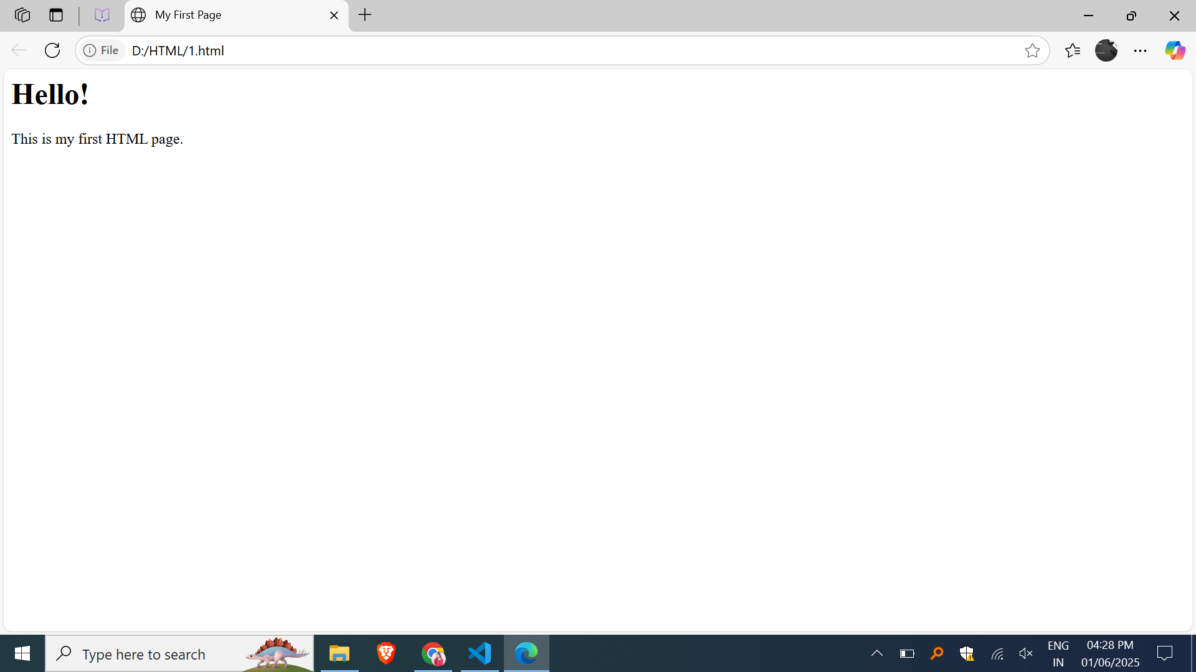

1. **Multiple Headings**

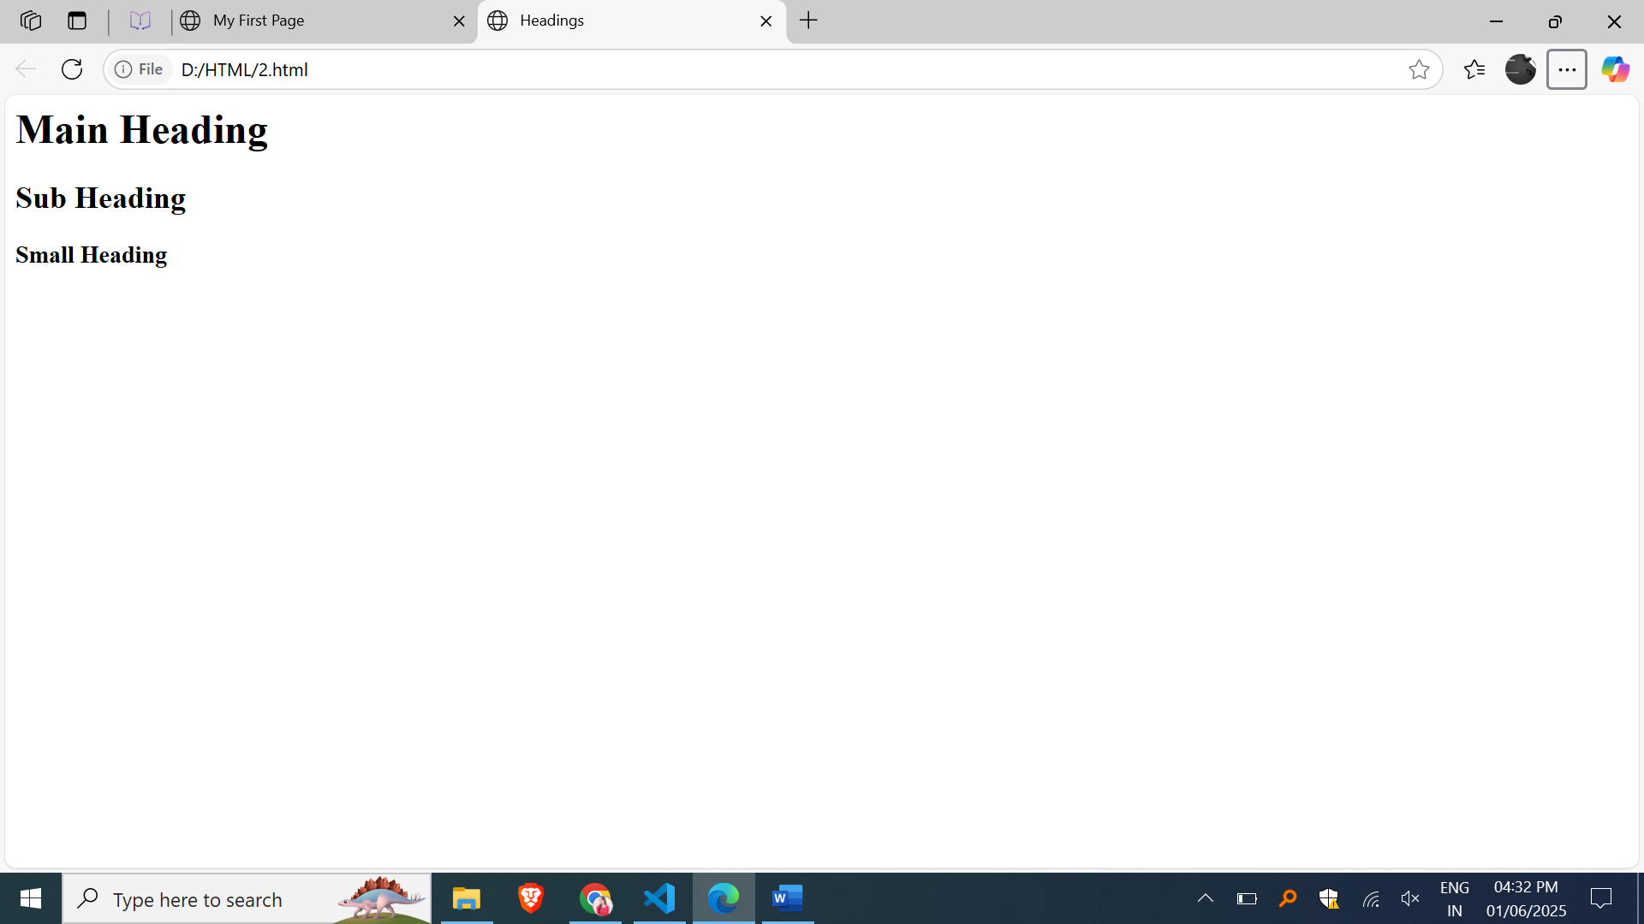

1. **Link to Another Website**

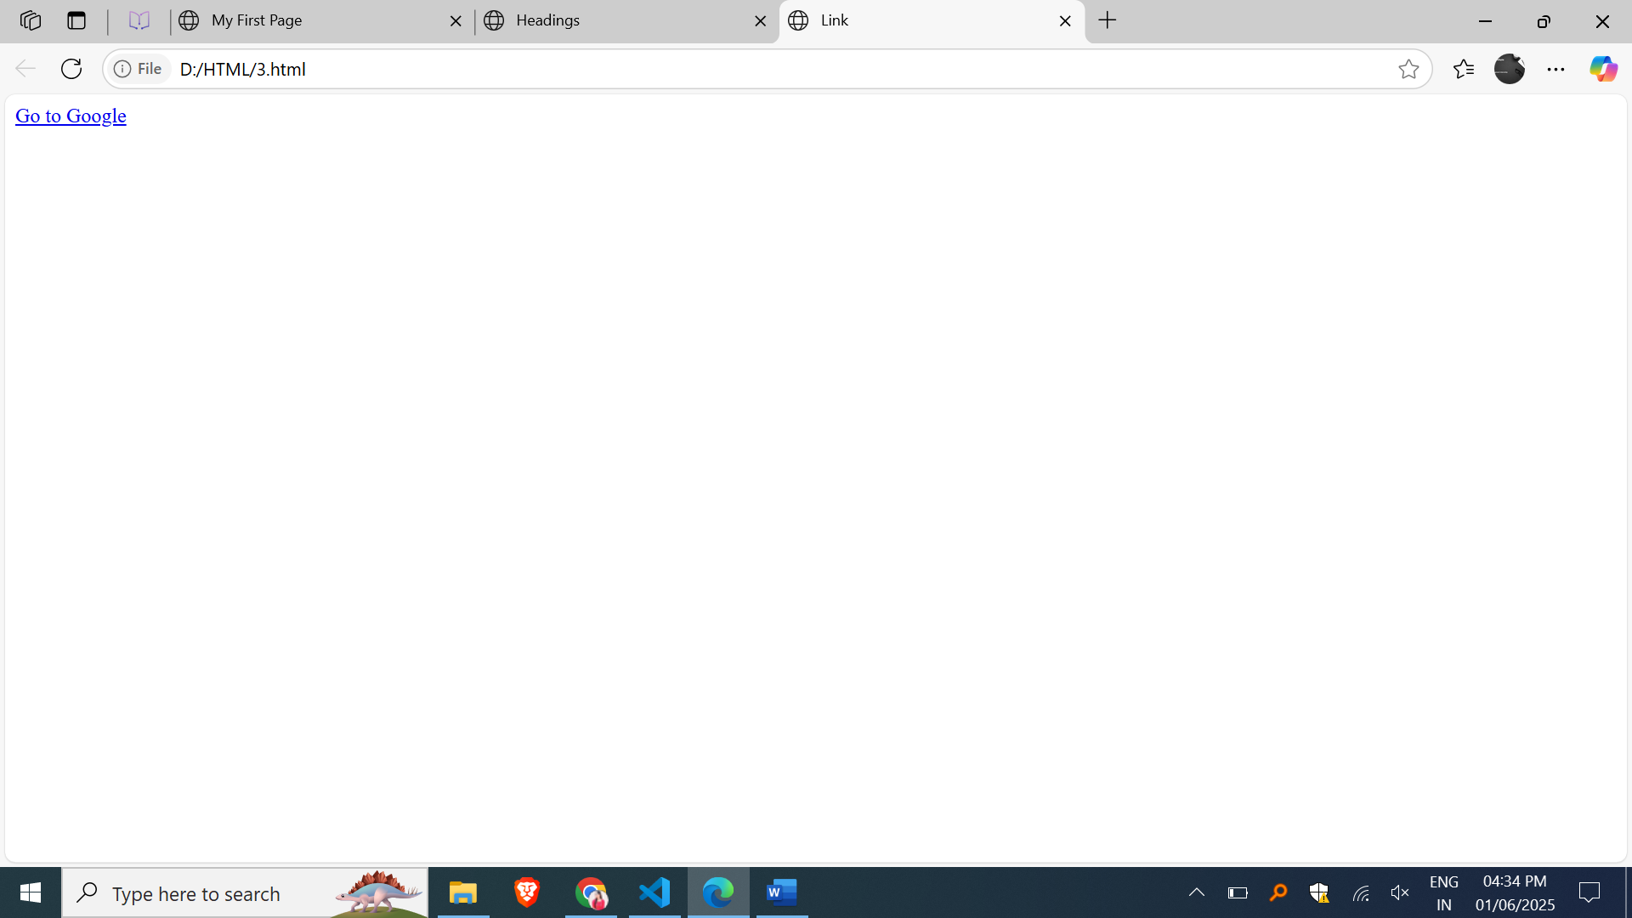

1. **List – Unordered**

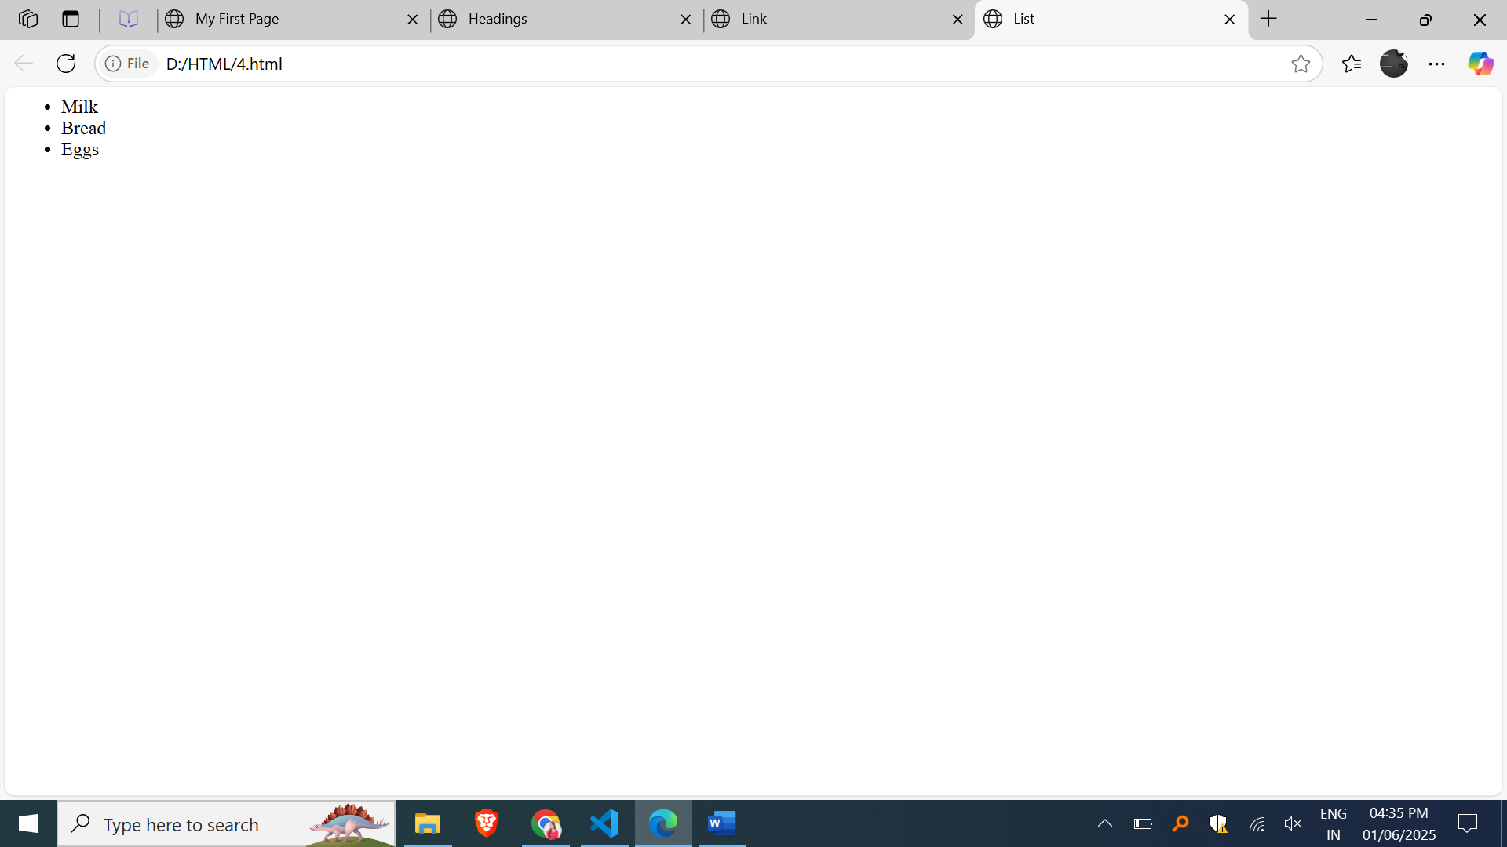

1. **List – Ordered**

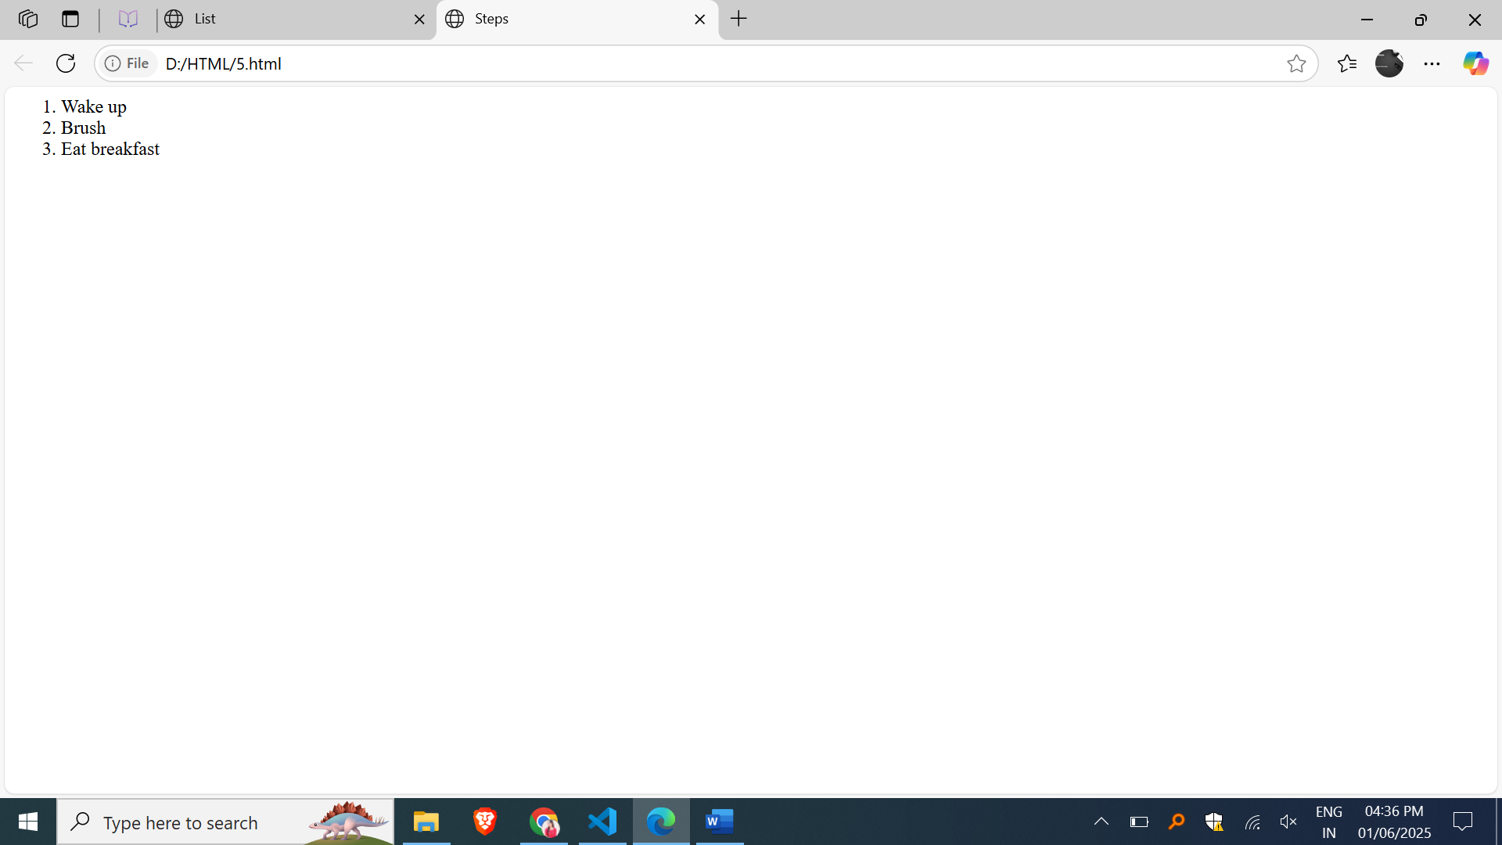

1. **Bold and Italic Text**

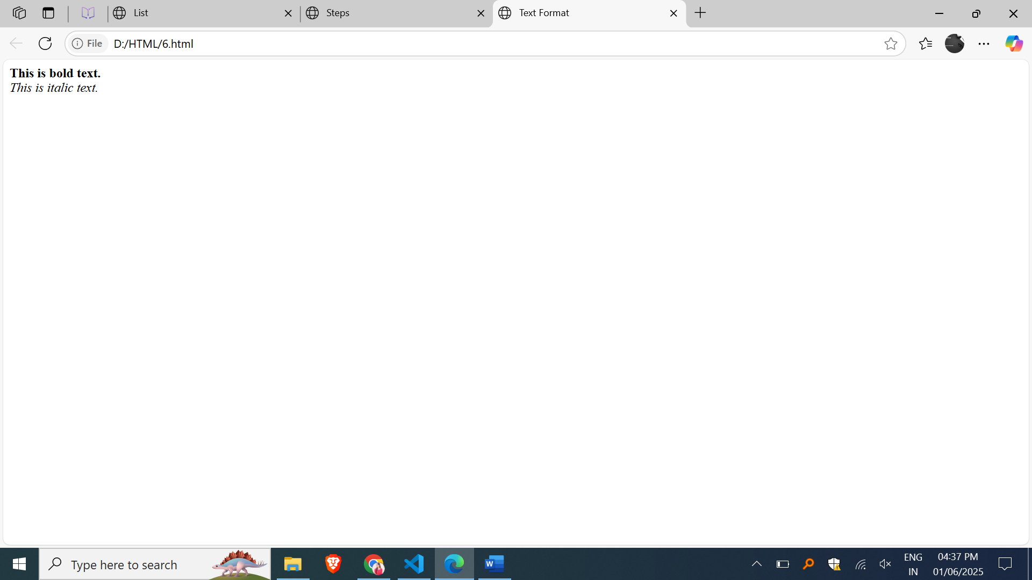

1. **Registration Form with name,email,password,contact no,gender and country fields**

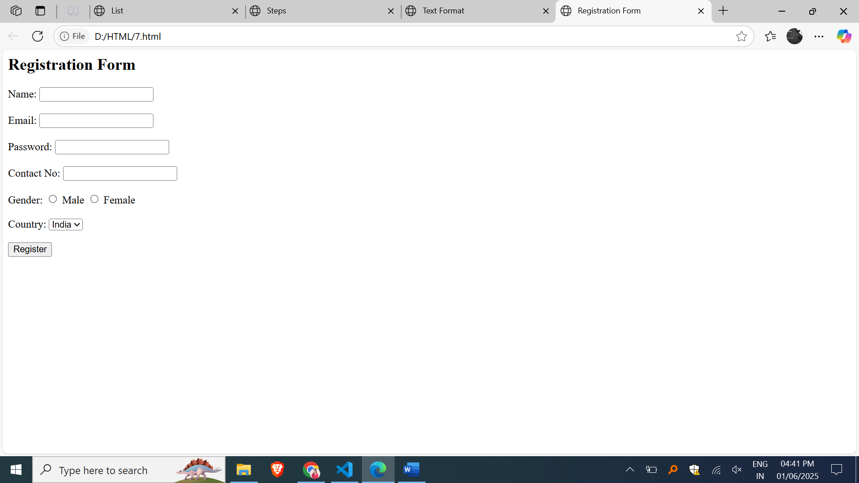

1. **Create a table using HTML4 that shows the Roll No, Name, and Marks of 3 students.**

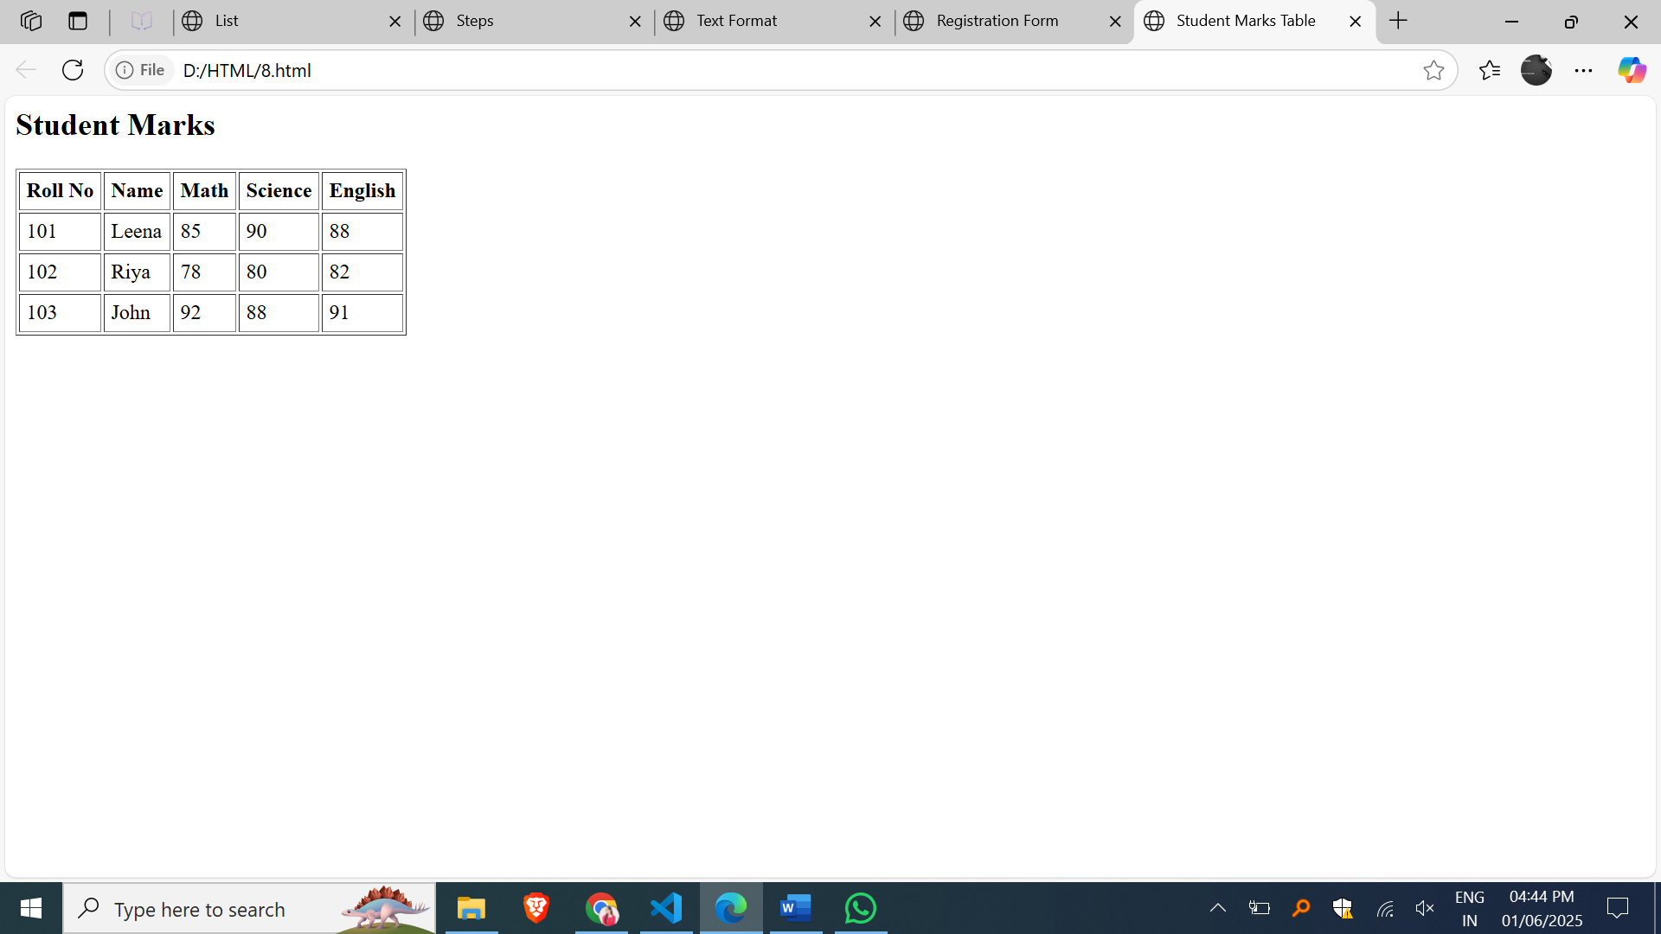

1. **Show a table of 3 products with image, name, price**

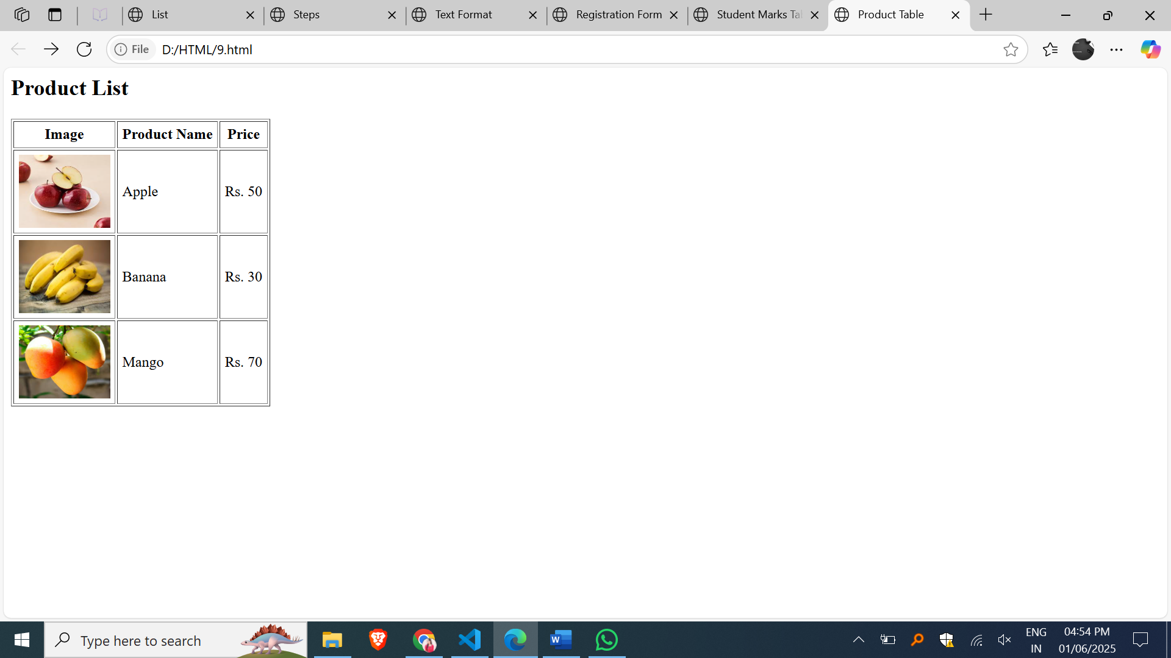

1. **Display Personal Information in Tabular Format**

