VLSI Internship – Task 1 Report
Name: Komal Lokwani
Branch: Electronics & Communication Engineering
Internship Module: Introduction to VLSI Design Flow and Digital Logic Implementation

1. Overview of VLSI
Very Large Scale Integration (VLSI) refers to the process of integrating millions to billions of transistors onto a single silicon chip to implement complex digital systems. Modern computing devices such as microprocessors, memory units, GPUs, mobile SoCs, and AI accelerators are built using VLSI technology.
The significance of VLSI lies in:
- High integration density
- Reduced power consumption
- Increased performance
- Compact system design
- Cost-effective mass production
VLSI serves as the backbone of modern semiconductor technology and digital electronics.
2. Standard VLSI Design Flow (Industry Perspective)
The VLSI design process follows a structured methodology:
1. System Specification
Defines:
- Functional requirements
- Performance targets
- Power constraints
- Area limitations
2. Architecture Design
- High-level block diagram creation
- Module partitioning
- Data path and control path definition
3. RTL (Register Transfer Level) Design
- Hardware description using Verilog/VHDL
- Describing logic at register-transfer abstraction
4. Functional Verification
- Simulation of RTL code
- Ensuring logical correctness
5. Synthesis
- Converting RTL into gate-level netlist
6. Physical Design
- Floorplanning
- Placement
- Routing
7. Timing & Power Analysis
- Static timing analysis
- Power estimation
8. Fabrication
- Manufacturing the chip using semiconductor processes
9. Testing & Validation
- Post-fabrication testing
- Functional and reliability validation
This structured flow ensures that the chip design meets industry standards for performance and reliability.

3. Digital Logic Fundamentals
Digital systems operate on binary values (0 and 1).
Logic gates form the building blocks of all digital circuits.
The following gates were implemented and simulated:
- AND
- OR
- NOT
- NAND
- NOR
- XOR
Each gate was verified using truth tables to ensure correct logical behavior.

4. Implementation and Simulation of Basic Logic Gates
4.1 AND Gate
Expression:
Y = A · B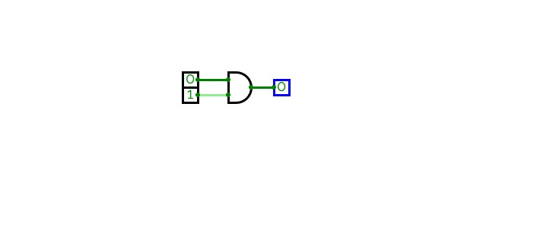
Behaviour:
Output is HIGH only when both inputs are HIGH.

4.2 OR Gate
Expression:
Y = A + B
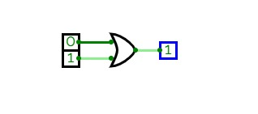
Behaviour:
Output is HIGH when at least one input is HIGH.

4.3 NOT Gate
Expression:
Y = A̅
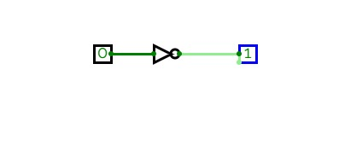
Behaviour:
Output is the logical inversion of input.

4.4 NAND Gate
Expression:
Y = (A · B)̅
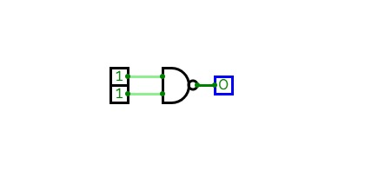
Behaviour:
Universal gate. Output is LOW only when both inputs are HIGH.

4.5 NOR Gate
Expression:
Y = (A + B)̅
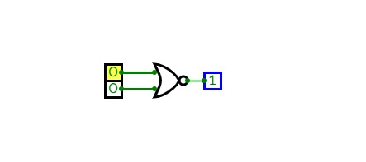
Behaviour:
Universal gate. Output is HIGH only when both inputs are LOW.

4.6 XOR Gate
Expression:
Y = A ⊕ B
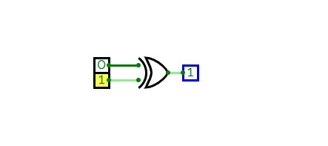
Behaviour:
Output is HIGH when inputs are different.

5. Half Adder Design and Analysis
A Half Adder is a combinational circuit that performs addition of two 1-bit binary inputs.
Inputs:
- A
- B
Outputs:
- SUM
- CARRY
Logical Expressions:
SUM = A ⊕ B
CARRY = A · B
Functional Understanding:
- XOR operation produces the sum without carry.
- AND operation detects carry generation condition.
Truth Table:
A | B | SUM | CARRY
0 | 0 | 0 | 0
0 | 1 | 1 | 0
1 | 0 | 1 | 0
1 | 1 | 0 | 1
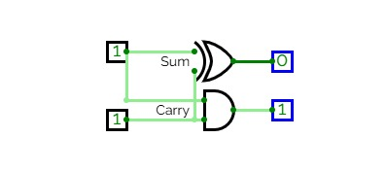
6. Technical Observations
- Simulation results matched theoretical truth tables.
- XOR gate is essential in arithmetic logic circuits.
- AND gate effectively detects carry condition.
- NAND and NOR gates are universal gates capable of implementing any logic function.
- Practical implementation reinforced understanding of combinational circuit behaviour.
- This task establishes a foundation for RTL coding and hardware design.

7. Learning Outcome
Through this task, I gained:
- Understanding of the complete VLSI design flow
- Practical exposure to digital logic gate simulation
- Clear understanding of combinational circuits
- Conceptual readiness for RTL and Verilog-based design

8. Conclusion
This task provided a strong foundational understanding of digital logic design and VLSI workflow. Implementing and verifying basic logic gates and the half adder circuit strengthened both theoretical and practical knowledge, forming a base for advanced digital system design and RTL development.

