VLSI Design Internship – Task 2 Report
Title
Implementation of Logic Gates, Half Adder and Full Adder using Verilog HDL

Objective
To design and simulate basic digital circuits including Logic Gates, Half Adder, and Full Adder using Verilog HDL, and verify their outputs using EDA Playground.

Tools Used
- EDA Playground
- Icarus Verilog
- EPWave (Waveform Viewer)

1. Logic Gates Implementation
Design Code
module logic_gates(
input A,
input B,
output AND_out,
output OR_out,
output NOT_out
);
assign AND_out = A & B;
assign OR_out = A | B;
assign NOT_out = ~A;
endmodule
Testbench Code
module tb;
reg A,B;
wire AND_out, OR_out, NOT_out;
logic_gates uut(A,B,AND_out,OR_out,NOT_out);
initial begin
$dumpfile("dump.vcd");
$dumpvars(0, tb);
A=0; B=0; #10;
A=0; B=1; #10;
A=1; B=0; #10;
A=1; B=1; #10;
end
endmodule
Explanation
Basic logic gates (AND, OR, NOT) were implemented using Verilog and verified through simulation. The waveform confirms correct logical behavior.
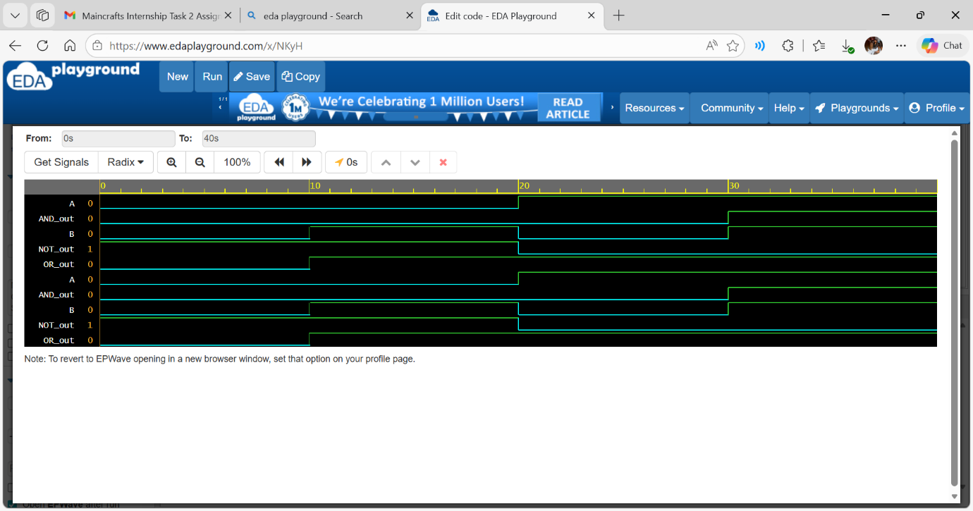

2. Half Adder Implementation
Design Code
module half_adder(
input A,
input B,
output Sum,
output Carry
);
assign Sum = A ^ B;
assign Carry = A & B;
endmodule
Testbench Code
module tb;
reg A,B;
wire Sum,Carry;
half_adder uut(A,B,Sum,Carry);
initial begin
$dumpfile("dump.vcd");
$dumpvars(0, tb);
A=0; B=0; #10;
A=0; B=1; #10;
A=1; B=0; #10;
A=1; B=1; #10;
end
endmodule
Explanation
Half Adder adds two binary inputs and produces:
- Sum = A XOR B
- Carry = A AND B
The simulation waveform verifies correct output.
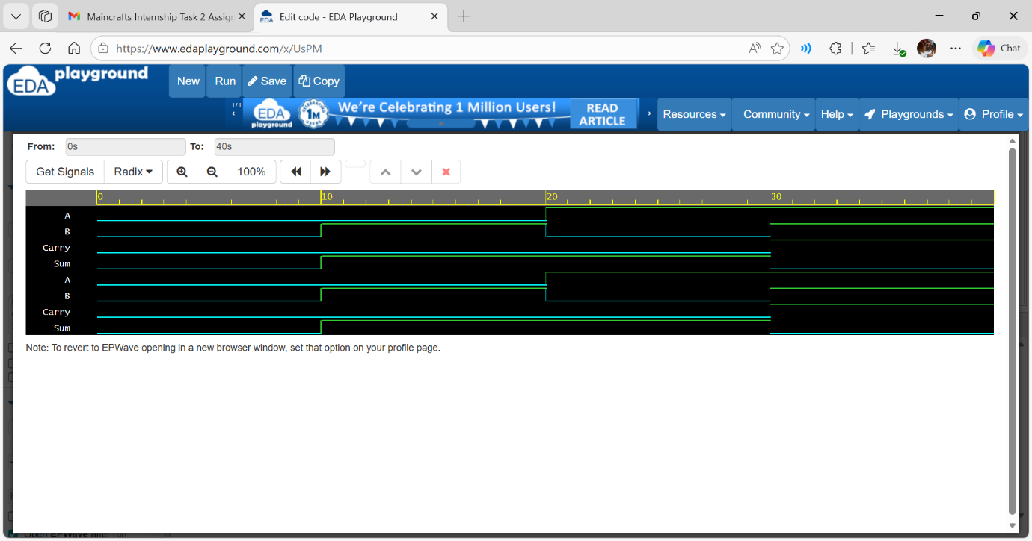

3. Full Adder Implementation
Design Code
module full_adder(
input A,
input B,
input Cin,
output Sum,
output Cout
);
assign Sum = A ^ B ^ Cin;
assign Cout = (A & B) | (B & Cin) | (A & Cin);
endmodule
Testbench Code
module tb;
reg A,B,Cin;
wire Sum,Cout;
full_adder uut(A,B,Cin,Sum,Cout);
initial begin
$dumpfile("dump.vcd");
$dumpvars(0, tb);
A=0; B=0; Cin=0; #10;
A=0; B=0; Cin=1; #10;
A=0; B=1; Cin=0; #10;
A=1; B=1; Cin=1; #10;
end
endmodule
Explanation
Full Adder adds three inputs (A, B, Cin) and produces:
- Sum = A ⊕ B ⊕ Cin
- Carry = Majority of inputs
Waveform confirms correct operation.
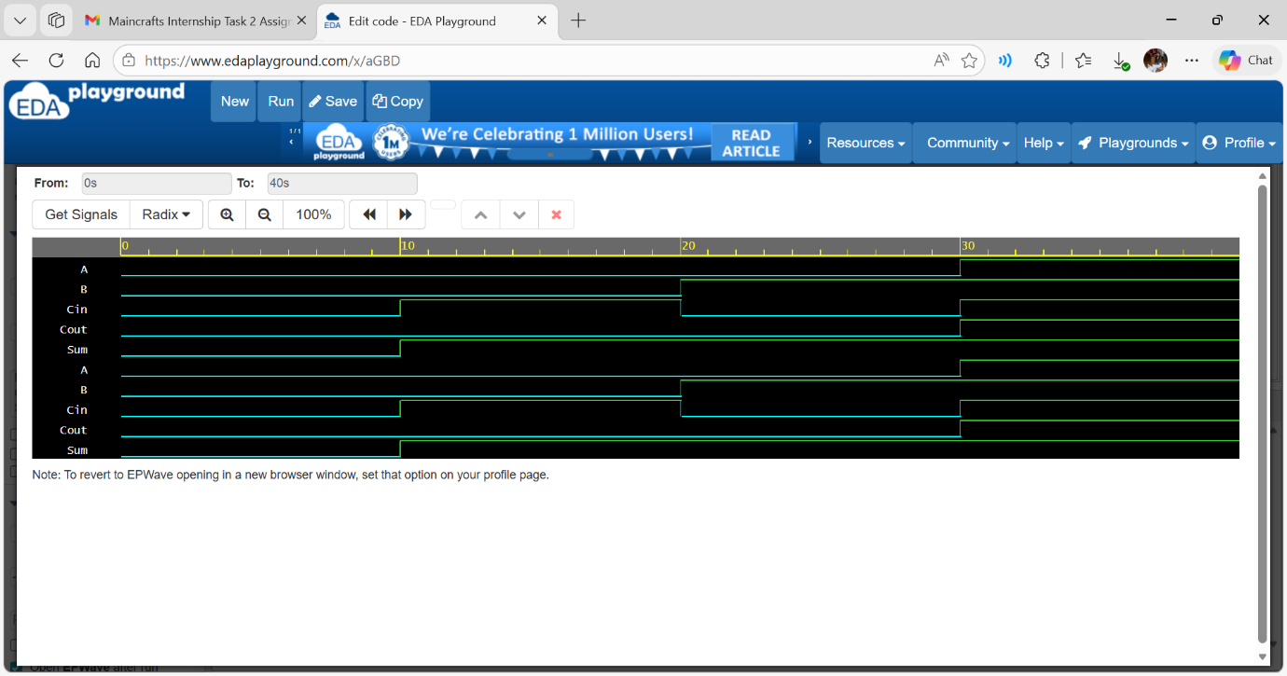

Conclusion
The implementation and simulation of Logic Gates, Half Adder, and Full Adder were successfully completed using Verilog HDL. The outputs were verified using waveform analysis in EDA Playground, confirming correct functionality of all circuits.

