Veritas — Approach, Worked Examples, Trade-offs & Roadmap
Multi-Source Candidate Data Transformer · Java (JDK 17, zero dependencies)
1 · The problem, in one breath
Candidate data arrives from many places at once — a recruiter CSV, an ATS JSON blob with its own field names, a GitHub API response, a LinkedIn profile, résumé prose, free-text recruiter notes. The same person shows up in several of them with conflicting values; any source may be missing, empty, or malformed. Downstream hiring products need exactly one clean profile per candidate: fixed fields, normalized formats, deduplicated, plus a record of where each value came from and how confident we are. The hard rule: *wrong-but-confident is worse than honestly-empty*, because a bad value silently pollutes hiring decisions.
2 · The approach — an Evidence Ledger reduced deterministically
The one idea everything follows from: never merge raw values directly. Each source is converted into a list of small, fully-traced assertions called Claims. All Claims for a candidate form an Evidence Ledger, and the final profile is a pure, deterministic reduction over that ledger. Merging becomes a function of immutable data — which is what simultaneously makes the system reproducible, explainable, robust, and easy to scale. The whole flow — heterogeneous inputs on the left, the engine in the middle, the two output shapes on the right, and how it meets the three constraints — is shown in Figure 1.
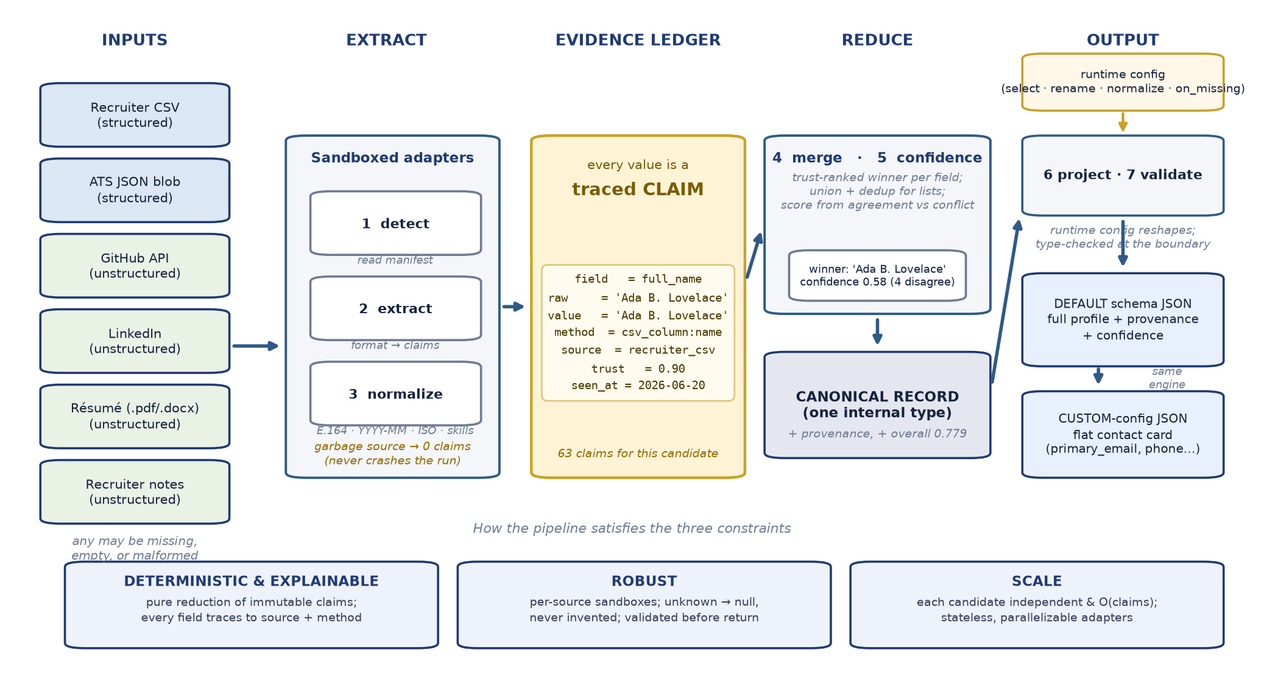
Figure 1 — High-level design flow: many messy sources → traced Claims in one Evidence Ledger → deterministic reduction into a canonical record → a config-driven projection into the requested output. The bottom band shows how each stage satisfies the deterministic, robust, and scalable constraints.
2.1 · The atom: a Claim
A Claim records one normalized assertion about one canonical field, with its full lineage:
Claim {
fieldPath = "full_name" // canonical target
raw = "Ada B. Lovelace" // exactly as the source had it
value = "Ada B. Lovelace" // normalized (null if it could not be)
method = "csv_column:name" // how we derived it -> provenance
sourceId = "recruiter_csv"
trust = 0.90 // effective trust for THIS field
observedAt = "2026-06-20" // recency tie-breaker
order = 0 // manifest position -> final tie-break
}
Because Claims keep both raw and value, the audit trail survives all the way to output, and normalization failures are visible (a null value), never hidden.
2.2 · The seven-stage pipeline
detect → extract → normalize → merge → confidence → project → validate
- detect — read a manifest naming each source (type, path, optional trust + timestamp).
- extract — run the matching adapter inside a sandbox; output is a list of claim drafts.
- normalize — happens inside each adapter, so the merge stage only ever sees clean, comparable values.
- merge — reduce the ledger into one canonical record (winner per scalar field; union/dedup per list).
- confidence — score every field from agreement, authority, and conflict.
- project — apply the runtime config to reshape the output (the required twist).
- validate — check the result against the requested schema before returning it.
2.3 · The trust model — per source AND per field
Conflict resolution needs a defensible notion of *who to believe*. Trust is a per-source base, overridden per field because a source can be authoritative for some fields and useless for others:
Source | Base | Per-field overrides
recruiter_csv | 0.90 | —
ats_json | 0.85 | —
linkedin | 0.75 | headline 0.90, links.linkedin 0.99
github_api | 0.60 | skills 0.95, links.github 0.99, phones 0.00
resume | 0.55 | experience 0.80, education 0.85, skills 0.70
recruiter_notes | 0.40 | phones 0.55, skills 0.45

So GitHub is gold for skills but is forbidden from ever winning a phone number; the recruiter CSV outranks LinkedIn on identity. A manifest entry can also override a source's base trust per run.
2.4 · The confidence model
Scalar-field confidence combines four independent signals, clamped to [0, 1]:
confidence = authority (winner trust)
+ agreement_bonus (decaying bonus per corroborating source)
- conflict_penalty (0.08 per disagreeing source)
- normalize_penalty (0.15 if the winning value never normalized)
overall_confidence is a weighted mean that deliberately prioritizes identity and reachability (full_name, emails, phones) over enrichment (skills, education).
2.5 · Canonical record vs. projection layer — two separate types
The engine always builds the same internal canonical record. A second, independent layer — the projection — interprets a runtime config (pure data) to reshape that record. The engine never changes to satisfy a new output shape, which is what makes *“same engine, no code changes”* literally true.
3 · How it solves the problem — a worked example
Throughout, we use the sample candidate Ada Lovelace, whose seven sources disagree on purpose. The engine turns 63 Claims into one profile with overall_confidence = 0.779.
3.1 · The messy inputs (excerpt)
Source | Says the name is… | Phone | A few skills
recruiter_csv | Ada B. Lovelace | (415) 555-0142 | —
ats_json | Ada Lovelace | +1 415 555 0142 | Python, golang, k8s
github_api | Ada Lovelace | (none) | Go, Python, Rust, JavaScript
linkedin | Ada Byron Lovelace | (none) | Distributed Systems, Kafka
resume | Ada Lovelace | +1 (415) 555-0142 | Go, Rust, Spark, Kafka
recruiter_notes | (none) | 415-555-0199 | distributed systems, Go, Kafka
corrupt_ats.json | GARBAGE (broken JSON) | — | —

3.2 · Example A — resolving the name conflict
Five sources make a full_name Claim with three different values. The reduction sorts them by (trust ↓, recency ↓, order ↑, value ↑) and takes the head:
value | source | trust | outcome
Ada B. Lovelace | recruiter_csv | 0.90 | WINNER
Ada Lovelace | ats_json | 0.85 | conflicts
Ada Byron Lovelace | linkedin | 0.75 | conflicts
Ada Lovelace | github_api | 0.60 | conflicts
Ada Lovelace | resume | 0.55 | conflicts

Winner = “Ada B. Lovelace”. Confidence = authority 0.90 − conflict 0.08×4 = 0.58 — correctly *lower* than a clean field, signalling the disagreement to downstream consumers. Provenance records {field: full_name, source: recruiter_csv, method: csv_column:name}. The choice is fully reproducible: even if every trust were equal, the manifest order breaks the tie identically every run.
3.3 · Example B — folding and scoring skills
Skills arrive in many spellings across sources. Normalization canonicalizes aliases (golang→Go, k8s→Kubernetes), then a case-insensitive fold merges variants — so the free-text “distributed systems” from notes merges with the ATS “Distributed Systems”. Confidence rises with the number and trust of corroborating sources:
skill | sources | confidence
Go | ats, github, linkedin, notes, resume (5) | 1.00
Distributed Systems | ats, linkedin, notes (3) | 1.00
Apache Kafka | linkedin, notes, resume (3) | 0.91
JavaScript | github only (1) | 0.95
Apache Spark | resume only (1) | 0.70

Note the judgment encoded here: Go (5 independent sources) is a near-certainty; Apache Spark (résumé only, trust 0.70) is kept but flagged as weaker — we never *drop* a niche skill, we just score it honestly.
3.4 · Example C — normalization & dedup
Phones appear as (415) 555-0142, +1 415 555 0142, +1 (415) 555-0142, 415-555-0199. Each is normalized to E.164 and deduped, yielding ["+14155550142", "+14155550199"] — the four spellings of the primary collapse to one, and the backup mobile from the notes is preserved. Emails are lower-cased and deduped: Ada.Lovelace@example.com and ada.lovelace@example.com become one entry, while ALOVELACE@oldmail.com is kept as a second address. Country United States/USA → US (ISO-3166), confidence 1.0 (every source agrees).
3.5 · Example D — robustness to a garbage source
corrupt_ats.json is intentionally invalid JSON. Its adapter throws while parsing; the pipeline's per-source sandbox catches it, records SKIP (extract failed: …), and the run continues on the other six sources. No field is invented from the broken input — exactly the *“honestly-empty beats wrong-but-confident”* rule in action.
3.6 · Example E — the configurable twist
A caller wants a flat contact card, not the full profile. They send a config — no engine change:
{ "fields": [
{ "path": "full_name", "type": "string", "required": true },
{ "path": "primary_email", "from": "emails[0]", "type": "string", "required": true },
{ "path": "phone", "from": "phones[0]", "type": "string", "normalize": "E164" },
{ "path": "skills", "from": "skills[].name", "type": "string[]" } ],
"on_missing": "omit" }
The projection layer remaps emails[0] → primary_email, plucks skills[].name into a flat list, type-validates each value, and omits anything missing. Result:
{ "full_name": "Ada B. Lovelace",
"primary_email": "ada.lovelace@example.com",
"phone": "+14155550142",
"skills": ["Apache Kafka","Apache Spark","Distributed Systems","Go", ...],
"overall_confidence": 0.779 }
Switch on_missing to error and a missing required field raises instead; switch a type and an invalid value is rejected at the boundary. Same canonical record, three different contracts.
3.7 · …which maps cleanly to the three constraints
- Deterministic & explainable — pure reduction over immutable Claims; total ordering of tie-breaks; every output field carries provenance + confidence.
- Robust — per-source sandboxes; normalizers return null rather than guess; validation gate before return.
- Scale — each candidate is independent and O(claims); adapters are stateless and parallelizable; no cross-candidate state.
4 · Pros of this approach
- Explainability is free, not bolted on. Provenance and confidence fall directly out of the ledger; you can always answer “why does the profile say X?”.
- Determinism by construction. Same inputs → byte-identical output, because the result is a pure function of immutable Claims with a total tie-break order. Trivial to gold-test.
- Policy lives in one place. Trust and conflict rules sit in the merge stage, not smeared across adapters — easy to read, defend, and change.
- Open to extension, closed to modification. A new source = a new adapter implementing one interface; a new output shape = a new config, no code. Adapters never know about each other.
- Fails safe. The default outcome of any uncertainty is null + low confidence, never a fabricated value.
- Zero-dependency & portable. Bare JDK, no build tool or network required — easy to run and audit.
5 · Cons & honest limitations
- Trust weights are hand-tuned heuristics. They are sensible defaults, not learned from outcomes; a miscalibrated weight can pick the wrong winner on an unusual candidate.
- Confidence is a designed score, not a probability. The numbers are useful for ranking and thresholds, but they are not calibrated likelihoods.
- Single-record identity assumption. One candidate per manifest; the approach does not yet do cross-candidate entity resolution (fuzzy matching the same person across files).
- Deterministic parsing under-extracts. The résumé reader is regex + section headers (for reproducibility), so it deliberately misses prose it cannot parse confidently.
- Ledger memory cost. Keeping every Claim is great for auditing but is more memory than a merge-in-place approach; for very wide fan-in this would need streaming/spilling.
- Normalization tables are finite. Country and skill-alias maps are curated; an unknown alias passes through verbatim (safe, but not canonical).
6 · How it can be improved
- Learn trust from feedback. Replace static weights with per-(source, field) reliability learned from recruiter corrections or downstream outcomes — turning the heuristic into a calibrated prior.
- Calibrated, probabilistic confidence. Fit the score to observed correctness (e.g. isotonic/Platt calibration) so 0.8 genuinely means 80% right.
- Cross-candidate identity resolution. Add a blocking + fuzzy-match stage (name/email/phone similarity) so the same person across sources merges into one record.
- Stronger extractors behind the same contract. Swap regex résumé parsing for an LLM/NER extractor that still emits Claims — the ledger and merge stay unchanged, and we keep determinism via cached, versioned extractions.
- Real connectors. Replace the captured GitHub JSON with a live HttpClient fetch (with caching for reproducibility); add LinkedIn/ATS API adapters — again, only new adapters, no engine change.
- Schema-driven validation & config. Express the default schema and configs as JSON-Schema and validate against it; add a tiny UI over the existing config for non-engineers.
- Observability. Emit per-run metrics (claims per source, conflict rate, fields left null) to catch a drifting source before it pollutes profiles.
In short: model every assertion as traceable evidence, reduce it with an explainable, deterministic policy, and keep the output shape a matter of configuration — so the system is trustworthy first, and flexible without becoming fragile.

