PENETRATION TESTING REPORT
Footprinting & Network Scanning Phases
W2 – CYBERSECURITY INTERNSHIP SUBMISSION

Field | Detail
Report Reference | W2 – Cybersecurity Internship Submission
Program / Batch | Networkwalks (Batch-84)
Prepared by | KOMAL KUMARI SHAW
Date | 13-11-2026
Modules / Tasks | theHarvester OSINT Footprinting; Zenmap / Nmap Network Discovery
Targets | microsoft.com (public-source OSINT exercise); own local /24 network (host discovery)
Authorization | Public-source information gathering for the specified domain; network scan limited to own network or an explicitly authorized network
Phases Covered | Phase 1: Reconnaissance & Footprinting; Phase 2: Scanning & Network Discovery
Prepared for educational and authorized cybersecurity lab documentation.

1. Liability Disclaimer
This report documents educational cybersecurity exercises involving publicly available information gathering and network host discovery. The theHarvester exercise uses public data sources to examine information associated with the specified domain, microsoft.com. The network discovery exercise must be restricted to a network owned by the report author or one for which explicit permission has been granted.
No exploitation, authentication bypass, service intrusion, or vulnerability validation is described as part of these tasks. The author is responsible for ensuring that all activity remains within the permitted scope and complies with applicable laws, organizational policies, and the terms of the tools and data sources used.

2. Introduction
This report combines two Week 2 practical activities: (1) OSINT-based footprinting using theHarvester in Kali Linux, and (2) local network discovery using Nmap and its graphical interface, Zenmap. Together, the activities introduce two early stages of a security assessment: collecting publicly available information about a domain and identifying live hosts within an authorized network.
The first activity targets microsoft.com and uses Baidu with a configured result limit of 1,000, followed by a second run using all supported sources with a configured limit of 50. The second activity uses ifconfig to inspect the local network configuration, ping to test reachability, and the Nmap host-discovery scan nmap -sn against the author's own /24 subnet. Zenmap may be used to view and present the scan results graphically.
This report provides the purpose, commands, parameter explanations, procedures, evidence placeholders, observations to record, risk considerations, recommendations, and learning outcomes. Actual scan outputs were not supplied with the request; therefore, no specific email addresses, subdomains, live hosts, IP addresses, MAC addresses, or scan counts are invented.

3. Tools Used
Tool | Purpose
Kali Linux | Operating system used for the theHarvester reconnaissance exercise.
theHarvester | Collects publicly available information such as email addresses, subdomains, and hostnames from supported sources.
Baidu | Search engine source selected for the first theHarvester exercise.
All supported theHarvester sources | Broader source selection for the second theHarvester exercise; availability depends on the installed version and source requirements.
ifconfig | Displays local network interface and IP configuration.
ping | Tests reachability to a specified IP address or hostname using ICMP echo requests.
Nmap | Performs host discovery on the specified local subnet.
Zenmap | Graphical interface for configuring Nmap scans and reviewing results.
Kali Linux Terminal | Environment for running the commands and reviewing output.

4. Activities Performed

4.1 OSINT Footprinting with theHarvester
Objective: identify publicly available email addresses and subdomains associated with microsoft.com using theHarvester in Kali Linux.

4.1.1 Exercise 1 – Baidu source (limit: 1,000)
The first exercise specifies Baidu as the data source and configures the maximum result limit to 1,000.
theHarvester -d microsoft.com -b baidu -l 1000
Parameter | Explanation
theHarvester | Starts the theHarvester application.
-d microsoft.com | Sets microsoft.com as the target domain.
-b baidu | Selects Baidu as the source.
-l 1000 | Sets the maximum result limit to 1,000.

Procedure: open the Kali Linux terminal; verify that theHarvester is available; execute the command; allow the tool to query the selected source; then review and record the returned email addresses, subdomains, hostnames, errors, and any source limitations.

4.1.2 Exercise 2 – All supported sources (limit: 50)
The second exercise repeats the domain reconnaissance with all sources supported by the installed theHarvester version and a configured result limit of 50.
theHarvester -d microsoft.com -b all -l 50
Parameter | Explanation
theHarvester | Starts the theHarvester application.
-d microsoft.com | Sets microsoft.com as the target domain.
-b all | Requests all sources supported by the installed version.
-l 50 | Sets the maximum result limit to 50.

Procedure: execute the command in Kali Linux; review the sources queried and the results returned; record email addresses, subdomains, hostnames, errors, and any sources that require API keys or are unavailable. The configured limit is a maximum, not a guarantee that 50 results will be returned.

4.1.3 theHarvester observations to record
Observation
Emails discovered
Subdomains / hosts discovered
Sources successfully queried
Errors / API-key requirements
Notable output

Interpretation: theHarvester results represent information discoverable through the selected public sources at the time of the exercise. Results can vary by tool version, source availability, rate limits, indexing, and API-key requirements. A configured result limit should not be reported as the number of results actually found.

4.2 Network Discovery with Nmap and Zenmap
Objective: identify active hosts within the author's own local /24 network using basic network configuration checks, a connectivity test, and Nmap host discovery. The scan scope must be the author's own network or a network with explicit authorization.

4.2.1 Identify the local network configuration
ifconfig
Run ifconfig in the Kali Linux terminal to identify the active network interface and its IPv4 address, subnet mask, and other interface details. Use the actual interface configuration to determine the correct /24 network address before scanning.

4.2.2 Test connectivity with ping
ping <target-IP>
Replace <target-IP> with a suitable IP address on the authorized local network, such as the local router or another device you own. Review whether echo replies are received, along with packet loss and response time. A device may still be active even if it does not respond to ping, depending on firewall and network configuration.

4.2.3 Discover hosts on the /24 subnet
nmap -sn <your-network-IP>/24
Replace <your-network-IP> with the correct network address for the local /24 subnet. For example, if the subnet is 192.168.1.0/24, the command is:
nmap -sn 192.168.1.0/24
Option | Explanation
nmap | Starts the Nmap network scanner.
-sn | Performs host discovery without a port scan.
<your-network-IP>/24 | Specifies the authorized /24 subnet to check.

Review the output and record the number of hosts reported as up, the IP addresses shown, and any MAC address or vendor details returned. Do not assume that all devices on the subnet will respond to the same discovery probes.

4.2.4 Review the scan in Zenmap
Open Zenmap, enter the same authorized subnet as the target, and select or enter a Ping Scan / host-discovery profile corresponding to the Nmap -sn operation. Run the scan and review the host list and available topology view. Save a screenshot of the scan results. If a topology diagram is generated, include it as additional evidence.

5. Risk Analysis / Impact
The tasks are reconnaissance and host-discovery exercises. The following table identifies potential security implications of the types of information sought. These are general risk considerations, not confirmed vulnerabilities or findings against Microsoft or the local network.
# | Potential risk / observation | Why it matters | Risk level
1 | Publicly discoverable email addresses | May increase exposure to targeted phishing or social-engineering attempts. | Low–Medium
2 | Publicly indexed subdomains and hostnames | Can help an assessor map an organization's external footprint and identify assets requiring review. | Low–Medium
3 | Information aggregated from multiple sources | Combining public-source data may provide a more complete picture of an organization's internet-facing footprint. | Low–Medium
4 | Active hosts visible on a local subnet | Unexpected devices may indicate unmanaged or unauthorized assets and should be verified by the network owner. | Medium
5 | Incomplete host visibility | A scan may not identify devices that block discovery probes; relying on one scan can leave inventory gaps. | Low–Medium

Risk levels above are indicative and must be adjusted only after reviewing the actual evidence, scope, asset criticality, and organizational context. The exercises do not establish that any listed condition is exploitable.

6. Recommendations
- Review publicly indexed organizational email addresses and subdomains as part of an authorized external attack-surface management process.
- Ensure public-facing assets and subdomains have an identified owner and are maintained, monitored, and decommissioned when no longer required.
- Provide security awareness training and appropriate email protections to reduce phishing and social-engineering risk.
- Use more than one authorized asset-inventory method when validating the organization's external footprint; public-source results may be incomplete.
- Maintain an up-to-date inventory of devices connected to the local network.
- Investigate unfamiliar hosts discovered during an authorized network scan and confirm whether they are expected.
- Repeat internal host discovery periodically and compare results to identify newly connected or missing devices.
- Document the exact scan scope, date, commands, tool versions, and observed results so that findings are reproducible.
- Perform reconnaissance and network scanning only within an explicitly authorized scope.

7. Conclusion
During Week 2, I worked on two practical areas of cybersecurity: OSINT-based footprinting with theHarvester and local network discovery with Nmap and Zenmap. The theHarvester exercises used microsoft.com as the target domain, first querying Baidu with a result limit of 1,000 and then using all supported sources with a result limit of 50. These exercises demonstrate how public sources can be used to identify information such as email addresses and subdomains.
The network discovery exercise introduced the use of ifconfig to inspect local network settings, ping to test connectivity, and nmap -sn to discover responsive hosts on an authorized /24 subnet. Zenmap provides a graphical way to run and review the Nmap scan.
Together, these tasks helped build an understanding of how reconnaissance and host discovery contribute to the early stages of a security assessment. The key lesson is to document the scope, commands, evidence, and actual results accurately. No specific scan findings should be claimed unless they are supported by the screenshots and terminal output included with the final submission.

8. Evidence Collected
Add the screenshots below to the report and keep the same filenames in the GitHub screenshots folder. The placeholders in this report are intended to be replaced with the actual screenshots from the completed exercises.
- baidu-scan.png – theHarvester Baidu scan, limit 1,000.

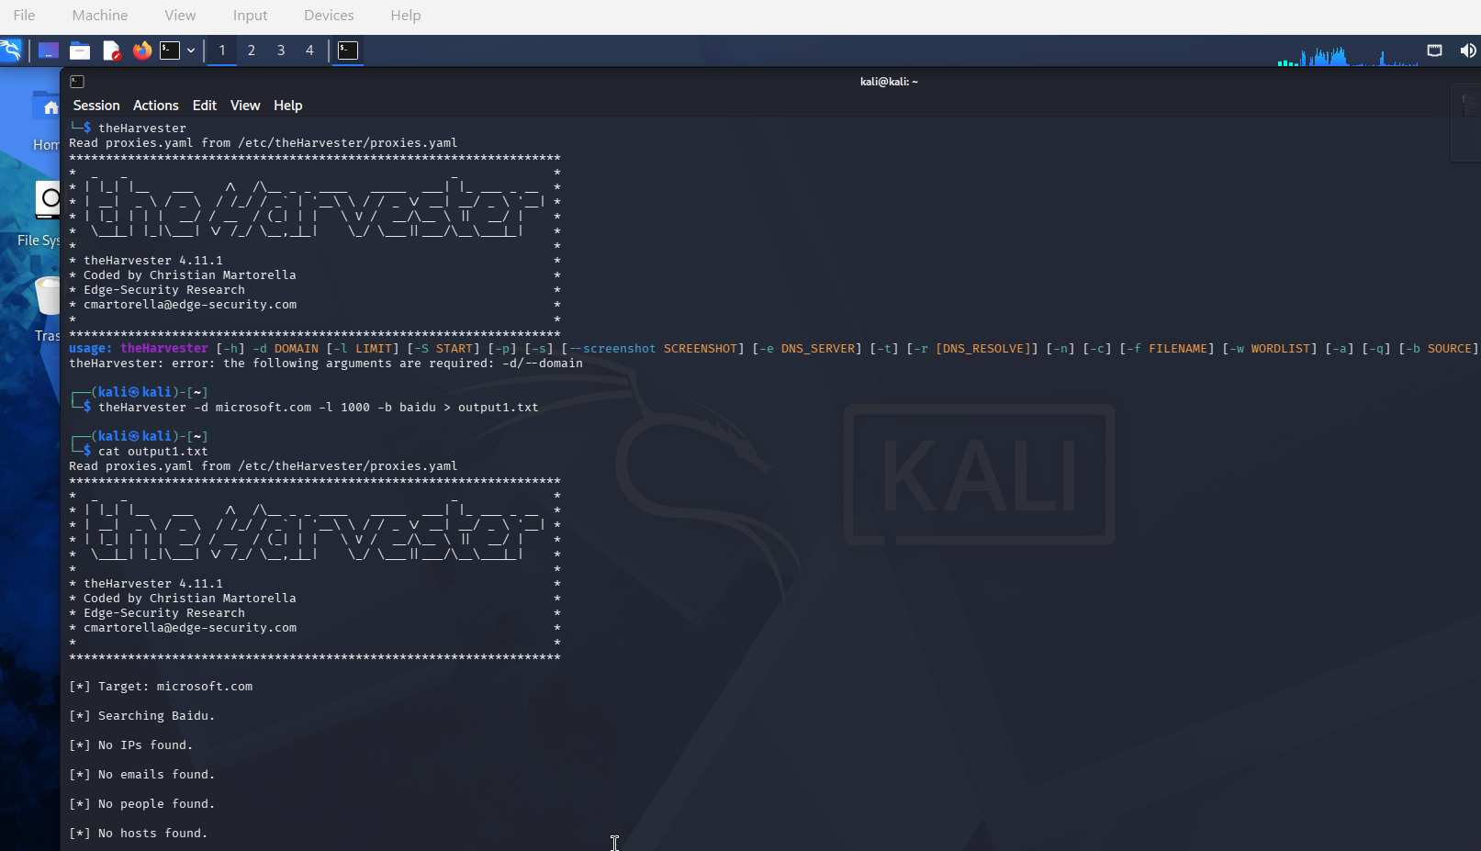

- all-sources-scan.png – theHarvester all-sources scan, limit 50.

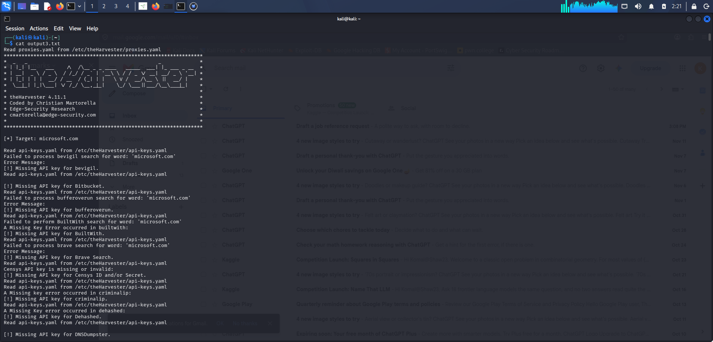

- ifconfig.png – local network interface configuration.

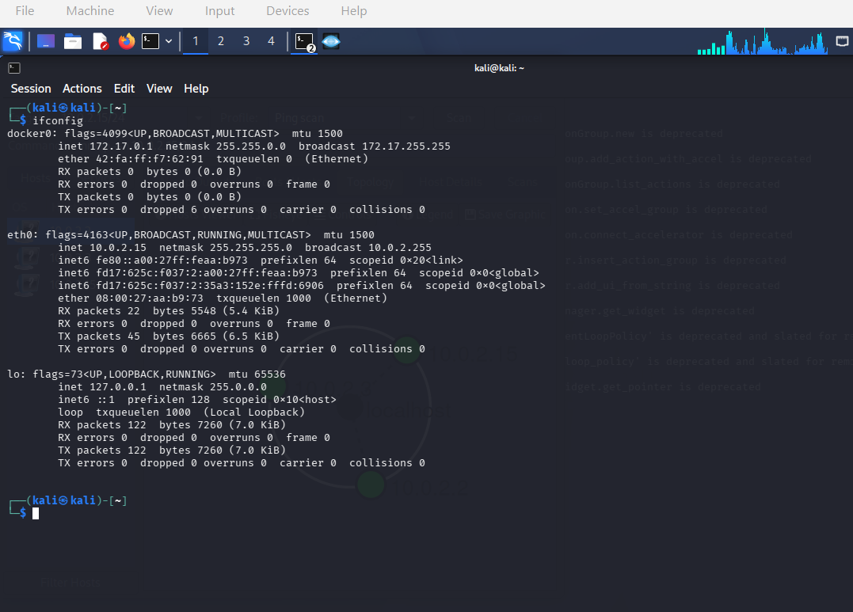

- network-scan.png – Nmap host discovery output.

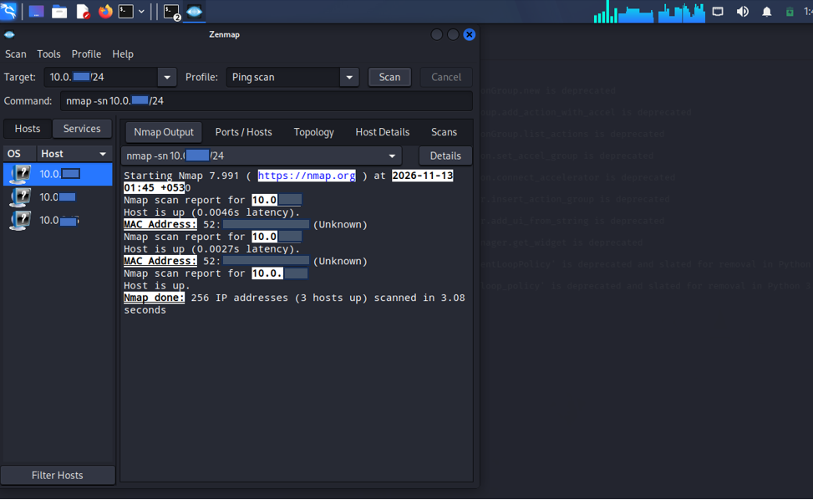

- zenmap-results.png – Zenmap scan results or topology, if available.

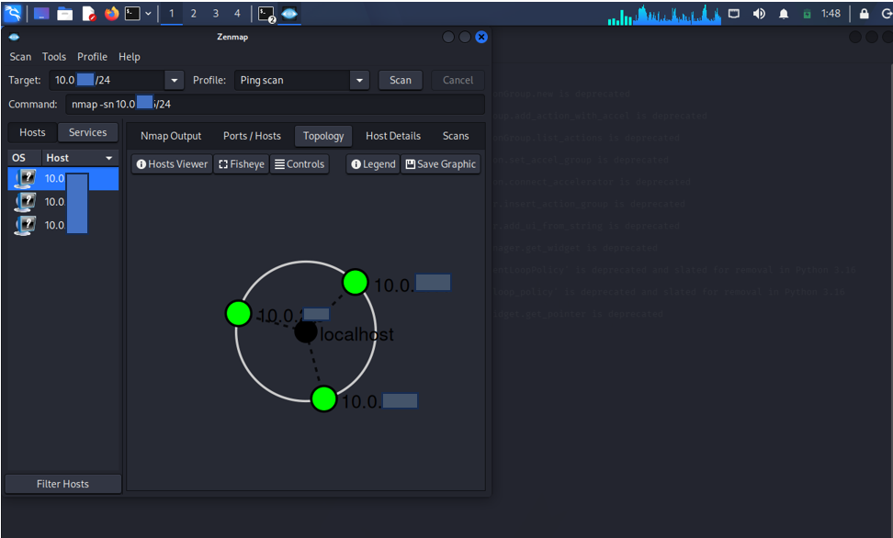

9. References
- theHarvester documentation and help output available for the installed Kali Linux version.
- Nmap Reference Guide: https://nmap.org/book/man.html
- Zenmap documentation: https://nmap.org/book/zenmap.html
- Kali Linux documentation: https://www.kali.org/docs/

