**Design Thinking**

**What is Design Thinking?**

Design thinking is a non-linear, iterative process that teams use to understand users, challenge assumptions, redefine problems and create innovative solutions to prototype and test. Involving five phases—Empathize, Define, Ideate, Prototype and Test—it is most useful to tackle problems that are ill-defined or unknown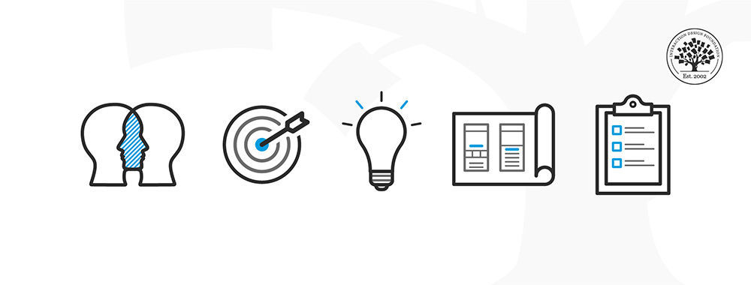

## **Why Is Design Thinking so Important?**

In [user experience (UX) design](https://www.interaction-design.org/literature/topics/ux-design), it’s crucial to develop and refine skills to understand and address rapid changes in users’ environments and behaviors. The world has become increasingly interconnected and complex since cognitive scientist and Nobel Prize laureate Herbert A. Simon first mentioned design thinking in his 1969 book, The Sciences of the Artificial, and then contributed many ideas to its principles.

**Design teams use design thinking to tackle ill-defined/unknown problems (aka**[**wicked problems**](https://www.interaction-design.org/literature/topics/wicked-problems)**) because they can reframe these in *human-centric* ways and focus on what’s most important for users**.

Design thinking’s value as a world-improving, driving force in business (global heavyweights such as Google, Apple and Airbnb have wielded it to notable effect) matches its status as a popular subject at leading international universities.

**The Five Stages of Design Thinking**

1. **Stage 1:**[**Empathize**](https://www.interaction-design.org/literature/topics/empathize)**—*Research Your Users' Needs***

Here, you should gain an empathetic understanding of the problem you’re trying to solve, typically through user research. Empathy is crucial to a human-centered design process such as design thinking because it allows you to set aside your own assumptions about the world and gain real insight into users and their needs.

1. **Stage 2: Define—*State Your Users' Needs and Problems***

It’s time to accumulate the information gathered during the Empathize stage. You then analyze your observations and synthesize them to define the core problems you and your team have identified. These definitions are called [problem statements](https://www.interaction-design.org/literature/topics/problem-statements). You can create [personas](https://www.interaction-design.org/literature/topics/user-personas) to help keep your efforts human-centered before proceeding to [ideation](https://www.interaction-design.org/literature/topics/ideation).

**Stage 3: Ideate—*Challenge Assumptions and Create Ideas***

Now, you’re ready to generate ideas. The solid background of knowledge from the first two phases means you can start to “think outside the box”, look for alternative ways to view the problem and identify innovative solutions to the problem statement you’ve created. [Brainstorming](https://www.interaction-design.org/literature/topics/brainstorming) is particularly useful here..

**Stage 4: Prototype—*Start to Create Solutions***

This is an experimental phase. The aim is to identify the best possible solution for each problem found. Your team should produce some inexpensive, scaled-down versions of the product (or specific features found within the product) to investigate the ideas you’ve generated. This could involve simply [paper prototyping](https://www.interaction-design.org/literature/topics/paper-prototyping).

**Stage 5: Test—*Try Your Solutions Out***

Evaluators rigorously test the prototypes. Although this is the final phase, design thinking is iterative: **Teams often use the results to *redefine*one or more further problems**. So, you can return to previous stages to make further iterations, alterations and refinements – to find or rule out alternative solutions.