Mortgage Trading Analysis Dashboard – Documentation

1. Requirement and Need of the Dashboard
The requirement for building this dashboard was to create a consolidated and interactive analytical view of mortgage loan trading data. Mortgage portfolios involve multiple dimensions such as loan volume, borrower credit quality, pricing behavior, geographic exposure, counterparty participation, and operational execution. Analyzing these dimensions through static reports is inefficient and limits insight discovery.
This dashboard was designed to support informed trade and portfolio decisions by enabling stakeholders to quickly assess portfolio health, identify risk concentration, monitor pricing consistency, and evaluate operational efficiency. The interactive nature of the dashboard allows users to filter and explore data dynamically, making it suitable for both executive-level review and detailed analytical investigation.

2. Data Description and Data Model
The dashboard integrates six datasets, each representing a specific aspect of the mortgage loan lifecycle:
1. Loan Data – Contains core loan attributes such as loan ID, closing date, state, AUS type, and median FICO score.
2. Loan Balances – Includes financial exposure metrics such as loan amount, current balance, amortization amount, and payment-related fields.
3. Loan Bids – Captures bid pricing information across different counterparties.
4. Loan Status – Tracks operational workflow and trade stages, including audit-related dates.
5. UMBS Prices – Represents external mortgage-backed securities benchmark pricing.
6. Target Profit – Stores benchmark or target profitability metrics.
Loan ID acts as the primary key linking loan-level datasets. The data model follows a star-like structure with multiple fact tables connected at the loan level. Per-loan aggregation measures were implemented to avoid double counting caused by multiple records per loan. Date fields enable time-series analysis, while categorical fields such as state, counterparty, AUS type, and trade status support segmentation. External benchmark tables were handled cautiously due to differences in data granularity.

3. Challenges Faced During Development
Several challenges were encountered while building the dashboard. Differences in data granularity across datasets led to incorrect aggregations when measures were not carefully designed. Double counting of loan amounts occurred due to multiple balance or status records per loan and required per-loan aggregation logic using DAX.
Geographic mapping presented challenges when state codes were misinterpreted by Azure Maps, which required conversion to full state names. Null values in audit-related date fields caused errors in duration calculations and had to be handled through filtering logic. Additionally, care was needed to avoid redundant visuals and ensure that each dashboard page contributed unique analytical value.

4. What the Dashboard Is About
The dashboard provides an end-to-end analytical view of mortgage loan trading and portfolio performance. It connects loan origination activity, pricing trends, borrower credit quality, geographic concentration, and operational execution into a cohesive narrative.
Page 1 focuses on executive-level insights such as total loans, outstanding balance, pricing trends, credit quality, and trade status distribution. Page 2 explores geographic concentration and exposure, highlighting regional diversification risks and counterparty dominance. Page 3 provides diagnostic insights into pricing behavior, FICO-based risk segmentation, balance concentration, and audit execution efficiency.

5. Outcomes and Key Learnings
The final outcome of this exercise is a multi-page, interactive Power BI dashboard that enables comprehensive mortgage portfolio analysis. The dashboard successfully integrates multiple datasets into a single analytical framework and provides actionable insights for decision-making.
Key learnings from this exercise include the importance of robust data modeling, correct measure design, and understanding data granularity. The project reinforced that meaningful insights depend not only on visualization design but also on accurate aggregation logic and narrative clarity. Additionally, the exercise demonstrated how combining financial, geographic, and operational metrics can significantly enhance portfolio oversight.

Glossary
- Amortization: The gradual repayment of a loan over time through scheduled payments of principal and interest.
- FICO Score: A credit score that represents a borrower’s creditworthiness based on credit history.
- Audit: An operational process used to verify loan documentation and compliance before trade completion.
- AUS Type: Automated Underwriting System used to assess loan eligibility, such as DU or LP.
- Counterparty: A financial institution or entity involved in bidding or trading mortgage loans.
- Trade Status: The stage of a loan within the trading and settlement lifecycle.
- UMBS: Uniform Mortgage-Backed Securities, a standardized mortgage-backed security benchmark.

Dashboard Screenshots and Explanations

Page 1: Mortgage Trading Analysis Dashboard
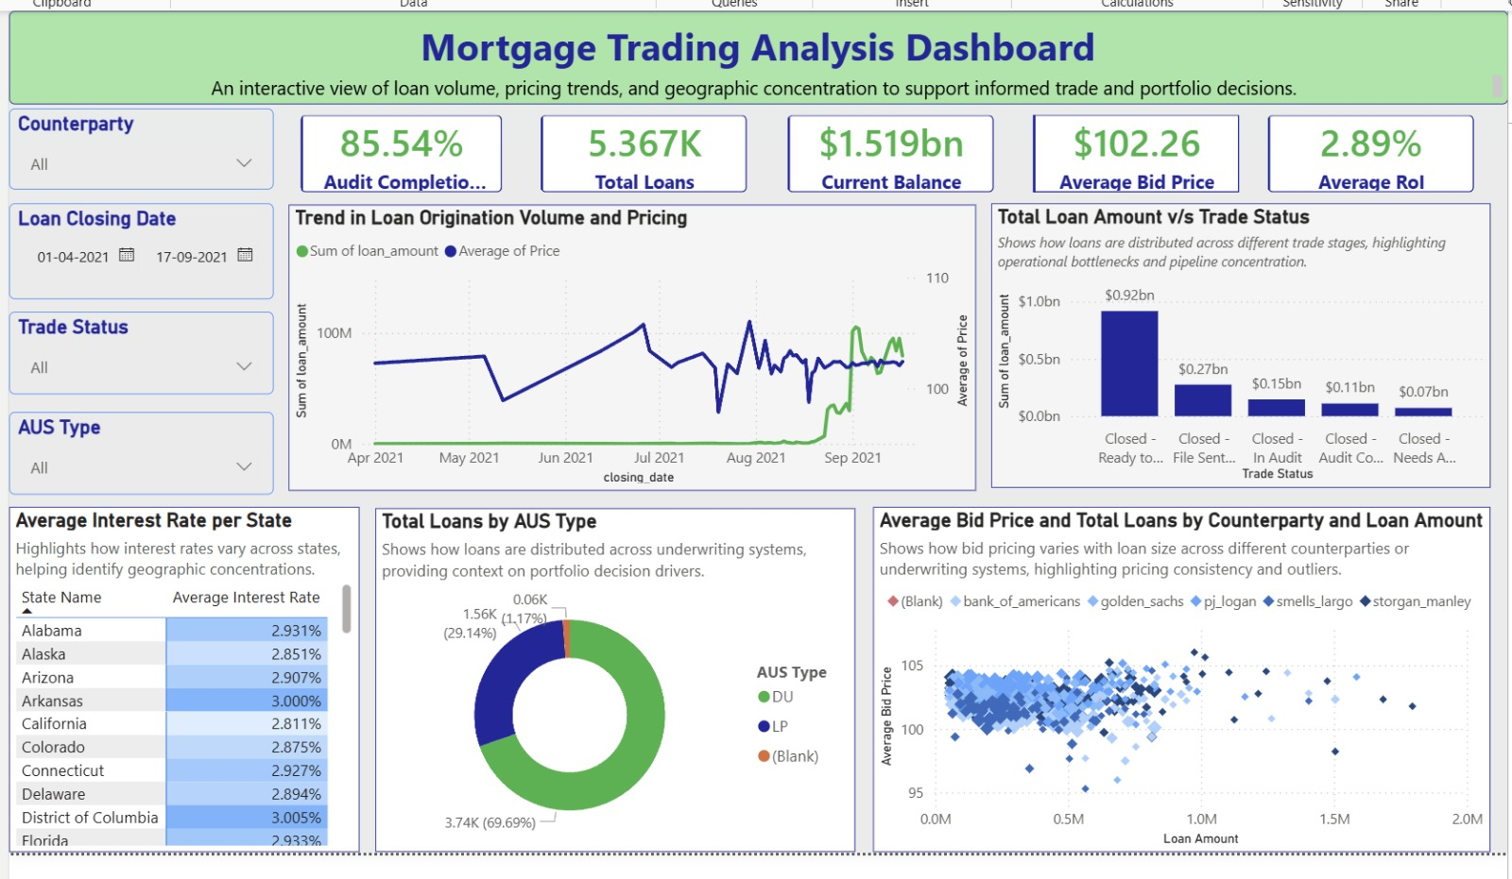

Page 1: Mortgage Trading Analysis Dashboard
Page 1 functions as the strategic executive overview of the mortgage trading portfolio. Its primary objective is to provide decision-makers with a holistic, at-a-glance understanding of portfolio scale, pricing behavior, credit composition, and operational readiness before deeper analysis.
The KPI section summarizes critical portfolio indicators, including total loan count, outstanding balance, average bid price, return metrics, and audit completion rate. Together, these KPIs establish a baseline assessment of portfolio health and execution maturity.
The combined time-series visualization of loan origination volume and pricing enables users to evaluate how market activity and bid pricing evolved simultaneously over time. This allows stakeholders to detect periods where pricing diverged from volume trends, which may indicate shifts in market conditions or risk appetite.
The trade status distribution highlights how loan exposure is positioned across the trading lifecycle, revealing potential pipeline concentration and signaling stages where operational delays or bottlenecks may occur.
Credit and underwriting composition is examined through the AUS Type distribution, while geographic pricing variation is introduced via the average interest rate by state view. Finally, the loan amount versus bid price scatter plot by counterparty evaluates pricing consistency and identifies potential outliers, supporting counterparty performance assessment.
Overall, Page 1 establishes the strategic context for the dashboard by answering what the portfolio looks like today and where attention may be required.

Page 2: Geographic Distribution of Loan Originations
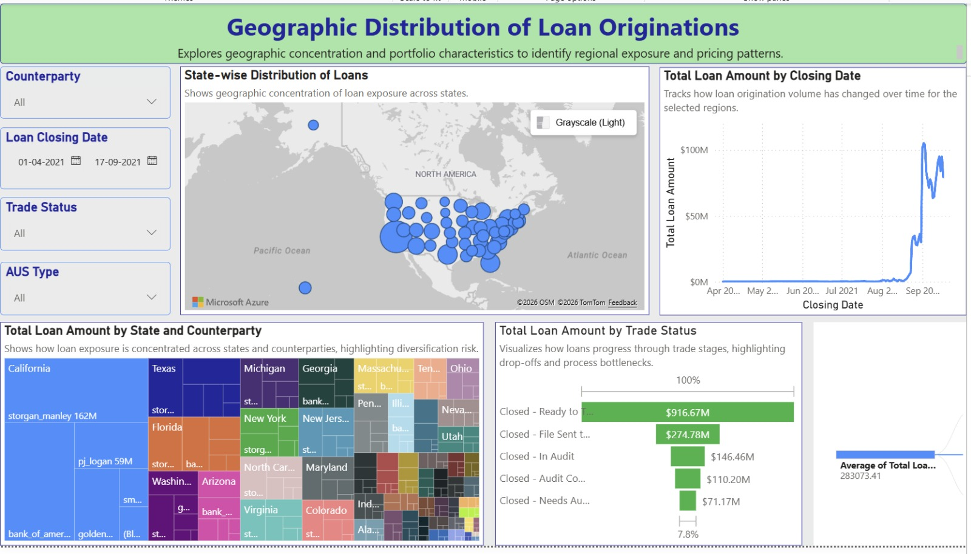

Page 2: Geographic Distribution of Loan Originations
Page 2 focuses on spatial risk and exposure analysis, addressing the question of where loan origination and exposure are concentrated and how this concentration interacts with counterparties and operational flow.
The state-wise geographic map visually represents loan concentration across the United States, allowing immediate identification of regions with disproportionately high origination volumes. This view is critical for understanding geographic diversification risk and regional dependency.
The time-series analysis of total loan amount by closing date complements the map by showing how origination activity has evolved over time within selected regions. This enables stakeholders to assess whether growth patterns are geographically driven or broadly distributed.
The state and counterparty treemap provides a deeper concentration analysis by layering counterparties within each state. This visualization highlights scenarios where geographic exposure is further amplified by reliance on a small number of counterparties, increasing portfolio risk.
The trade status funnel links geographic exposure to operational execution, showing how loan value progresses through trade stages and where value accumulates or drops off. This helps determine whether regions with high exposure are also experiencing execution inefficiencies.
By integrating geography, exposure, counterparty concentration, and execution flow, Page 2 provides a structural understanding of regional risk and diversification, supporting informed geographic and counterparty strategy decisions.

Page 3: Pricing, Profitability & Execution Analysis
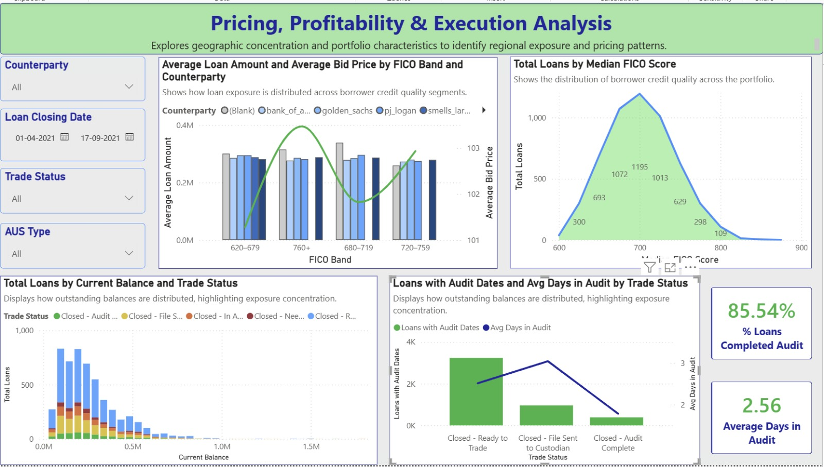

Page 3: Pricing, Profitability & Execution Analysis
Page 3 delivers diagnostic and causal analysis, connecting borrower credit quality, pricing behavior, outstanding exposure, and operational efficiency to explain why observed portfolio patterns exist.
The FICO-based analysis serves as the foundation of this page. The distribution of loans by median FICO score reveals the overall credit quality profile of the portfolio, indicating whether exposure is skewed toward prime or near-prime borrowers. This establishes the portfolio’s inherent credit risk baseline.
The Average Loan Amount and Average Bid Price by FICO Band and Counterparty visualization examines how pricing and exposure vary across borrower risk segments. It evaluates whether higher-credit-quality borrowers receive more favorable pricing and whether counterparties apply consistent risk-based pricing strategies.
Outstanding exposure is further analyzed through the current balance distribution by trade status, highlighting where large balances remain within the trading pipeline and signaling potential liquidity or settlement risk.
Operational efficiency is assessed through the audit execution analysis, which combines the number of loans with valid audit dates and the average time spent in audit by trade status. This allows stakeholders to identify stages where delays are most impactful and to quantify execution performance.
The supporting KPIs for audit completion rate and average days in audit provide concise operational benchmarks, enabling quick performance assessment.
Collectively, Page 3 moves beyond descriptive reporting to deliver explanatory insight, linking credit risk, pricing behavior, exposure concentration, and execution efficiency into a unified analytical framework.

