1.Write a java program to demonstrate use of predefined package(java.util)
Sol:-
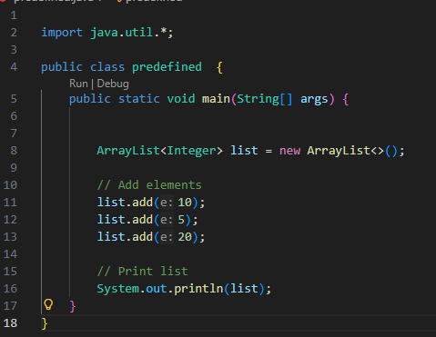

Output:-

2.Write a program to create and use a user defined package.
Sol:- User.java file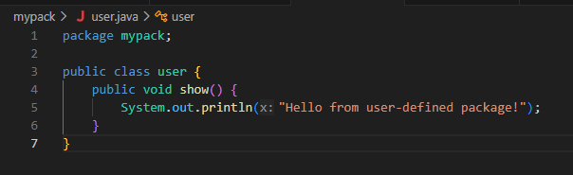

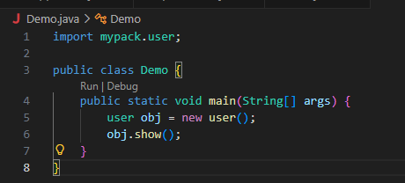

OUTPUT:-

