**SCREENSHOTS**

1. Caching thehindu.com

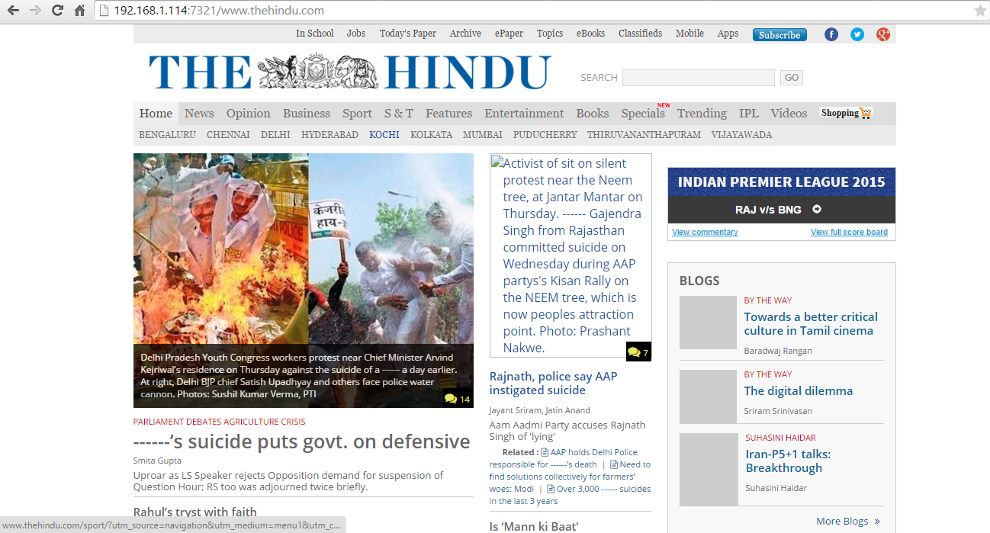

1. Response in the server program.

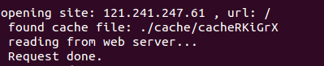

1. Retreiving cached content from server.



1. Response in the server.

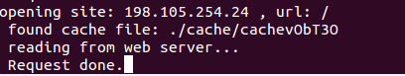

1. Blocking www.facebook.com

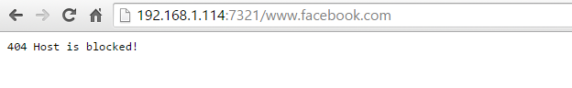

1. Response in the server when site block

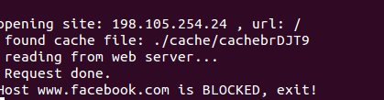

1. Server blocking youtube.com

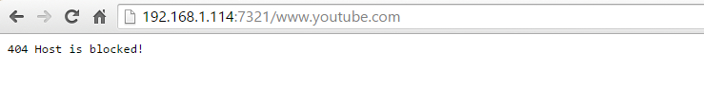

1. Response in the server

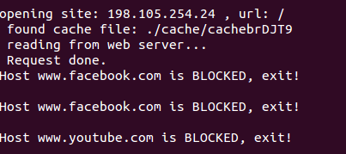

1. Blocking bad words.

