Instruction

1. Clone the repository or open in editor.
2. Create a database in your local database server and map it with the project.
3. In order to map with database update **connectionstring**  in web.config file.
4. Add a table in database as shown in image.  
   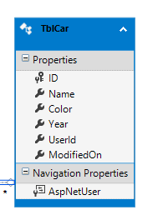
5. Run the project.
6. Open the postman:
7. Enter the <https://localhost:44301/api/Account/Register>  
   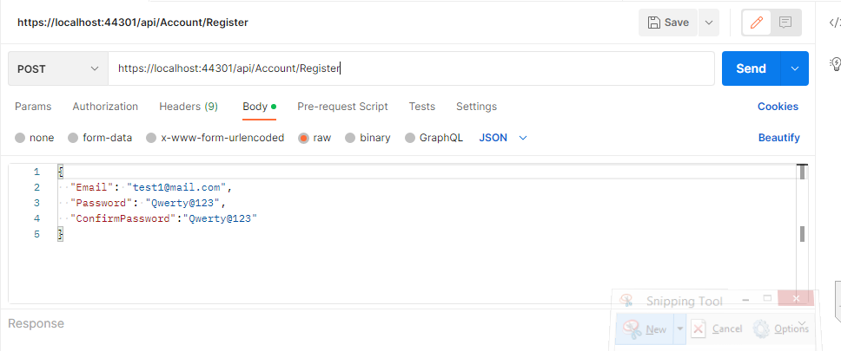
8. Once register the user, you can login by using the email and password.  
   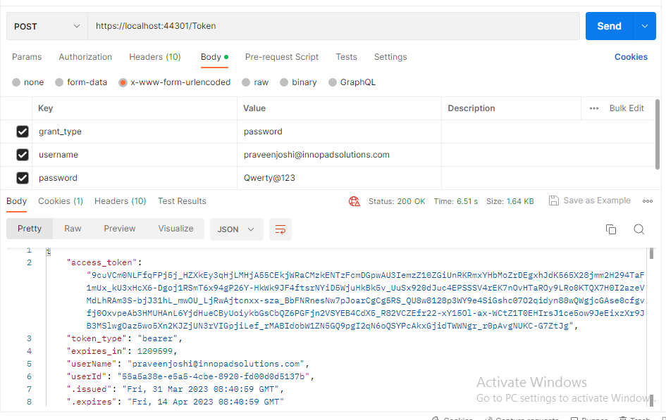
9. On successfully login it will return the access token.
10. The following endpoints can access by using this access_token. Add Bearer and token in authorization in header.  
    A. GET: {host}/api/cars/get : parameter can be passed in query as minYear:{date-format} & maxYear{date-fromat}  
      
    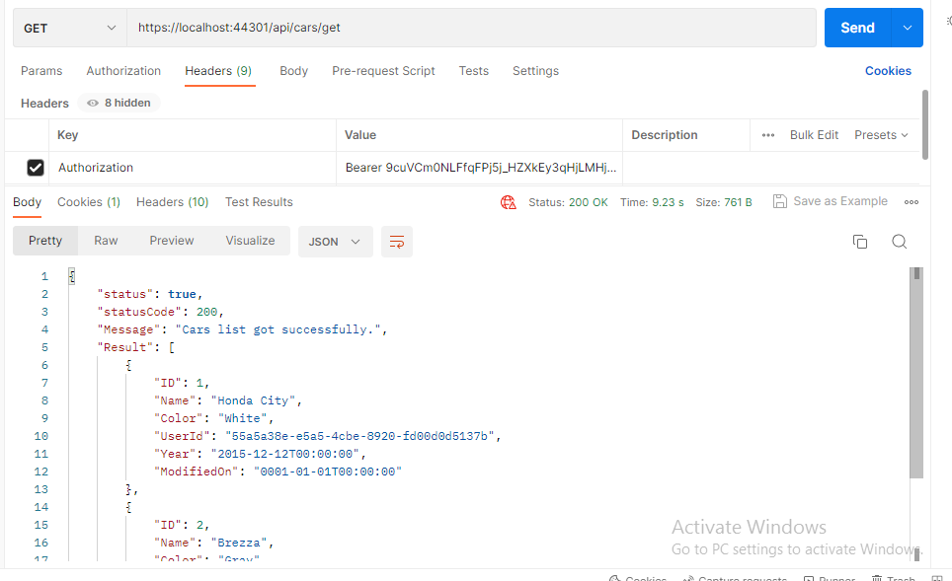

B. GET: {host}/api/cars/getcarbyId  
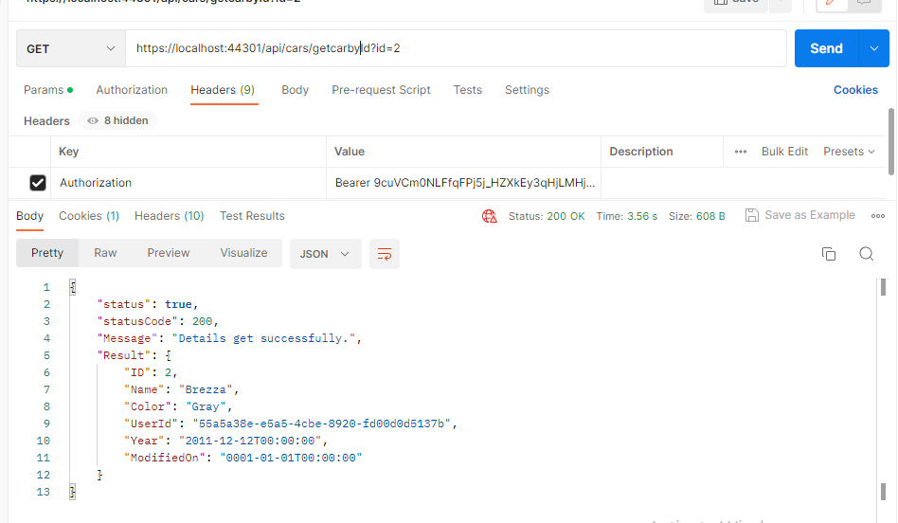  
  
  
C. POST: GET: {host}/api/cars/Addupdatecar  
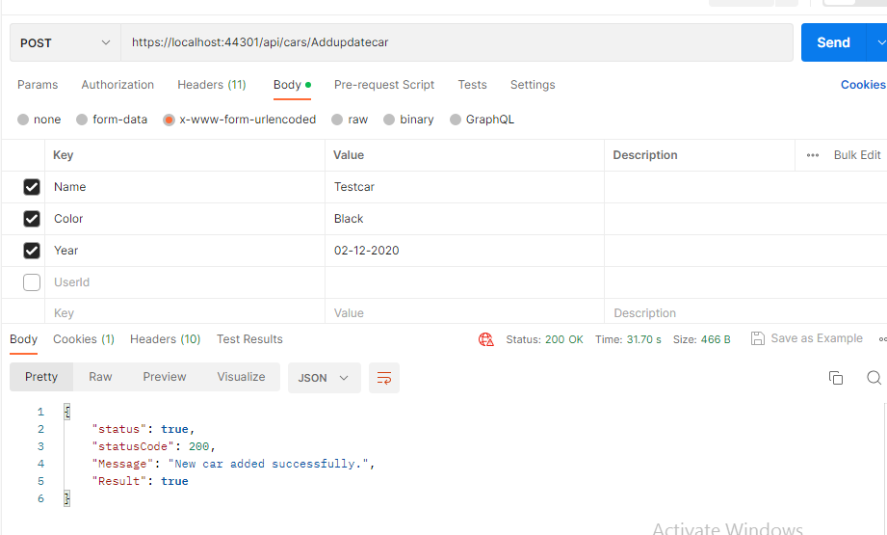  
That’s all..!