**CN Lab: Week 4**

**Static Routing and Application Layer Protocols**

Komal Mathur, CSE B2, 220905546

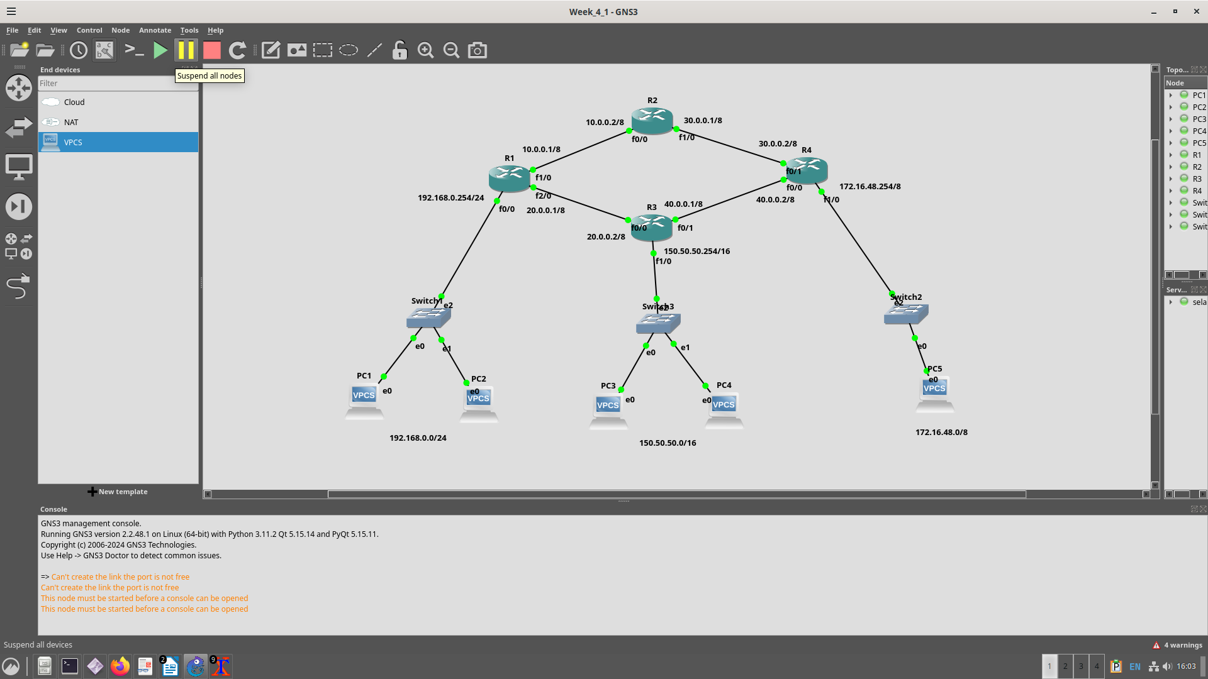**Static Routing**

**Important Points to consider:**

* To assign the IP addresses of internal interfaces of the router, assign a different network address to each connection.
* If both PCs in the same network ID, no need for routers since switch is enough to connect them
* Which configuring static routes, you have to assign routes both sides

**#Note:**

$ ip route <destination network address (dependant on subnet mask, ends with 0, generalization)> <destination network subnet mask> <next hop address>

**Router connections for pinging PC1 to PC5:**

**To destination connections**

**From destination connections**

**Pinging from PC1 -> PC5**

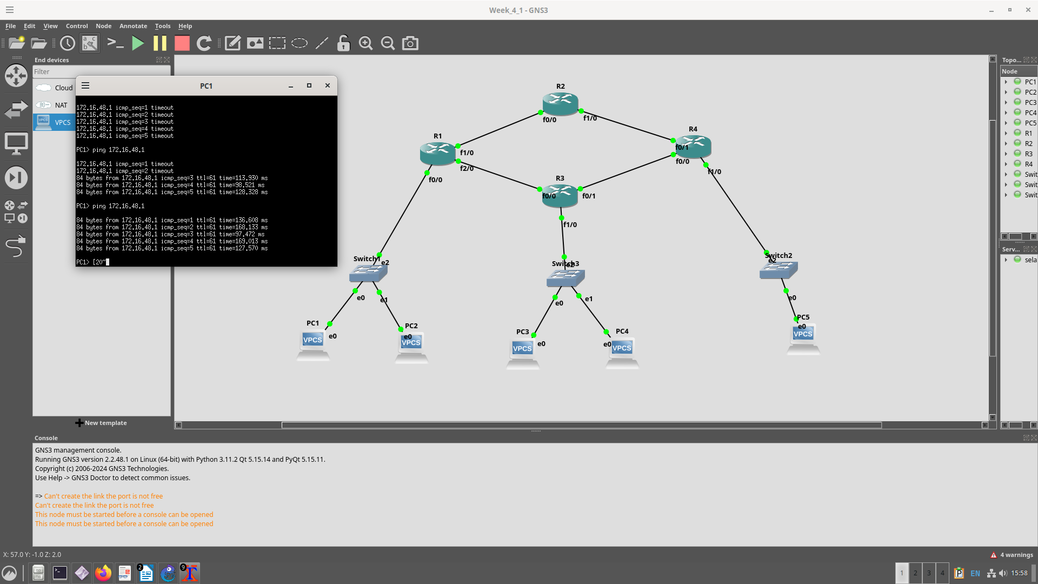

**Q1) mistake in diagram in second default gateway it should be 192.168.2.1**





a) yes

b) yes

c) no because no routing done

**Q2. Configure a web server within the network, create a simple web page, and ensure HTTP access from PCs located in a different LAN**

**Setting DNS Name Resolution Record**

**Access to HTML via domain name**

**Additional Exercise:**

**The PT network requires static routes to provide internet access to the internal LAN users through the ISPs. In addition, the ISP routers require static routes to reach the internal LANs.**

**Set up Customer Server as a web server and DNS Server.**

