CN LAB-10
Disha Jain – 220905554 – B2

Example
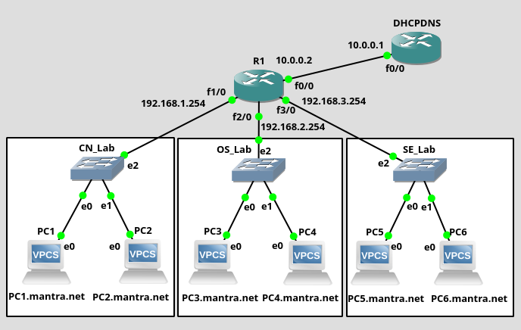
1) Configure each of the interfaces of R1
2) Configure DHCP Server
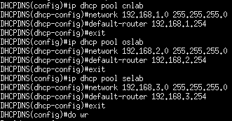

3) Get ip address for PC2
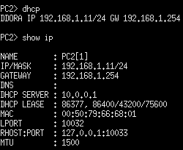

4) DHCP Relay agents

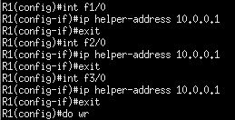

5) Configure DNS Server
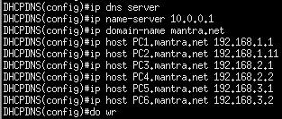

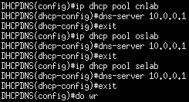

6) Get DNS Server for each of the PCs
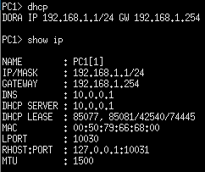

7) Test DNS Server
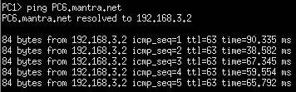

Q1)

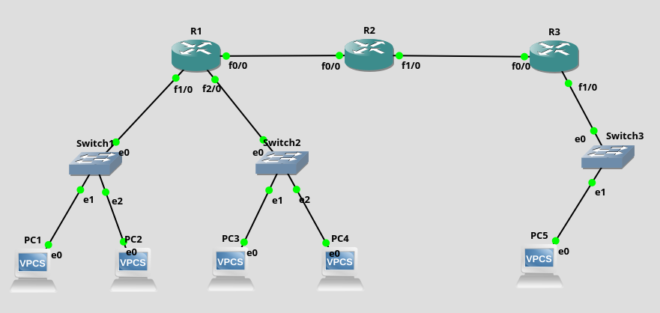

1) Configure each of the router interfaces
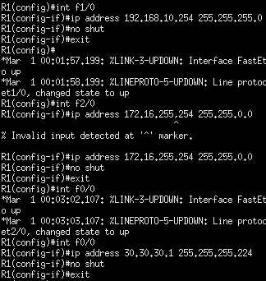

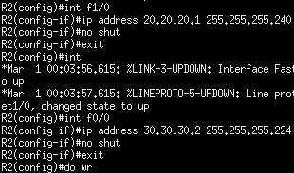

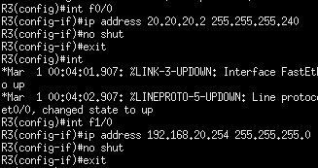

2) Configure rip for each of the routers

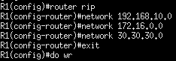

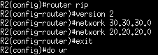

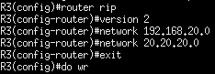

3) Configure DNS Server at R3
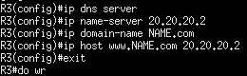

4) Statically assign ip to PC2 and test DNS
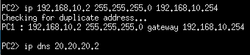

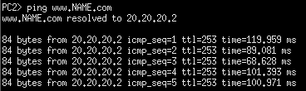

5) Configure DHCP Server at R3
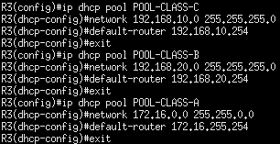

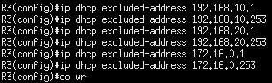

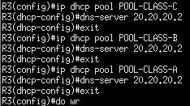

6) Assigning appropriate DHCP relay agent
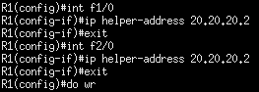

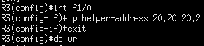

Note: R2 doesnt need helper address as it has no direct networks connected.

7) Assigning ip to PC1 and Testing DNS
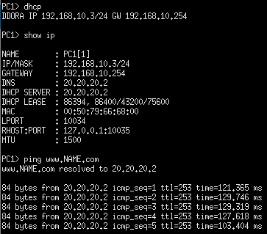

8) Capturing packets in Wireshark for PC4
