Week 6: Concurrent Socket Programming in TCP
Komal Mathur, CSE B2, 220905546

My notes
- the return value of the function call to fork() tells the process whether it is the parent or the child.

Sample Programs

1. Example : fork()
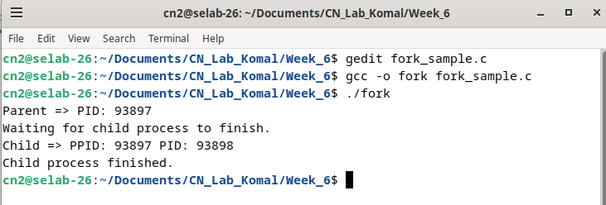
2. TCP Concurrent Server
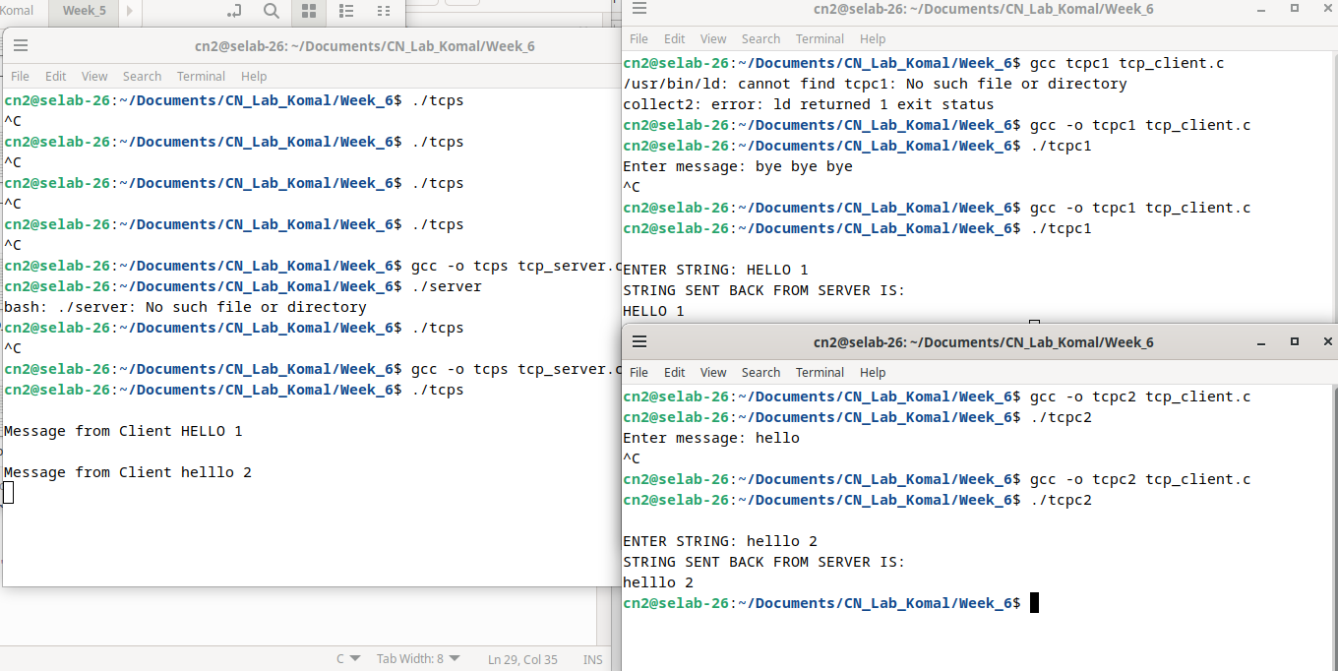

Lab Exercises:

1. Implement concurrent Remote Math Server To perform arithmetic operations in the server and display the result to the client. The client accepts two integers and an operator from the user and sends it to the server. The server then receives integers and operator. The server will perform the operation on integers and sends the result back to the client which is displayed on the client screen. Then both the processes terminate.

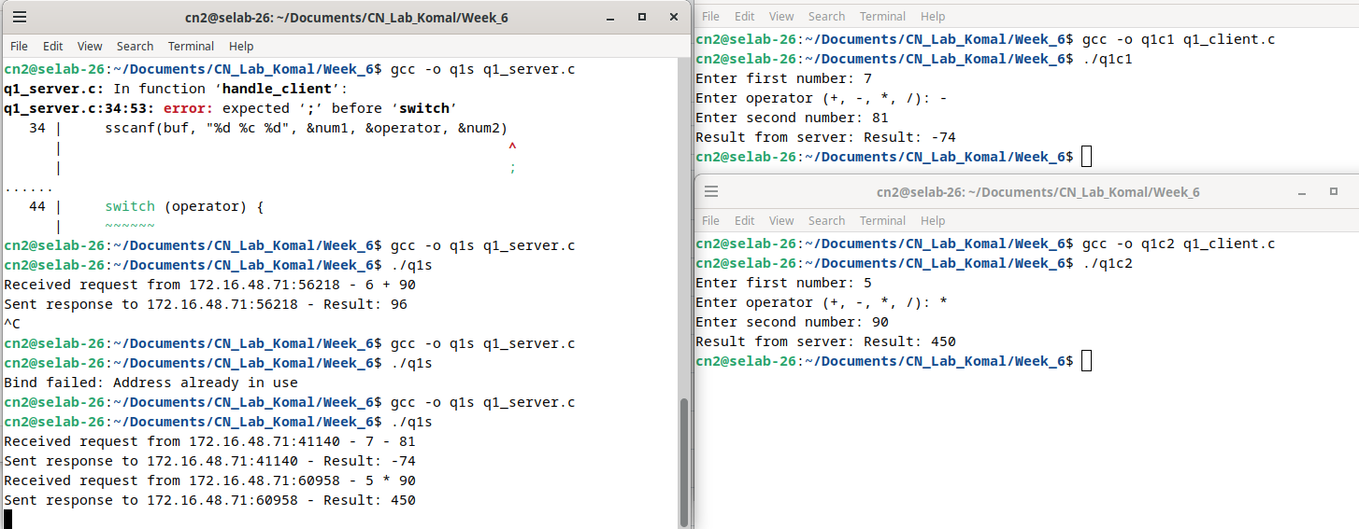
//TCP Server
#include<stdio.h>
#include<string.h>
#include<sys/types.h>
#include<sys/socket.h>
#include<netinet/in.h>
#include<unistd.h>
#include<arpa/inet.h>
#include<stdlib.h>
#define PORTNO 10205
int calculate(char*buf)
{
char op;
int num1,num2;
sscanf(buf,"%d %c %d",&num1,&op,&num2);
printf("%d\n",num1);
printf("%d\n",num2);
int sol;
switch (op)
{
case '+': sol=num1+num2;
return sol;
case '-': sol=num1-num2;
return sol;
case '*': sol=num1*num2;
return sol;
case '/': sol=num1/num2;
return sol;
case '%': sol=num1%num2;
return sol;
}
}
int main()
{
int sockfd,newsockfd,portno,clilen,n=1;char buf[256];
struct sockaddr_in seraddr,cliaddr;
int i,value;
sockfd = socket(AF_INET,SOCK_STREAM,0);
seraddr.sin_family = AF_INET;
seraddr.sin_addr.s_addr = inet_addr("172.16.48.71");
seraddr.sin_port = htons(PORTNO);
bind(sockfd,(struct sockaddr *)&seraddr,sizeof(seraddr));
// Create a connection queue, ignore child exit details, and wait for clients
listen(sockfd,5);
printf("Server waiting...\n");
while(1){
//Accept the connection
clilen = sizeof(clilen);
newsockfd=accept(sockfd,(struct sockaddr *)&cliaddr,&clilen);
//Fork to create a process for this client and perform a test to see whether
//you’re the parent or the child:
if(fork()==0){
// If you’re the child, you can now read/write to the client on newsockfd.
n = read(newsockfd,buf,sizeof(buf));
printf(" \nQuestion from Client %s \n",buf);
int solution = calculate(buf);
printf("Solution: %d \n",solution);
sprintf(buf,"%d",solution);
n = write(newsockfd,buf,sizeof(buf));
close(newsockfd);
exit(0);
}
//Otherwise, you must be the parent and your work for this client is finished
else
close(newsockfd);
}
}

//TCP Client
#include<sys/types.h>
#include<sys/socket.h>
#include<stdio.h>
#include<netinet/in.h>
#include<arpa/inet.h>
#include<stdlib.h>
#include<unistd.h>
#include<string.h>
int main()
{
int len,result,sockfd,n=1;
struct sockaddr_in address;
char ch[256],buf[256];
//Create a socket for the client
sockfd = socket(AF_INET, SOCK_STREAM, 0);
//Name the socket as agreed with the server
address.sin_family=AF_INET;
address.sin_addr.s_addr=inet_addr("172.16.48.71");
address.sin_port=htons(10205);
len = sizeof(address);
//Connect your socket to the server’s socket
result=connect(sockfd,(struct sockaddr *)&address,len);
if(result==-1)
{
perror("\nCLIENT ERROR");
exit(1);
}
//You can now read and write via sockfd (Logic for problem mentioned here)
printf("\nEquation: ");
scanf("%[^\n]s",ch);
write(sockfd,ch,strlen(ch));
printf("SOLUTION SENT BACK FROM SERVER IS ... ");
//while(n){
n=read(sockfd,buf,sizeof(buf));
printf("%s\n",buf);
//} //lab manual has this loop but then you have to do forceful termination, my code works fine without the loop as well
return 0;
}

2. Write a concurrent TCP client server ‘C’ program where the client accepts a sentence from the user and sends it to the server. The server will check for duplicate words in the string. Server will find the number of occurrences of duplicate words present and remove the duplicate words by retaining single
occurrence of the word and send the resultant sentence to the client.
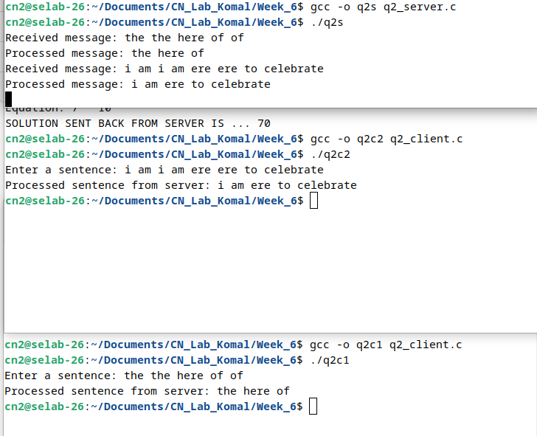
// TCP Server Code
#include <stdio.h>
#include <string.h>
#include <sys/types.h>
#include <sys/socket.h>
#include <netinet/in.h>
#include <arpa/inet.h>
#include <stdlib.h>
#include <unistd.h>
#include <ctype.h>

#define PORTNO 10205
#define BUF_SIZE 1024

void remove_duplicates(char *sentence) {
char *words[100];
int word_count = 0;
char temp[BUF_SIZE];
char *token;

// Tokenize the input sentence
strcpy(temp, sentence);
token = strtok(temp, " ");
while (token != NULL) {
words[word_count++] = strdup(token);
token = strtok(NULL, " ");
}

// Remove duplicates
for (int i = 0; i < word_count; i++) {
for (int j = i + 1; j < word_count; j++) {
if (strcmp(words[i], words[j]) == 0) {
free(words[j]);
for (int k = j; k < word_count - 1; k++) {
words[k] = words[k + 1];
}
word_count--;
j--;
}
}
}

// Reconstruct the sentence
sentence[0] = '\0';
for (int i = 0; i < word_count; i++) {
strcat(sentence, words[i]);
strcat(sentence, " ");
free(words[i]);
}
sentence[strlen(sentence) - 1] = '\0'; // Remove the trailing space
}

void handle_client(int newsockfd) {
char buf[BUF_SIZE];
int n;

// Read the message from the client
n = read(newsockfd, buf, sizeof(buf) - 1);
if (n < 0) {
perror("Read failed");
close(newsockfd);
exit(1);
}
buf[n] = '\0'; // Null-terminate the buffer

printf("Received message: %s\n", buf);

// Remove duplicate words
remove_duplicates(buf);

printf("Processed message: %s\n", buf);

// Send the result back to the client
n = write(newsockfd, buf, strlen(buf));
if (n < 0) {
perror("Write failed");
close(newsockfd);
exit(1);
}

close(newsockfd);
}

int main() {
int sockfd, newsockfd, clilen;
struct sockaddr_in seraddr, cliaddr;
pid_t pid;

// Create a socket for the server
sockfd = socket(AF_INET, SOCK_STREAM, 0);
if (sockfd < 0) {
perror("Socket creation failed");
exit(1);
}

// Set up server address
seraddr.sin_family = AF_INET;
seraddr.sin_addr.s_addr = INADDR_ANY; // Bind to any interface
seraddr.sin_port = htons(PORTNO);
if (bind(sockfd, (struct sockaddr *)&seraddr, sizeof(seraddr)) < 0) {
perror("Bind failed");
close(sockfd);
exit(1);
}

// Listen for incoming connections
listen(sockfd, 5);

while (1) {
// Accept a connection
clilen = sizeof(cliaddr);
newsockfd = accept(sockfd, (struct sockaddr *)&cliaddr, &clilen);
if (newsockfd < 0) {
perror("Accept failed");
close(sockfd);
exit(1);
}

// Fork to handle the client
pid = fork();
if (pid < 0) {
perror("Fork failed");
close(newsockfd);
close(sockfd);
exit(1);
}

if (pid == 0) { // Child process
close(sockfd); // Close the listening socket in the child
handle_client(newsockfd);
exit(0);
} else { // Parent process
close(newsockfd); // Close the connected socket in the parent
}
}

close(sockfd);
return 0;
}

// TCP Client Code
#include <stdio.h>
#include <string.h>
#include <sys/types.h>
#include <sys/socket.h>
#include <netinet/in.h>
#include <arpa/inet.h>
#include <stdlib.h>
#include <unistd.h>

#define PORTNO 10205
#define BUF_SIZE 1024

int main() {
int sockfd;
struct sockaddr_in servaddr;
char buf[BUF_SIZE];

// Create a socket for the client
sockfd = socket(AF_INET, SOCK_STREAM, 0);
if (sockfd < 0) {
perror("Socket creation failed");
exit(1);
}

// Set up server address
servaddr.sin_family = AF_INET;
servaddr.sin_addr.s_addr = inet_addr("127.0.0.1"); // Change to server IP if needed
servaddr.sin_port = htons(PORTNO);

// Connect to the server
if (connect(sockfd, (struct sockaddr *)&servaddr, sizeof(servaddr)) < 0) {
perror("Connection failed");
close(sockfd);
exit(1);
}

// Get the input sentence from the user
printf("Enter a sentence: ");
fgets(buf, sizeof(buf), stdin);
buf[strcspn(buf, "\n")] = '\0'; // Remove the trailing newline character

// Send the sentence to the server
if (write(sockfd, buf, strlen(buf)) < 0) {
perror("Write failed");
close(sockfd);
exit(1);
}

// Receive the processed sentence from the server
int n = read(sockfd, buf, sizeof(buf) - 1);
if (n < 0) {
perror("Read failed");
close(sockfd);
exit(1);
}
buf[n] = '\0'; // Null-terminate the buffer

printf("Processed sentence from server: %s\n", buf);

close(sockfd);
return 0;
}

