Week 9: VLAN Configuration and InterVLAN Communication
Komal Mathur, CSE B2, 220905546

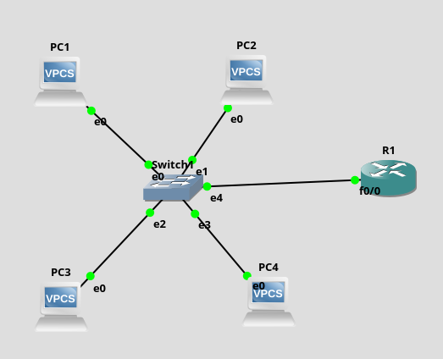
Intra VLAN Routing
In Router R1 to create 2 logical interfaces from a single interface:
int f0/0
no shut // no need for random ip address

int f0/0.1 // logical gateway name
encapulation dot1q 1 //trunk port
ip address <default gateway ip> <its mask>

int f0/0.2 // logical gateway name
encapulation dot1q 2
ip address <default gateway ip> <its mask>

#Note:
- To configure VLANs on switch, right click on switch and go to configure
- For the trunk port make type = dot1q. The rest should be access type
- Switch Virtual Interface (SVI) instructons only for cisco
- VLAN id of trunk port should always be native VLAN id ie. 1

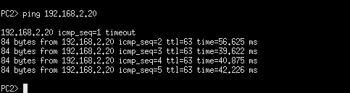
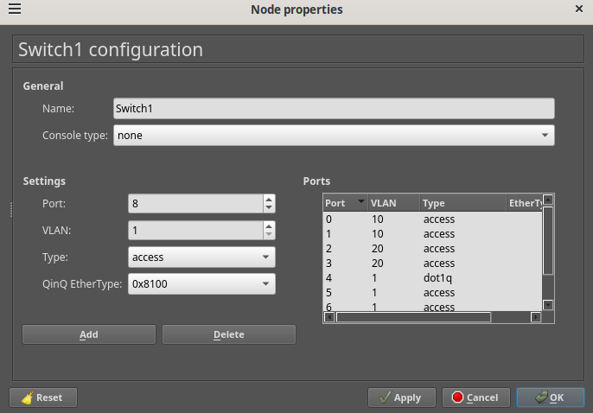
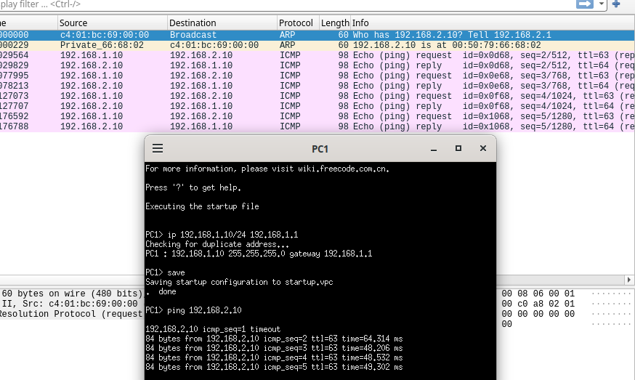

Additional Exercise:
You are a network administrator tasked with segmenting the network into VLANs for different
departments within a company. The topology diagram provided shows the network setup, which
includes two switches (Switch1 and Switch2) and four departments: Staff, Admin, HR, and
Accounting (Acct).
Create VLANs on Switch1 and Switch2 and Assign the appropriate ports to each VLAN based on the VLAN assignments. Test communication within the same VLAN. Test communication between different VLANs (will fail initially)
Provide inter-VLAN communication using Router-on-a-Stick between Acct, HR and Admin only.
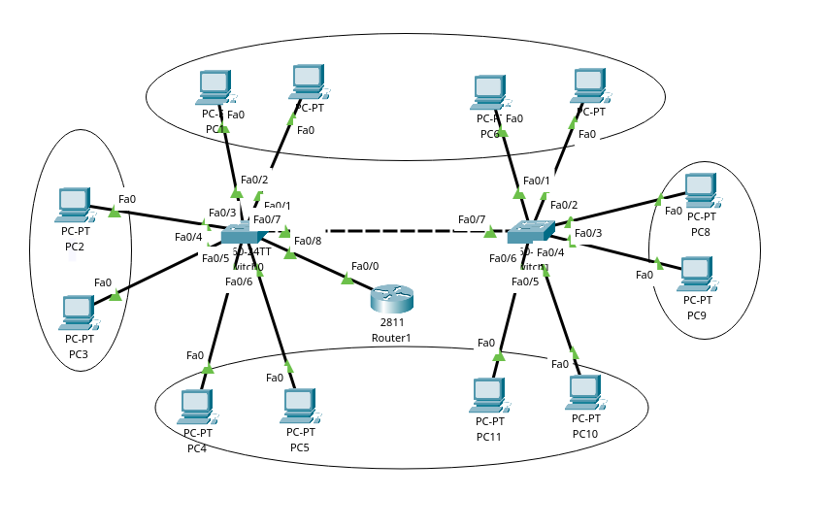
#Note:
- Connections on both switches
