CN Lab: Week 2
Komal Mathur, CSE B2, 220905546

GNS3 Network:
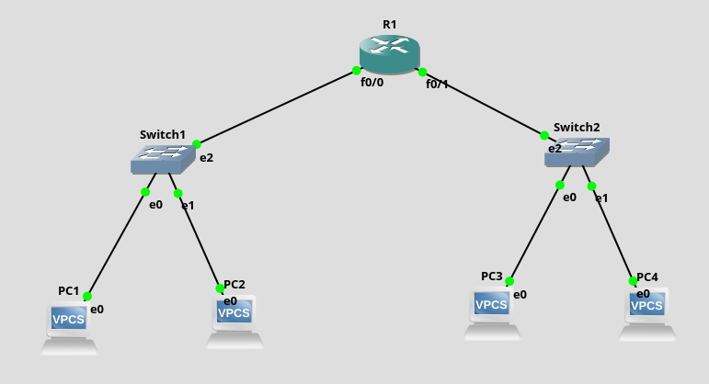

Default Gateway
This refers to the ip address of a router for a given interface/ connection, through which a SUBNET will communicate.

Configuration of VPCs
$ ip dns {ip address} {mask} {default gateway}
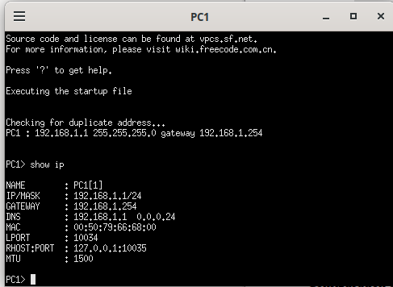

Configuration of Router

The steps to configure the router is:
1. Open the console of the router
2. Enable the router (only for cisco packet tracer)
3. Go to configuration mode
$ config t
4. Configure that interface of the router (get the ame by clicking on ‘abc widget’)
$ int f0/0
5. $ ip address 192.168.1.254 255.255.255.0
6. $ no shut (to make it permanent)
7. $ do wr (to save the configuration)
8. $ end
Now these steps must be repeated for each interface.

Note: The slash notation doesn’t work

Note: The VPCs connected to one side of the interface must have the similar ip address of that side router, else an error is thrown.

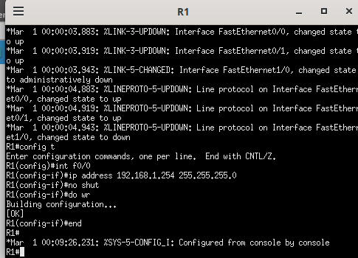
The below 2 commands give more router information (keep clicking enter to get)
$ show interfaces
$ show running-config

Installation of ISO Router images

The steps to be followed are
Edit > Preferences > Under Dynamips, click on IOS Routers > New > Browse >Open the download of the router image > Yes to decompress > 3 times next > In slot 1, take the first option > Click on Idle PC Finder > Finish > Apply > OK

Cisco Packet Tracer Network:

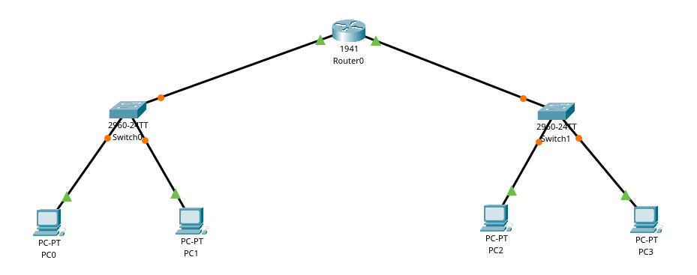
VPC Cofigurations
The steps to follwo to configure the Pcs are:
Click on PC > Desktop > ip configuration > follow commands as above + Also add default gateway

To ping another PC: Desktop > command prompt
Note: The count parameter doent work here. By default 4 packets are sent.

Router Configuration
Set up the interfaces in the config bar. Also, check the On button.

Pinging from PC1 to PC2
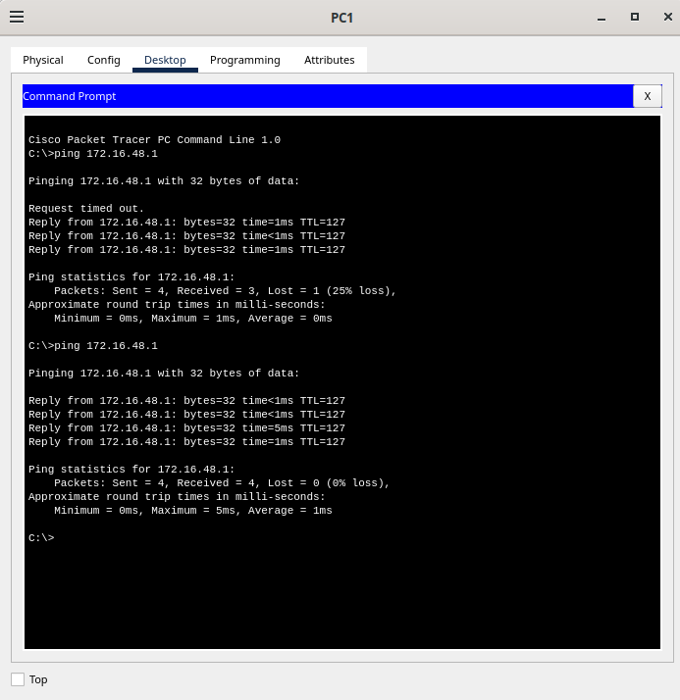

With the sniffer,

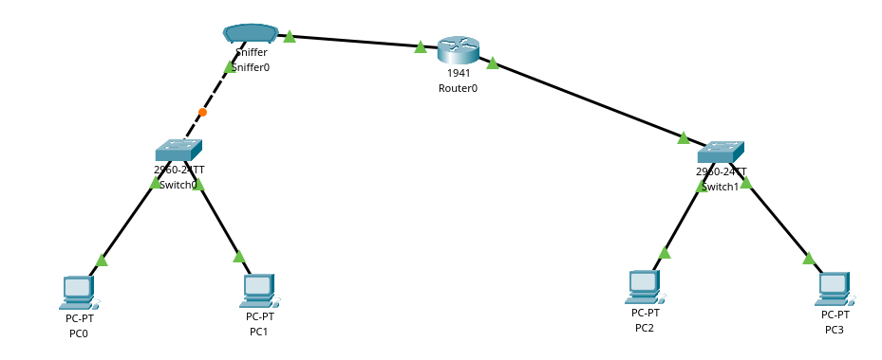

A packet from sniffer

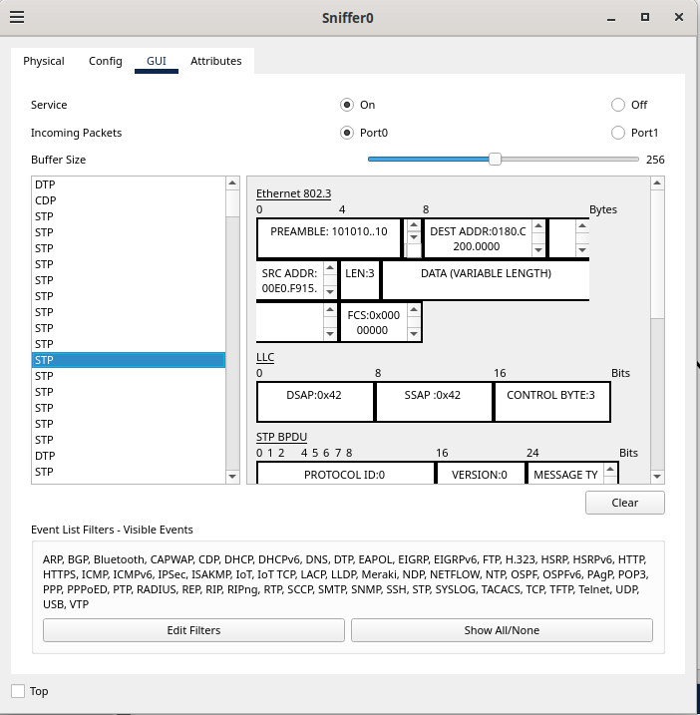

PROBLEM 2:
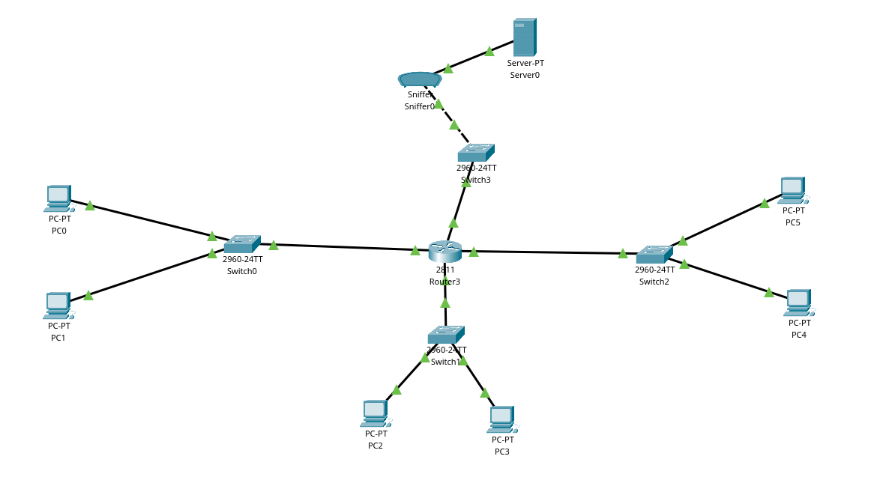
How to increase the number of slots in the router:

- In GNS3:
Go to Configure > Select 1st option for slot 2

- In Cisco Packet Tracer:
Click on router, and switvh it off physically. Then drag and drop the NM – 2FE2W option to the paly area. Finally switch the router on.

In GNS3:
