CN Lab: Week 3
Komal Mathur, CSE B2, 220905546

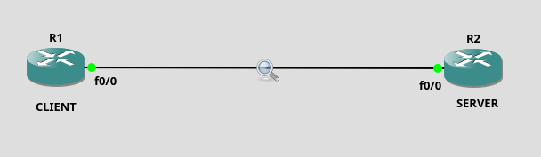

At SERVER end: (use router c3600)
config t
ip http server
ip http path flash:
ip http max-connections 5
ip http port 5001
ip http access-class 1
access-list 1 permit 192.168.12.0 0.0.0.255
username student privilege 15 password student
ip http authentication local
do copy running-config flash:startup-config
end

dir flash:
config t
int f0/0
ip address 192.168.12.2 255.255.255.0
no shut
do wr
end

