Week 8: Advanced IP Configuration Lab: Subnetting, Static Routing
Komal Mathur, CSE B2, 220905546

Q1. As a network Engineering, you are required to subnet the 192.168.1.0 network to provide IP addresses to the given network. Show all calculations. What is the Then configure all devices and ensure that PCs can ping each other.

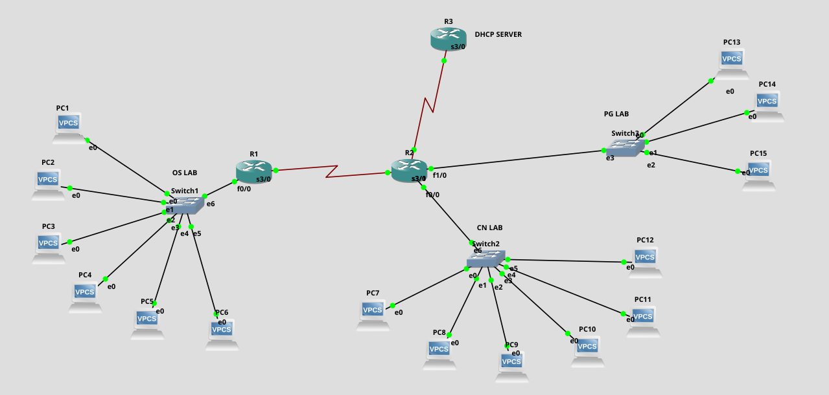
How to configure a DHCP Server
- We have 3 subnets ie. 3 POOLS of ip addresses
- The helper-address commands have to go to the switch side interfaces of each of the routers ie the gateway interfaces (it is the DHCP interface address)
- end takes you back fully. exit takes you back to config t
At router R3 (DHCP Server) which is connected to R2
config t
int f0/0
ip address 30.0.0.1 255.0.0.0
no shut
exit
ip dhcp pool oslab
network 192.168.1.0 255.255.255.240 // net address of oslab, net mask of os lab
default-router 192.168.1.14 // default gateway
ip dhcp pool cnlab
network 192.168.1.16 255.255.255.240
default-router 192.168.1.30
ip dhcp pool pglab
network 192.168.1.32 255.255.255.248
default-router 192.168.1.38

In each gateway interface of other routers, write this:
ip helper-address 30.0.0.1 // request forwarded to 30.0.0.1

