Week 10: Dynamic Routing with RIP and Router configuration with DHCP / DNS
Komal Mathur, CSE B2, 220905546
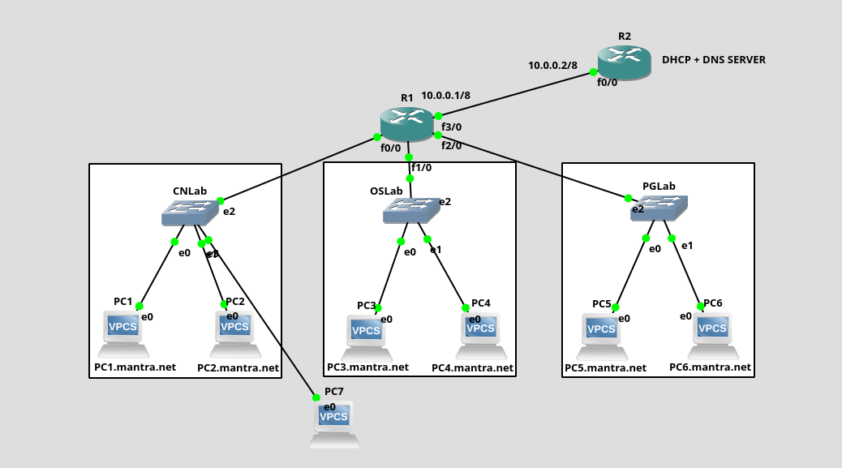
Commands at Router R2 for DHCP
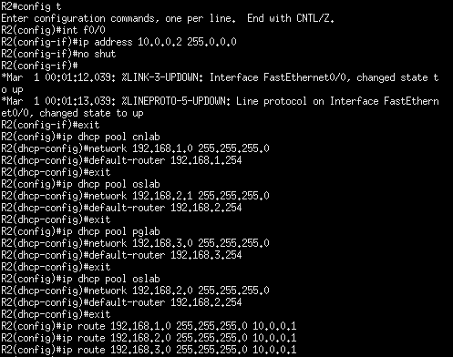

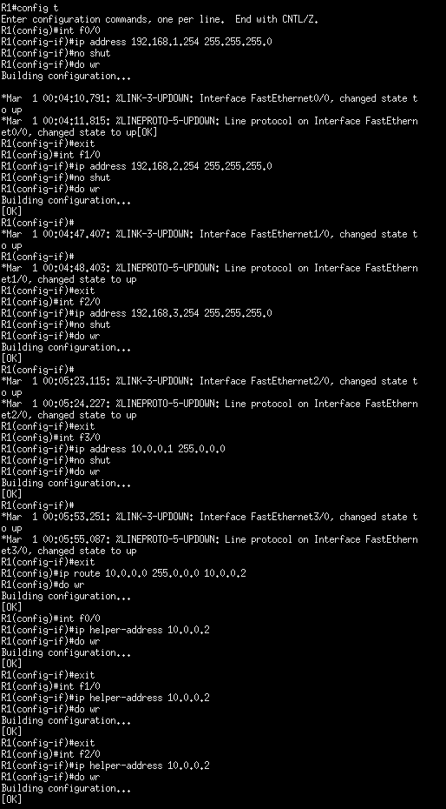
Commands at R1
Assigning IP addresses
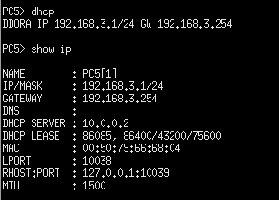

# Note:
- ip helper-address commands to be given for all the interfaces of router R1 except the one directly connected to the DHCP server
- routing has to be done both ways for till the dhcp server

Commands for DNS Server
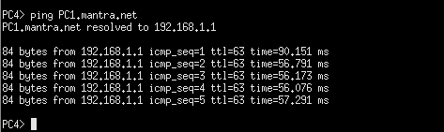

- The name-server needs to have ip address of dns server
- The host command needs to have ip address of static PC / Server
- The dns-server command has to be given to each dhcp pool with the address of dns server
Lab Exercise 1
