Week 7: Socket Programming Applications
Komal Mathur, CSE B2, 220905546

Scenario:
1. You are tasked with developing a secure communication system where a client and a server exchange a symmetric encryption key securely over a network. The exchanged key will then be used to encrypt and decrypt messages between the client and server.

To implement this code, I wrote the TCP Concurrent server code, with an infinite client code. Appropriate string hadling functons have been included.

//TCP Server
#include<stdio.h>
#include<string.h>
#include<sys/types.h>
#include<sys/socket.h>
#include<netinet/in.h>
#include<unistd.h>
#include<arpa/inet.h>
#include<stdlib.h>
#define PORTNO 10200

int main()
{
int sockfd,newsockfd,portno,clilen, key,n=1;
char buf[256];
struct sockaddr_in seraddr,cliaddr;
int i,value;

sockfd = socket(AF_INET,SOCK_STREAM,0);
seraddr.sin_family = AF_INET;
seraddr.sin_addr.s_addr = inet_addr("172.16.48.48");
seraddr.sin_port = htons(PORTNO);

bind(sockfd,(struct sockaddr *)&seraddr,sizeof(seraddr));
listen(sockfd,5);
printf("Server waiting...\n");

while(1){
clilen = sizeof(clilen);
newsockfd=accept(sockfd,(struct sockaddr *)&cliaddr,&clilen);

if(fork()==0) {
while(1){
memset(buf, 0, sizeof(buf));
read(newsockfd, &key, sizeof(key));
//printf("%d is key", key);
//getchar();
n = read(newsockfd,buf,sizeof(buf)-1);
buf[n] = '\0';
//printf("\nThe received string from client: %s\n", buf);
printf(" \nEncrypted text from Client: %s \n",buf);
for (int i=0;buf[i]!='\0';i++){
buf[i] = buf[i] - key;
}
if (strcmp(buf, "stop") == 0){
printf("\nDisconecting client socket...\n");
close(newsockfd);
break;
}
printf("Decrypted text: %s \n",buf);
n = write(newsockfd,buf,n);
sleep(5);
}
exit(0);
}

else close(newsockfd);
}
}

//TCP Client

#include<sys/types.h>
#include<sys/socket.h>
#include<stdio.h>
#include<netinet/in.h>
#include<arpa/inet.h>
#include<stdlib.h>
#include<unistd.h>
#include<string.h>

int main()
{
int len,result,sockfd,key,chlen,i, n=1;
struct sockaddr_in address;
char ch[256],buf[256], ch2[256];

sockfd = socket(AF_INET, SOCK_STREAM, 0);
address.sin_family=AF_INET;
address.sin_addr.s_addr=inet_addr("172.16.48.48");
address.sin_port=htons(10200);
connect(sockfd,(struct sockaddr *)&address, sizeof(address));

//Logic for problem mentioned here
while(1){
memset(buf, 0, sizeof(buf));
memset(ch, 0, sizeof(ch));
memset(ch2, 0, sizeof(ch2));
printf("Enter secret key: ");
scanf("%d", &key);
write(sockfd, &key, sizeof(key));
//SUPER IMPORTANT AFTER SCANF AND BEFORE READING STRING
getchar();

printf("\nEnter text: ");
fgets(ch, sizeof(ch), stdin);
ch[strcspn(ch, "\n")] = '\0';

for (i=0;ch[i]!='\0';i++){
ch2[i] = ch[i];
ch[i] = ch[i] + key;
}
ch2[i] = '\0';
//chlen = strlen(ch);
write(sockfd,ch, strlen(ch)+1);
if (strcmp(ch2, "stop") == 0) {
close(sockfd);
break;
}

printf("FROM SERVER decrypted text is ... ");
n=read(sockfd,buf,sizeof(buf)-1);
buf[n] = '\0';
printf("%s\n",buf);
}
exit(0);
}
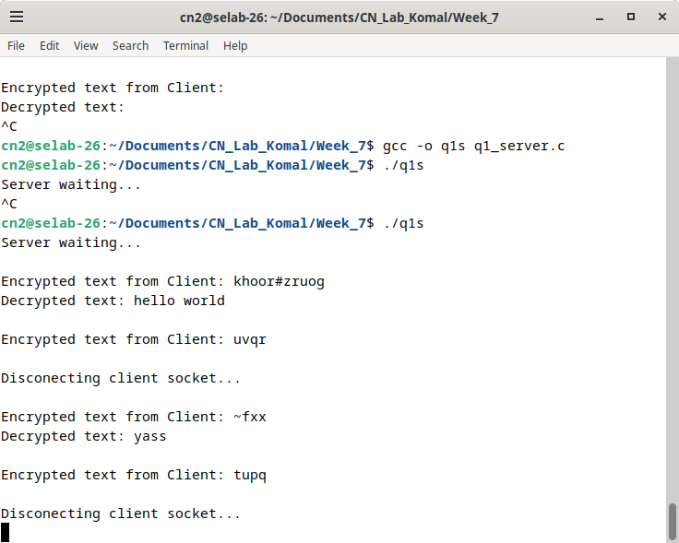
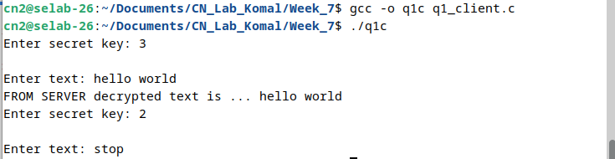
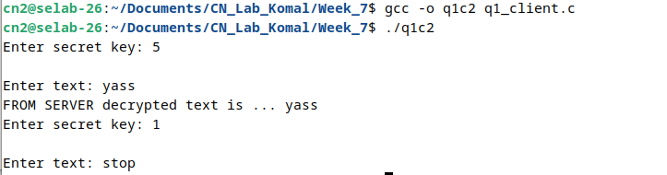

2. Implement a basic chat application where multiple clients can send and receive messages through a server.

//SERVER
#include <stdio.h>
#include <string.h>
#include <sys/types.h>
#include <sys/socket.h>
#include <netinet/in.h>
#include <arpa/inet.h>
#include <stdlib.h>
#include <unistd.h>
#include <pthread.h>

#define PORTNO 10201
#define MAX_CLIENTS 3

int clients[MAX_CLIENTS];
int client_count = 0;

void* handle_client(void* arg) {
int newsockfd = *(int*)arg;
free(arg);

char buf[256];
while (1) {
int h = read(newsockfd, buf, sizeof(buf) - 1);
if (h <= 0)
break;
buf[h] = '\0';

char output[300];
sprintf(output, "sent from %d: %s", newsockfd, buf);
printf("%s\n", output);
for (int l = 0; l < client_count; l++) {
write(clients[l], output, strlen(output)); // Send the message to all clients
}
}
return NULL;
}

int main() {
int sockfd, newsockfd, clilen;
struct sockaddr_in seraddr, cliaddr;
sockfd = socket(AF_INET, SOCK_STREAM, 0);
seraddr.sin_family = AF_INET;
seraddr.sin_addr.s_addr = inet_addr("172.16.48.48");
seraddr.sin_port = htons(PORTNO);

if (sockfd < 0) {
perror("ERROR opening socket");
exit(1);
}

if (bind(sockfd, (struct sockaddr *)&seraddr, sizeof(seraddr)) < 0) {
perror("ERROR on binding");
exit(1);
}

if (listen(sockfd, 3) < 0) {
perror("ERROR on listen");
exit(1);
}

while (1) {
clilen = sizeof(cliaddr);
newsockfd = accept(sockfd, (struct sockaddr *)&cliaddr, &clilen);
if (newsockfd < 0) {
perror("ERROR on accept");
continue;
}
if (client_count < MAX_CLIENTS) {
clients[client_count++] = newsockfd;
int* sockfd_ptr = malloc(sizeof(int));
*sockfd_ptr = newsockfd;
pthread_t thread_id;
pthread_create(&thread_id, NULL, handle_client, sockfd_ptr);
} else {
printf("Max clients reached. Connection refused.\n");
close(newsockfd);
}
}

close(sockfd);
return 0;
}

//CLIENT
#include <stdio.h>
#include <stdlib.h>
#include <fcntl.h>
#include <sys/socket.h>
#include <sys/types.h>
#include <netinet/in.h>
#include <arpa/inet.h>
#include <unistd.h>
#include <string.h>
#include <pthread.h>

int sd; // Socket descriptor

void* read_messages(void* arg) {
char output[300];
while (1) {
int bytes_read = read(sd, output, sizeof(output) - 1);
if (bytes_read > 0) {
output[bytes_read] = '\0'; // Null-terminate the string
printf("Received: %s\n", output);
}
}
return NULL;
}

void* write_messages(void* arg) {
char buf[256];
while (1) {
//printf("Enter string: ");
gets(buf); // Safer than gets
// Remove newline character if present
//buf[strcspn(buf, "\n")] = 0;
write(sd, buf, strlen(buf));
//sleep(1); // Throttle sending
}
return NULL;
}

int main() {
struct sockaddr_in address;
sd = socket(AF_INET, SOCK_STREAM, 0);
address.sin_family = AF_INET;
address.sin_addr.s_addr = inet_addr("172.16.48.48");
address.sin_port = htons(10201);

if (connect(sd, (struct sockaddr*)&address, sizeof(address)) < 0) {
perror("Connection failed");
exit(1);
}

pthread_t read_thread, write_thread;

// Create threads for reading and writing
pthread_create(&read_thread, NULL, read_messages, NULL);
pthread_create(&write_thread, NULL, write_messages, NULL);

// Wait for both threads to finish (they won't in this case)
pthread_join(read_thread, NULL);
pthread_join(write_thread, NULL);

close(sd);
return 0;
}

