Week 5: Iterative Socket Programming in UDP and TCP
Komal Mathur, CSE B2, 220905546

My notes
- bind – to name socket
- error handling very important in these types of codes
- ip config - to get ip address of host
- int newsockid = accept(sockid, &clientAddr, &addrLen); --these are output arguments, not input
- To get ip address of computer: $ip address
- TCP – ephimeral port number needs to be changed for each run, as long as you dont stop the server you dont have to change the port number (only use ctrl+C to terminate a program otherwise port number gets blocked)
- UDP – ephimeral may be same between runs

Sample TCP Program: Write an iterative TCP client server program where client sends a message to server and server echoes back the message to client. Client should display the original message and echoed message. Note: As socket is also a file descriptor, we can use read and write system calls to receive and send data.

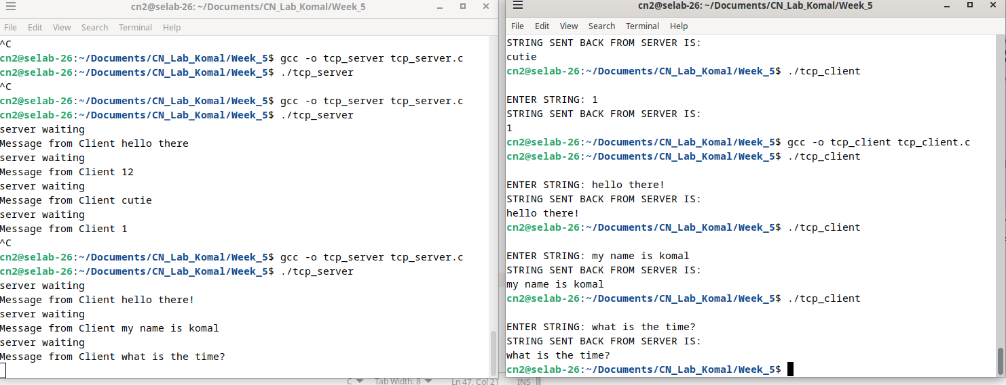

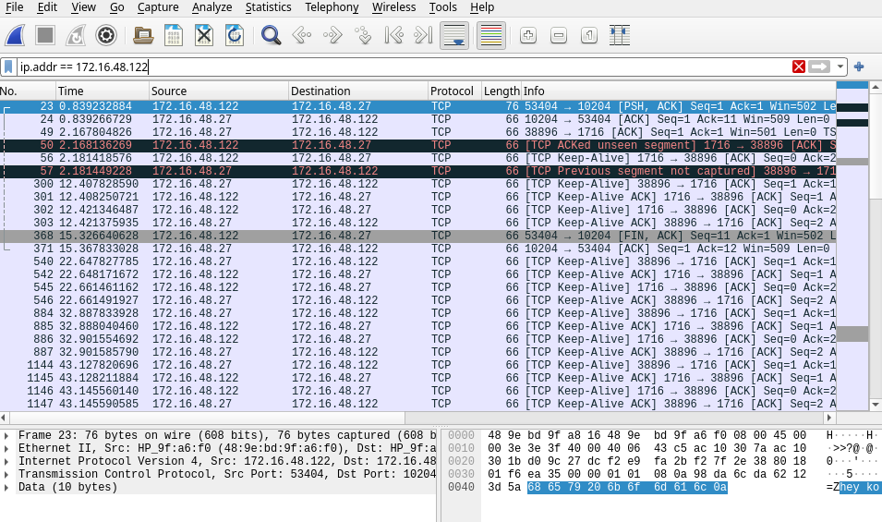
Sample UDP Code

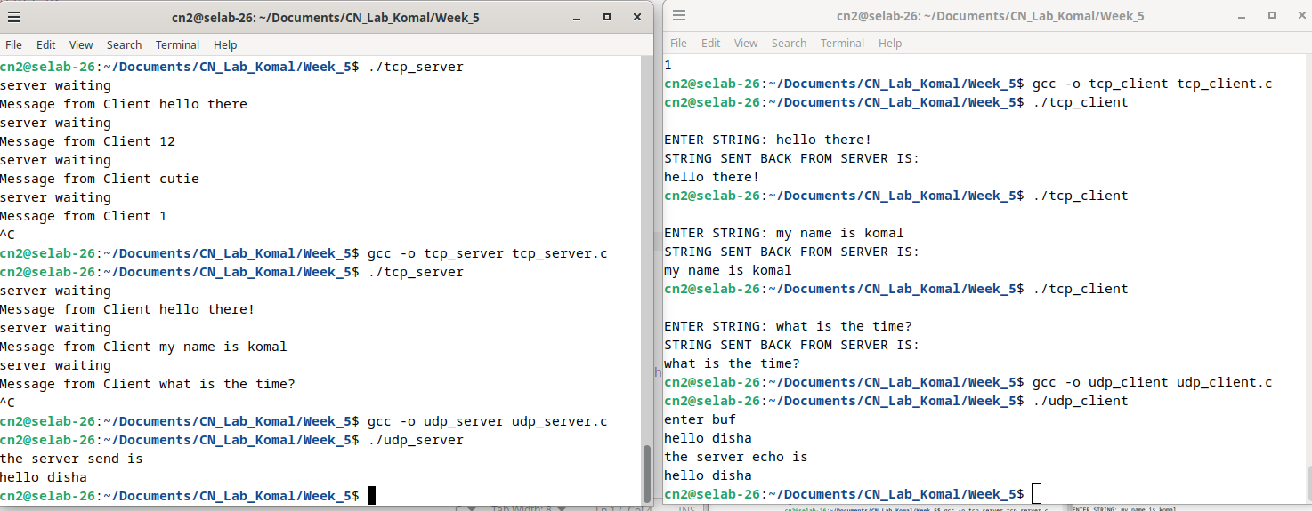

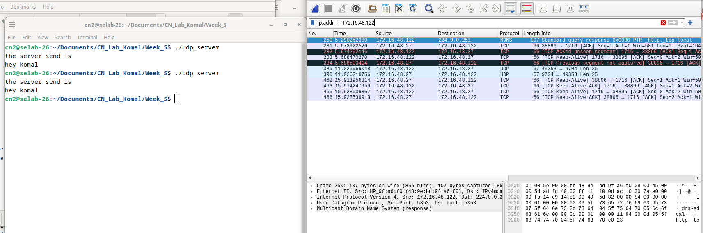

Lab Exercises:
- Write an iterative TCP client-server program where the client accepts a sentence from the user and sends it to the server. The server will check for duplicate words in the string. Server will find number of occurrences of duplicate words present and remove the duplicate words by retaining single occurrence of the word and send the resultant sentence to the client. The client displays the received data on the client screen. The process repeats until the user enter the string “Stop”. Then both the processes terminate.

// TCP Server code:
#include<stdio.h>
#include<string.h>
#include<sys/types.h>
#include<sys/socket.h>
#include<netinet/in.h>
#include<arpa/inet.h>
#include<stdlib.h>
#include<unistd.h>
#include<stdbool.h>
#include<ctype.h>
#define PORTNO 10200
#define MAX_WORD_LENGTH 100
#define INITIAL_SIZE 10
// Function to check if a word is in the list
bool is_in_list(char **list, int size, const char *word) {
for (int i = 0; i < size; i++) {
if (strcmp(list[i], word) == 0) {
return true;
}
}
return false;
}
// Function to remove duplicate words from a sentence and count duplicates
void remove_duplicate(char str[]) {
char **words = malloc(INITIAL_SIZE * sizeof(char*));
int capacity = INITIAL_SIZE;
int size = 0;
char buffer[MAX_WORD_LENGTH];
char *ptr = str;
char *result = malloc(strlen(str) + 1);
result[0] = '\0';
char *result_ptr = result;
while (*ptr) {
int len = 0;
while (*ptr && !isspace(*ptr)) {
buffer[len++] = *ptr++;
}
buffer[len] = '\0';

while (*ptr && isspace(*ptr)) {
ptr++;
}
if (len > 0) {
if (!is_in_list(words, size, buffer)) {
if (size >= capacity) {
capacity *= 2;
words = realloc(words, capacity * sizeof(char*));
}
words[size] = strdup(buffer);
size++;
if (result_ptr != result) {
*result_ptr++ = ' ';
}
strcpy(result_ptr, buffer);
result_ptr += strlen(buffer);
}
}
}
for (int i = 0; i < size; i++) {
free(words[i]);
}
free(words);
if (result_ptr != result) {
*result_ptr = '\0';
}
strcpy(str, result);
free(result);
}

int main()
{
int sockfd,newsockfd,portno,clilen,n=1;
struct sockaddr_in seraddr,cliaddr;
int i,value;
// create an unnamed socket for the server
sockfd = socket(AF_INET,SOCK_STREAM,0);
//Name the socket
seraddr.sin_family = AF_INET;
seraddr.sin_addr.s_addr = inet_addr("172.16.48.71");
seraddr.sin_port = htons(PORTNO);
bind(sockfd,(struct sockaddr *)&seraddr,sizeof(seraddr));
//Create a connection queue and wait for clients
listen(sockfd,5);
while (1) {
char buf[256];
printf("server waiting\n");
//Accept a connection
clilen = sizeof(clilen);
newsockfd=accept(sockfd,(struct sockaddr *)&cliaddr,&clilen);
//Read and write to client on client_sockfd
while(1){
memset(buf, 0, sizeof(buf)); // Clear the buffer before reading
n = read(newsockfd,buf,sizeof(buf)-1);
buf[n] = '\0';
printf(" Sentence sent from Client is - \"%s\" \n",buf);
if(strcmp(buf,"stop")==0||strcmp(buf,"Stop")==0){
close(newsockfd);
break;
}
remove_duplicate(buf);
printf(" Modified sentence sent to Client is - \"%s\" \n",buf);
n = write(newsockfd,buf,strlen(buf)); // Send only the necessary bytes
}
if(!strcmp(buf,"stop")){
break;
}
}
}

// TCP Client Code:
#include <sys/types.h>
#include <sys/socket.h>
#include <stdio.h>
#include <netinet/in.h>
#include <arpa/inet.h>
#include <stdlib.h>
#include <string.h>
#include <unistd.h> // For close()
int main()
{
int len, result, sockfd;
struct sockaddr_in address;
char ch[256], buf[256];
// Create a socket for the client
sockfd = socket(AF_INET, SOCK_STREAM, 0);// SOCK_STREAM used for TCP
// AF_INET is for IPv4 and 0 is the default protocol.
if (sockfd < 0) {

perror("Socket creation failed");
exit(1);
}
// Set up the address structure
address.sin_family = AF_INET; // IPv4 address family
address.sin_addr.s_addr = inet_addr("172.16.48.71"); // Server's IP address
// inet_addr converts the dot representation into binary.
address.sin_port = htons(10200); // Server's port number
// Host to network short: converts port number from host byte order to network byte order.
len = sizeof(address);
// Connect your socket to the server’s socket
result = connect(sockfd, (struct sockaddr *)&address, len);
// Here address is socket address of server and sockfd is file descriptor returned while creating the socket.
if (result == -1) {
perror("Connection failed");
close(sockfd);
exit(1);
}
// Loop to repeatedly send and receive data
while (1) {
// Prompt user to enter a string
printf("ENTER STRING: ");
if (fgets(ch, sizeof(ch), stdin) == NULL) {// Use fgets instead of gets for safety
perror("Input error");
close(sockfd);
exit(1);
}// Remove newline character if present
ch[strcspn(ch, "\n")] = '\0';

// Write the input string to the server
write(sockfd, ch, strlen(ch));
// Send "stop" message to terminate both client and server
if (strcmp(ch, "stop") == 0) {
break;// Exit the loop and terminate the client
}
// Read the response from the server
int n = read(sockfd, buf, sizeof(buf) - 1);
if (n < 0) {
perror("Read error");
close(sockfd);
exit(1);
}
buf[n] = '\0';// Null-terminate the buffer
puts(buf); // Print the buffer content to stdout
}
close(sockfd);
return 0;
}
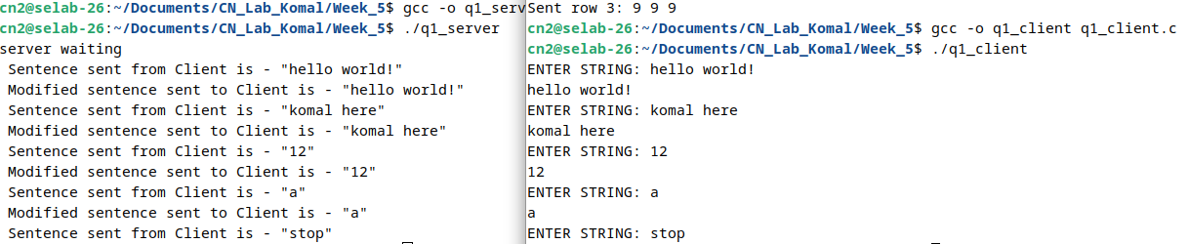
Wireshark with adjacent computer

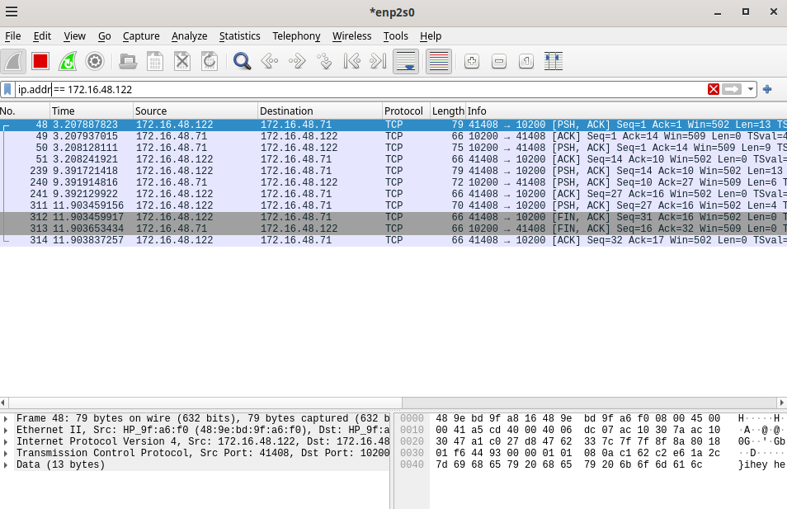

- Write an iterative UDP client-server program where the client sends rows of a matrix, and the server combines them together as a matrix.

//UDP Server
#include<stdio.h>
#include<fcntl.h>
#include<stdlib.h>
#include<string.h>
#include<sys/socket.h>
#include<sys/types.h>
#include<netinet/in.h>
#include<arpa/inet.h>
#include<unistd.h>

#define PORT 9704
#define ROWS 3
#define COLS 3

int main() {
int sd;
char buf[100];
struct sockaddr_in sadd, cadd;
int matrix[ROWS][COLS];
int row_counter = 0;

// Create a UDP socket
sd = socket(AF_INET, SOCK_DGRAM, 0);
if(sd < 0) {
perror("Socket creation failed");
exit(EXIT_FAILURE);
}

// Construct the address for the server
sadd.sin_family = AF_INET;
sadd.sin_addr.s_addr = inet_addr("172.16.48.71");
sadd.sin_port = htons(PORT);

// Bind the socket to the address
if(bind(sd, (struct sockaddr *)&sadd, sizeof(sadd)) < 0) {
perror("Bind failed");
close(sd);
exit(EXIT_FAILURE);
}

int len = sizeof(cadd);

printf("Server is waiting for matrix rows...\n");

// Receive matrix rows one at a time
while(row_counter < ROWS) {
int m = recvfrom(sd, buf, sizeof(buf), 0, (struct sockaddr *)&cadd, &len);
if(m < 0) {
perror("Receive failed");
close(sd);
exit(EXIT_FAILURE);
}

buf[m] = '\0'; // Null-terminate the received string

// Convert the received string to matrix row
int i = 0;
char *token = strtok(buf, " ");
while(token != NULL && i < COLS) {
matrix[row_counter][i] = atoi(token); // Convert to integer
token = strtok(NULL, " ");
i++;
}
row_counter++;
}

printf("The received matrix is:\n");
for(int i = 0; i < ROWS; i++) {
for(int j = 0; j < COLS; j++) {
printf("%d ", matrix[i][j]);
}
printf("\n");
}

close(sd);
return 0;
}
//UDP Client
#include<stdio.h>
#include<stdlib.h>
#include<fcntl.h>
#include<string.h>
#include<sys/socket.h>
#include<sys/types.h>
#include<netinet/in.h>
#include<arpa/inet.h>
#include<unistd.h>

#define PORT 9704
#define ROWS 3
#define COLS 3

int main() {
int sd;
struct sockaddr_in address;
int matrix[ROWS][COLS];

// Create a UDP socket
sd = socket(AF_INET, SOCK_DGRAM, 0);
if(sd < 0) {
perror("Socket creation failed");
exit(EXIT_FAILURE);
}

// Construct the address for the server
address.sin_family = AF_INET;
address.sin_addr.s_addr = inet_addr("172.16.48.71");
address.sin_port = htons(PORT);

printf("Enter a %dx%d matrix (row-wise):\n", ROWS, COLS);

// Input matrix from the user
for(int i = 0; i < ROWS; i++) {
for(int j = 0; j < COLS; j++) {
scanf("%d", &matrix[i][j]);
}
}

int len = sizeof(address);

// Send matrix rows one at a time
for(int i = 0; i < ROWS; i++) {
char buf[100];
memset(buf, 0, sizeof(buf));

// Convert the matrix row to a string
sprintf(buf, "%d %d %d", matrix[i][0], matrix[i][1], matrix[i][2]);

// Send the row to the server
int m = sendto(sd, buf, sizeof(buf), 0, (struct sockaddr *)&address, len);
if(m < 0) {
perror("Send failed");
close(sd);
exit(EXIT_FAILURE);
}

printf("Sent row %d: %s\n", i+1, buf);
}

close(sd);
return 0;
}

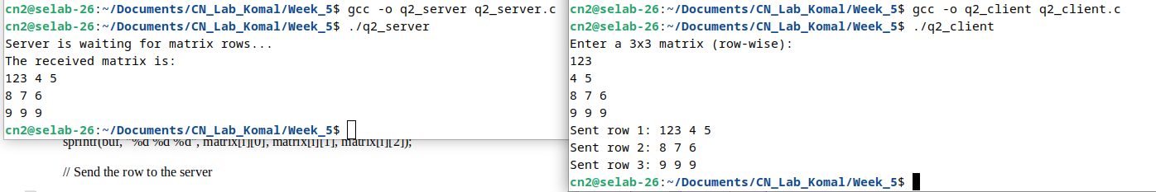

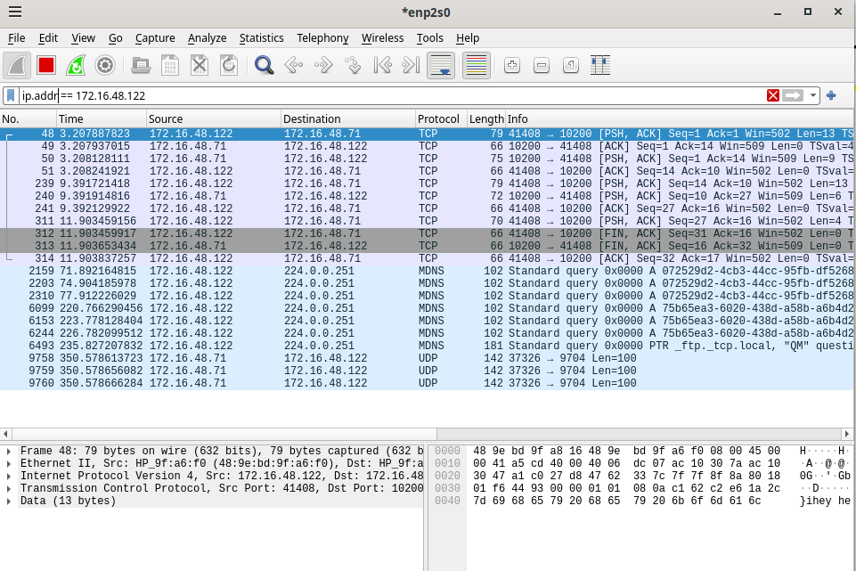
Wireshark with adjacent computer

