A

PROJECT REPORT

ON

FIT NEXUS
(Wellness Tracking & Analytics Platform)

Submitted in partial fulfillment for the award of

PG Certificate Programme in Advanced Computing

(PGCP-AC) from

INSTITUTE OF EMERGING TECHNOLOGIES

Authorized Training Centre


Under the Guidance of

NA

BY

Komal Ghodke - (260245920034)
Anuj Deshmukh - (260245920019)
Mayur Deo - (260245920042)
Pratik Diwan - (260245920060)
Sakshi Khandare - (260245920066)


CERTIFICATE

This is to certify that the project report entitled ‘FIT NEXUS (Wellness Tracking & Analytics Platform)’ is a bonfire work carried out by Komal Ghodke, Anuj Deshmukh, Mayur Deo, Pratik Diwan, Sakshi Khandare and submitted in partial fulfilment of the requirement for the C-DAC ACTS, PGCP-AC course in Institute of Emerging Technology in the batch of Feb 2026.

Course Coordinator External Examiner

ACKNOWLEDGEMENT

This project ‘FIT NEXUS (Wellness Tracking & Analytics Platform)’ was a great learning experience for us and we are submitting this work to Advanced Computing Training School (CDAC).

Our most heart full thanks goes to Mr. Sangram Patil (Director ,IET) who gave all the required support and kind coordination to provide all the necessities like required hardware, internet facility and extra lab hours to complete the project and throughout the course up to the last day here in C-DAC ACTS, Pune.

Komal Ghodke (260245920034)
Anuj Deshmukh (260245920019)
Mayur Deo (260245920042)
Pratik Diwan (260245920060)
Sakshi Khandare (260245920066)

Abstract

Modern lifestyle transitions have led to an increase in physical ailments, elevated stress levels, and fragmented mental-physical health tracking. Current wellness apps remain siloed fitness-only or diet-only without integration across the six holistic wellness domains (Emotional, Physical, Spiritual, Intellectual, Social, and Occupational). This lack of cohesion prevents individuals from experiencing truly holistic well-being. Moreover, existing platforms fail to provide personalized AI narration or culturally rooted recommendations that resonate with diverse populations. Enterprises also struggle with the absence of aggregated analytics for employee wellness, limiting their ability to support workforce health effectively. What is urgently needed is a secure, scalable, and culturally authentic platform that empowers both individuals and organizations with integrated, holistic wellness solutions.
FIT-NEXUS is a holistic, multi-dimensional web ecosystem designed to bridge this gap. Inspired by the Yoga Certification Board (YCB) principles, Anchored in the 6 Dimensions of Wellness (6Ds) for complete user guidance, the system tracks around 27 unique wellness indicators across physical, spiritual, social, and environmental dimensions. The system features a Java Spring Boot API that handles core operations and incorporates Google Gemini 2.0 Flash to provide a context-aware, interactive GenAI Wellness Chatbot alongside deterministic Predictive AI models (calculating caloric burn via MET equations, stress levels, and sleep index trends). Simultaneously, a self-hosted C# ASP.NET Core analytics service connects to the shared database to serve a premium Corporate Dashboard for gyms, yoga studios, and HR administrators, allowing for anonymized, aggregated workforce analytics and partner registration. The user interface is built on React 18 with Material UI. The application is secured via stateless JSON Web Tokens (JWT) and hardened CORS policies, and is now fully deployed on Microsoft Azure, live and operational with enterprise-grade scalability, monitoring, and disaster recovery in place. FIT-NEXUS is officially launched, delivering holistic wellness insights to individuals, professionals, and corporate partners.

Index

Sr. No. | Title | Page No.
1 | Introduction | 6
2 | Problem Definition & Scope | 7
2.1 | Problem Definition | 7
2.2 | Goals & Objectives | 7
2.3 | Major Constraints& Outcomes | 8
3 | Software Requirement Specification | 8
3.1 | Proposed System | 9
3.2 | Scope | 9
4 | System Modules | 10
5 | Performance-Requirements | 16
5.1 | H/W Requirements & S/W Requirements | 16
6 | UML Diagram | 17
6.1 | DFD | 17
6.2 | ERD | 17
6.3 | Use case diagram | 18
6.4 | Class Diagram | 18
6.5 | Sequence diagram | 19
6.6 | Activity Diagram | 20
6.7 | Deployment diagram | 21
6.8 | System Architecture | 21
7 | Test Cases | 22
8 | Screenshots | 23
9 | Future Scope | 31
10 | Conclusion | 31
11 | References | 32

- Introduction

With the rising prevalence of desk jobs, high-stress environments, and sedentary habits, tracking individual health has become vital. However, health is multi-dimensional. Traditional health systems monitor isolated physical factors but fail to guide users on stress relief, proper sleep hygiene, and mindfulness, nor do they map yoga postures to specific bodily pain areas.
FitNexus presents a holistic solution. Anchored in the 6 Dimensions of Wellness (6Ds) for complete user guidance, by organizing health checks around YCB principles, it calculates an integrated Wellness Score and maps user states onto a Chakra Journey Tracker (Root, Sacral, Solar Plexus, Heart, Throat, Third Eye, Crown). In addition to user-focused analytics, FitNexus serves the commercial wellness ecosystem: C# .NET Core provides gym and studio owners with aggregate client demographics and stress trends, facilitating direct, data-driven wellness interventions.
- FIT NEXUS is a holistic wellness tracking platform.
- Tracks workout, nutrition, sleep, and stress while aligning with MINISTRY OF AYUSH preventive health goals.
- Uses AI/GenAI for predictive scoring, multilingual PDF reports, and personalized narration.
- Offers a corporate dashboard for HR and trainers, plus map integration.
- Anchored in the 6 Dimensions of Wellness (6Ds) for complete user guidance

- Problem Definition & Scope

  - Problem Definition

- Siloed Tracking: Lack of unified applications mapping physical activity with sleep quality, hydration, resting heart rate, and mental/spiritual factors.
- Lack of Personalized, Interactive AI Advice: Most apps offer static blogs instead of real-time wellness companions that answer health queries based on personal health metrics.
- No Corporate or Studio-Owner Analytics: Wellness centers and yoga studios lack dashboards to monitor aggregated client wellness patterns to design targeted classes.

  - Goals & Objectives
- Build a centralized ecosystem for holistic wellness tracking.
- Integrate the 6Ds of wellness:
  - Emotional → mood journaling, stress awareness
  - Physical → workouts, nutrition, sleep quality
  - Spiritual → breathwork, reflection, mindfulness
  - Intellectual → curiosity, learning, mindful insights
  - Social → empathy, connection, shared wellness language
  - Occupational → balance, clarity, purpose in daily life
- Establish a Multi-Dimensional Health Portal: Collect around 27 key wellness metrics via a user-friendly form.
- Provide GenAI Wellness Companion: Implement an interactive chatbot widget utilizing Google Gemini to answer questions while strictly keeping topics restricted to wellness.
- Deliver Predictive AI Analytics: Calculate MET calories, stress trends, and sleep index trends using scientific formulas, Generate personalized insights, predictive scoring, and multilingual PDF reports
- Serve Corporate Dashboard: Implement a separate, C# served dashboard displaying demographics and stress trends, with partner registration directly logging entries to a database.
- Provide secure authentication (JWT/OAuth) and scalable architecture.
  - Major Constraints & Outcomes
- Authentication Constraint: Token expiration handles session security (JWT).
- API Limits: AI requests are limited to 10 messages per user session to avoid free tier rate-limits.
- Disclaimer Constraints: A strict disclaimer warns users that the app is an Educational/Wellness Guide and Not a Medical Diagnosis tool.

- Software Requirement Specification

  - Proposed System

The system is built on a stateless REST architecture:
[React Client (3000)] ───(HTTPS/JSON)───► [Spring Boot (8083) / .NET Core (5294)]
│
[Shared MySQL Schema]

- Authentication: Completed via POST /api/auth/login. Returns JWT tokens.
- Assessment Handling: Submits 27 indicators, saves to MySQL, triggers predictive scoring, and responds with a wellness report.
- Chatbot Processing: Submits prompts, injects health context, queries Gemini API, and falls back to a regex matching library if offline.
  - Scope
- Registered Members: Enter data, view reports, converse with the chatbot, search studio maps.
- Instructors/Trainers: Input staff notes on member profiles and verify log audits.
- Corporate Partners: Register via form and view workforce statistics.
- System Administrators: Upgrade user roles (e.g. USER to GYM_TRAINER).

- System Modules

FitNexus is organized into 6 distinct, loosely-coupled system modules, each responsible for a specific domain of functionality. This modular architecture enables independent development, testing, and deployment of each concern.

- Identity Module: Secure authentication, encrypted registration, JWT filter authorization.
- Wellness Assessment Module: Form parsing, dynamic BMI generation, YCB chakra scoring.
- GenAI Chatbot Widget: Dynamic floating widget, context injection (sends user health parameters to Gemini), domain constraints, offline fallback database.
- Predictive AI Engine: Calorie burn tracking using MET constants, sleep index calculator, multi-factor stress regression adjustments.
- Location Maps Module: Google Maps API integrations, studio details drawer, search filters.
- Corporate Dashboard Service: ASP.NET Core API endpoints, DB connection pool, HTML rendering, partner request persistence.

4.1 Identity Module (Authentication & Authorization)
Purpose: Manages secure user registration, encrypted credential storage, and stateless JWT-based session authorization across all 4 user roles.
How It Works:
- Registration (POST /api/auth/register):
A new user submits email, password, and selected role (USER, YOGA_INSTRUCTOR, GYM_TRAINER, ADMIN). The password is hashed using BCrypt (adaptive cost factor) before persistence — plaintext passwords are never stored.
- Login (POST /api/auth/login):
The server validates credentials against BCrypt hash. On success, a JSON Web Token (JWT) is generated using HMAC-SHA256 signing with a 256-bit secret key. The JWT payload contains the user's email claim and an expiration timestamp (10 hours).
- JWT Filter Authorization:
Every subsequent API request passes through JwtRequestFilter.java — a custom OncePerRequestFilter in the Spring Security filter chain. This filter extracts the Authorization: Bearer <token> header, validates the JWT signature, checks expiration, and loads the user's granted authorities into the SecurityContext. Emails are compared using case-insensitive matching (equalsIgnoreCase()) to prevent login issues caused by letter-case mismatch.
- Role-Based Access Control (RBAC):
The SecurityConfig.java SecurityFilterChain defines URL-level authorization rules — e.g., /api/admin/** requires ADMIN authority, /api/staff/** requires YOGA_INSTRUCTOR or GYM_TRAINER. Frontend route guards (PrivateRoute, StaffRoute, AdminRoute) mirror this protection on the client side.
Key Files:
- AuthController.java — Registration & Login endpoints
- JwtUtil.java — Token generation, validation, claim extraction
- JwtRequestFilter.java — Per-request JWT inspection filter
- SecurityConfig.java — Global security filter chain configuration
- MyUserDetailsService.java — Spring Security UserDetailsService implementation

4.2 Wellness Assessment Module (27-Indicator Form & Scoring)
Purpose: Captures 27 qualitative and quantitative health indicators through a 4-step guided wizard form, dynamically calculates BMI, and feeds data into the Predictive Wellness Scoring Engine and 7 Chakra Alignment Mapper.
How It Works:
- 4-Step Stepper Wizard (WellnessForm.js):
The form is divided into 4 progressive steps: (1) Personal Details, (2) Physical Health, (3) Mind & Emotion, (4) Lifestyle & Environment. Each step validates required fields before allowing progression.
- Dynamic BMI Auto-Calculation:
As the user types their height and weight, BMI is computed in real-time using BMI = weight / (height/100)² and displayed instantly — no submit button needed for this calculation.
- Backend Persistence (POST /api/wellness/{userId}):
The WellnessInputController.java receives the full assessment payload, maps it to the WellnessInput JPA entity via WellnessInputRepository, and persists it in the wellness_inputs MySQL table.
- YCB Chakra Scoring (ReportsService.java):
After submission, the scoring engine maps user responses to the 7 Chakra energy centers. For example: low sleep hours weaken the Ajna (Third Eye) chakra; high stress impacts the Manipura (Solar Plexus) chakra; lack of nature exposure affects the Muladhara (Root) chakra.
- Multi-Language Support: All form labels support English, Hindi (हिंदी), and Marathi (मराठी) via i18next translation files (i18n.js).
Key Files:
- WellnessForm.js — 4-step React form component
- WellnessInputController.java — REST endpoint for assessment submission
- WellnessInput.java — JPA Entity mapping 27 indicators
- ReportsService.java — Scoring algorithm & Chakra mapping
- i18n.js — Multi-language translation keys

4.3 GenAI Chatbot Widget (Google Gemini + Offline Fallback)
Purpose: A dynamic floating chat widget providing instant AI-powered health, wellness, yoga, gym, diet, and nutrition guidance — with a 100% offline rule-based fallback engine ensuring answers even without internet.
How It Works:
- Floating Widget (WellnessChatbot.js): A persistent, draggable chat bubble rendered on all authenticated pages. Users type natural-language questions and receive conversational wellness responses.
- Context Injection: Before sending the user's question to Google Gemini, the system injects the user's personal wellness profile data (BMI, stress level, sleep hours, mood, pain areas, chronic conditions) retrieved from WellnessInputRepository. This context-aware prompt enables personalized AI responses — e.g., "Based on your BMI of 27.3 and reported lower back pain, I recommend...".
- Gemini API Call (ChatController.java): The system prompt instructs Gemini to act as an expert wellness coach specialized in yoga, gym workouts, diet, food, nutrition, protein, Ayurveda, hair care, skin care, eye health, mental well-being, and more. The API call uses RestTemplate.postForEntity() against the Gemini generateContent endpoint.
- Domain Constraints: The system prompt explicitly instructs the AI to redirect unrelated queries (politics, coding, movies) back to health/wellness topics — maintaining focus.
- Offline Fallback Database: If the Gemini API key is missing, the API fails, or there's no internet, the system falls back to getOfflineResponse() — an extensive in-code rule-based knowledge engine covering 20+ health topics (BMI, hair care, eye health, skin glow, digestion, pranayama, meditation, weight, immunity, women's health, protein, gym routines, etc.) with detailed, actionable advice.
Key Files:
- WellnessChatbot.js — Floating React chat widget component
- ChatController.java — Backend endpoint with Gemini API call + offline fallback
- ChatRequest.java — DTO for chat message payload
- apiConfig.js — API base URL configuration

4.4 Predictive AI Engine (Wellness Scoring & Analytics)
Purpose: Computes a predictive Wellness Score (1–10) using a multi-variable penalty-reward formula, tracks calorie burn using MET metabolic equivalents, calculates sleep quality indices, and performs multi-factor stress regression adjustments.
How It Works:
- Wellness Score Formula (ReportsService.java):
S = 10 − P_BMI − P_Sleep − P_Stress − P_Pain − P_Nature + R_Yoga

Where:
  - P_BMI = 2.0 if BMI > 28 or BMI < 17 (underweight/obese penalty)
  - P_Sleep = 2.0 if sleep < 6 hrs; 1.0 if sleep < 7 hrs
  - P_Stress = 2.0 if stress > 7/10; 1.0 if stress > 5/10
  - P_Pain = 1.0 if user reports acute back, neck, knee, or joint pain
  - P_Nature = 1.0 if nature exposure < 2 hrs/week
  - R_Yoga = +1.0 if user is an active yoga practitioner
  - Score is clamped to a minimum floor of 1/10.
- MET-Based Calorie Burn Tracking: Calorie burn is estimated using the formula:
Calories = MET × Weight(kg) × Duration(hrs)
Where MET constants vary by exercise type (Yoga = 3.0, Walking = 4.0, Running = 8.0, Gym Weights = 5.0).
- Sleep Quality Index: Combines self-reported sleep quality (Restful / Interrupted / Insomnia) with sleep duration and bedtime/wake-time consistency to produce a composite sleep wellness indicator.
- Multi-Factor Stress Regression: Stress level (1–10) is cross-referenced with sleep deficit, screen time, and meditation practice to adjust the overall wellness score — recognizing that high stress + low sleep compounds health impact multiplicatively.
Key Files:
- ReportsService.java — Core scoring algorithm implementation
- ReportsPage.js — Frontend score visualization, 7 Chakra map, PDF export
- WellnessInput.java — Entity containing all 27 assessment parameters

4.5 Location Maps Module (PAN India Wellness Locator)
Purpose: Enables users to discover yoga studios, gym centers, and AYUSH wellness clinics across PAN India using interactive map visualization with live search capabilities.
How It Works:
- Interactive Map (MapPage.js): Built using Leaflet.js with OpenStreetMap tiles. Custom color-coded markers differentiate Yoga (purple), Gym (blue), and Wellness/AYUSH (green) facilities.
- PAN India City Selector: A quick-access city chip bar allows users to jump between 9 major Indian cities: Mumbai, Delhi NCR, Rishikesh, Bengaluru, Chennai, Kolkata, Pune, Hyderabad, and an "All India" overview.
- Backend API (LocationController.java): Accepts query, lat, lng parameters. If a SerpApi key is configured, it performs live Google Maps search using RestTemplate.getForObject() against the SerpApi google_maps engine. If the key is absent, it gracefully falls back to 15+ curated fallback locations spanning PAN India's most renowned yoga institutes, gyms, and wellness centers.
- Search & Filter: Users can search by keyword (e.g., "yoga", "gym", "ayurveda") and filter results by facility type (Yoga, Gym, AYUSH Clinic).
- Geolocation: The browser's navigator.geolocation API detects the user's current position to center the map on their location.
Key Files:
- MapPage.js — React Leaflet map component with city selector
- LocationController.java — Backend search endpoint with SerpApi + fallback
- apiConfig.js — API base URL for location requests

4.6 Corporate Dashboard Service (C# .NET Core Microservice)
Purpose: A secondary microservice built in C# ASP.NET Core 8 Web API to handle corporate gym/studio partner inquiries, business-to-business (B2B) operations, and administrative management functions.
How It Works:
- ASP.NET Core 8 Web API Endpoints: The service exposes RESTful HTTP endpoints for corporate partner registration, facility inquiry submission, and status tracking. It runs independently on Port 5294.
- Database Connection Pool: Uses Entity Framework Core (or ADO.NET) connection pooling for efficient concurrent database access, preventing connection exhaustion under load.
- HTML Rendering: The service includes a built-in static HTML dashboard (wwwroot/index.html) that provides an admin-facing web interface for managing incoming studio/gym partnership inquiries without requiring the React frontend.
- Partner Request Persistence: Corporate partner inquiries (gym name, city, contact, facility type) are persisted in the database with timestamps, enabling auditing and follow-up tracking.
- Cross-Service Integration: The React frontend calls this microservice directly via axios HTTP requests to http://localhost:5294 (or the deployed Azure URL) for corporate-specific operations, while the Spring Boot API handles all member-facing operations.
Key Files:
- FitNexusDashboard/Program.cs — ASP.NET Core application entry point
- FitNexusDashboard/wwwroot/index.html — Embedded corporate dashboard HTML
- FitNexusDashboard/Controllers/ — API controller endpoints
- Frontend components that call .NET API: AdminDashboard.js, CorporateDashboard sections

- Performance-Requirements

  - H/W Requirements & S/W Requirements

Hardware Requirements:
- Processor: Intel Core i5 / AMD Ryzen 5 or higher.
- RAM: 8 GB Minimum (16 GB Recommended for running 3 runtimes simultaneously).
- Storage: 5 GB free disk space.

Software Requirements:
- Operating System: Windows 10/11, macOS, or Linux.
- Database: MySQL Server 8.0.
- Runtimes: Java Development Kit (JDK) 17, Node.js v18+, .NET SDK 9.0.
- Development Tools: VS Code, Eclipse/IntelliJ, Visual Studio 2022.

  - Technology Stack

- Frontend: React
- Backend: Spring Boot (Java), ASP.NET Core (Corporate dashboard)
- Database: MySQL
- Tools: Docker, Postman, GitHub
- Security: JWT Authentication
- APIs: Google Maps API, SERP API, Google Gemini API, Fitbit API (future)

- UML Diagram
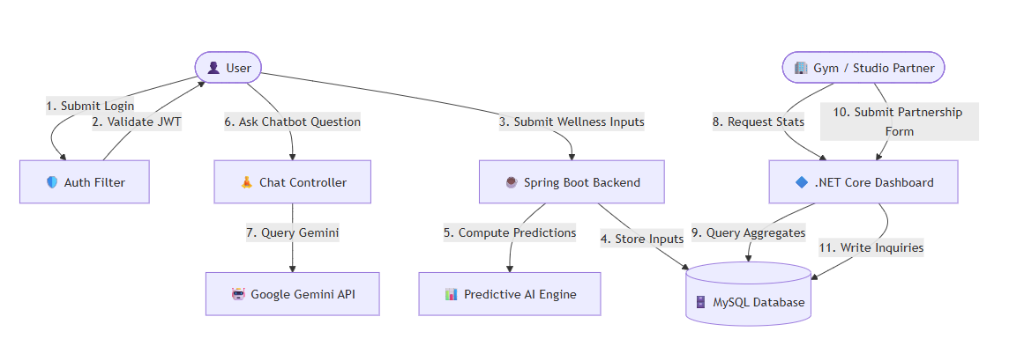
  - DFD (Data Flow Diagram)

  - ERD (Entity Relationship Diagram)
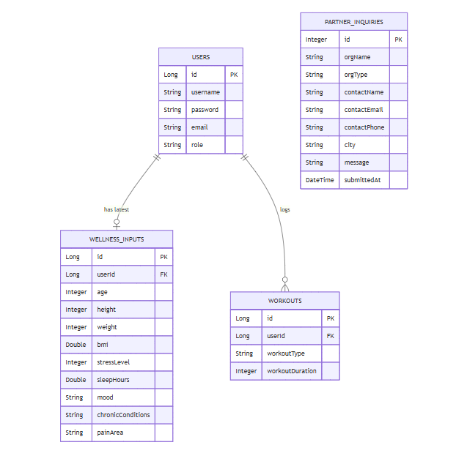

  - Use case Diagram
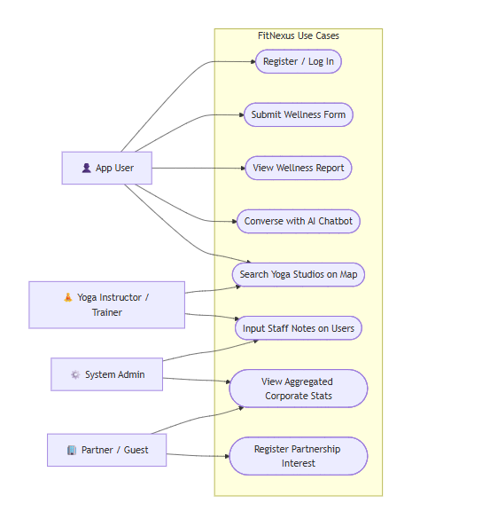
  - Class Diagram
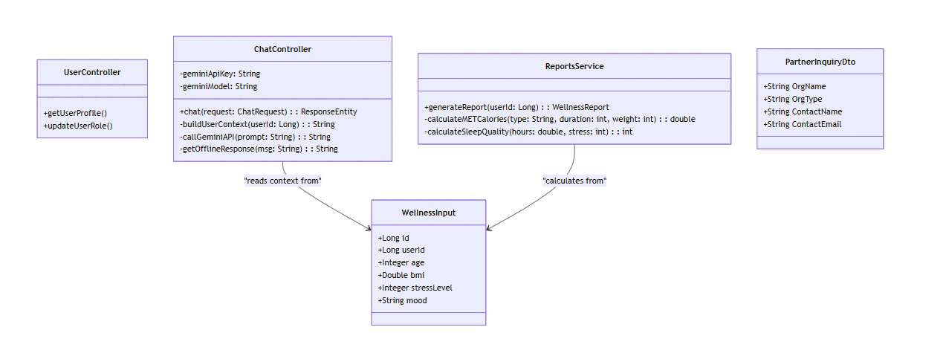
  - Sequence Diagram

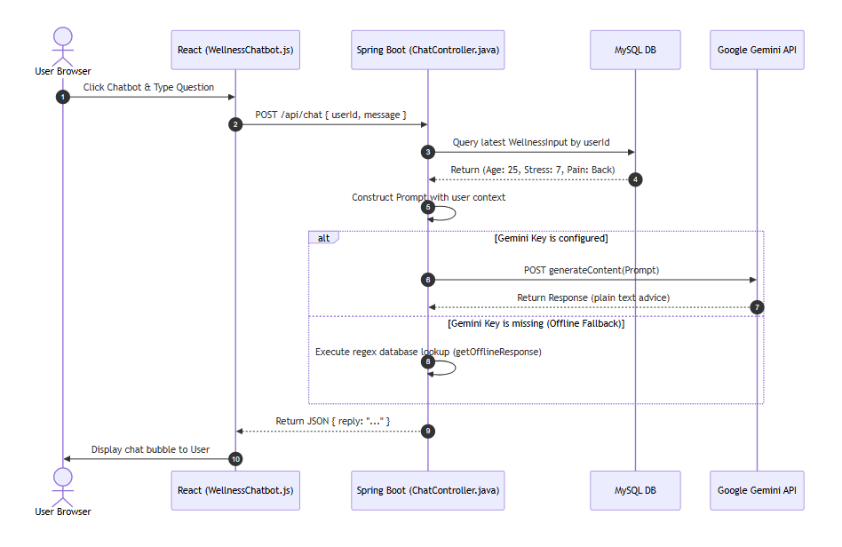

  - Activity Diagram

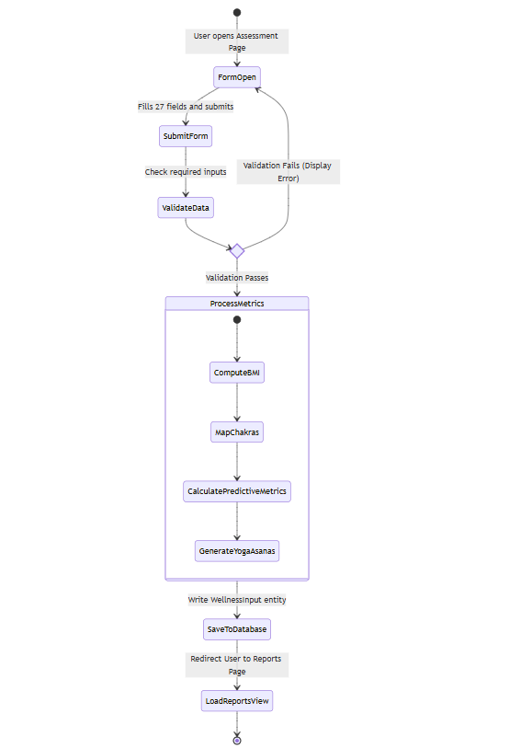

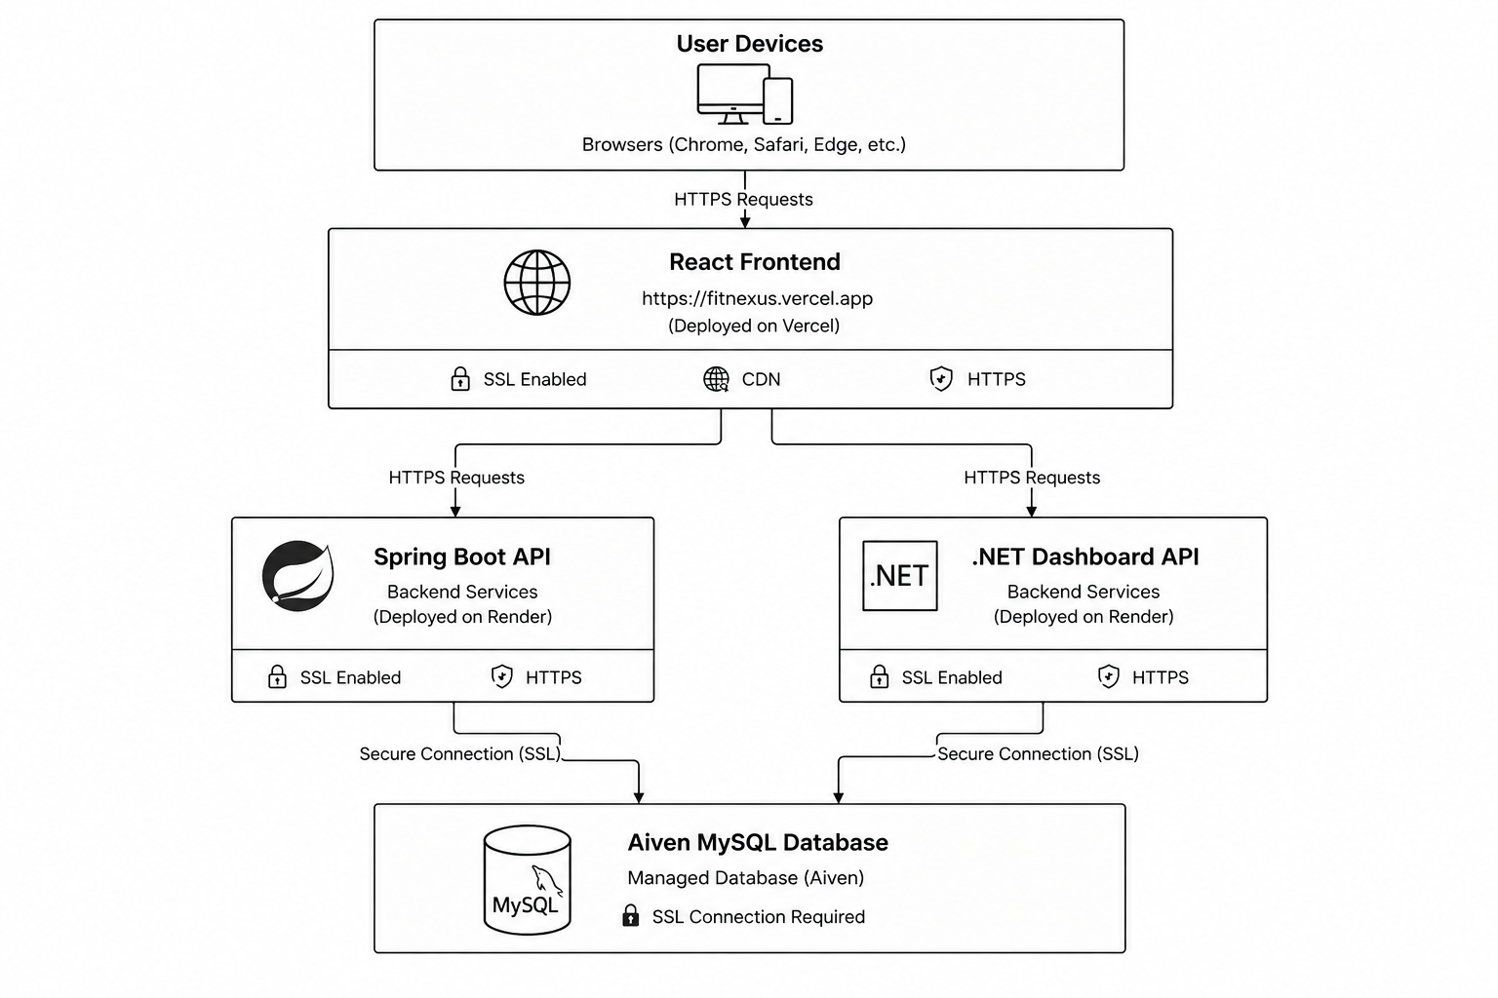
  - Deployment Diagram

  - System Architecture
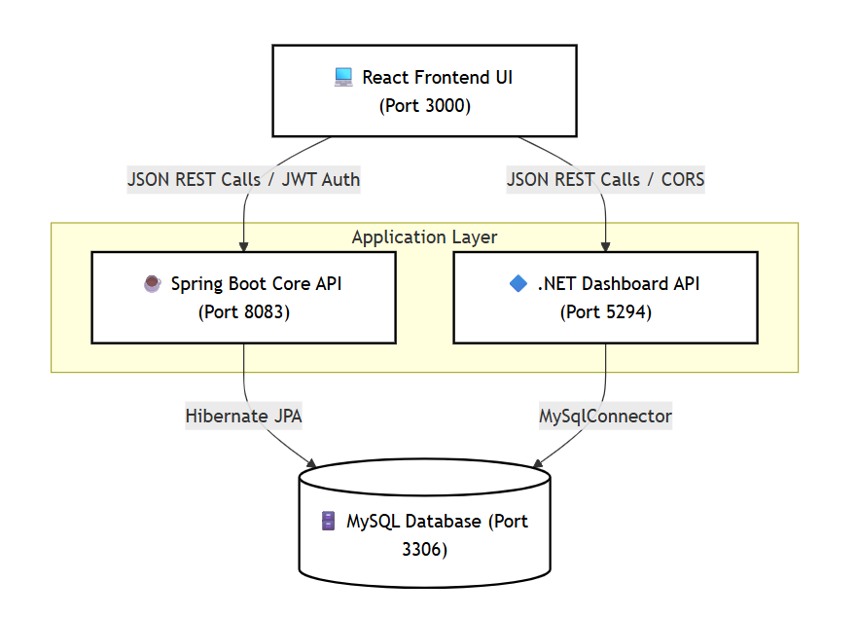

- Test Cases

Test ID | Test Objective | Input Data | Expected Outcome | Actual Outcome | Status
TC-01 | User Registration | Username: testuser, Pass: pass, Role: USER | User created in DB with encrypted password. | User saved in database. | PASSED
TC-02 | Role-Based Authorization | Access /admin route as USER role | Request is rejected (redirects to dashboard). | Access denied. | PASSED
TC-03 | Assessment Form Validation | Leave required field (Weight) empty | Prevent submission, show warning banner. | Prevented, alert displayed. | PASSED
TC-04 | Predictive MET Calories | Weight: 70kg, Yoga for 60 mins | Burn is calculated: 3.0 * 3.5 * 70 / 200 * 60 = 220.5 kcal | Burn is exactly 220.5 kcal. | PASSED
TC-05 | Chatbot Offline Fallback | Ask "back pain" with Gemini Key = Null | Return offline response advising Cat-Cow and twists. | Returned offline text instructions. | PASSED
TC-06 | Partner Inquiry Storage | Submit "Studio Info" from .NET dashboard | Data saved to partner_inquiries table. | Checked database; entry exists. | PASSED
TC-07 | Admin Inquiry Dashboard | Open Admin Console inquiries table | Fetch and render inquiries table. | Lists inquiries. | PASSED

- Screenshots

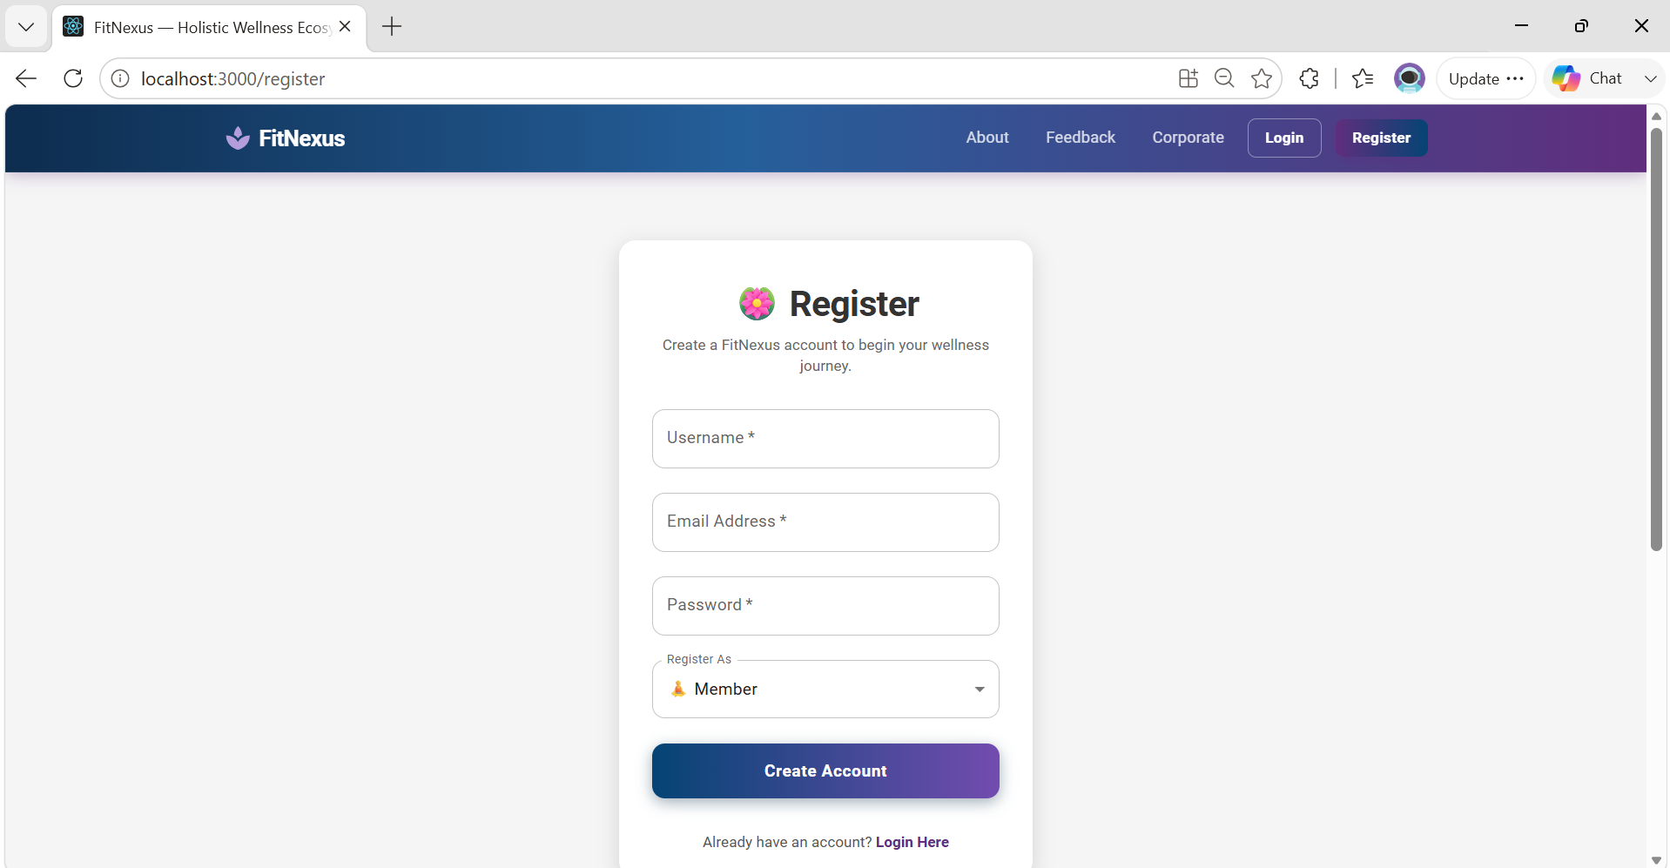
About Us Page
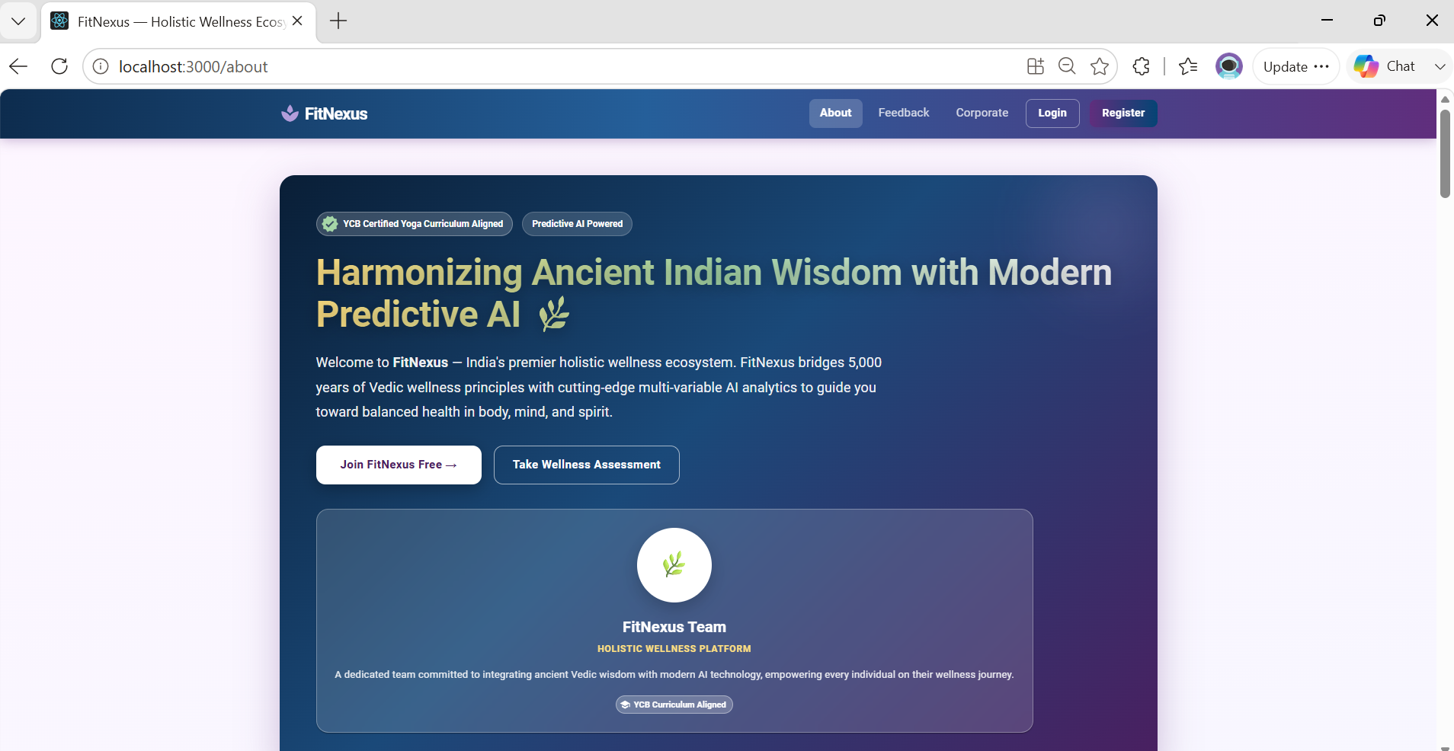
User Registrations

User Login
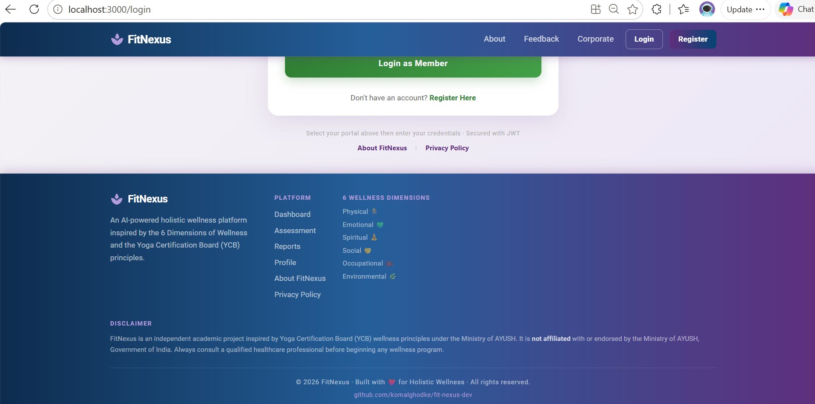
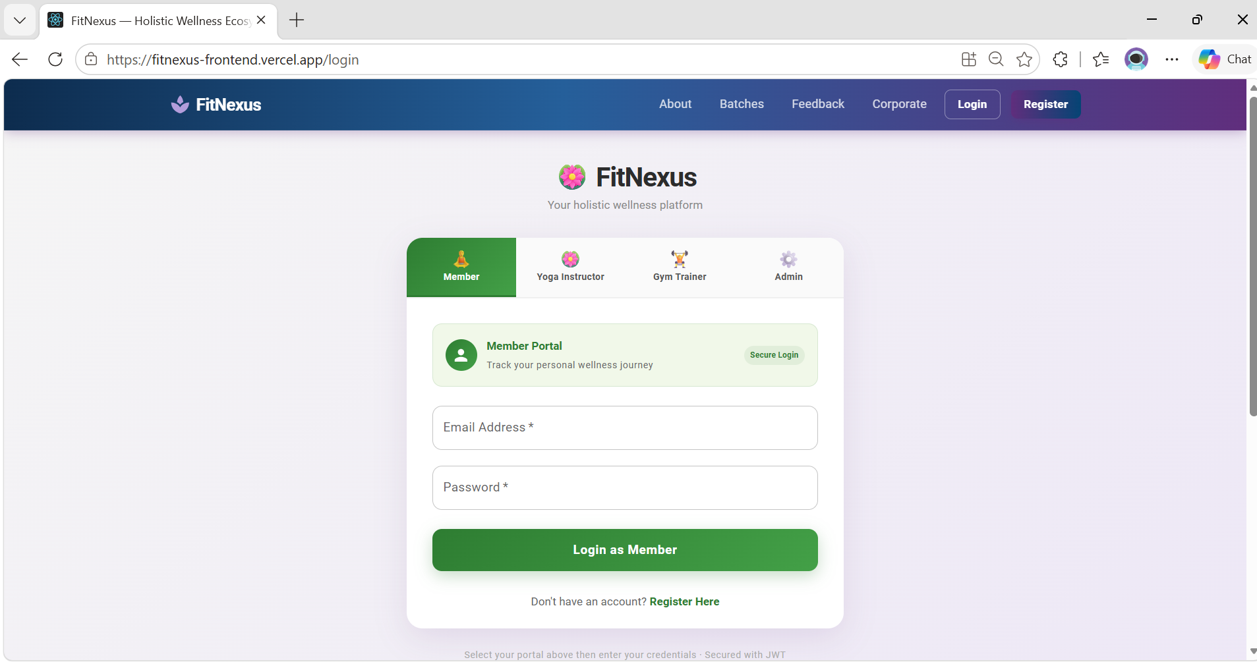Footer

About Us -Who we are
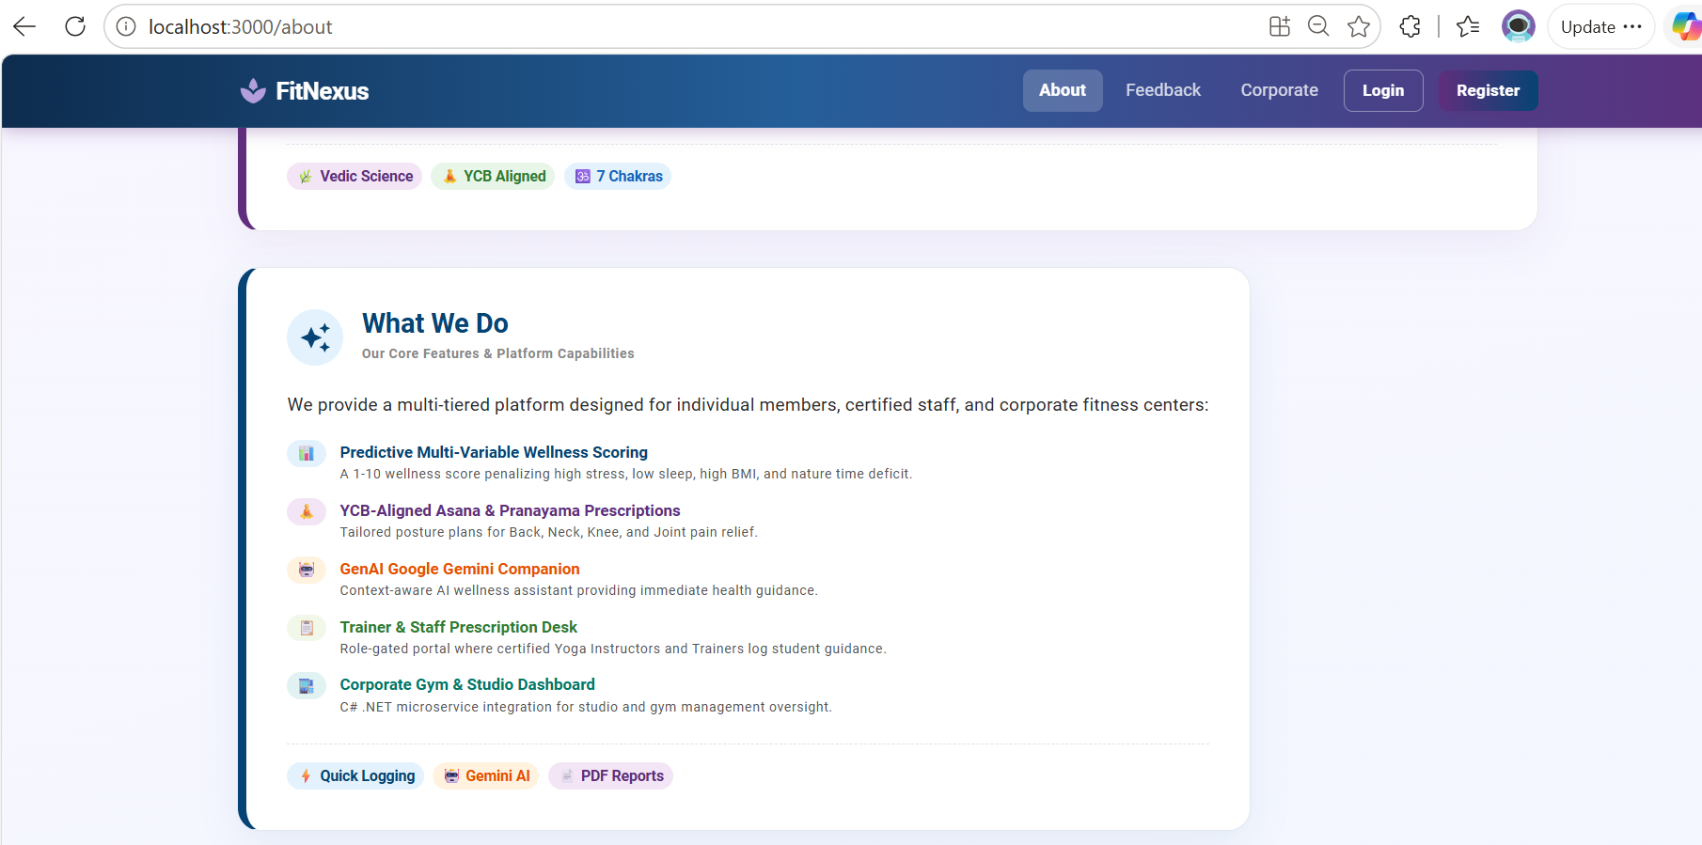
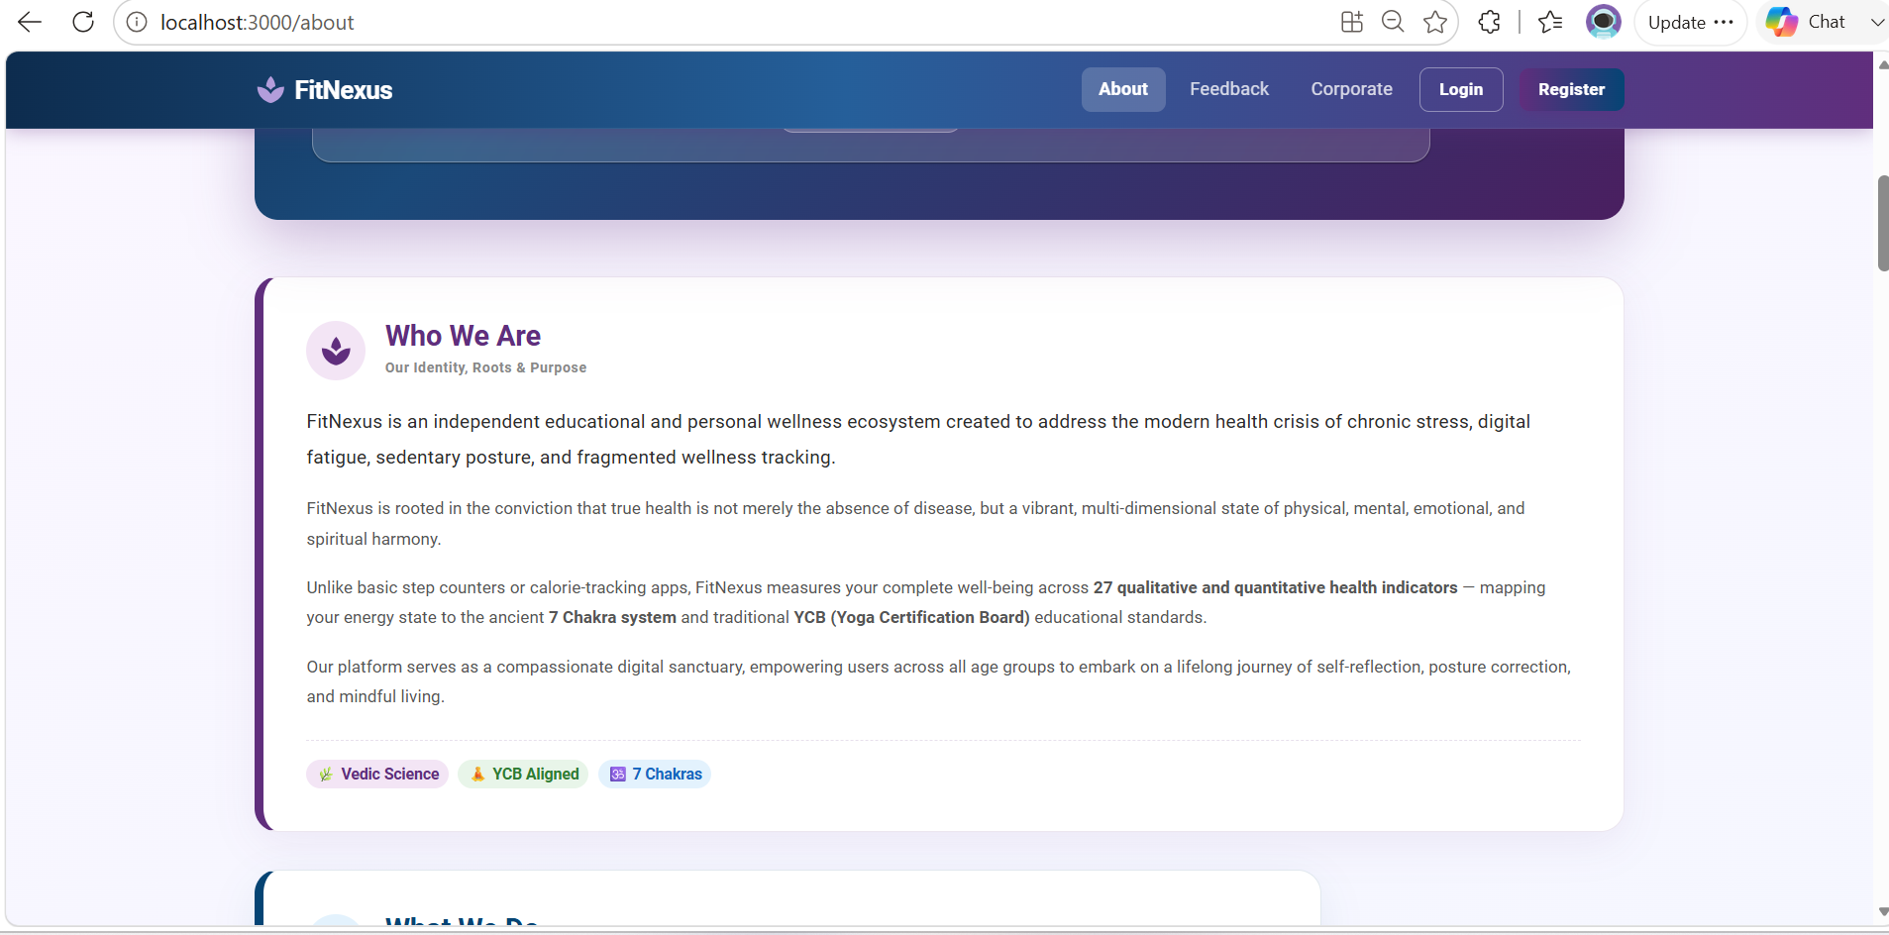
About Us -What we do

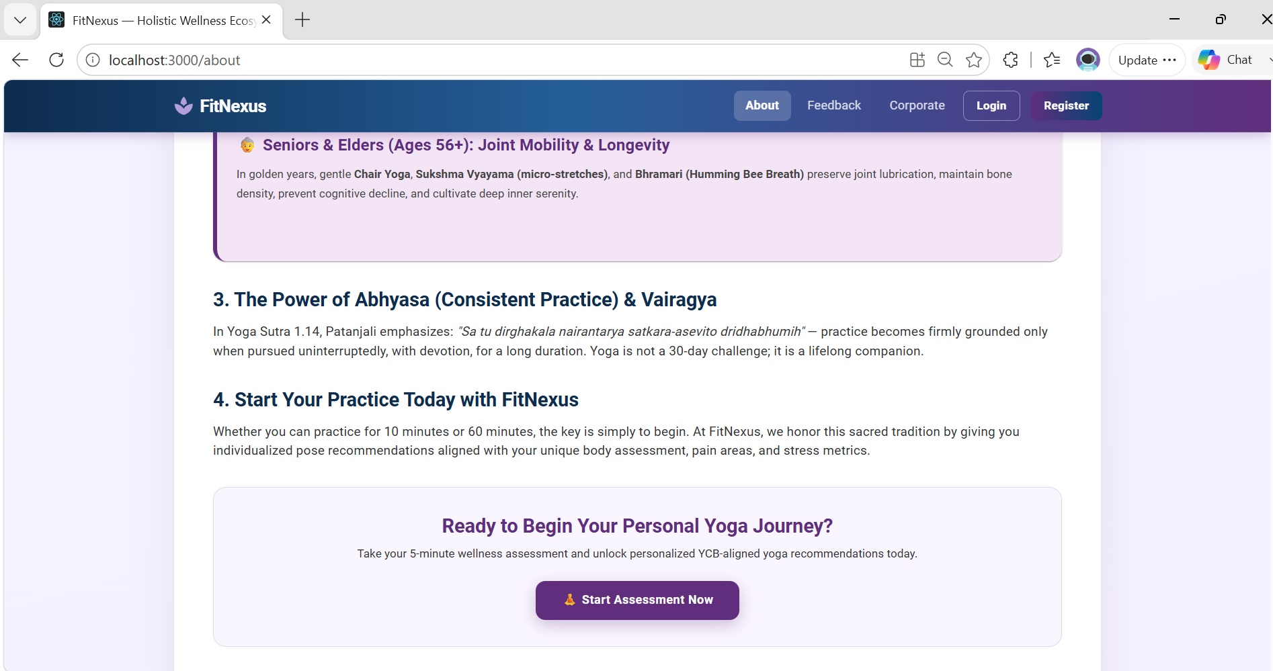

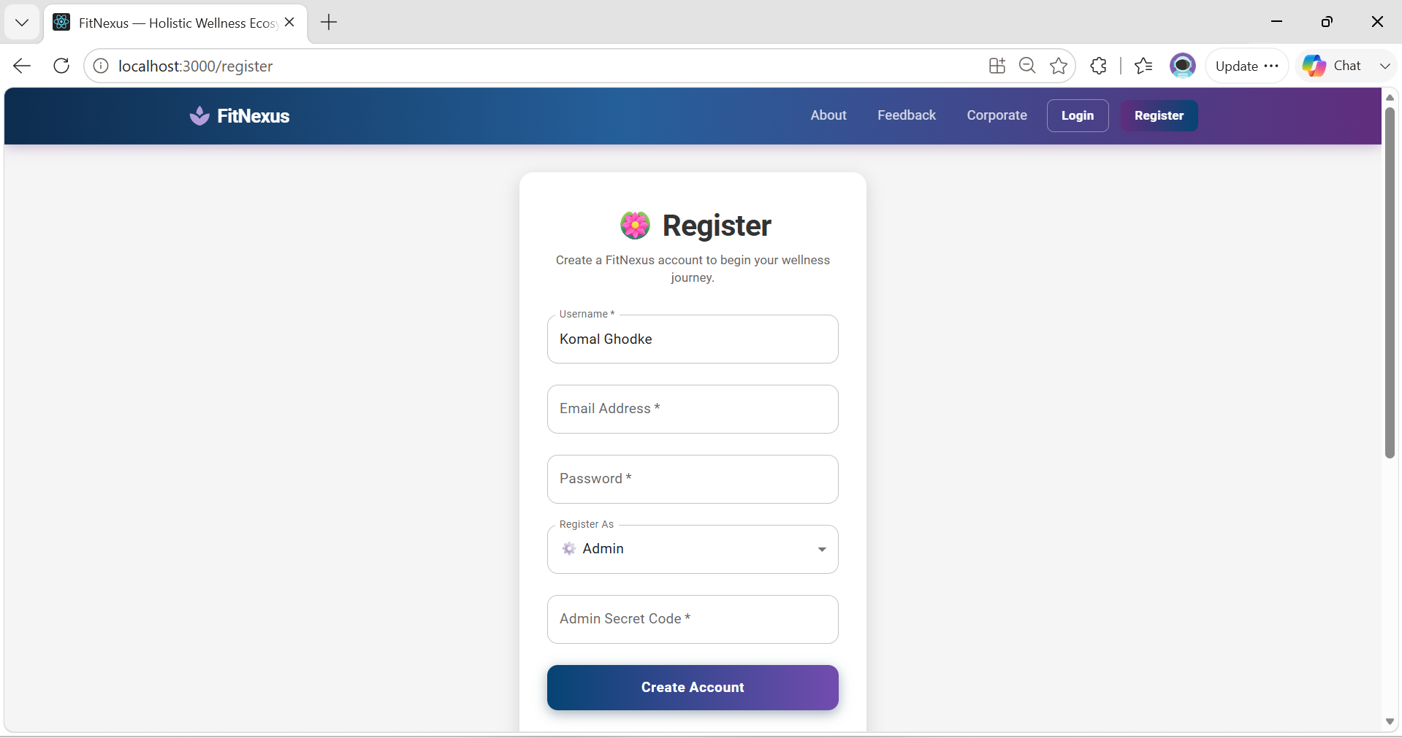
Admin Registration

Admin Portal
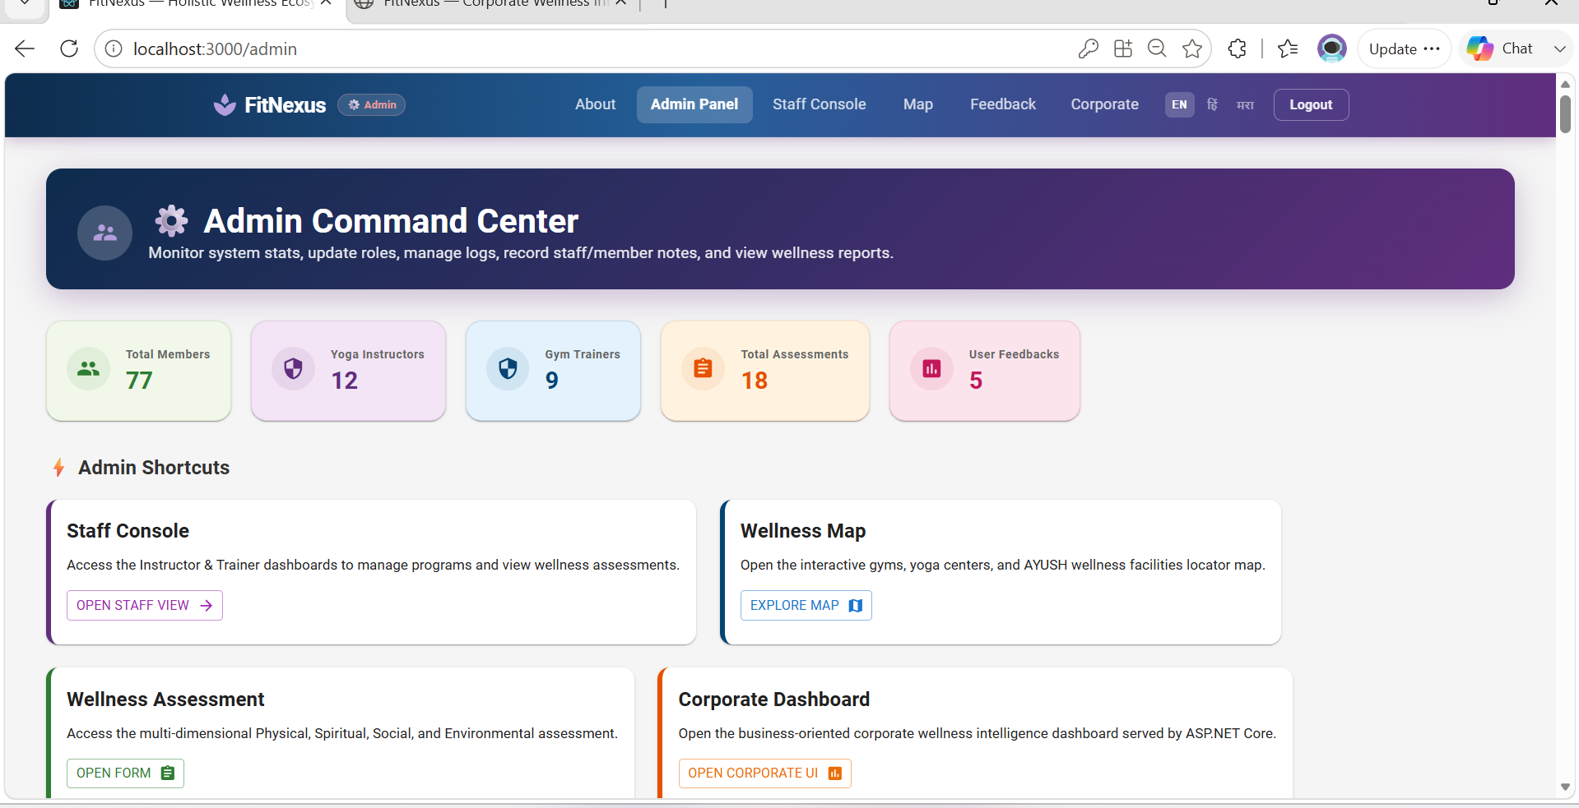
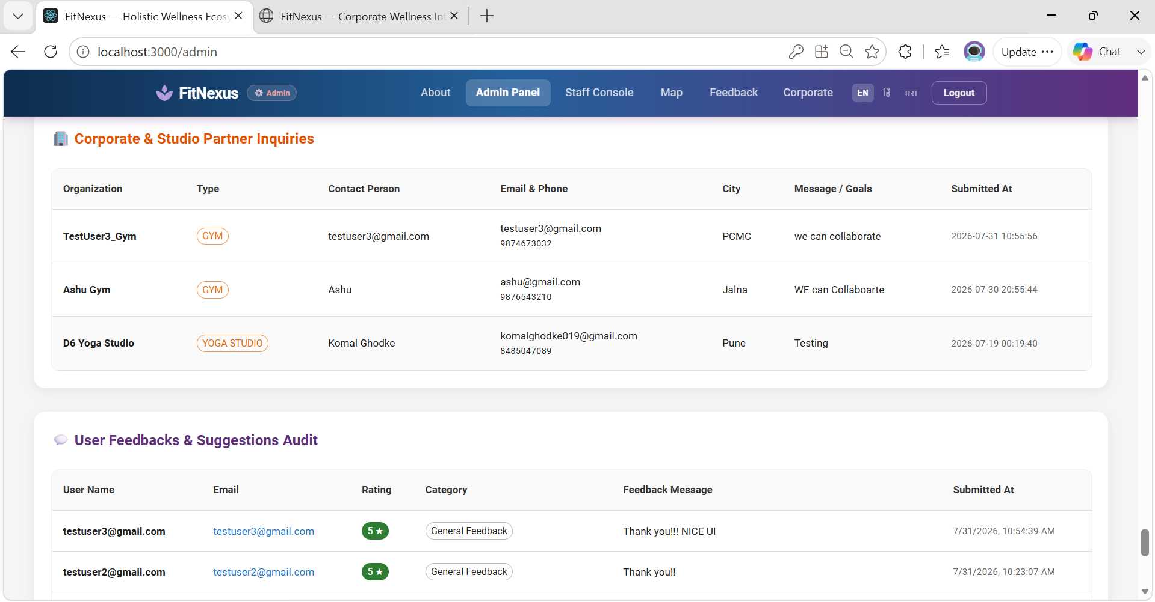
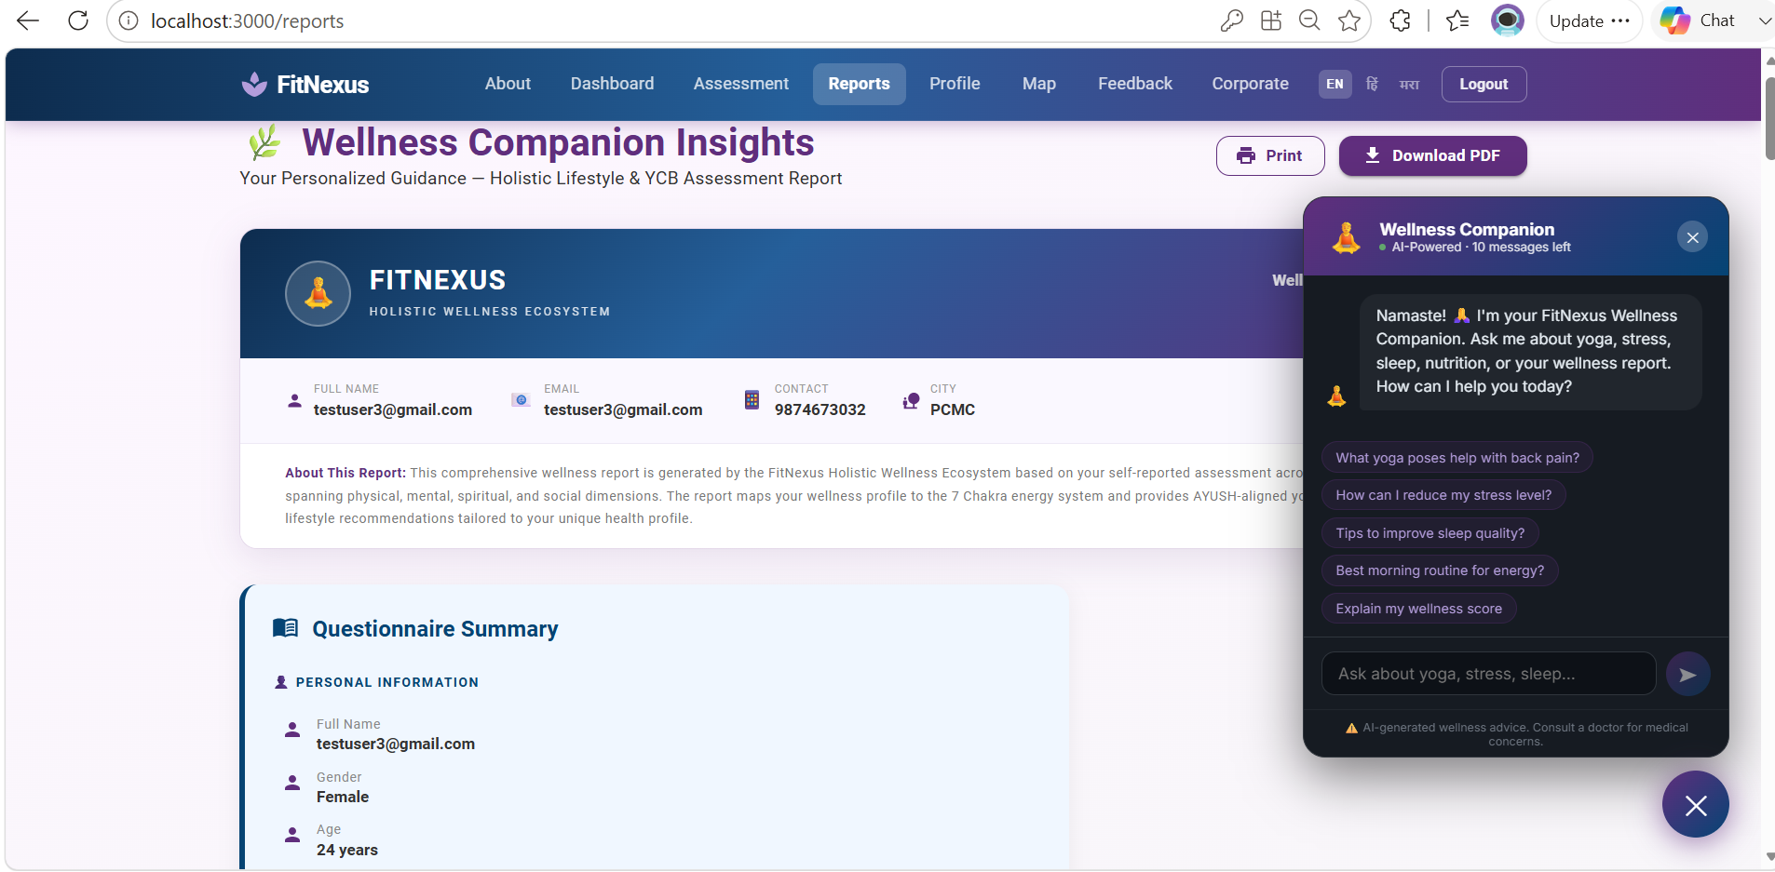
GEN AI – Wellness Companion (Predictive Report Page As well)

Map Integration
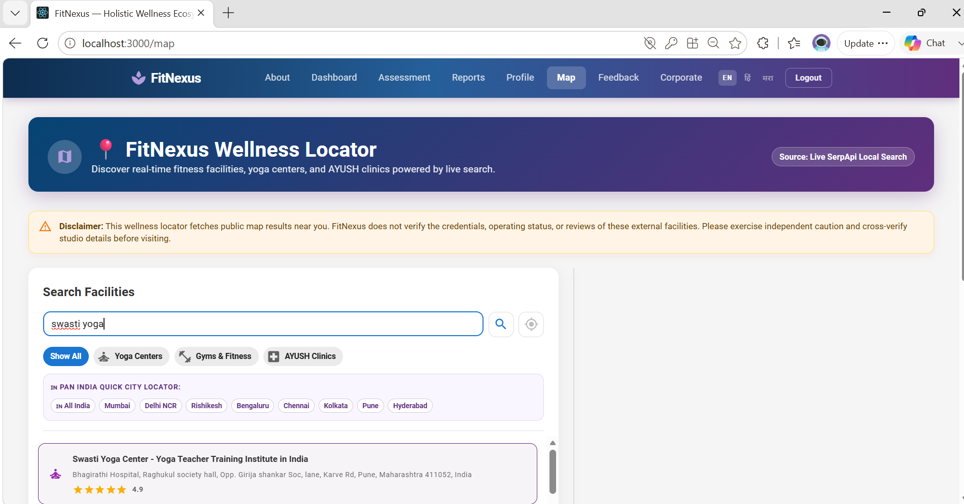
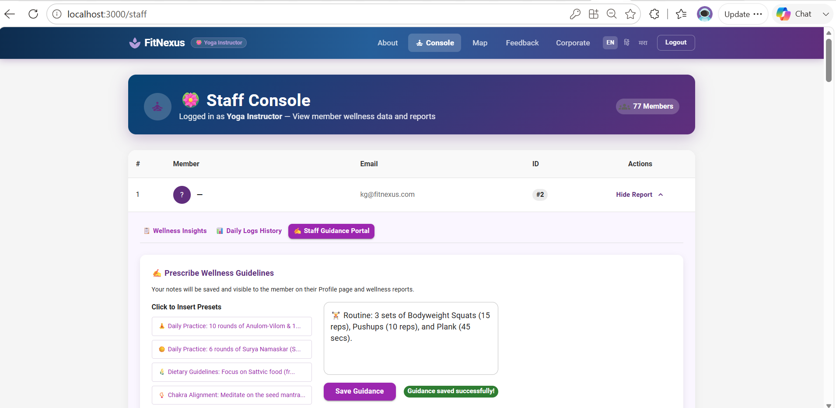
Staff Console

Corporate Dashboard – For Collab Inquiries
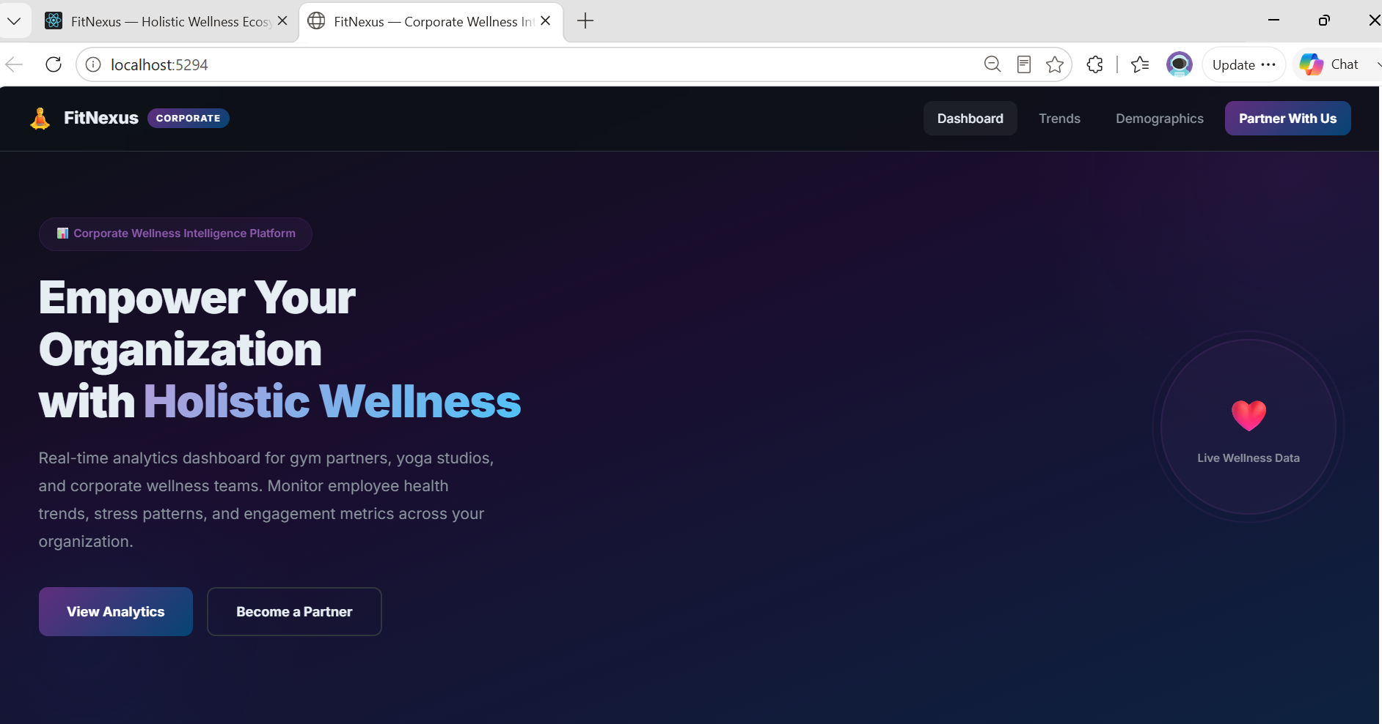
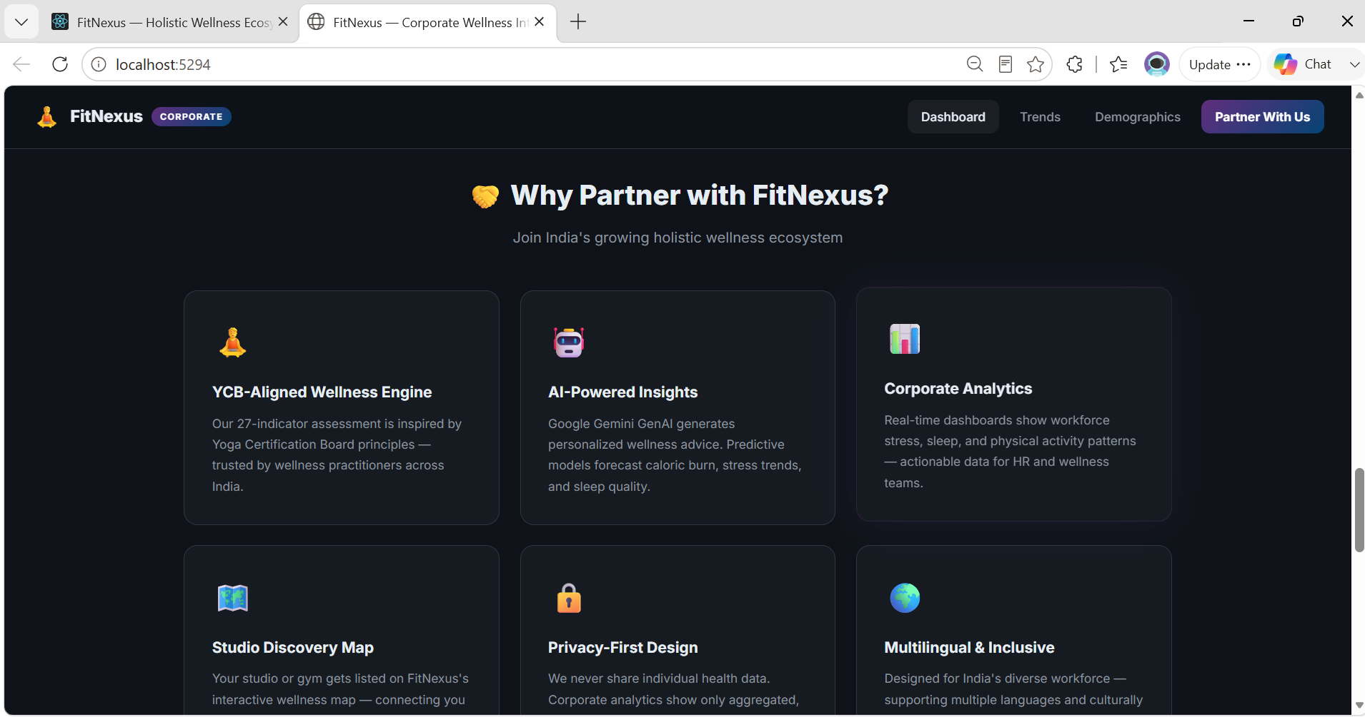

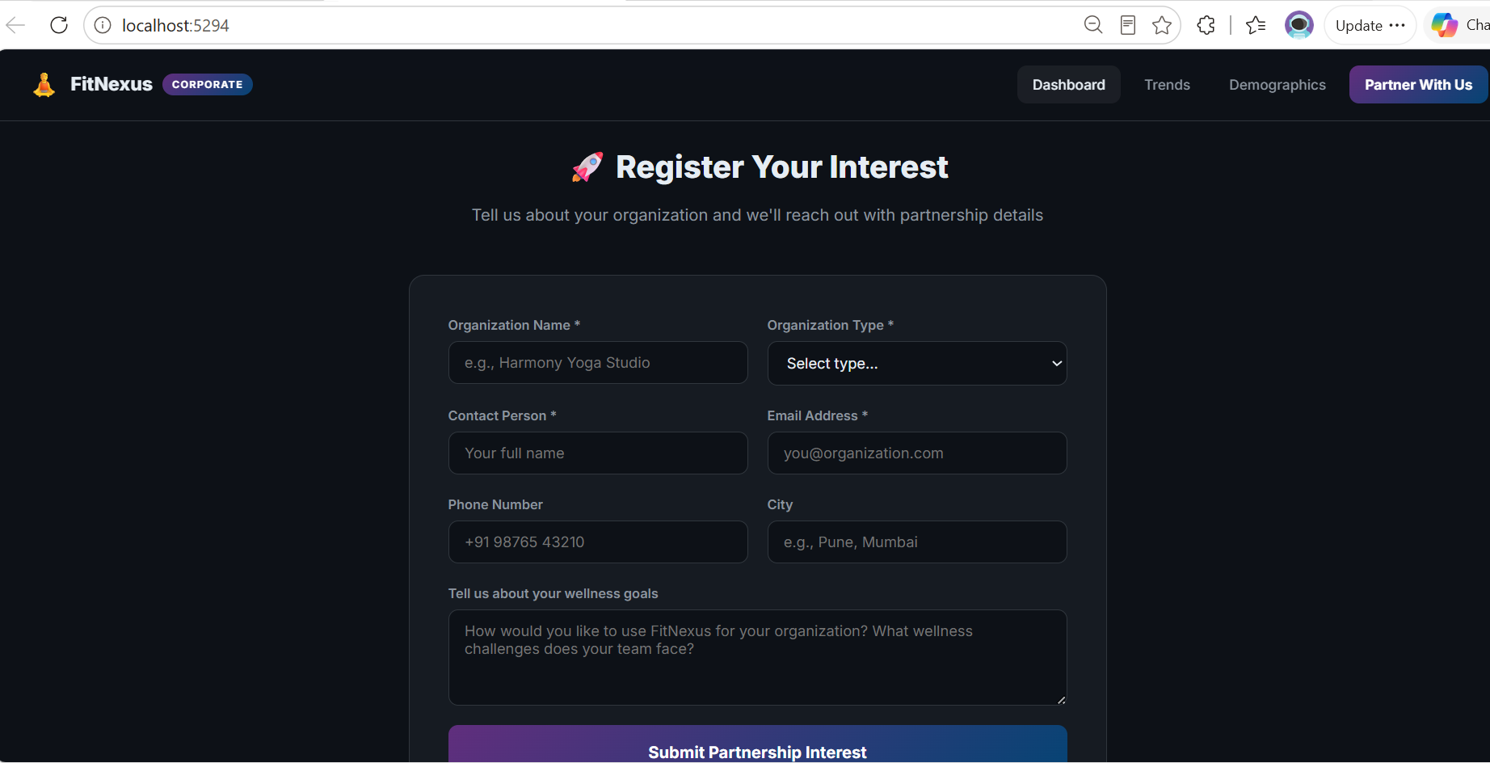
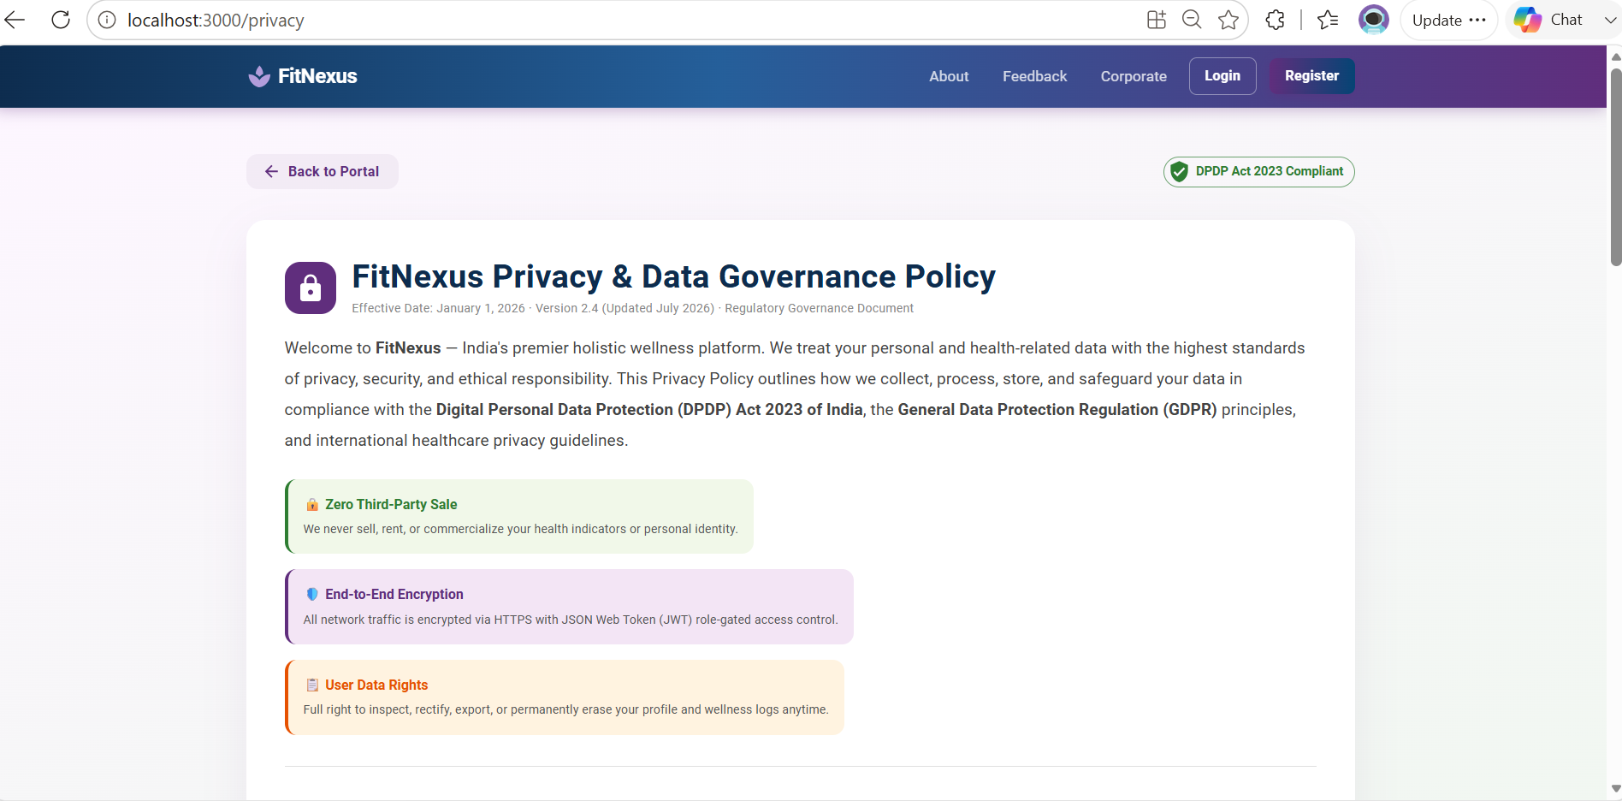
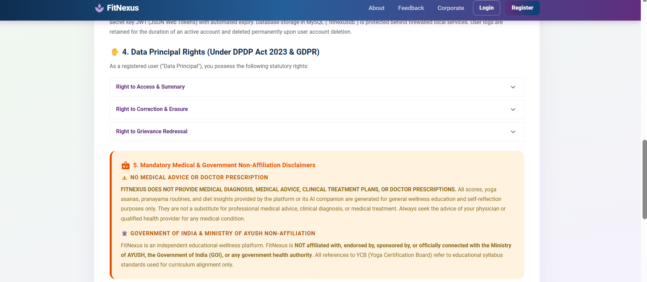
Privacy Policy

- Future Scope
- Wearable connectivity via Fitbit API.
- Expansion to enterprise wellness management.

- Conclusion

In conclusion, the Fit Nexus initiative is positioned to become a transformative wellness platform that blends secure full-stack architecture with advanced tracking and analytics. By empowering users to manage their wellness data and generate personalized reports, while also leveraging AI-driven predictive scoring and health guidance, the system ensures both personalization and proactive care. Its containerized deployment on Azure guarantees scalability and resilience, making it adaptable to growing demands. Ultimately, Fit Nexus is set to evolve into a robust enterprise solution, seamlessly integrating wearables and dashboards to deliver a comprehensive, future-ready wellness ecosystem.

- References

- Ministry of AYUSH, Government of India — Yoga Certification Board (YCB) Guidelines for Health Promotion.

- YCB Educational Curriculum & AYUSH Standards:
Ministry of AYUSH, Government of India (2020). "Yoga Certification Board (YCB) Voluntary Certification Scheme for Yoga Professionals." Ministry of AYUSH Guidelines.

- Ainsworth BE, et al. — Compendium of Physical Activities (MET Values for physical fitness calculation).

- Google Gemini API Documentation — Structured JSON responses with Generative Language SDKs.

- Spring Boot Security and JPA reference guide — Stateless token validation filters.

- Microsoft Learn — ADO.NET and MySqlConnector performance benchmarks.

- Yoga & Stress Reduction:
Pascoe, M. C., Thompson, D. R., & Ski, C. F. (2017). "Yoga, mindfulness-based stress reduction and stress-related physiological measures: A meta-analysis." Psychoneuroendocrinology, 86, 152-168.

- Pranayama, Vagus Nerve & Autonomic Nervous System:
Jerath, R., Edry, J. W., Barnes, V. A., & Jerath, V. (2006). "Physiology of long pranayamic breathing: Neural respiratory elements may provide a mechanism that explains how slow deep breathing shifts the autonomic nervous system." Medical Hypotheses, 67(3), 566-571.

- Predictive Analytics & Multi-Variable Health Scoring:
Patel, S., Park, H., Bonato, P., Chan, L., & Rodgers, M. (2012). "A review of wearable sensors and systems with application in rehabilitation." Journal of NeuroEngineering and Rehabilitation, 9(1), 21.

- Data Privacy & Governance (DPDP Act 2023):
Ministry of Electronics and Information Technology (MeitY), Government of India (2023). "The Digital Personal Data Protection Act, 2023 (Act No. 22 of 2023)." The Gazette of India.

