CLASSIFICATION OF IRIS FLOWER SPECIES USING MACHINE LEARNING ALGORITHMS
kginwal@stevens.edu

ABSTRACT
Classification is a supervised learning problem in that values are in finite unordered set. In this paper Scikit learn tools has been used for classification problem. The problem statement is concerned with building and finding the accurate models that outputs the highest accuracy. Classification of IRIS data set would be discovering patterns from examining petal and sepal size of the IRIS flower and how the prediction was made from analyzing the pattern to from the class of IRIS flower. In this paper we train the machine learning model with data and when unseen data is discovered the predictive model predicts the species using what it has been learnt from the trained data.
Keywords: Classification, K Nearest Neighbour, Machine Learning, Naïve Bayes, SVM.

1. INTRODUCTION
This paper focuses on IRIS flower classification using Machine Learning with scikit tools. The problem statement concerns the classification of IRIS flower species on the basic of flower attribute measurements. Classification of IRIS data set would be discovering patterns from examining petal and sepal size of the IRIS flower and how the prediction
2. DATA STATISTICS
The Iris flower data set or Fisher's Iris data set is a multivariate data set introduced by the British statistician and biologist Ronald Fisher in his 1936 paper.
Iris Flower Dataset : It contains 150 observations of iris flowers. It consists of four columns of measurements of the flowers in centimeters. The fifth column is the species of the flower observed.
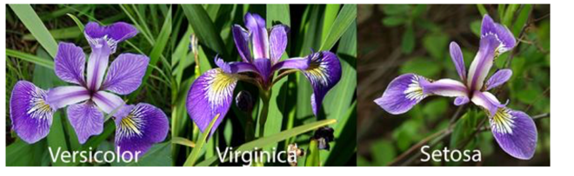
3. PROBLEM DEFINITION
To design and implement the Classification of Iris Flower species using machine learning using Python and the tool Scikit-Learn.
4. WORK CARRIED OUT
- Collection and Loading Dtaset
- Data Visualization:
  - Multivariate Plot to understand relationship between attributes.
  - Univariate Plot to understand each attribute.
- Evaluation of Algorithm
We will split the loaded dataset into two, 80% of which we will use to train, evaluate and select among our models, and 20% that we will hold back as a validation dataset.

Test Harness:
Stratified 10-fold cross validation to estimate model accuracy.
This will split our dataset into 10 parts, train on 9 and test on 1 and repeat for all combinations of train-test splits.

Build Models: Six types of classification algorithms were tested. The reasons for experimenting with each of these algorithms and their prediction approaches will be discussed below:
We'll evaluate these 6 -algorithms:
- Logistic Regression (LR)
- Linear Discriminate Analysis (LDA)
- K-Nearest Neighbours (KNN)
- Classification and Regression Trees (CRT)
- Guassian Naive Bayes (GNN)
- Support Vector Machine (SVM)
5. RESULT

5.1 Make Predictions
We can make predictions on the validation dataset by fitting the entire model on training dataset.

5.2 Evaluate Predictions
We can evaluate the predictions by comparing them to the expected results in the validation set, then calculate classification accuracy, as well as a confusion matrix and a classification report.
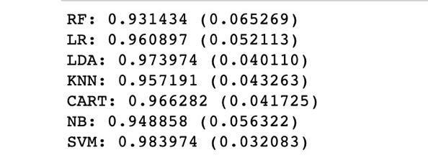

We can see that the accuracy is 0.966 or about 96% on the hold out dataset.
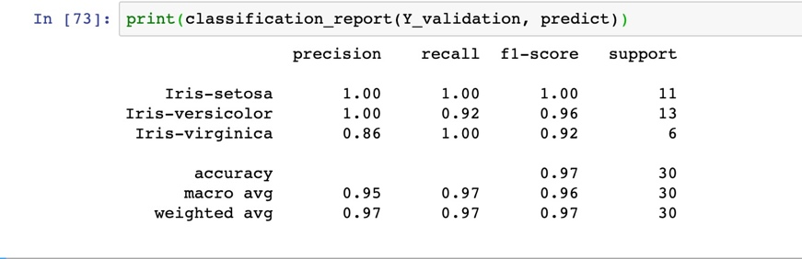

The results in the previous section suggest that the SVM was perhaps the most accurate model. We will use this model as our final model.
We can evaluate the predictions by comparing them to the expected results in the validation set, then calculate classification accuracy,
Finally, the classification report provides a breakdown of each class by precision, recall, f1-score and support showing excellent results (granted the validation dataset was small).
6. CONCLUSION
The primary goal of supervised learning is to build a model that “generalizes”. Here in this project we make predictions on unseen data which is the data not used to train the model hence the machine learning model built should accurately predicts the species of future flowers rather than accurately predicting the label of already trained data.
7. REFERENCES
1.https://ipasj.org/IIJCS/Volume5Issue8/IIJCS-2017-08-18-18.pdf
2.https://elitedatascience.com/machine-learning-for-beginners#stock-prices

