PRACTICAL NO. 1
Aim: Import the legacy data from different sources such as ( Excel , SqlServer, Oracle etc.) and load in the target system. ( You can download sample database such as Adventureworks, Northwind, foodmart etc.)
Step 1: Open Power BI
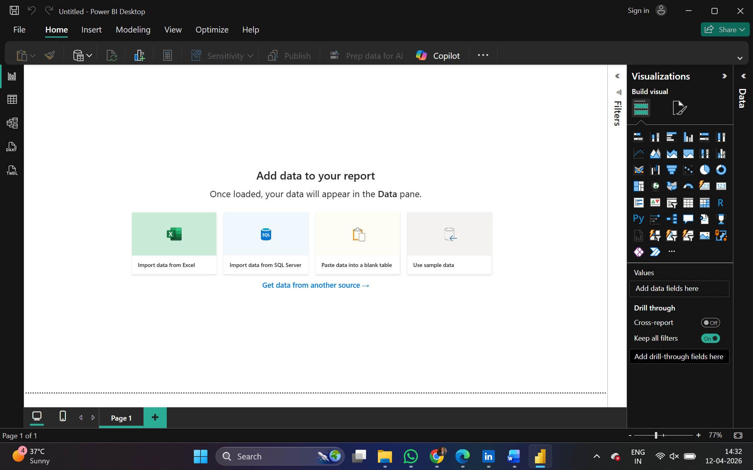
Step 2: Click on Get data following list will be displayed → select Excel
Data can also be imported from SQL Server and Oracle databases using the Get Data option in Power BI.
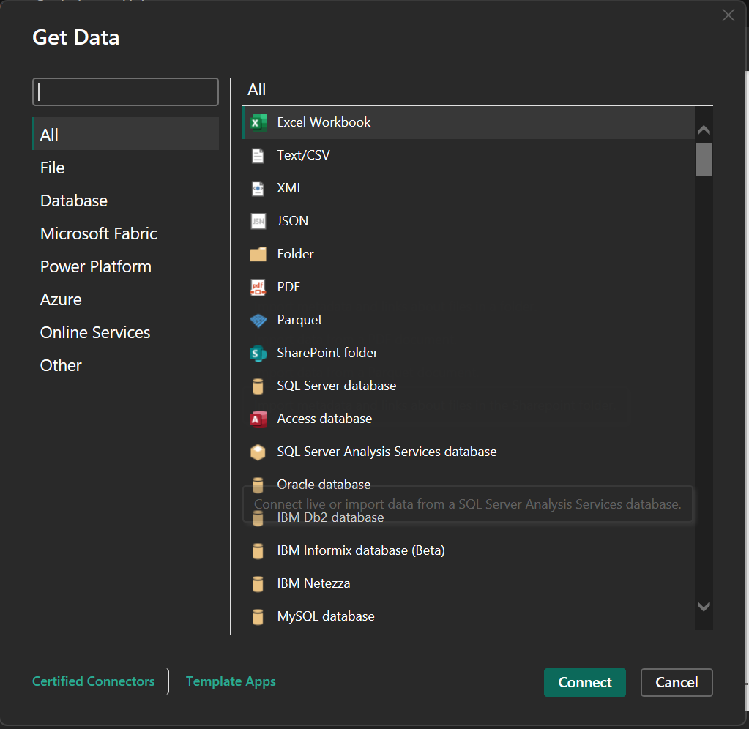

Step 3: Select required file and click on Open, Navigator screen appears

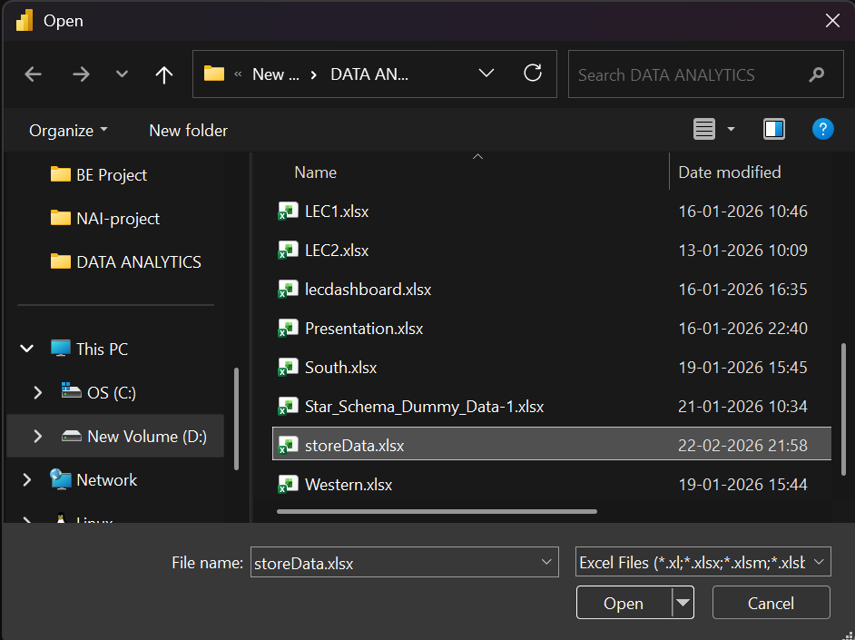.
Step 4: Select file and click on transform data

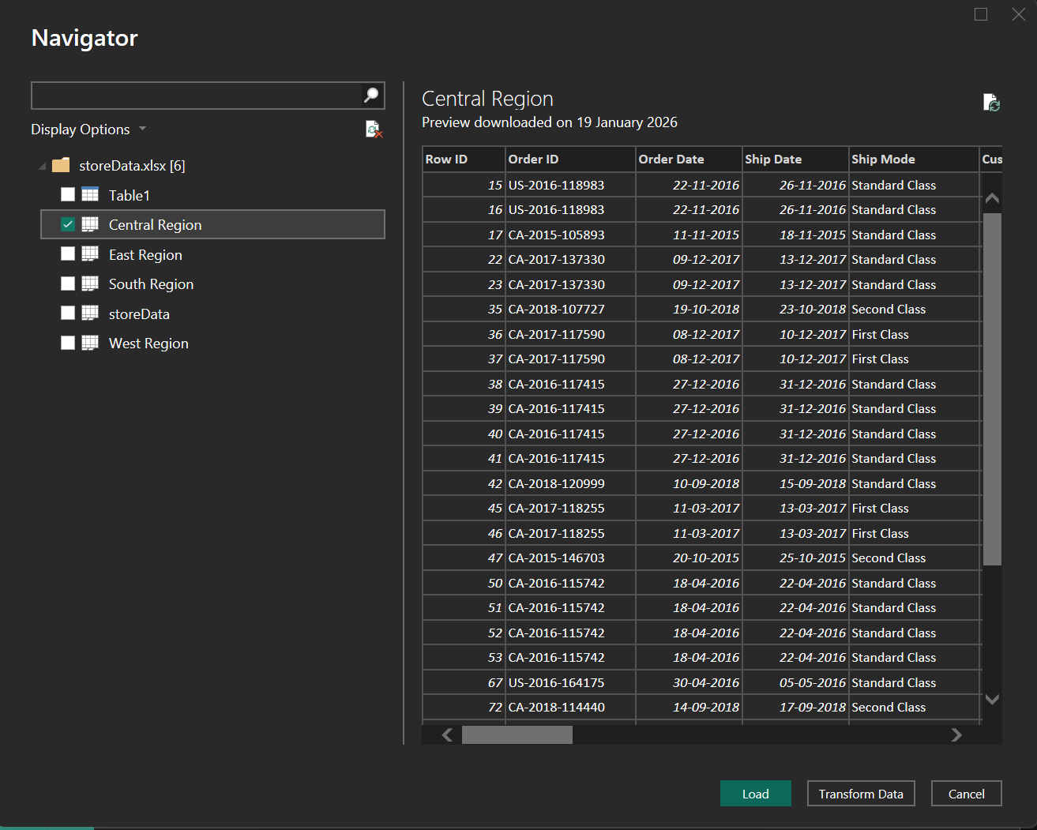

Step 5: Power query editor appears
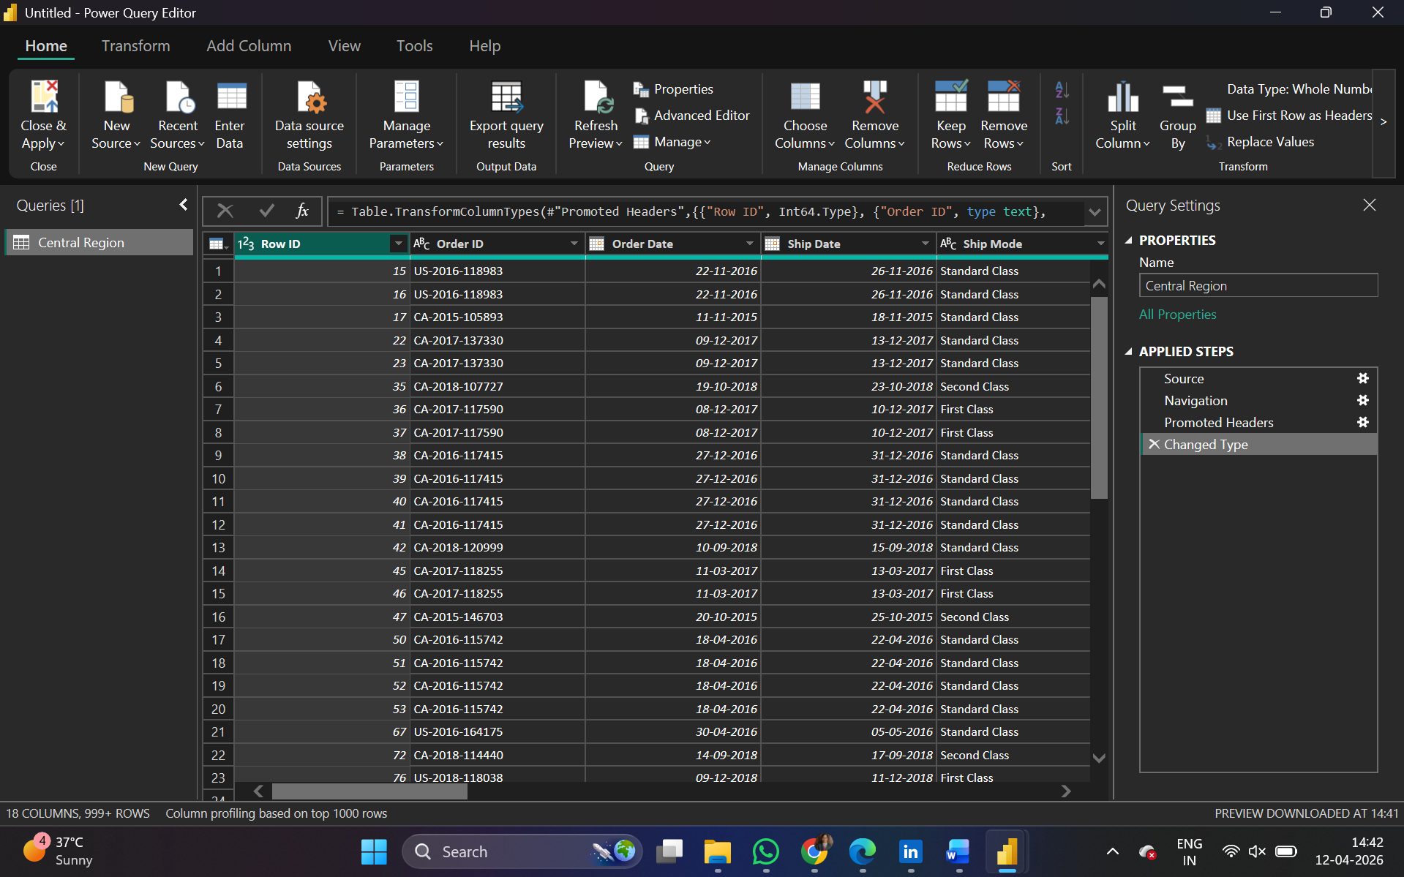

Step 6: Again, go to Get Data and select OData feed
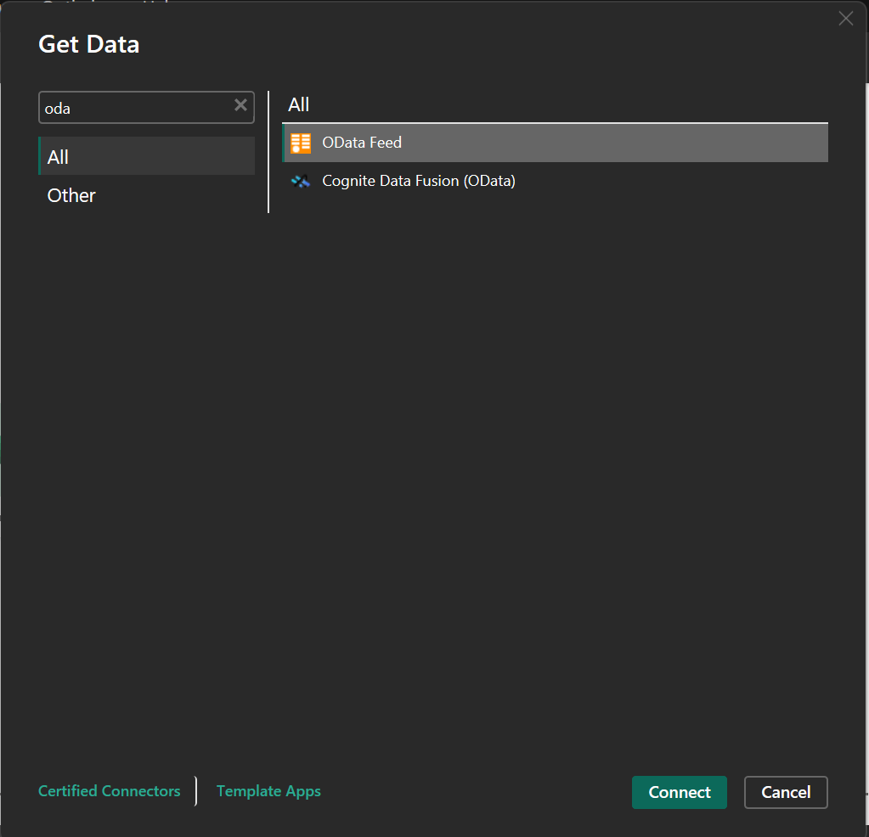
Step 7:
Paste url as http://services.odata.org/V3/Northwind/Northwind.svc/ Click on ok
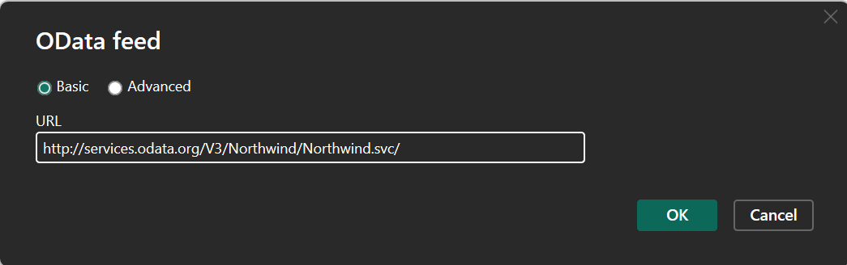

Step 8: Select orders table
And click on edit
Note: If you just want to see preview you can just click on table name without clicking on checkbox
Click on transform to view table
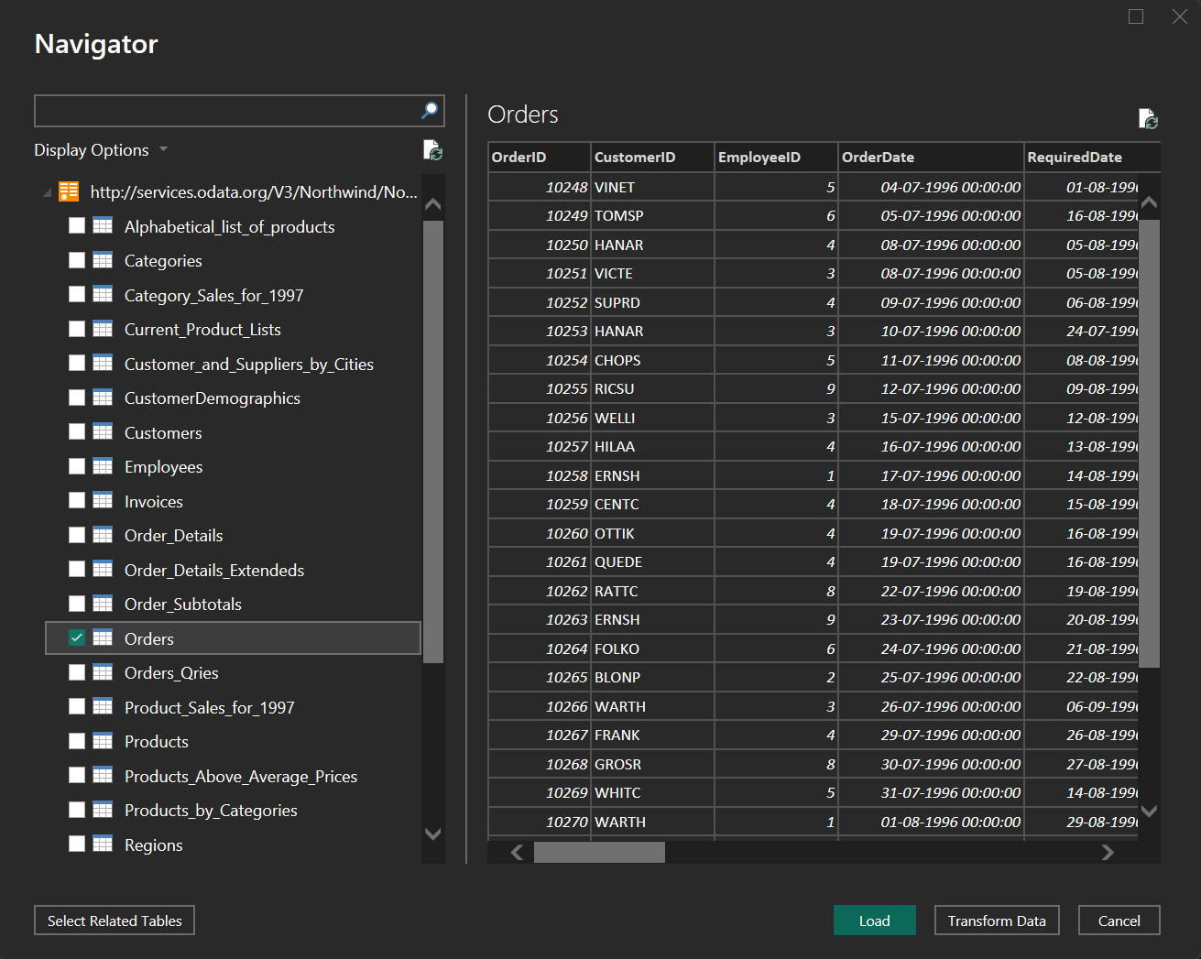
Step 9: Click on Close & Apply to load the data into Power BI.
The Orders table from Northwind OData source is successfully loaded and displayed.

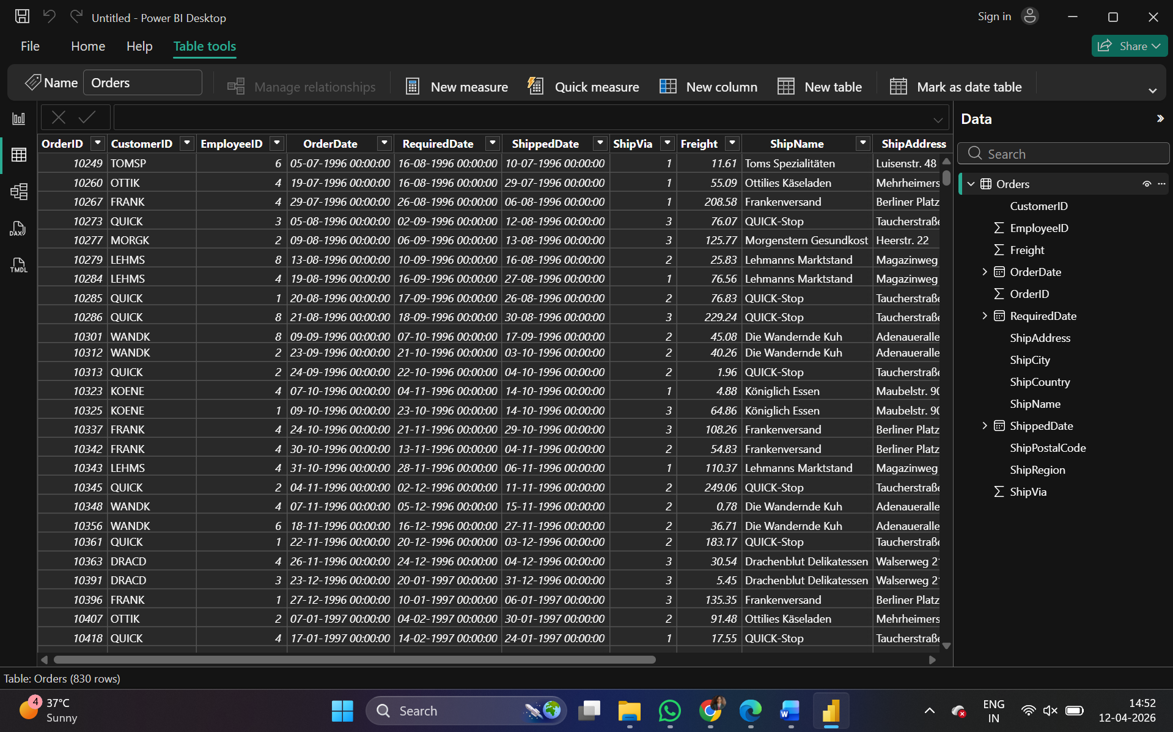
Result:
The legacy data from Excel and OData (Northwind Orders table) is successfully imported and loaded into Power BI.
Conclusion
The practical demonstrated how legacy data from heterogeneous sources such as Excel files and OData services can be integrated into Power BI. It shows that Power BI acts as a powerful data ingestion and transformation tool, forming the foundation for further data analysis and visualization in Business Intelligence workflows.

