PRACTICAL NO. 2
Aim: To perform Extraction, Transformation and Loading (ETL) process using SQL Server.
Theory:
ETL stands for Extraction, Transformation and Loading.
- Extraction: Data is collected from different sources such as files or databases.
- Transformation: Data is cleaned, modified, or processed into a suitable format.
- Loading: The processed data is stored into a target database.
In this practical, SQL Server is used to perform ETL operations.
Step 1: Installation of SQL Server
SQL Server 2022 Express Edition was installed successfully.
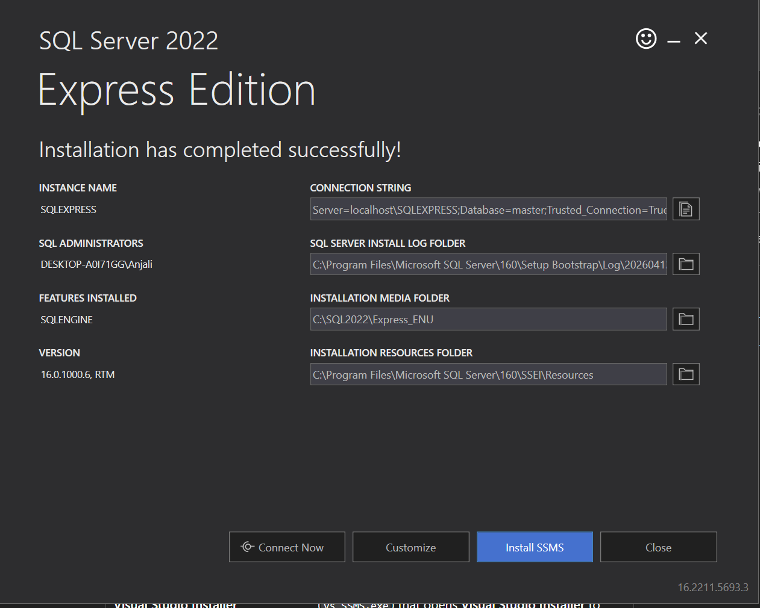
Step 2: Installation of SSMS
SQL Server Management Studio (SSMS) was installed to manage and interact with the database.
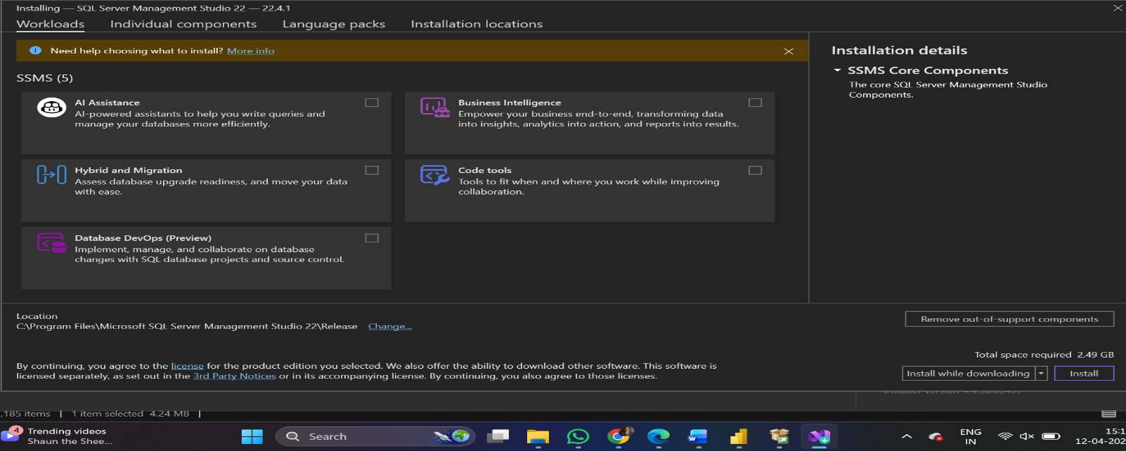
Step 3: Connecting to SQL Server
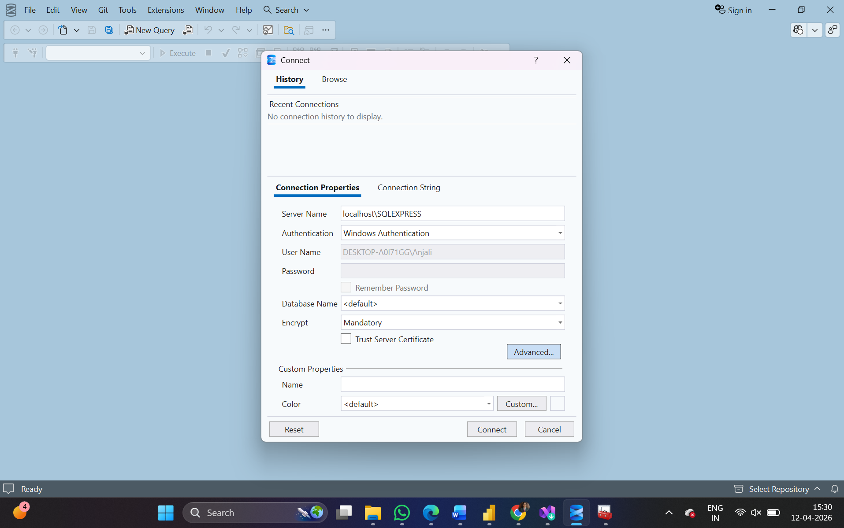
Step 4: Creating Database
A database named BI_Practical was created using SQL query.
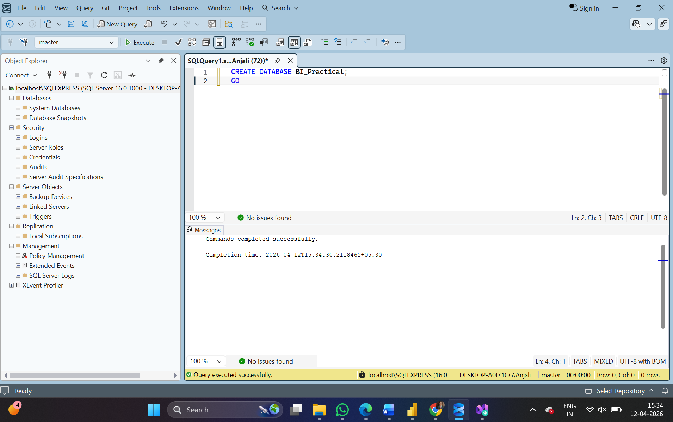
Step 5: Creating Table
A table named StudentData was created in the database.
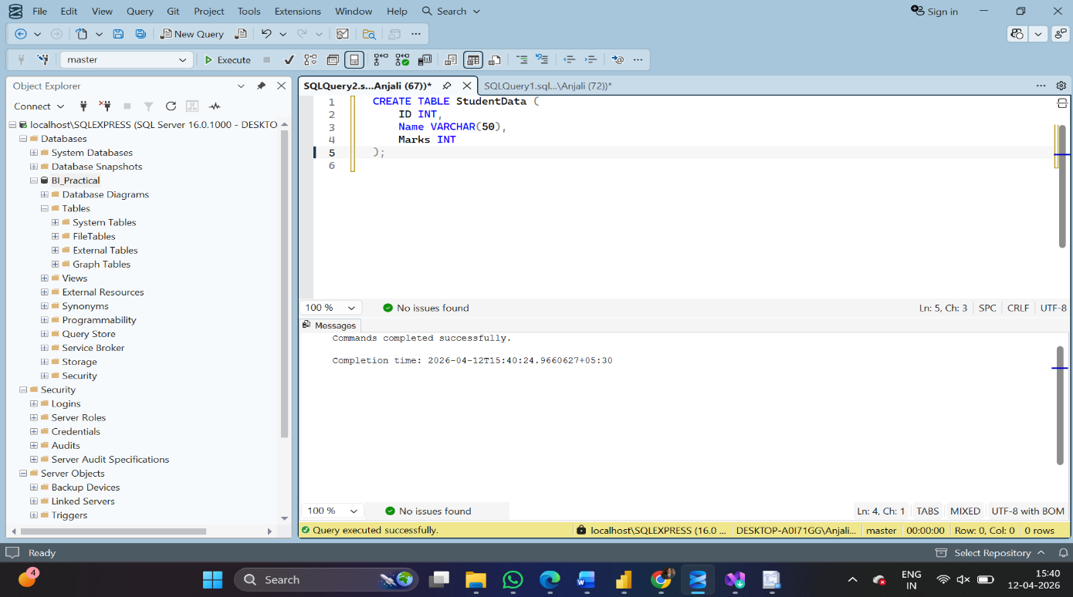
Step 6, 7, 8: Data Loading, Transformation and Output
Data was inserted into the table using INSERT query.
Transformation was performed by increasing marks by 10%.
Finally, the data was retrieved using SELECT query.
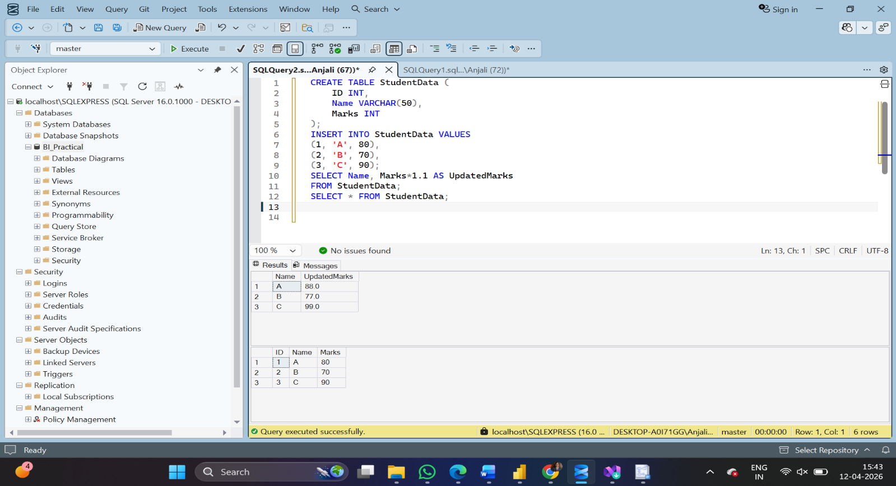
Result:
The ETL process was successfully performed using SQL Server. Data was extracted, transformed, and loaded into the database.
Conclusion
The practical demonstrated the complete ETL pipeline using SQL Server, where data was extracted from source input, transformed using SQL queries, and loaded into a structured database. This shows that ETL is a process rather than a tool, and SQL itself can be used to perform data cleaning and transformation, which is essential for building reliable data warehouses.

