PRACTICAL NO. 3
Aim: Create the cube with suitable dimension and fact tables based on ROLAP, MOLAP and HOLAP model.
Tools Used:
Microsoft SQL Server 2022
SQL Server Management Studio (SSMS)

Theory:
ROLAP (Relational OLAP):
- Data is stored in relational tables
- Queries are performed using SQL
- Suitable for large datasets

MOLAP (Multidimensional OLAP):
- Data is stored in multidimensional cube
- Fast query performance due to pre-computation
- Requires OLAP tools like SQL Server Analysis Services

HOLAP (Hybrid OLAP):
- Combination of ROLAP and MOLAP
- Detailed data in relational tables
- Aggregated data stored in cube
Procedure:
Step 1: Create Dimension and Fact Tables
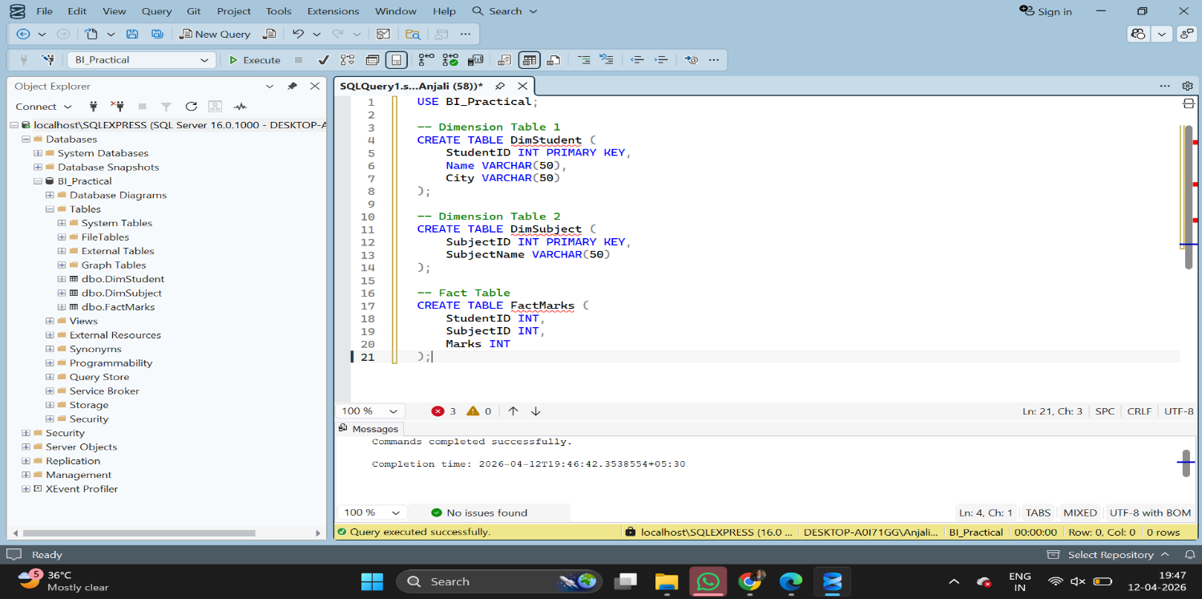

Step 2: Insert Data into Tables
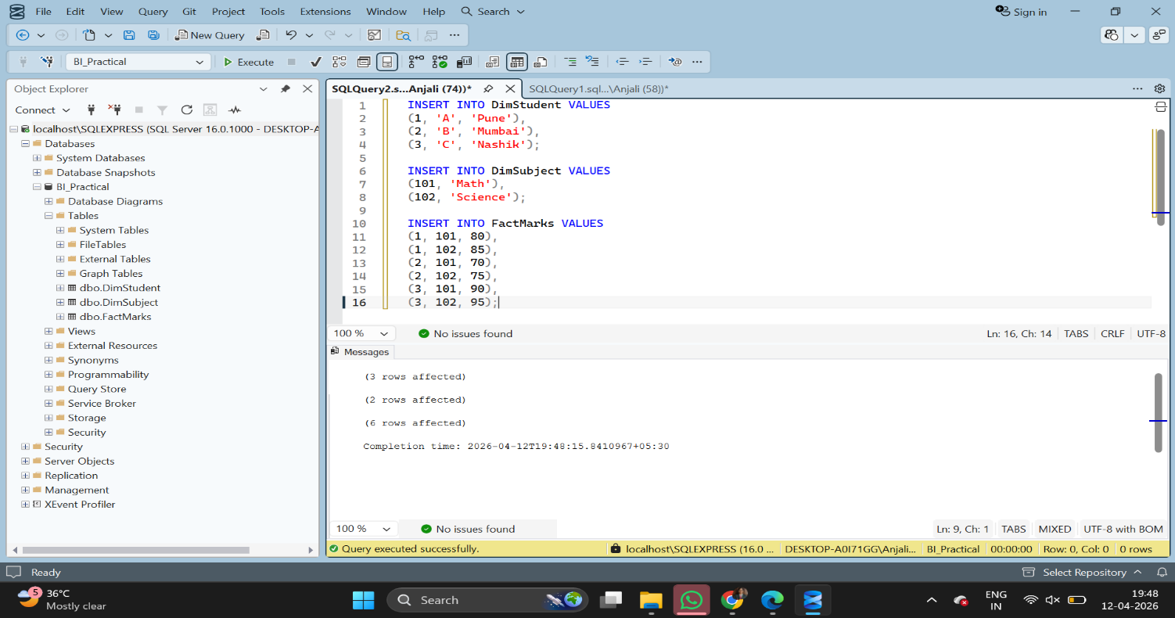
Step 3: Perform OLAP Operation (ROLAP Query)
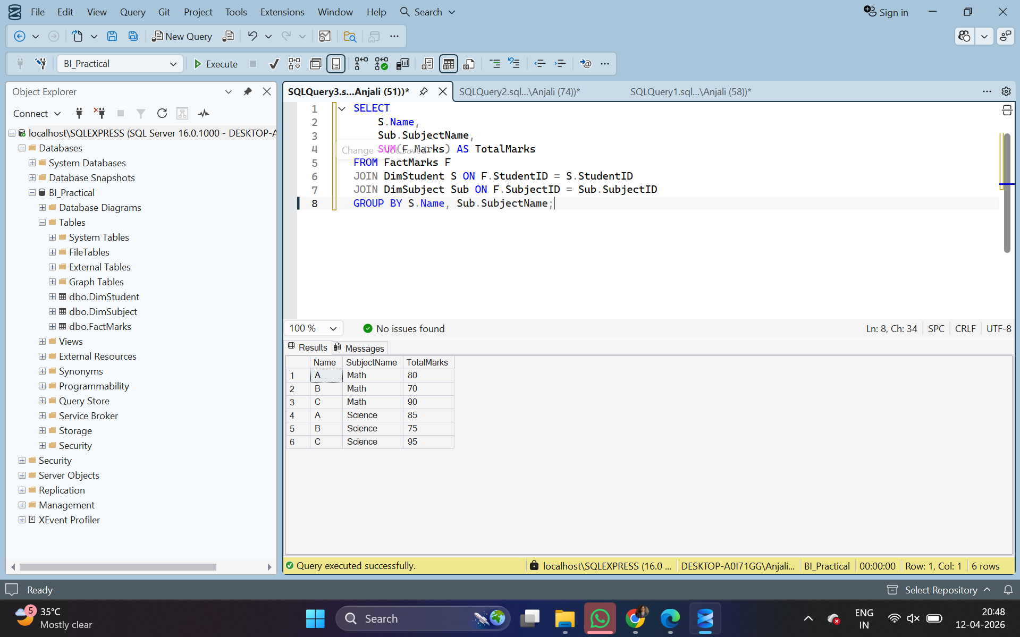
Result:
- Fact and Dimension tables were successfully created.
- Data was inserted successfully.
- OLAP operation was performed using SQL query (ROLAP).
- Output shows aggregated marks based on student and subject.
Conclusion:
- ROLAP model was implemented using SQL queries.
- MOLAP and HOLAP models were studied theoretically.
- Cube creation requires additional tools like Analysis Services.

