PRACTICAL NO. 4
Aim: To import data warehouse data from SQL Server into Microsoft Excel and create Pivot Table and Pivot Chart for analysis.

Tools Used:
- Microsoft SQL Server
- SQL Server Management Studio (SSMS)
- Microsoft Excel

Procedure:
Step 1: Connect Excel to SQL Server
- Open Excel
- Go to Data → Get Data → From SQL Server Database
- Enter server name: localhost\SQLEXPRESS
- Select database: BI_Practical
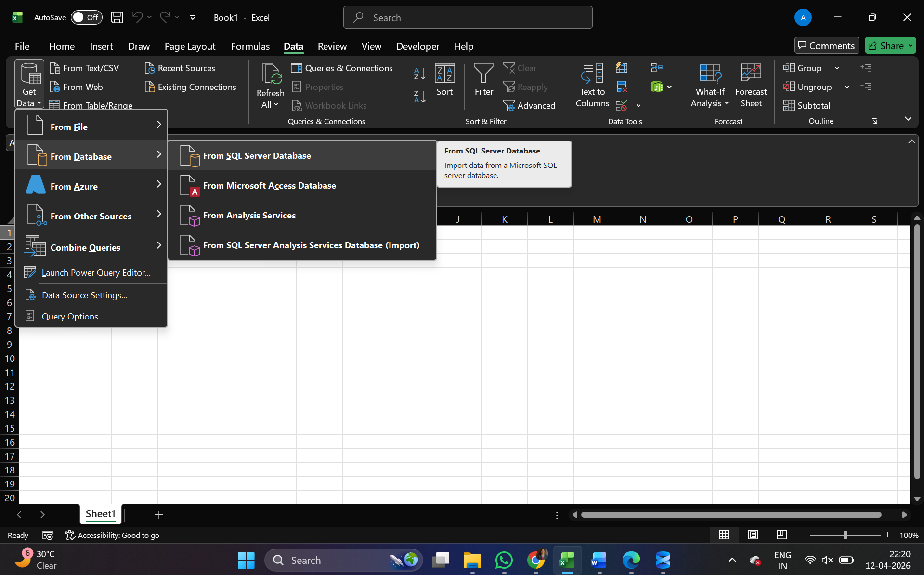
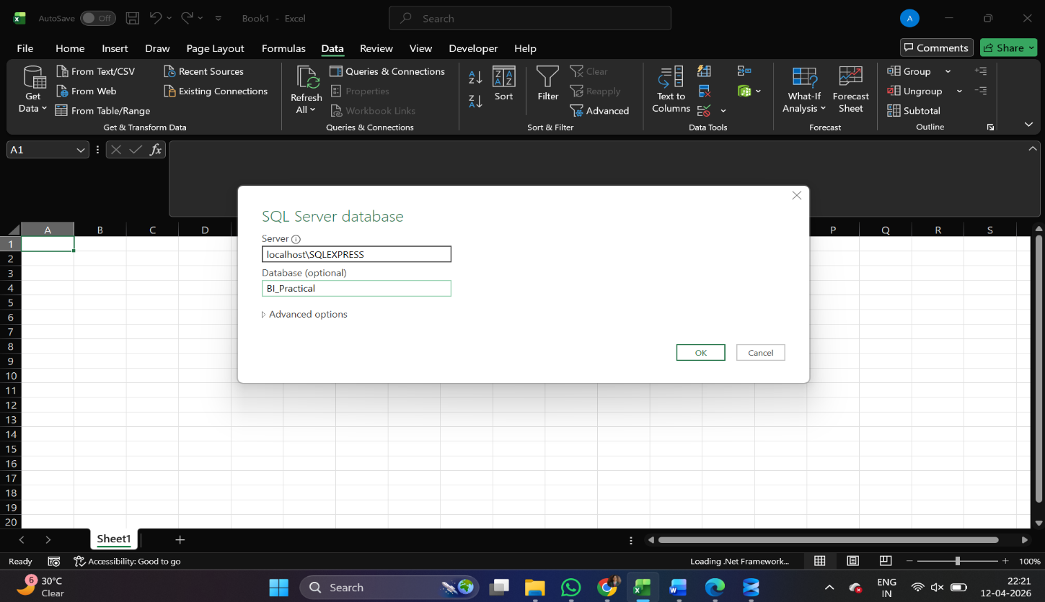

Step 2: Select Tables
- In Navigator, select:
  - DimStudent
  - DimSubject
  - FactMarks
- Click Transform Data
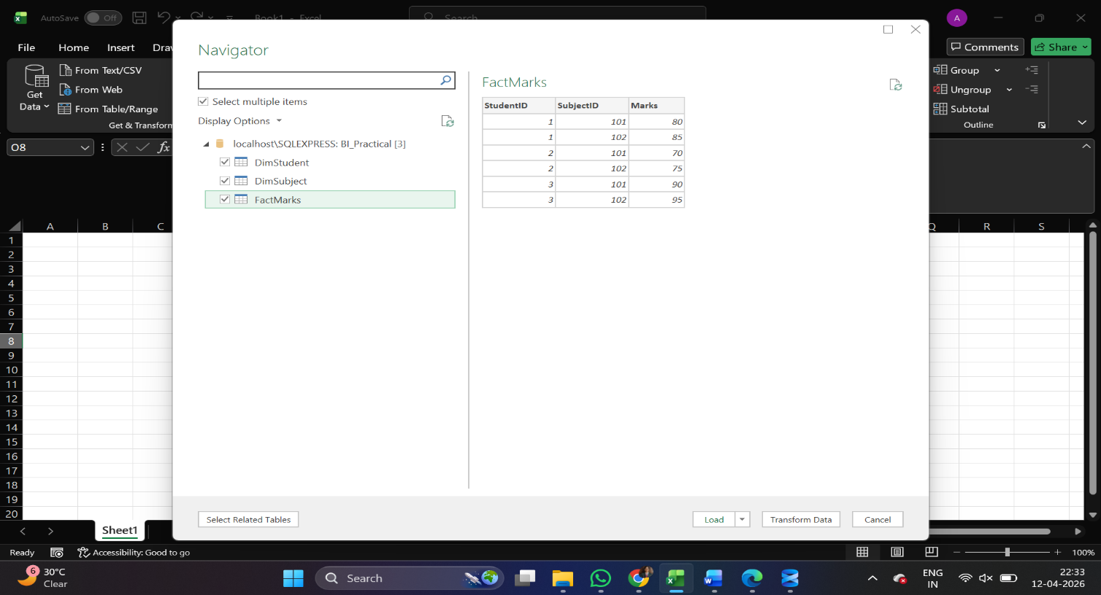
Step 3: Merge Tables
- Merge FactMarks with DimStudent using StudentID
- Expand and select Name
- Merge with DimSubject using SubjectID
- Expand and select SubjectName
- Final table contains: Name, SubjectName, Marks
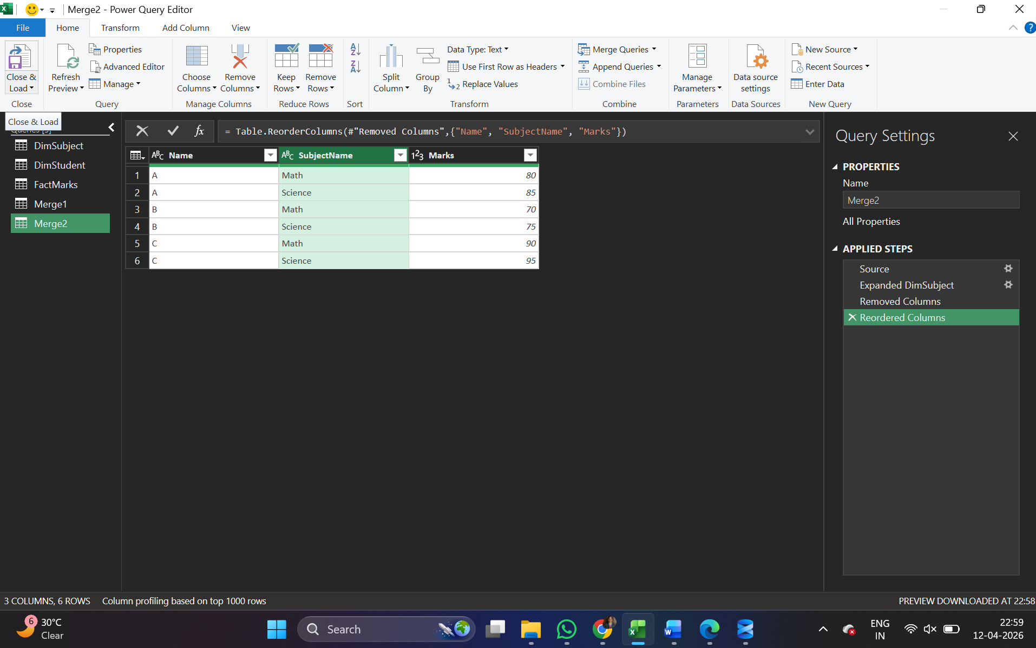

Step 4: Load Data into Excel
- Click Close & Load
- Data is loaded into Excel sheet
Step 5: Create Pivot Table
- Select the table
- Go to Insert → Pivot Table → New Worksheet
- Set fields:
  - Rows → Name
  - Columns → SubjectName
  - Values → Marks (Sum)
Step 6: Create Pivot Chart
- Select Pivot Table
- Go to Insert → Chart → Column Chart
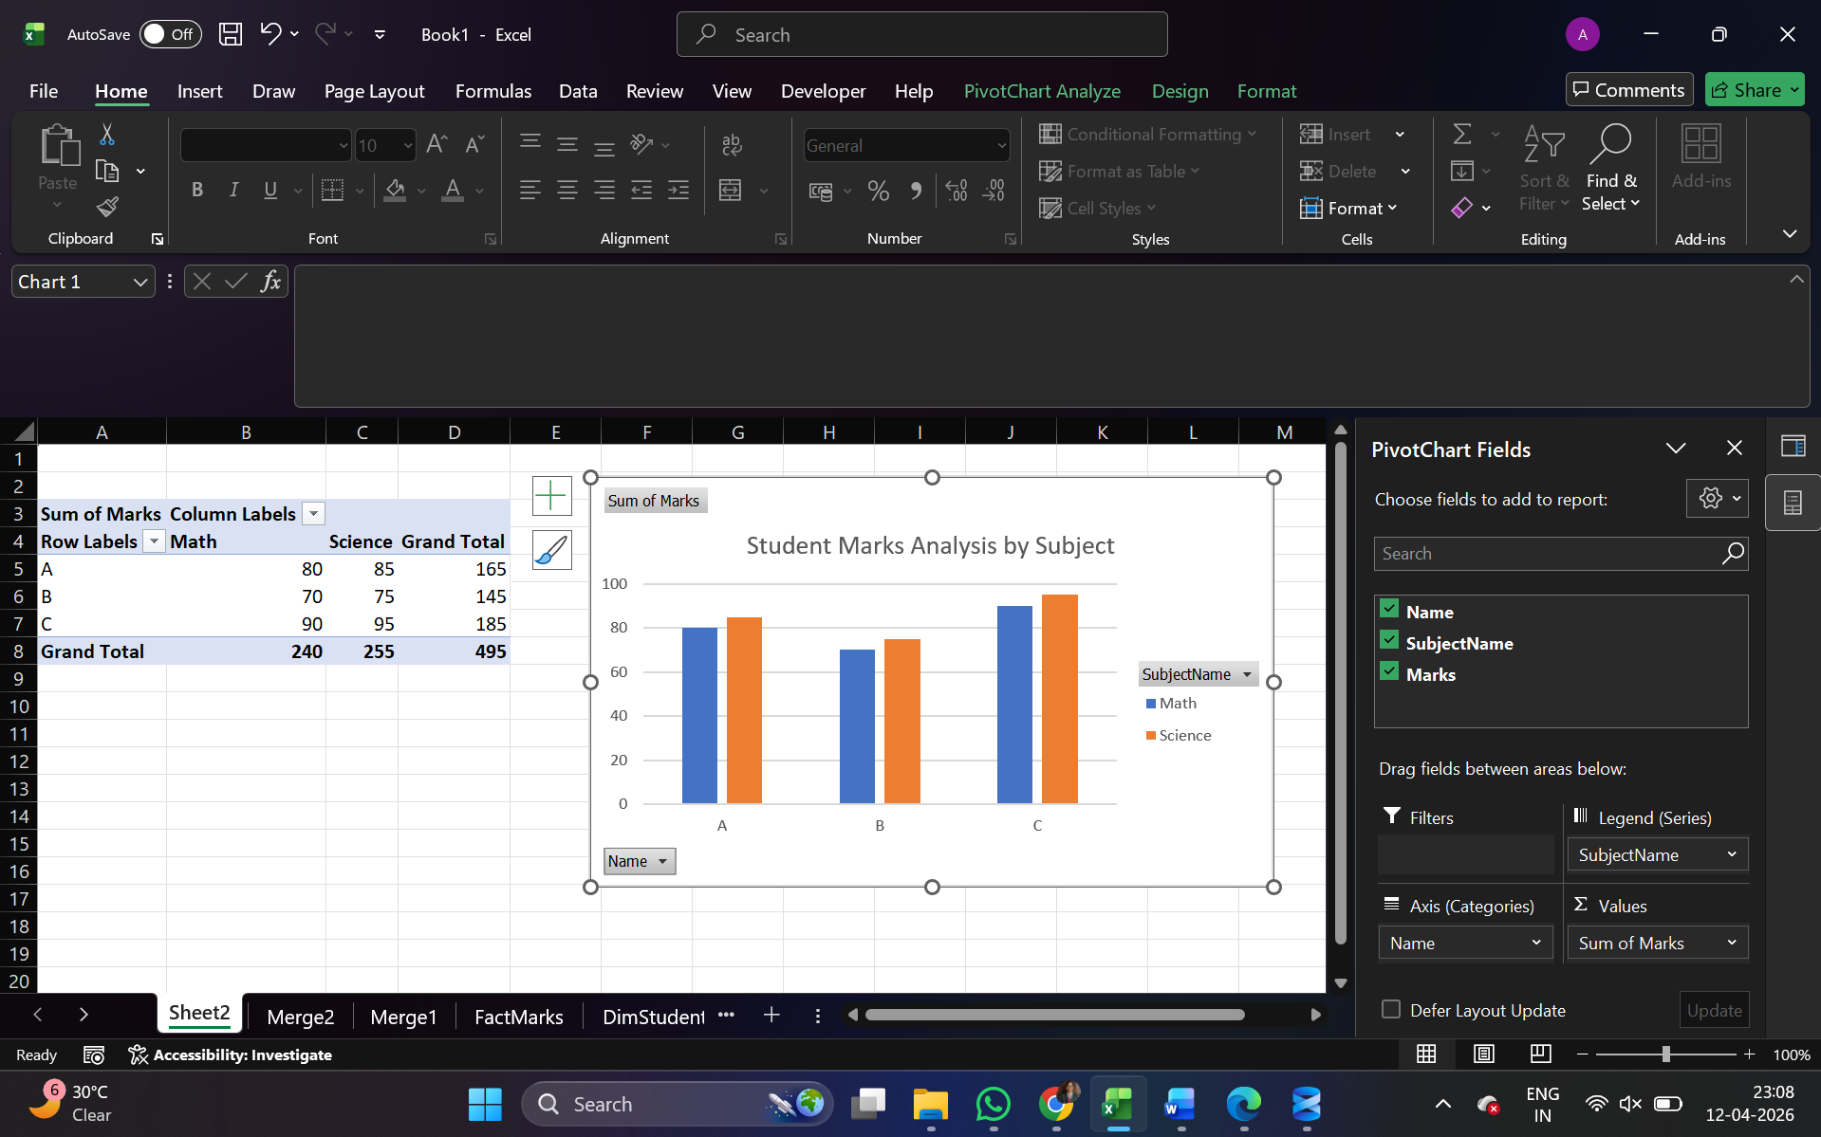
Result:
- Data warehouse data was successfully imported into Excel.
- Pivot Table was created to summarize student marks.
- Pivot Chart was generated to visualize the data effectively.

Conclusion:
- Excel can be used for analyzing data warehouse data.
- Pivot Tables help in summarizing data efficiently.
- Pivot Charts provide better visualization for decision making.

