Mini Project Report

ON

“Student Performance Prediction”

Submitted to
SAVITRIBAI PHULE PUNE UNIVERSITY

In Partial Fulfillment of the Requirement for the Award of

B.E COMPUTER ENGINEERING
SEMESTER VIII

SUBMITTED BY

Anjali Santosh Barge Exam No.:
Neha Nana Dhurgude Exam No.:
Dhanashree Tanaji Jadhav Exam No.:

Under the Guidance of
Prof. Sujata Gaikwad



DEPARTMENT OF COMPUTER ENGINEERING
ALARD COLLEGE OF ENGINEERING AND MANAGEMENT
MARUNJI, PUNE-57
(AFFILIATED TO SAVITRIBAI PHULE PUNE UNIVERSITY)
2025 – 2026



CERTIFICATE

This is to certify that the Mini Project report entitles

“Student Performance Prediction”

Submitted by

Anjali Santosh Barge Exam No.:
Neha Nana Dhurgude Exam No.:
Dhanashree Tanaji Jadhav Exam No.:

Are bonafide students of this institute, and the work has been carried out by them under the supervision of Prof. Sujata Gaikwad and it is approved for the partial fulfillment of the requirement of Savitribai Phule Pune University, for the B.E. Computer Engineering.

Prof. Sujata Gaikwad Prof. Dipali Mane
Project Guide Head of Department
Dept. of Computer Engg. Dept. of Computer Engg.

Place:
Date:

Acknowledgements
It is our privilege to express our sincerest regards to our Project guide, Prof. Sujata Gaikwad, for her valuable inputs, able guidance, encouragement, whole-hearted cooperation and constructive criticism throughout the duration of our project. We deeply express our sincere thanks to our Head of Department Prof. Dipali Mane for encouraging and allowing us to present the project on the topic “Student Performance Prediction” at our department premises. We take this opportunity to thank all our faculties who directly or indirectly helped our project. We pay our respect and love to our parents and all other family members and friends for their love and encouragement throughout our career. Last but not the least we express our thanks to our friends for their cooperation and support.

Abstract
This project focuses on predicting student academic performance using machine learning classification techniques. The primary objective is to classify students into pass or fail categories based on various influencing factors such as study time, absences, family background, and previous academic performance.
The dataset used in this project contains multiple attributes related to students’ academic and personal information. Data preprocessing and feature selection techniques were applied to remove irrelevant features and improve model efficiency. A Decision Tree Classifier was implemented to build the prediction model.
The model was evaluated using performance metrics such as accuracy, confusion matrix, and classification report. The achieved accuracy of approximately 73% indicates that the model performs reasonably well in predicting student outcomes. The analysis shows that study habits and attendance play a significant role in determining student success.
This project highlights the importance of machine learning in the education sector by enabling early identification of students at risk, allowing timely intervention and improved academic performance.

Table of Contents
Sr. No. | Topic | Page No.
1 | Introduction | 1
2 | Project Overview | 2
3 | Methodology and Implementation | 3-4
4 | Code Description | 5-6
5 | Result and Analysis | 7
6 | Conclusion and References | 8

Introduction
In recent years, the use of data-driven techniques in the education sector has significantly increased. Educational institutions generate large volumes of data related to student performance, attendance, study habits, and socio-economic background. Analyzing this data can provide valuable insights into student behavior and help improve academic outcomes. One of the key applications of such analysis is predicting student performance using machine learning techniques. Student performance prediction is an important task that helps in identifying students who are at risk of failing. Early prediction allows educators to take necessary actions such as providing additional support, personalized guidance, and academic interventions. Traditional methods of evaluating student performance are often reactive and based only on final examination results. However, machine learning enables a proactive approach by analyzing multiple influencing factors and predicting outcomes in advance.
This project focuses on predicting whether a student will pass or fail using classification techniques. It is formulated as a binary classification problem where the output is either Pass (1) or Fail (0). The prediction is based on various input features such as study time, number of absences, family background, and previous academic performance. These features play a crucial role in determining the overall academic success of a student. The dataset used in this project contains multiple attributes related to students, including academic, social, and personal factors. Before applying machine learning algorithms, data preprocessing is performed to clean and organize the dataset. Certain features such as previous grades (G1, G2, G3) are removed during feature selection to avoid data leakage and ensure fair model training. The dataset is then divided into training and testing sets using an 80:20 ratio to evaluate model performance effectively.
A Decision Tree Classifier is used as the primary machine learning algorithm in this project. Decision trees are widely used for classification problems due to their simplicity, interpretability, and ability to handle both numerical and categorical data. The model is trained using the training dataset and then used to predict outcomes on unseen test data. The performance of the model is evaluated using metrics such as accuracy, confusion matrix, and classification report. The confusion matrix shows that the model performs better in predicting students who pass compared to those who fail, highlighting areas for further improvement.
This project demonstrates how machine learning techniques can be effectively applied in the field of education to support decision-making processes. By identifying key factors affecting student performance, educators can design better strategies to improve learning outcomes. Additionally, this system can be extended in the future by using advanced algorithms such as Random Forest, Support Vector Machines, or Neural Networks to enhance prediction accuracy. Overall, the project highlights the potential of data analytics and machine learning in transforming traditional educational systems into more intelligent and adaptive environments.
- Project Overview
The Student Performance Prediction system is designed to analyze student data and predict whether a student will pass or fail using machine learning techniques. This project focuses on applying classification algorithms to educational data to support academic decision-making.
The main objective of this project is to classify students into two categories: Pass (1) and Fail (0). This helps in identifying students who are at risk of failing so that early interventions can be taken to improve their performance.
The problem is treated as a binary classification task. The prediction is based on various features such as study time, number of absences, family background, and previous academic records. These factors play a significant role in determining student success.
The dataset used in this project is “student-mat-pass-or-fail.csv”, which contains both academic and personal attributes of students. It includes features such as study time, absences, parental education, free time, and health status. The target variable is “pass”, where 1 represents pass and 0 represents fail.
The system follows a structured workflow. First, the dataset is loaded using Python libraries. Then, preprocessing is performed to clean the data and remove unnecessary features such as G1, G2, and G3 to avoid data leakage. The dataset is split into training and testing sets using an 80:20 ratio.
A Decision Tree Classifier is used as the machine learning model. The model is trained on the training dataset and then used to make predictions on the test dataset. The performance of the model is evaluated using accuracy, confusion matrix, and classification report.
The expected outcome of the project is to achieve a reasonably accurate prediction model. The system helps in identifying key factors affecting student performance and can assist educators in improving academic results. However, the model has certain limitations, such as moderate accuracy and better performance in predicting pass cases compared to fail cases.

- Methodology and Implementation
This section describes the methodology followed and the steps implemented to build the student performance prediction system using machine learning techniques. The project follows a systematic approach starting from data collection to model evaluation.
  - Data Collection

The dataset used in this project is “student-mat-pass-or-fail.csv”. It contains various attributes related to students, including academic, social, and personal factors. These attributes are used to analyze and predict student performance.
  - Data Preprocessing
Data preprocessing is an important step to ensure data quality and consistency. The dataset is loaded using the Pandas library in Python.
Unnecessary and redundant features are removed to improve model performance. In particular, the columns G1, G2, and G3 (previous grades) are removed to avoid data leakage, as they directly influence the final result.
Categorical data is handled appropriately, and the dataset is cleaned to remove inconsistencies.
  - Feature Selection

After preprocessing, the dataset is divided into:
- Independent variables (X) – input features
- Dependent variable (y) – target variable (pass/fail)

Feature selection helps in improving model efficiency and reducing overfitting by removing irrelevant attributes.
  - Train-Test Split

The dataset is split into training and testing sets using an 80:20 ratio.
- Training data is used to train the model
- Testing data is used to evaluate model performance

This ensures that the model is tested on unseen data and can generalize well.
  - Model Building
A Decision Tree Classifier is used as the machine learning model. It is a supervised learning algorithm that creates a tree-like structure based on feature values.
The model learns patterns from the training dataset by splitting data into nodes based on the most significant features.
  - Model Training
The model is trained using the training dataset. During training, the algorithm learns the relationship between input features and the target variable.
The trained model is then ready to make predictions.
  - Prediction
After training, the model is used to predict the outcomes on the test dataset. The predicted results are compared with actual values to evaluate performance.
  - Model Evaluation

The performance of the model is evaluated using the following metrics:
- Accuracy Score – measures overall correctness
- Confusion Matrix – shows correct and incorrect predictions
- Classification Report – provides precision, recall, and F1-score

The model achieves an accuracy of approximately 73%, indicating a reasonably good performance.
  - Visualization
A histogram of student absences is plotted using Matplotlib to understand the distribution of attendance. This helps in analyzing how absences affect student performance.

- Code Description

This section describes the implementation of the student performance prediction system using Python and machine learning techniques.

The program begins by importing the required libraries such as Pandas and NumPy for data handling and numerical operations.

import pandas as pd

import numpy as np

The dataset is then loaded using the Pandas library and displayed to understand its structure.

data = pd.read_csv("student-mat-pass-or-fail.csv")

data.head()

Basic data understanding is performed by checking column names and the distribution of the target variable.

print(data.columns)

print(data['pass'].value_counts())

The feature set (X) and target variable (y) are defined. The columns G1, G2, and G3 are removed to avoid data leakage.

X = data.drop(['pass', 'G1', 'G2', 'G3'], axis=1)

y = data['pass']

The dataset is divided into training and testing sets using an 80:20 ratio.

from sklearn.model_selection import train_test_split

X_train, X_test, y_train, y_test = train_test_split(

X, y, test_size=0.2, random_state=42

)

A Decision Tree Classifier is used to train the model.

from sklearn.tree import DecisionTreeClassifier

model = DecisionTreeClassifier()

model.fit(X_train, y_train)

Predictions are made on the test dataset.

y_pred = model.predict(X_test)

The performance of the model is evaluated using accuracy, confusion matrix, and classification report.

from sklearn.metrics import accuracy_score, confusion_matrix, classification_report

print("Accuracy:", accuracy_score(y_test, y_pred))

print("Confusion Matrix:\n", confusion_matrix(y_test, y_pred))

print("Classification Report:\n", classification_report(y_test, y_pred))

Finally, a histogram is plotted to visualize the distribution of student absences.

import matplotlib.pyplot as plt

data['absences'].hist()

plt.title("Absences Distribution")

plt.show()

The above implementation successfully builds a machine learning model that predicts student performance based on input features.

- Result and Analysis

The performance of the model is evaluated using accuracy, confusion matrix, and classification report.

The model achieved an accuracy of approximately 73%, which indicates a reasonably good performance for the given dataset.

The confusion matrix shows that the model correctly predicts most of the pass cases, while some fail cases are misclassified. This indicates that the model performs better in predicting students who pass compared to those who fail.

The classification report shows that the precision and recall for the pass class are higher than for the fail class, indicating an imbalance in prediction performance.

The following figure shows the distribution of student absences:

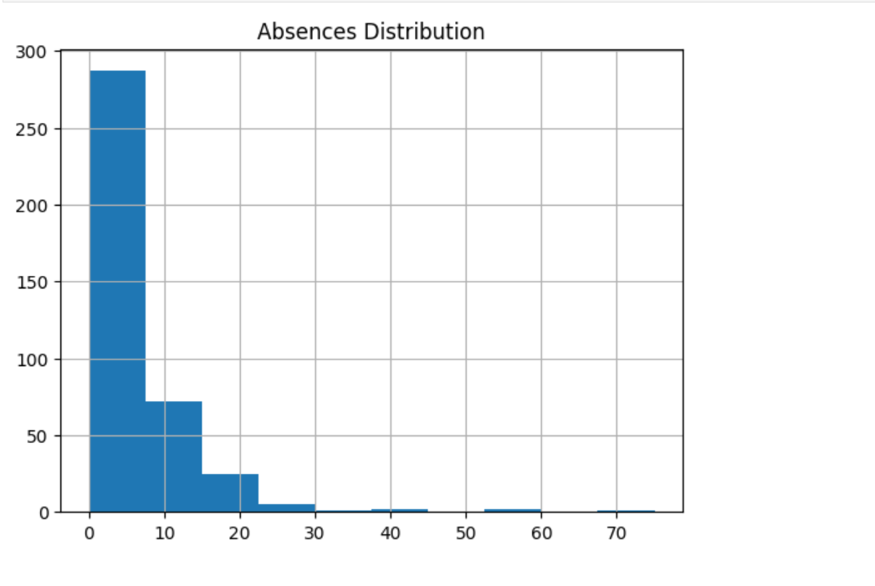

From the above graph, it can be observed that most students have low absences, while a few students have very high absences. This uneven distribution suggests that attendance plays an important role in student performance. Students with higher absences are more likely to perform poorly.

Overall, the model successfully predicts student performance based on input features such as study time and absences. However, there is scope for improvement in predicting fail cases more accurately.

- Conclusion and References

This project demonstrates the application of machine learning techniques for predicting student performance. A Decision Tree Classifier was implemented to classify students into pass and fail categories based on various factors such as study time, absences, and personal background.

The model achieved an accuracy of approximately 73%, which indicates a reasonably good performance for the given dataset. The results show that features like attendance and study habits have a significant impact on student outcomes. The confusion matrix and classification report reveal that the model performs better in predicting students who pass compared to those who fail.

The project highlights the importance of data-driven approaches in the education sector. By identifying students at risk of failure in advance, educators can take proactive measures such as providing additional support and guidance.

However, the model has certain limitations, including moderate accuracy and lower performance for fail predictions. Future improvements can include the use of advanced machine learning algorithms such as Random Forest, Support Vector Machines, and Neural Networks. Additionally, using larger and more diverse datasets can further improve prediction accuracy.

Overall, this project demonstrates how machine learning can be effectively used to support educational decision-making and improve student performance.

References
- Pedregosa, F., et al. (2023). Scikit-learn: Machine Learning in Python. Journal of Machine Learning Research.
- Géron, A. (2022). Hands-On Machine Learning with Scikit-Learn, Keras, and TensorFlow (3rd ed.). O’Reilly Media.
- Brownlee, J. (2022). Machine Learning Mastery with Python. Machine Learning Mastery.
- Dua, D., & Graff, C. (2021). UCI Machine Learning Repository. University of California, Irvine.
- Raschka, S., & Mirjalili, V. (2021). Python Machine Learning (3rd ed.). Packt Publishing.
- Han, J., Kamber, M., & Pei, J. (2021). Data Mining: Concepts and Techniques (3rd ed.). Elsevier.
- Aggarwal, C. C. (2021). Machine Learning for Text. Springer.
- Mitchell, T. M. (2020). Machine Learning. McGraw-Hill Education.
- Kotu, V., & Deshpande, B. (2020). Data Science: Concepts and Practice. Morgan Kaufmann.
- Witten, I. H., Frank, E., & Hall, M. A. (2020). Data Mining: Practical Machine Learning Tools and Techniques. Morgan Kaufmann.
- Scikit-learn Documentation (2024). https://scikit-learn.org
- Python Documentation (2024). https://docs.python.org
- Matplotlib Documentation (2023). https://matplotlib.org
- Pandas Documentation (2024). https://pandas.pydata.org
- NumPy Documentation (2023). https://numpy.org

