Table of contents
Character properties: 2
Font 2
Font size 3
Bold, Italics and Underline 3
Text color and Highlight/Shading color 3
Solid and Dashed borders 3
Background color 3
Strikethrough and Double strikethrough 3
Superscript and Subscript 4
Shadow, Outline, Emboss, Engrave, All caps, Small caps 4
Hidden text follows 4
Symbols 4
Character spacing 4
Paragraph properties: 4
Double line spacing 4
Spacing before and spacing after the paragraph 5
Indentation 5
First line indentation 5
Hanging 6
Different alignment: left, right, centered and justified 6
Bulleted and numbered lists 7
Bulleted list 7
Nested bulleted list with different bullet symbols 7
Numbered list 7
Nested numbered list 7
Display numbers in numbered list 8
Tables 8
Shading patterns, Cell shading, Vertical alignment, Image inside table cell, Split cells, Uneven row height and column width 8
Text wrapping around table with solid border 8
Table borders 9
No border, Different line style, Different line weight, Different color 9
Images 10
Inline, Rotated image, Image size, Image border, Image fill 10
Transparency/Brightness, Multiple images grouped 10
Comments 11
Footnotes, Endnotes, References 11
Captions 11
Hyperlinks 11
Bookmarks 11
Fields 12
Section 12
Page border and page orientation 12
Header and Footer 12
Table styles 12
Drawing 13
WordArt 13
AutoShape 13
Organization chart 14
Text box 14
Objects 14
Embedded Excel table 14
Embedded Excel chart 15
Embedded Adobe PDF 15
Forms 15
Check box 15
Drop down form field 15

This document covers most of the features.

Character properties:

Font

This line is in Verdana, size 10.
This line is in Calisto MT, size 10.
Τηισ λινε ισ ιν Σψμβολ, σιζε 10.

Arial 12 Tahoma 12 Bradley Hands ITC 12

Font size
This line has each character increase font size by one from 4 pt to 59

Bold, Italics and Underline

New York (CNN) – Officers shot and killed an 18-year-old man believed to be armed, New York police said Tuesday, but he was only hiding a hairbrush.

New York (CNN) – Officers shot and killed an 18-year-old man believed to be armed, New York police said Tuesday, but he was only hiding a hairbrush.

Text color and Highlight/Shading color

The changes and additions to the 2007 Office release may pose a challenge to even skilled users who have worked with programs for years.

Solid and Dashed borders

The Wonderful Wizard of Oz (1900) is a children’s novel written by L. Frank Baum and illustrated by W.W. Denslow.

Background color

In this document the background color is set to Light Yellow.

Strikethrough and Double strikethrough

A black hole is a region of space in which the gravitational field is so powerful that nothing can escape after having fallen past the event horizon.

Superscript and Subscript

The name comes from the fact that even electromagnetic radiation (e.g. light) is unable to escape, rendering the interior invisible. However, black holes can be detected if they interact with matter outside the event horizon, for example by drawing in gas from an orbiting star.

Shadow, Outline, Emboss, Engrave, All caps, Small caps

Shadow shadow shadow shadow
Outline outline outline outline
Emboss emboss emboss emboss
Engrave engrave engrave engrave
All caps all caps all caps all caps
Small caps small caps small caps small caps

Hidden text follows

To reveal hidden text select Tools->Options->View tab and check Hidden text box.

Symbols

¡ £ § © ® µ ¶ ¾ ¿ ℘ ♥ Җ ∑ ∞ ≈

Character spacing

The character spacing is expanded by 1pt.
The character spacing is expanded by 5pt.
The character spacing is condensed by 1pt.

Paragraph properties:

Double line spacing

When you turn on individual formatting marks, they will remain on even if you turn off formatting marks using Show/Hide ¶ (CTRL+SHIFT+8).

Spacing before and spacing after the paragraph

In this paragraph spacing before and spacing after are set to 0 pt. In this paragraph spacing before and spacing after are set to 0 pt. In this paragraph spacing before and spacing after are set to 0 pt. In this paragraph spacing before and spacing after are set to 0 pt.
In this paragraph spacing before and spacing after are set to 12 pt. In this paragraph spacing before and spacing after are set to 12 pt. In this paragraph spacing before and spacing after are set to 12 pt. In this paragraph spacing before and spacing after are set to 12 pt.
In this paragraph spacing before and spacing after are set to 30 pt. In this paragraph spacing before and spacing after are set to 30 pt. In this paragraph spacing before and spacing after are set to 30 pt. In this paragraph spacing before and spacing after are set to 30 pt.

Indentation

Indentation is 0 pt. Indentation is 0 pt. Indentation is 0 pt. Indentation is 0pt. Indentation is 0pt. Indentation is 0 pt. Indentation is 0 pt. Indentation is 0 pt. Indentation is 0 pt. Indentation is 0 pt. Indentation is 0 pt. Indentation is 0 pt. Indentation is 0 pt. Indentation is 0 pt. Indentation is 0 pt.

Left indentation is 15 pt. Left indentation is 15 pt. Left indentation is 15 pt. Left indentation is 15 pt. Left indentation is 15 pt. Left indentation is 15 pt. Left indentation is 15 pt. Left indentation is 15 pt. Left indentation is 15 pt. Left indentation is 15 pt. Left indentation is 15 pt. Left indentation is 15 pt.

Left indentation is -85 pt. Left indentation is -85 pt. Left indentation is -85 pt. Left indentation is -85 pt. Left indentation is -85 pt. Left indentation is -85 pt. Left indentation is -85 pt. Left indentation is -85 pt. Left indentation is -85 pt. Left indentation is -85 pt. Left indentation is -85 pt. Left indentation is -85 pt.

First line indentation

In this paragraph the first line is indented. In this paragraph the first line is indented. In this paragraph the first line is indented. In this paragraph the first line is indented. In this paragraph the first line is indented.

Hanging

In this paragraph the first line is hanging by 36 pt. In this paragraph the first line is hanging by 36 pt. In this paragraph the first line is hanging by 36 pt. In this paragraph the first line is hanging by 36 pt.

Different alignment: left, right, centered and justified

Left alignment. Left alignment. Left alignment. Left alignment. Left alignment. Left alignment. Left alignment. Left alignment. Left alignment. Left alignment. Left alignment. Left alignment. Left alignment. Left alignment.

Right alignment. Right alignment. Right alignment. Right alignment. Right alignment. Right alignment. Right alignment. Right alignment. Right alignment. Right alignment. Right alignment. Right alignment. Right alignment. Right alignment. Right alignment. Right alignment.

Centered. Centered. Centered. Centered. Centered. Centered. Centered. Centered. Centered. Centered. Centered. Centered. Centered. Centered. Centered. Centered. Centered. Centered. Centered. Centered. Centered.

This paragraph is justified. This paragraph is justified. This paragraph is justified. This paragraph is justified. This paragraph is justified. This paragraph is justified. This paragraph is justified. This paragraph is justified. This paragraph is justified. This paragraph is justified. This paragraph is justified. This paragraph is justified. This paragraph is justified.
Page break is here.

Bulleted and numbered lists

Bulleted list

- Bullet 1
- Bullet 2
- Bullet 3
- Bullet 4

Nested bulleted list with different bullet symbols

- Level 1
- Level 1
- Level 2
- Level 2
  - Level 3
  - Level 3
  - Level 3
- Level 2

Numbered list

- Line 1
- Line 2
- Line 3

Nested numbered list

- Level 1
- Level 1
  - Level 2
  - Level 2
    - Level 3
    - Level 3
  - Level 2
- Level 1

Display numbers in numbered list

- 123
- 456
- 789
  - 100
  - 200
  - 300
    - .012
    - .013
    - .014
  - 400

Tables

Shading patterns, Cell shading, Vertical alignment, Image inside table cell, Split cells, Uneven row height and column width

Text in a cell | Centered | Centered | Right aligned
 | Centered
Cell color is orange |  | Yellow |  Image has been inserted in this cell.

Text wrapping around table with solid border

Tip: Avoid using text wrap around tables. Instead, when you need content beside a table, nested tables are the perfect, simple solution. Avoid using text wrap around tables. Instead when you need content beside the table, nested tables are the perfect simple solution. Avoid using text wrap around the table. Instead when you need content beside the table, nested tables are the perfect simple solution. And one more time, the same information. Avoid using text wrap around the table. Nested tables are the better solution.
Cell1 | Cell2 | Cell3
Cell4 | Cell5 | Cell6
Cell7 | Cell 8 | Cell9

Table borders

No border, Different line style, Different line weight, Different color

The tables below have different alignment. Table 1 - left alignment, Table 2 - right and Table 3 is centered.

Table 1
This table has no borders. Switch to Print preview to see this table without borders. This table has right alignment.
Cell 1 | Cell 2 | Cell 3
Cell 4 | Cell 5 | Cell 6

Table 2
Table with dashed borders. It is right aligned.

Table 3
Line weight is set to 3 pt and line color is green. The entire table is centered.
Page break is here.

Images

Inline, Rotated image, Image size, Image border, Image fill

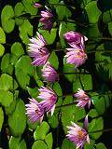
Rotated to the left by 90 degrees; dashed border with line weight 3 pt.

Transparency/Brightness, Multiple images grouped

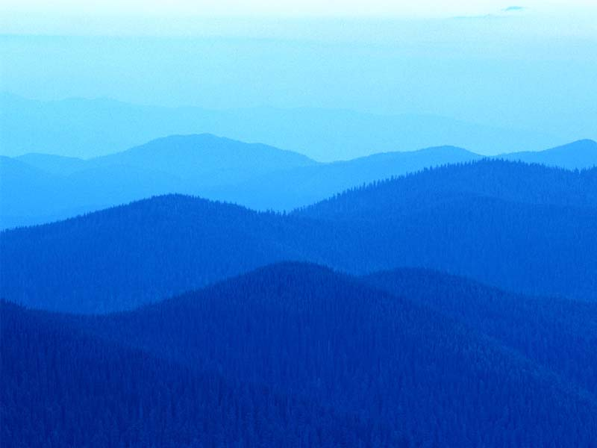 More brightness

Less brightness
Pasting graphics into Word as pictures can help to minimize file size in complex documents, and make the document easier to manage, and help ensure the appearance of your graphics on computers.
This image is placed behind the text.

Comments (to see comment on this line select View->Markup)

Footnotes, Endnotes, References
Number 1 refers to the endnote at the bottom of this page

Captions (The figure captions have been specified. When you build a table of figures, Microsoft Word searches for the captions, sorts them by number, and displays the table of figures in the document.)
Table 4
Cell1 | Cell2 | Cell3
Cell4 | Cell5 | Cell6
Cell7 | Ceell8 | Cell9

Hyperlinks

Top of the Document
Go to Quickoffice.com

Reference to Table 1 in this document (to go to Table 1 CTRL+click on the reference below)

Table 1

Bookmarks

A bookmark identifies a location or selection of text that you name and identify for future reference. For example, you might use a bookmark to identify text that you want to revise at a later time.

Select Insert->Bookmarks->highlight the bookmark you want to follow and press Go to button.

Fields

Created date filed: [Tuesday, November 13, 2007]

File name field: [0000.doc]

File size field: [202] Kb

Created by field: [Created by] QA

Section

Page border and page orientation
Page border is set to “Shadow” with orange color.

From this point forward, page orientation is Landscape

Header and Footer

Headers and footers provide the sort of useful information such as page number, creation date, title and other items. In this document header and footer should be displayed on each page.

Table styles

‘Classic 2’ table style.
Year | 2007 | 2008
Region 1 | 1000 | 1050
Region 2 | 1200 | 1250

Drawing

WordArt

AutoShape

Transparency
is 50%.

Organization chart

Drawings
WordArt
AutoShape
Textbox

Text box
By default, when you create a text box, it appears as a white (not transparent) box surrounded by thin black line.

Objects

Embedded Excel table

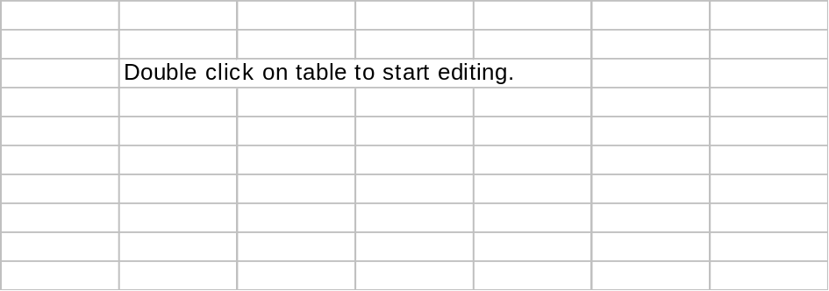

Embedded Excel chart

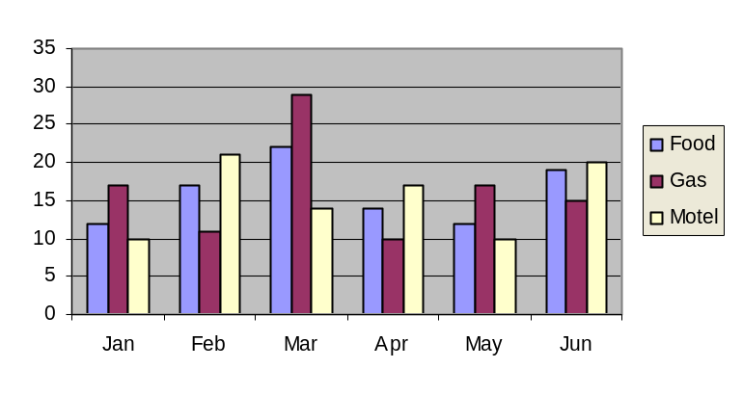

Embedded Adobe PDF
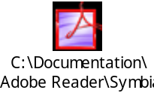 Double click on icon to open PDF file.

Forms

Check box

Trial?

Drop down form field

Select your credit card:

Footnotes and endnotes are used in printed documents to explain, comment on, or provide references for text in a document. You might use footnotes for detailed comments and endnotes for citation of sources.

