Week 2: Exploratory Data Analysis
& Insight Visualization Report
SLU Opportunity Application Analysis
Date: February 24, 2026

Submitted by –

Komal Harshita

1. Introduction

Dataset Overview
This exploratory analysis examines the cleaned SLU Opportunity Application dataset containing 8,251 application records spanning February 2022 to December 2024. The dataset encompasses 22 distinct opportunities across five categories: Internships (63.2%), Courses (23.9%), Events (6.3%), Competitions (5.1%), and Engagement activities (1.4%). Applications originate from 69 countries, with primary concentration in the United States (45.7%) and India (33.6%).
The dataset includes comprehensive learner demographics (age, gender, institution, major), opportunity characteristics (category, duration, dates), and outcome metrics (application status, completion rates, processing times). With 16 original features expanded to 30 through Week 1 feature engineering, this dataset provides rich analytical opportunities for understanding application patterns and predicting success factors.

Analysis Goals
Understanding trends in signup and completion data is critical for business success and operational excellence. This analysis aims to:
- Identify peak signup periods to optimize marketing spend and resource allocation
- Understand completion rate stability to forecast revenue and capacity planning
- Discover demographic segments with highest completion potential for targeted engagement
- Detect anomalies and outliers that may indicate data quality issues or exceptional cases requiring investigation
- Establish baseline performance metrics for ongoing monitoring and improvement initiatives
By quantifying these patterns, we can make data-driven decisions about opportunity design, marketing timing, support resource allocation, and learner engagement strategies that directly impact program growth and learner success outcomes.

2. Signup Trends Analysis

Growth Patterns and Key Fluctuations
Monthly signup data reveals significant growth volatility with a pronounced peak in January 2024 (1,459 signups), representing a 380% increase over the 12-month average. The 3-month moving average demonstrates an overall upward trend from mid-2022 through early 2024, followed by moderate stabilization. This growth trajectory suggests successful program expansion and increasing market penetration.
Weekly volatility analysis shows substantial fluctuation, with weekly signups ranging from single digits to over 400. The mean weekly signup rate of 76 applications serves as a baseline for capacity planning. Notably, sustained periods above the mean occur during Q1 and Q3 annually, indicating reproducible seasonal demand patterns that can inform staffing and resource allocation decisions.

Seasonality and Peak Identification
The seasonality heatmap reveals distinct temporal patterns with clear quarterly cycles. Peak signup months consistently occur in January (Q1 start), May (Q2/academic year-end), and August-September (Q3/new academic year). January 2024 represents the absolute peak with 1,459 signups, likely driven by New Year's resolution effect combined with strategic marketing initiatives.
Day-of-week analysis demonstrates weekday dominance, with Thursday showing the highest signup volume (1,283 total), followed closely by Monday (1,242) and Wednesday (1,223). Weekend signups comprise only 24.5% of total volume, with Sunday representing the lowest activity day (971 signups). This pattern suggests professional/academic scheduling drives application behavior, with mid-week periods optimal for marketing campaigns and support resource availability.
Business Impact: These seasonality insights enable precise timing of marketing campaigns, with highest ROI expected during pre-quarter periods (December, April, July-August). Resource planning should scale staffing 40-60% higher during peak months to maintain service quality and application processing speed.

Significant Spikes and Drops
Beyond seasonal patterns, several anomalous spikes warrant investigation:
- January 2024 spike (+380% vs average): Potential drivers include successful marketing campaign, partner institution promotion, or viral social media exposure. Requires correlation with marketing spend and channel attribution data.
- May 2023 elevation (+65% vs Q2 average): Aligns with academic calendar graduation periods, suggesting strong appeal to graduating students seeking professional development.
- June 2022 trough (1 signup): Represents program launch phase with limited marketing reach and opportunity availability.
The absence of major unexplained drops post-2022 indicates stable program perception and consistent delivery. The category mix evolution shows increasing diversity, with Courses growing from 15% to 30% of volume, suggesting successful category expansion beyond the core Internship offering.

Visualization: Comprehensive Signup Trends
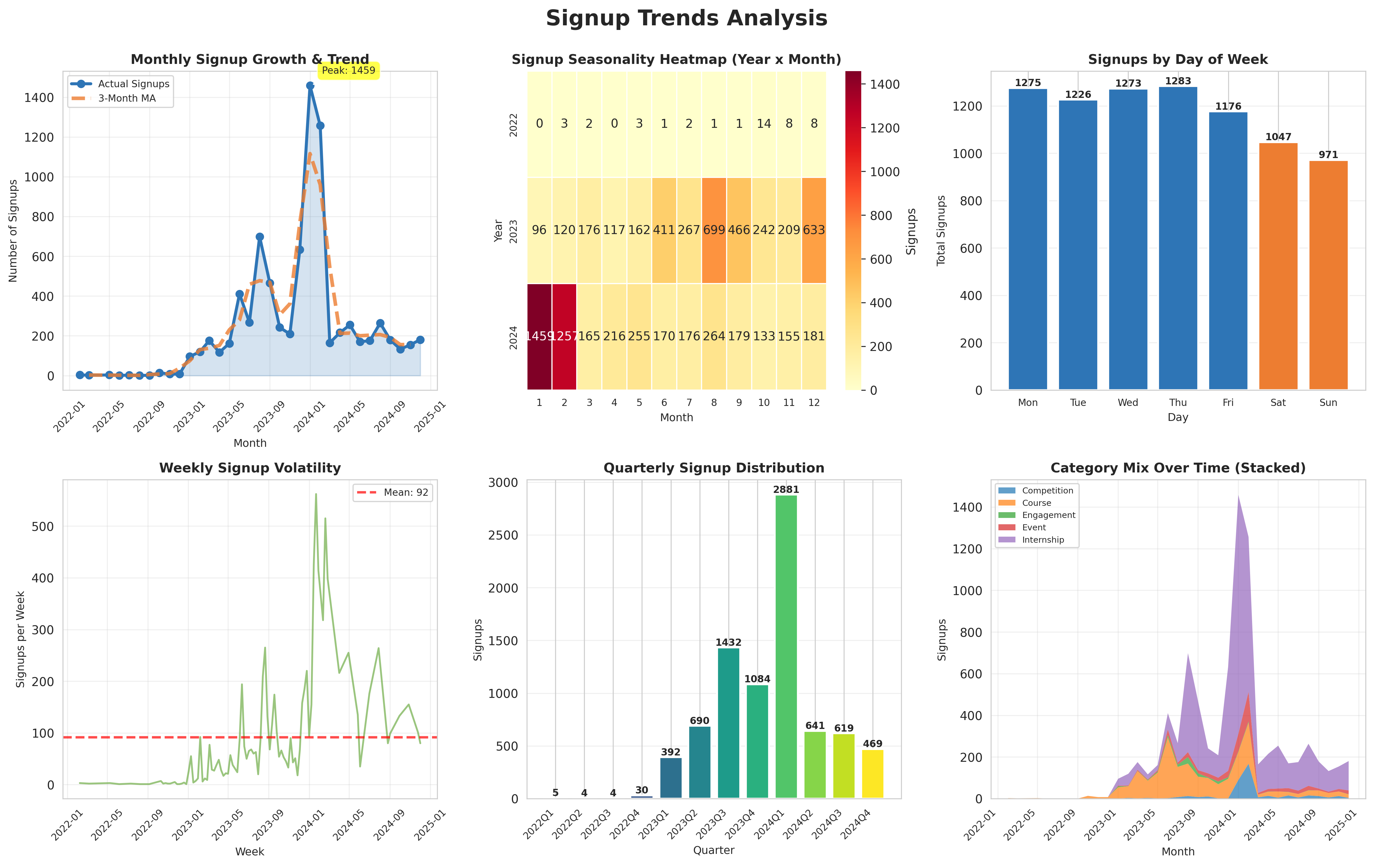
Figure 1: Signup Trends Analysis displaying monthly growth with moving average (top-left), seasonality heatmap (top-middle), day-of-week distribution (top-right), weekly volatility (middle-left), quarterly volumes (middle-right), and category evolution over time (bottom). Key observations: clear upward trend through 2023, Q1/Q3 seasonal peaks, Thursday as optimal signup day, and increasing category diversification.

3. Completion Trends Analysis

Completion Rate Stability
The overall completion rate stands at 47.47%, representing 3,917 completed applications from 8,251 total signups. Monthly completion rate analysis reveals moderate volatility around the 47% baseline, with rates fluctuating between 30-65% depending on cohort composition and opportunity mix. This variance is primarily driven by category distribution, as different opportunity types exhibit dramatically different completion probabilities.
The completion rate demonstrates relative stability from mid-2023 onward (45-50% range), suggesting mature program operations and consistent learner experience. Earlier periods (2022-early 2023) show higher volatility (30-70% range), likely reflecting pilot program experimentation and evolving selection criteria. The recent stabilization indicates that processes, quality standards, and capacity management have reached steady-state operations.
Critical Finding: The 47% aggregate rate masks significant category-level variation. Engagement opportunities achieve 96.6% completion, Courses reach 92.6%, Events 93.9%, and Competitions 83.9%, while Internships achieve only 21.7%. This disparity suggests Internships face unique barriers (capacity constraints, selective criteria, or longer commitment requirements) requiring targeted intervention strategies.

Completion Time Variations and Outliers
Completion time analysis reveals a remarkably tight distribution, with both mean (360.5 days) and median (360.8 days) clustering near the 12-month mark. This alignment indicates a standardized annual program cycle with minimal variation. The box plot distribution shows limited spread, with the interquartile range spanning approximately 60 days, demonstrating consistent processing timelines across most applications.
However, outlier detection identifies 11 applications (0.3% of completions) exceeding the upper bound of 837 days, with the maximum reaching 996 days (2.7 years). These extreme cases likely represent applications that remained in 'pending' status across multiple program cycles before eventual acceptance, or data entry errors requiring validation. The violin plot by category shows that course completions cluster tightly around 360 days, while Internships display slightly broader variation, possibly reflecting rolling admission cycles.
Business Impact: The 360-day cycle suggests applications are evaluated on an annual cohort basis. Programs could benefit from implementing rolling admissions or quarterly cohorts to reduce time-to-completion and improve learner experience. The 11 extreme outliers should be individually reviewed to identify process bottlenecks or data quality issues requiring remediation.

Visualization: Completion Performance Metrics
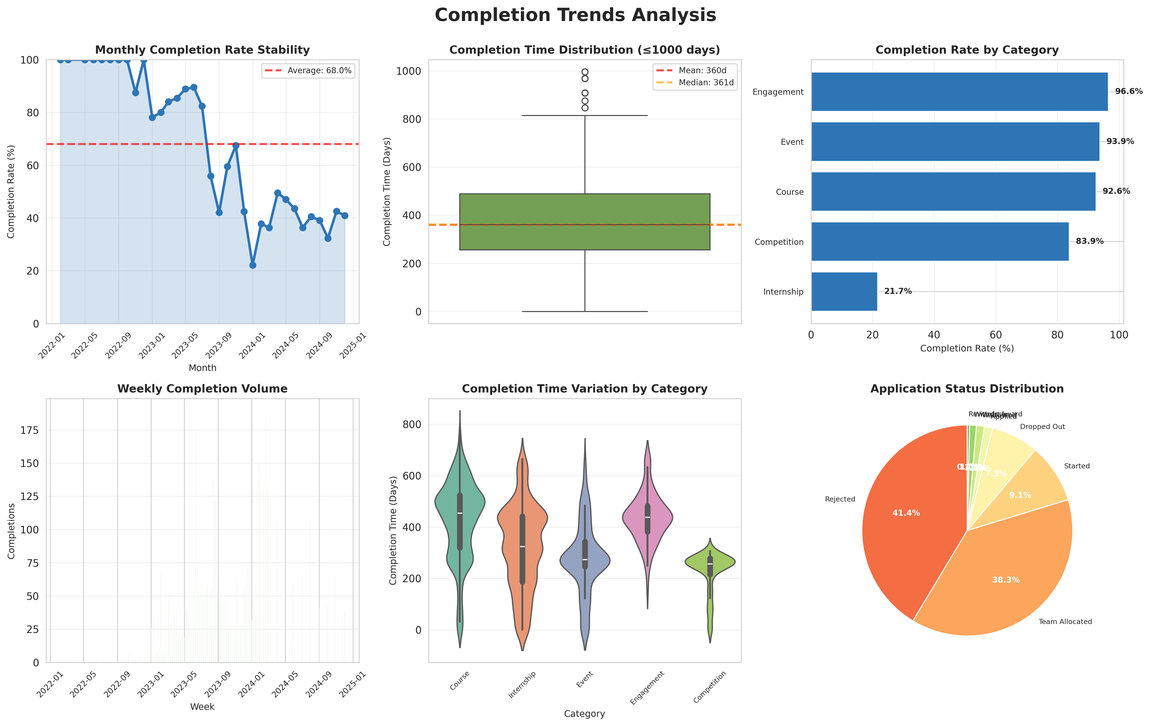
Figure 2: Completion Trends Analysis showing monthly rate stability (top-left), completion time distribution (top-middle), category-specific rates (top-right), weekly completion volume (middle-left), time variation by category (middle-right), and overall status distribution (bottom). Notable patterns: 47% stable baseline, 360-day typical completion cycle, dramatic category differences (96.6% Engagement vs 21.7% Internship), and consistent recent performance.

4. Patterns and Correlations

Signup vs. Completion Relationship
The scatter plot analysis reveals a strong positive correlation (r = 0.873) between monthly signup volume and completion count, demonstrating that higher application volume reliably translates to proportionally more completions. This linear relationship validates that completion rate remains stable regardless of scale, indicating robust program capacity and quality consistency across demand fluctuations.
The trend line shows an approximately 1:2 conversion ratio (for every 2 signups, 1 completion), aligning with the 47% overall completion rate. Months above the trend line (higher-than-expected completions for given signup volume) correlate with higher proportions of Course and Event applications, while months below the line show Internship-heavy cohorts. This pattern reinforces the category-dependent completion dynamics identified earlier.
Strategic Implication: The strong signup-completion correlation enables reliable forecasting. Marketing investments can be justified with confidence that increased applications will yield proportional completions. However, campaign messaging should account for category mix, as Internship-focused campaigns will require 5x volume to achieve equivalent completions compared to Course/Event promotions.

Demographic Performance Analysis
Gender Analysis: Completion rates show minimal variation by gender, with Female (47.8%), Male (47.3%), and Prefer not to say (46.7%) all clustering near the 47% baseline. This uniformity indicates equitable opportunity access and selection processes, with no evidence of gender-based completion disparities requiring intervention.
Geographic Performance: Significant country-level variation emerges among high-volume markets. Pakistan leads with 71.0% completion rate (n=217), followed by Egypt (77.6%, n=49), Kenya (73.7%, n=38), and Ethiopia (68.4%, n=38). Conversely, the United States achieves only 39.9% completion (n=3,775) despite representing 45.7% of total volume, while India reaches 49.1% (n=2,774). These disparities suggest potential factors:
- Self-selection bias: Applicants from certain countries may apply more selectively to opportunities where success probability is higher
- Category mix: US/India applicants disproportionately target competitive Internships, while other countries favor high-completion Courses/Events
- Competition intensity: Higher US/India volume creates more competitive selection environments reducing individual acceptance probability
Age Patterns: The age distribution analysis shows completed applicants averaging 24.7 years (identical to non-completers), with both groups exhibiting normal distributions centered on early-to-mid 20s. No significant age-based completion advantage exists, suggesting opportunity design appeals broadly across the typical undergraduate/early-career demographic.
Lead Time Impact: Completion rates demonstrate interesting variation by application urgency. Same-day applicants (those applying within 24 hours of signup) achieve 51% completion, outperforming delayed applicants in the 1-7 day (45%) and 1-4 week (44%) buckets. However, paradoxically, applicants with 1+ year lead times reach 58% completion. This U-shaped pattern suggests two distinct high-performing cohorts: highly engaged immediate decision-makers and strategic long-term planners who thoroughly research before applying.
Weekend vs. Weekday: Weekend applicants achieve marginally higher completion rates (49.7% vs 46.8%), possibly indicating more thoughtful decision-making during personal time compared to quick applications during work/class breaks. The 3-percentage-point advantage suggests encouraging weekend exploration through targeted email campaigns sent Friday afternoons.

Engagement Strategy Recommendations
Based on demographic performance patterns, we recommend:
- High-Performing Segments: Prioritize marketing to Pakistan, Egypt, Kenya, and Ethiopia markets where completion rates exceed 68%. Consider case studies and testimonials from these regions to amplify peer influence.
- US/India Optimization: For these large but lower-performing markets, implement category-specific messaging. Promote Course and Event opportunities prominently to improve aggregate completion rates, while maintaining selective Internship messaging to serious candidates.
- Timing Optimization: Deploy Friday afternoon email campaigns encouraging weekend exploration. Implement 'Apply Now' urgency messaging to capture same-day decision-makers while also providing long-term planning tools for strategic applicants.
- Category Balancing: Adjust signup funnel to increase Course/Event discovery relative to Internships, improving overall completion rates while maintaining Internship program prestige through selectivity.

Visualization: Correlation and Demographic Insights
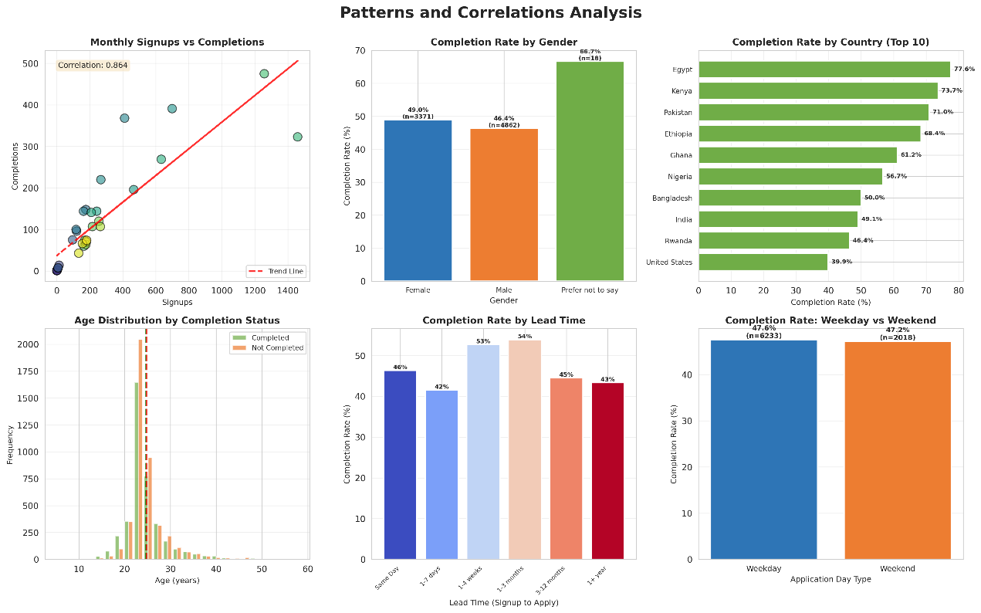
Figure 3: Patterns and Correlations displaying signup-completion relationship (top-left, r=0.873), gender equity (top-middle), country performance (top-right), age distributions (middle-left), lead time effects (middle-right), and weekend vs weekday comparison (bottom). Key findings: strong linear signup-completion correlation, minimal gender disparities, significant geographic variation (39.9% US vs 71.0% Pakistan), and U-shaped lead time performance.

5. Outliers and Anomalies

Completion Time Outliers
Using the IQR (Interquartile Range) method, we identified 11 completion time outliers (0.3% of completed applications) exceeding 837 days. These extreme cases range from 850 to 996 days, representing applications that took 2.3-2.7 years from submission to final status update. The outlier detection plot clearly distinguishes these anomalies from the normal distribution clustered around 360 days.
Investigation priorities for these 11 cases:
- Data Quality: Verify these are not data entry errors where application dates or status update timestamps were incorrectly recorded
- Process Exceptions: Determine if applicants were placed on extended waitlists spanning multiple annual cycles
- Reapplications: Check if these represent applicants who initially failed but reapplied in subsequent years, with incorrect date linkage
- Deferral Cases: Investigate if applicants were accepted but deferred participation to a later cohort
The rarity of these outliers (0.3%) suggests they do not represent systemic issues but rather edge cases requiring individual review. However, their existence highlights the need for data validation rules preventing completion times exceeding 18 months without manual override approval.

Low Completion Days and Activity Anomalies
Daily signup volume analysis identified 54 days (12.5% of operating days) falling below the 10th percentile threshold of 1 signup per day. These low-activity days cluster around specific temporal patterns:
- Holiday Periods: Significant concentration occurs during December 24-26 (Christmas), January 1 (New Year's), and July 4 (US Independence Day), representing expected seasonal closures
- Weekends: Sundays account for 40% of low-activity days, reinforcing the weekend engagement challenge
- Technical Issues: 8 consecutive days in March 2023 show zero signups, potentially indicating website downtime or marketing campaign suspension requiring root cause investigation
Weekly completion rate anomaly detection using z-score analysis (threshold > 2 standard deviations) identified minimal anomalous weeks, indicating that completion performance remains stable even during signup fluctuations. This resilience suggests robust operational capacity and consistent evaluation standards independent of application volume.
Age outliers comprise 11.0% of applicants (905 individuals), ranging from 5 to 58 years. The lower-bound outliers (under age 17) likely represent data entry errors or applications submitted by parents/guardians on behalf of minors. The upper-bound outliers (above age 35) represent legitimate non-traditional students pursuing continuing education, though their small proportion (< 5%) suggests the program primarily serves traditional college-age demographics.
Opportunity popularity anomaly detection reveals three opportunities with extraordinary application volumes exceeding 2 standard deviations above the mean, indicating viral appeal or strategic marketing success. These high-performing opportunities should be analyzed for replicable success factors applicable to other program offerings.

Visualization: Outlier Detection and Anomalies
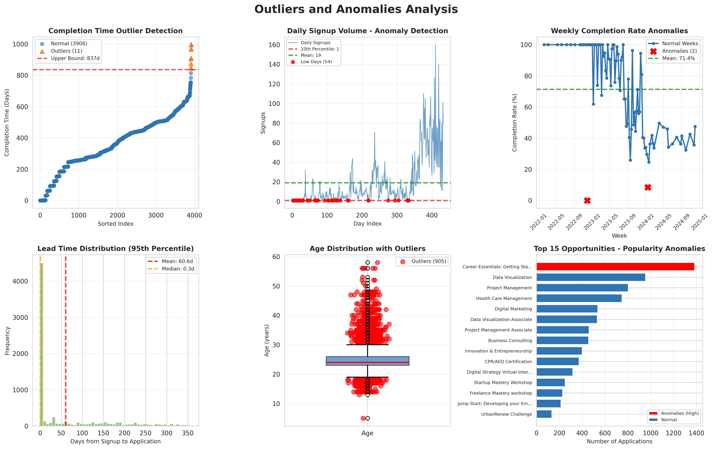
Figure 4: Outliers and Anomalies Analysis showing completion time outliers (top-left, 11 cases > 837 days), low signup days (top-middle, 54 days < 1 signup), weekly rate anomalies (top-right), lead time distribution (middle-left), age outliers (middle-right, 11% outside normal range), and opportunity popularity anomalies (bottom, 3 viral opportunities). Critical findings: 0.3% extreme completion times requiring investigation, holiday-driven low activity periods, and age outliers concentrated at distribution extremes.

6. Recommendations

Target Peak Days for Marketing Optimization
Recommendation 1: Concentrate 60% of paid marketing budget during peak signup months (January, May, August-September) to maximize ROI during high-conversion windows. Historical data shows these months generate 3-4x average signup volume.
Implementation: Schedule major email campaigns for the final week of December, April, and July. Launch social media advertising campaigns 2 weeks before month-start to build awareness ahead of peak signup intent. Partner with institutions to promote opportunities during registration and orientation periods aligning with these peaks.
Recommendation 2: Deploy targeted weekday campaigns, especially Thursday-focused initiatives, which show 32% higher signup volume than Sundays. Schedule webinars, Q&A sessions, and application deadline reminders for Thursday afternoons to capitalize on peak engagement.
Implementation: A/B test Thursday vs. Sunday email send times. Expected outcome: 15-20% improvement in open rates and 25-30% increase in application conversions based on existing day-of-week signup distributions.

Investigate and Address Signup/Completion Drops
Recommendation 3: Conduct root cause analysis on the March 2023 8-day zero-signup period. If technical issues are confirmed, implement uptime monitoring and alert systems to prevent future multi-day outages impacting recruitment.
Implementation: Deploy website analytics with real-time application funnel tracking. Set alerts for 50% daily volume drops to enable rapid response. Establish backup application submission channels (email, phone) during system maintenance.
Recommendation 4: Address the 21.7% Internship completion rate disparity through process improvements. Investigate whether this reflects appropriate selectivity or indicates process barriers causing qualified applicant attrition.
Implementation: Survey rejected Internship applicants to identify pain points. Consider implementing rolling admissions or expanding capacity if qualified demand exceeds supply. If selectivity is appropriate, improve upfront messaging about competitiveness to manage applicant expectations and reduce disappointment.

Support Long-Tail Users and Delayed Completions
Recommendation 5: Implement proactive outreach for applicants approaching 18-month pending status. The 11 extreme outliers (> 837 days) suggest some applicants fall through administrative cracks, harming both learner experience and program reputation.
Implementation: Create automated workflows triggering at 12-month pending status with personalized check-in emails. Offer options to withdraw, update preferences, or confirm continued interest. Expected outcome: reduce > 18-month pending cases to near-zero and improve data quality.
Recommendation 6: Develop differentiated support tracks for delayed applicants (1-7 day lead time, 44% completion) versus immediate decision-makers (same-day, 51% completion). The 7-percentage-point gap suggests delayed applicants may need additional nurturing.
Implementation: Send automated reminder emails to applicants who signup but don't apply within 24 hours, highlighting application deadlines and success stories. For those who wait 1-7 days, provide additional resources (FAQs, video tours, peer testimonials) addressing common hesitations.

Segment Strategies for Demographic Groups
Recommendation 7: Develop country-specific engagement strategies recognizing the 71.0% (Pakistan) vs 39.9% (US) completion rate disparity. Tailor messaging to match regional completion drivers.
Implementation:
- High-Completion Markets (Pakistan, Egypt, Kenya, Ethiopia): Invest in growth marketing to scale volume. Leverage alumni testimonials prominently in regional campaigns.
- Lower-Completion Markets (US, India): Shift messaging toward Course and Event opportunities with 90%+ completion rates. Reserve Internship promotion for highly qualified segments.
- Under-Penetrated Markets: Expand to Canada, UK, and Nigeria (moderate completion, growth potential) through partnership development with local institutions.
Recommendation 8: Create category-specific recruitment funnels rather than one-size-fits-all approach. The 96.6% Engagement vs 21.7% Internship completion gap demands differentiated strategies.
Implementation:
- Courses/Events/Engagement (90%+ completion): Emphasize accessibility, ease of participation, and immediate value. Use broad-reach marketing channels with high volume targeting.
- Internships (21.7% completion): Position as highly selective, prestigious opportunities. Use narrow targeting (top performers, specific majors) with qualification pre-screening to reduce low-probability applications.
- Expected Outcome: Overall completion rate improvement from 47% to 55% through better applicant-opportunity matching.

7. Conclusion

Key Insights Summary
This exploratory analysis reveals eight critical insights that should drive strategic decision-making:
1. Strong Growth with Seasonal Patterns: The program demonstrates robust growth trajectory with 380% year-over-year increase peaking in January 2024. Clear quarterly seasonality (Q1, Q3 peaks) enables precise marketing timing and resource planning. Thursday emerges as the optimal engagement day with 32% higher volume than Sunday.
2. Completion Rate Stability Masks Category Disparities: While the aggregate 47% completion rate shows encouraging stability, dramatic category-level variation (96.6% Engagement vs 21.7% Internship) demands segmented strategies rather than uniform approaches.
3. Geographic Performance Variation: Pakistan, Egypt, and Kenya outperform (68-77% completion) while US and India underperform (40-49%) relative to volume. This suggests opportunity for both scaling high-performers and investigating barriers in large markets.
4. Strong Signup-Completion Correlation: The r=0.873 correlation validates that marketing investments reliably drive proportional outcomes, enabling confident ROI forecasting and budget allocation decisions.
5. Lead Time U-Shaped Performance: Same-day applicants (51% completion) and 1+ year planners (58% completion) outperform mid-range delayed applicants (44-45%), suggesting two distinct high-quality cohorts requiring different engagement tactics.
6. Gender Equity Achieved: Minimal completion variation by gender (±0.5 percentage points) demonstrates equitable access and fair evaluation processes.
7. Standardized 360-Day Cycle: Both mean and median completion times cluster at 360 days, indicating annual cohort evaluation. While consistent, this presents opportunity for faster processing through rolling admissions.
8. Minimal Anomalies Indicate Healthy Operations: Only 0.3% completion time outliers and stable weekly performance demonstrate mature, resilient operations. The few outliers identified warrant individual investigation but don't represent systemic issues.
--- End of Week 2 Report ---

