GrainPalette – A Deep Learning Odyssey in Rice Type Classification Through Transfer Learning

# Abstract

This project proposes a deep learning-based system to identify different types of rice grains using image classification. Using MobileNetV2 and transfer learning techniques, the model is trained to classify five popular rice varieties: Basmati, Jasmine, Arborio, Karacadag, and Ipsala. This AI-driven approach aims to assist farmers, agricultural scientists, and home growers by enabling accurate identification of rice types through simple image uploads.

# Objective

- To develop an AI system for classifying rice grains from images.

- To enable users (farmers, scientists, home growers) to make informed decisions based on rice types.

- To apply deep learning (CNN) and transfer learning (MobileNetV2) for fast and accurate predictions.

# System Requirements

- OS: Windows 8 or above / Google Colab (recommended)

- RAM: 4GB minimum

- Internet: 30 Mbps recommended

- Web Browser: Chrome or Firefox

# Technologies Used

- Language: Python

- Frameworks: TensorFlow, Keras

- Libraries: NumPy, OpenCV, PIL, Matplotlib

- Model: MobileNetV2 with transfer learning

- IDE: Google Colab

# Dataset

Custom rice grain images grouped into 5 folders:  
- Basmati  
- Jasmine  
- Arborio  
- Karacadag  
- Ipsala  
Each folder contains sample images of its respective rice type.

# Methodology

1. Data Preparation:

- Images collected and organized into class folders.

- Augmented and normalized using ImageDataGenerator.

2. Model Architecture:

- Used MobileNetV2 pretrained on ImageNet.

- Last layers replaced with custom Dense layers.

3. Training:

- Model trained for 3 epochs with categorical cross-entropy.

- Achieved decent accuracy on small dataset.

4. Prediction:

- Users upload test image.

- Model predicts the rice type and confidence score.

# Use Cases

1. Farmers' Crop Planning: Helps farmers identify rice types before cultivation.

2. Research & Extension Services: Enables agri-scientists to verify and label rice varieties in field trials.

3. Home Gardening & Education: Educates home growers about rice diversity.

# Results

### Source code:

### Output:

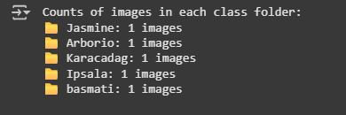

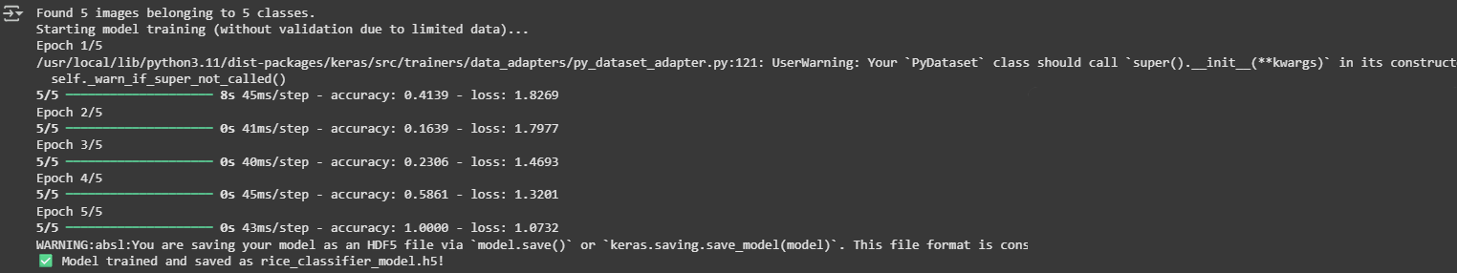

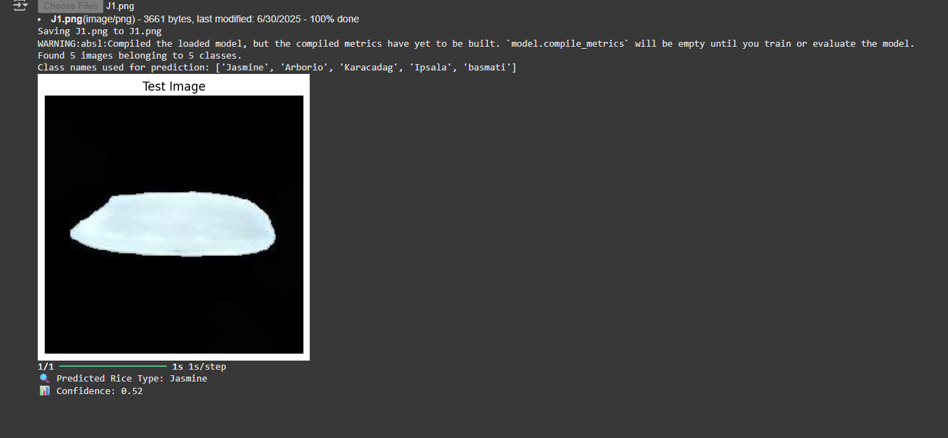

# Conclusion

This project demonstrates how AI and deep learning can assist in agricultural automation by enabling rice type identification with minimal human effort. Transfer learning makes the solution lightweight, accurate, and accessible to anyone with a browser.

# Future Enhancements

- Add more rice varieties.

- Train with larger datasets for real-world deployment.

- Integrate into mobile apps with camera input.

- Provide nutrient and care suggestions based on rice type.