**Supervised Learning**

**Definition:**

Supervised learning involves training a model on a labeled dataset, where each input is paired with the correct output. The model learns to map inputs to outputs based on this labeled data.

**Components:**

1. **Input (Features)**: The data points or variables used as input to the model (e.g., images, text, tabular data).
2. **Output (Labels/Targets)**: The expected results for each input (e.g., image categories, sentiment scores, regression values).

**Objective:**

To minimize the difference between the predicted outputs and the actual outputs (ground truth). This is achieved using a loss function.

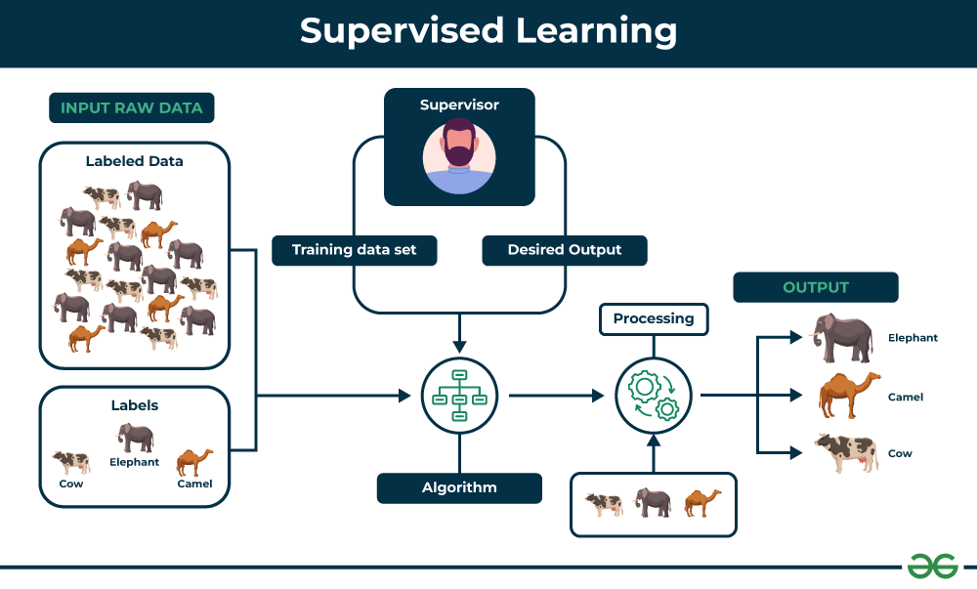

**Process:**

1. **Training Phase**:
   * Provide the model with labeled examples (xi,yi)(x_i, y_i)(xi​,yi​), where xix_ixi​ is the input and yiy_iyi​ is the output.
   * Adjust the model’s parameters using algorithms like gradient descent.
2. **Validation Phase**:
   * Test the model on unseen labeled data to evaluate its generalization performance.
3. **Inference Phase**:
   * Use the trained model to predict outputs for new, unseen inputs.

**Types of Supervised Learning**

Supervised learning is classified into two categories of algorithms:

* **Regression:** Regression is a type of supervised learning that is used to predict continuous values, such as house prices, stock prices, or customer churn. Regression algorithms learn a function that maps from the input features to the output value.
* **Classification:** Classification is a type of supervised learning that is used to predict categorical values, such as whether a customer will churn or not, whether an email is spam or not, or whether a medical image shows a tumor or not. Classification algorithms learn a function that maps from the input features to a probability distribution over the output classes.

**Algorithms:**

**Classification**:

**Support Vector Machine (SVM) Algorithm in Depth**

Support Vector Machine (SVM) is a powerful supervised learning algorithm used for both classification and regression tasks. It is widely used in binary classification problems.

**Key Concepts of SVM**

1. **Hyperplane**
   * A hyperplane is a decision boundary that separates data points into different classes.
   * In a 2D space, it’s a line; in 3D, it’s a plane; and in higher dimensions, it’s a hyperplane.
2. **Support Vectors**
   * These are the data points closest to the hyperplane.
   * They define the position and orientation of the hyperplane and play a critical role in maximizing the margin.
3. **Margin**
   * The margin is the distance between the hyperplane and the nearest data points (support vectors).
   * SVM aims to maximize this margin, leading to better generalization.

**Support Vector Machine (SVM) Algorithm in Depth**

Support Vector Machine (SVM) is a powerful supervised learning algorithm used for both classification and regression tasks. It is widely used in binary classification problems.

**Key Concepts of SVM**

1. **Hyperplane**
   * A hyperplane is a decision boundary that separates data points into different classes.
   * In a 2D space, it’s a line; in 3D, it’s a plane; and in higher dimensions, it’s a hyperplane.
2. **Support Vectors**
   * These are the data points closest to the hyperplane.
   * They define the position and orientation of the hyperplane and play a critical role in maximizing the margin.
3. **Margin**
   * The margin is the distance between the hyperplane and the nearest data points (support vectors).
   * SVM aims to maximize this margin, leading to better generalization.

**Algorithm Workflow**

**Step 1: Input the Data**

* Collect and preprocess the dataset.
* Split the data into training and testing sets.

**Step 2: Choose a Kernel**

* Decide between linear, polynomial, or RBF kernel depending on the data's nature.

**Step 3: Train the Model**

* Use the training data to solve the optimization problem.
* Identify the support vectors and the optimal hyperplane.

**Step 4: Make Predictions**

* For a new input x, predict the class using:

f(x)=sign(wTx+b)

**Step 5: Evaluate the Model**

* Use metrics like accuracy, precision, recall, F1-score, and confusion matrix to assess performance.

**Diagram**

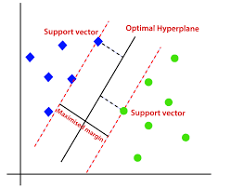

**Advantages of SVM**

* Effective in high-dimensional spaces.
* Works well for both linear and non-linear data (using kernels).
* Robust to overfitting (with proper regularization).

**Limitations of SVM**

* Computationally expensive for large datasets.
* Sensitive to the choice of kernel and hyperparameters.
* Less interpretable compared to simpler models like linear regression.

**Decision Trees Algorithm:**

A decision tree is a flowchart-like structure used to make decisions or predictions. It consists of nodes representing decisions or tests on attributes, branches representing the outcome of these decisions, and leaf nodes representing final outcomes or predictions. Each internal node corresponds to a test on an attribute, each branch corresponds to the result of the test, and each leaf node corresponds to a class label or a continuous value.

**Structure of a Decision Tree**

1. **Root Node**: Represents the entire dataset and the initial decision to be made.
2. **Internal Nodes**: Represent decisions or tests on attributes. Each internal node has one or more branches.
3. **Branches**: Represent the outcome of a decision or test, leading to another node.
4. **Leaf Nodes**: Represent the final decision or prediction. No further splits occur at these nodes.

**Algorithm Steps**

**Step 1: Select the Best Feature to Split**

* For each feature, calculate the impurity (Gini, Entropy, or Variance).
* Choose the feature that results in the lowest impurity after splitting.

**Step 2: Split the Data**

* Divide the dataset into subsets based on the chosen feature's values.

**Step 3: Repeat Recursively**

* For each subset, repeat step 1 to find the next best feature.
* Continue until a stopping criterion is met:
  + Maximum tree depth reached,
  + Minimum number of samples in a node,
  + No further reduction in impurity.

**Step 4: Assign Leaf Nodes**

* For classification: Assign the majority class in the subset.
* For regression: Assign the mean value of the target variable in the subset.

**Metrics for Splitting**

* **Gini Impurity**: Measures the likelihood of an incorrect classification of a new instance if it was randomly classified according to the distribution of classes in the dataset.
  + Gini=1–∑i=1n(pi)2Gini=1–∑*i*=1*n*​(*pi*​)2, where *pi*​ is the probability of an instance being classified into a particular class.
* **Entropy**: Measures the amount of uncertainty or impurity in the dataset.
  + Entropy=−∑i=1n pilog⁡2(pi)Entropy=−∑*i*=1*n*​*pi*​log2​(*pi*​), where *pi*​ is the probability of an instance being classified into a particular class.
* **Information Gain**: Measures the reduction in entropy or Gini impurity after a dataset is split on an attribute.
  + InformationGain=Entropyparent–∑i=1n(∣Di∣∣D∣∗Entropy(Di))InformationGain=Entropyparent​–∑*i*=1*n*​(∣*D*∣∣*Di*​∣​∗Entropy(*Di*​)), where *Di*​ is the subset of *D* after splitting by an attribute.

**Diagram**

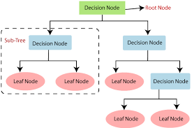

**Advantages of Decision Trees**

* Easy to understand and interpret.
* Handles both numerical and categorical data.
* Non-parametric, making no assumptions about data distribution.

**Limitations of Decision Trees**

* Prone to overfitting (can create very complex trees).
* Sensitive to small changes in data (unstable).
* Can be biased if classes are imbalanced.

**Random Forest:**

Machine learning, a fascinating blend of computer science and statistics, has witnessed incredible progress, with one standout algorithm being the **Random Forest**. **Random forests or Random Decision Trees** is a collaborative team of **decision trees** that work together to provide a single output. Originating in 2001 through Leo Breiman, Random Forest has become a cornerstone for machine learning enthusiasts. In this article, we will explore the fundamentals and implementation of **Random Forest Algorithm**.

**Key Concepts of Random Forest**

1. **Ensemble Learning**
   * Combines predictions from multiple models to produce a stronger result.
   * In Random Forest, the ensemble consists of **decision trees**.
2. **Bootstrap Aggregating (Bagging)**
   * Each tree is trained on a random subset of the data (sampled with replacement).
   * This helps reduce overfitting and improves generalization.
3. **Random Feature Selection**
   * At each split in a tree, only a random subset of features is considered.
   * This introduces more diversity among the trees, enhancing the model's robustness.
4. **Voting/Averaging**
   * **For Classification**: The final prediction is based on majority voting.
   * **For Regression**: The final prediction is the average of all tree predictions.

**Algorithm for Random Forest Work:**

1. Step 1: Select random K data points from the training set.
2. Step 2:Build the decision trees associated with the selected data points(Subsets).
3. Step 3:Choose the number N for decision trees that you want to build.
4. Step 4:Repeat Step 1 and 2.
5. Step 5: For new data points, find the predictions of each decision tree, and assign the new data points to the category that wins the majority votes.

**Diagram**

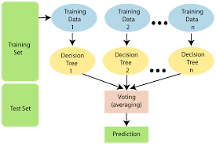

**Advantages of Random Forest**

1. **High Accuracy**
   * Reduces overfitting compared to single decision trees.
2. **Handles High-Dimensional Data**
   * Works well with many features and complex relationships**.**
3. **Robust to Outliers and Noise**
   * Random sampling and averaging help mitigate the impact of noisy data.
4. **Feature Importance**
   * Provides a measure of feature importance, useful for feature selection.

**Limitations of Random Forest**

1. **Computationally Expensive**
   * Training and prediction can be slow, especially with a large number of trees and features.
2. **Not Easily Interpretable**
   * Unlike single decision trees, random forests are complex and harder to interpret.
3. **Overfitting on Noisy Data**
   * May overfit if the number of trees is very large without proper regularization.

**Neural Networks:**

Neural networks are machine learning models that mimic the complex functions of the human brain. These models consist of interconnected nodes or neurons that process data, learn patterns, and enable tasks such as pattern recognition and decision-making.

**Structure of a Neural Network**

1. **Neuron (Node)**
   * The basic unit of a neural network.
   * Each neuron receives inputs, processes them, and produces an output.
2. **Layers**
   * **Input Layer**: Takes in the features of the dataset.
   * **Hidden Layers**: Intermediate layers that transform input into something meaningful for the output.
   * **Output Layer**: Produces the final prediction.
3. **Weights and Biases**
   * Weights determine the importance of each input.
   * Bias allows the model to shift the activation function.
4. **Activation Function**
   * Introduces non-linearity, enabling the network to learn complex patterns.

**Forward Propagation**

1. **Input Data**
   * Pass input data through the network.
2. **Calculate Weighted Sum**

z=w⋅x+bz

where w is the weight, x is the input, and b is the bias.

1. **Apply Activation Function**

a=f(z)a

1. **Repeat for Each Layer**
   * The output of one layer becomes the input for the next.

**Loss Function**

Measures the difference between the predicted output and the actual output. Common loss functions include:

* **Mean Squared Error (MSE)**: For regression.
* **Cross-Entropy Loss**: For classification.

**Backpropagation (Learning Process)**

1. **Compute Gradient of Loss**
   * Use the chain rule to compute the derivative of the loss with respect to each weight and bias.
2. **Update Weights and Biases**
   * Use gradient descent or a variant (e.g., stochastic gradient descent, Adam) to update parameters
3. **Repeat**
   * Perform forward propagation, compute loss, and backpropagate until the model converges.

**Types of Neural Networks**

1. **Feedforward Neural Network (FNN)**
   * Data flows in one direction (input → hidden layers → output).
2. **Convolutional Neural Network (CNN)**
   * Specialized for image data, uses convolution layers to extract spatial features.
3. **Recurrent Neural Network (RNN)**
   * Designed for sequential data (e.g., time series, text), includes feedback loops.
4. **Generative Adversarial Network (GAN)**
   * Used for generating new data, consists of a generator and a discriminator.

**Diagram**

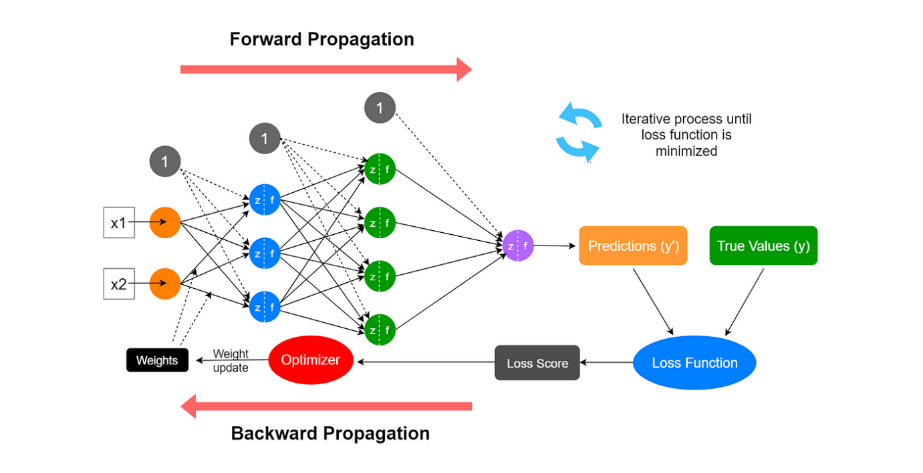

**Algorithm Workflow**

1. **Data Preparation**
   * Preprocess the data (e.g., normalization, one-hot encoding).
   * Split data into training, validation, and testing sets.
2. **Initialize Parameters**
   * Randomly initialize weights and biases.
3. **Forward Propagation**
   * Pass input data through the network to generate predictions.
4. **Compute Loss**
   * Measure the difference between predictions and true values.
5. **Backpropagation**
   * Calculate gradients and update parameters.
6. **Repeat**
   * Train the model for several epochs until convergence.
7. **Evaluate the Model**
   * Use the testing set to measure performance.

**Advantages of Neural Networks**

1. **Powerful for Complex Tasks**
   * Can model non-linear and complex relationships.
2. **Adaptable**
   * Works well with various types of data: images, text, audio, etc.
3. **Automatic Feature Extraction**
   * Can learn relevant features from raw data without manual intervention.

**Limitations of Neural Networks**

1. **Computationally Expensive**
   * Requires significant computational resources for training.
2. **Requires Large Datasets**
   * Needs large amounts of data to achieve good performance.
3. **Black Box Nature**
   * Difficult to interpret how decisions are made.

**Regression**:

**Logistic Regression**

* Logistic regression is one of the most popular Machine Learning algorithms, which comes under the Supervised Learning technique. It is used for predicting the categorical dependent variable using a given set of independent variables.
* Logistic regression predicts the output of a categorical dependent variable. Therefore the outcome must be a categorical or discrete value. It can be either Yes or No, 0 or 1, true or False, etc. but instead of giving the exact value as 0 and 1, it gives the probabilistic values which lie between 0 and 1.
* Logistic Regression is much similar to the Linear Regression except that how they are used. Linear Regression is used for solving Regression problems, whereas Logistic regression is used for solving the classification problems.
* In Logistic regression, instead of fitting a regression line, we fit an "S" shaped logistic function, which predicts two maximum values (0 or 1).

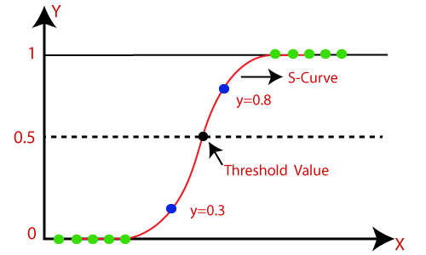

**Logistic Function (Sigmoid Function)**

* The sigmoid function is a mathematical function used to map the predicted values to probabilities.
* It maps any real value into another value within a range of 0 and 1.
* The value of the logistic regression must be between 0 and 1, which cannot go beyond this limit, so it forms a curve like the "S" form. The S-form curve is called the Sigmoid function or the logistic function.
* In logistic regression, we use the concept of the threshold value, which defines the probability of either 0 or 1. Such as values above the threshold value tends to 1, and a value below the threshold values tends to 0.

**Logistic Regression Equation:** The Logistic regression equation can be obtained from the Linear Regression equation. The mathematical steps to get Logistic Regression equations are given below:

* We know the equation of the straight line can be written as:



* In Logistic Regression y can be between 0 and 1 only, so for this let's divide the above equation by (1-y):



* But we need range between -[infinity] to +[infinity], then take logarithm of the equation it will become:



**Type of Logistic Regression**

1. Binomial: In binomial Logistic regression, there can be only two possible types of the dependent variables, such as 0 or 1, Pass or Fail, etc.
2. Multinomial: In multinomial Logistic regression, there can be 3 or more possible unordered types of the dependent variable, such as "cat", "dogs", or "sheep"
3. Ordinal: In ordinal Logistic regression, there can be 3 or more possible ordered types of dependent variables, such as "low", "Medium", or "High".

**Other Techniques**:

**K-Nearest Neighbors (KNN)**

The K-Nearest Neighbors (KNN) algorithm is a supervised machine learning method employed to tackle classification and regression problems. Evelyn Fix and Joseph Hodges developed this algorithm in 1951, which was subsequently expanded by Thomas Cover. The article explores the fundamentals, workings, and implementation of the KNN algorithm.

**Algorithm Steps**

**1. Choose the Number of Neighbors (K)**

* Decide how many neighbors to consider (e.g., K=3K = 3K=3).

**2. Calculate Distances**

* For each test point, calculate the distance between it and every point in the training set.

**3. Identify K Nearest Neighbors**

* Sort the distances and select the KKK closest points.

**4. Predict the Output**

* **For Classification**: Perform majority voting among the neighbors' classes.
* 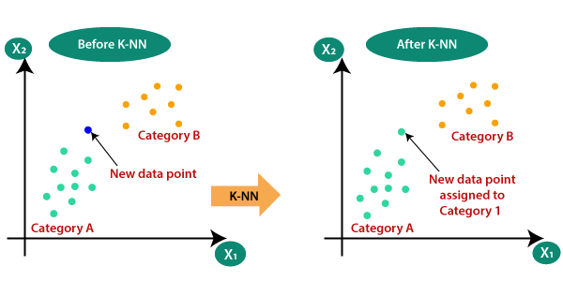**For Regression**: Compute the average of the neighbors' target values.

**Diagram**

**Advantages of KNN**

1. **Simple and Intuitive**
   * Easy to understand and implement.
2. **No Training Phase**
   * KNN is a lazy learner; it doesn't build a model during training.
3. **Versatile**
   * Can be used for both classification and regression tasks.
4. **Non-Parametric**
   * Makes no assumptions about the data distribution.

**Limitations of KNN**

1. **Computationally Expensive**
   * Requires calculating distances for all training points during prediction.
2. **Sensitive to Irrelevant Features**
   * Performance can degrade if irrelevant features are included.
3. **Choice of K**
   * Model performance depends heavily on the value of KKK.
4. **Imbalanced Data**
   * Biased towards the majority class in imbalanced datasets.

**Unsupervised Learning**

**Definition:**

Unsupervised learning involves training a model on a dataset without labeled outputs. The model identifies patterns, structures, or relationships in the data.

**Components:**

1. **Input (Features)**: Data points without associated labels.
2. **Output**: Not explicitly defined; the model’s goal is to uncover hidden patterns.

**Objective:**

To discover the underlying structure or distribution of the data.

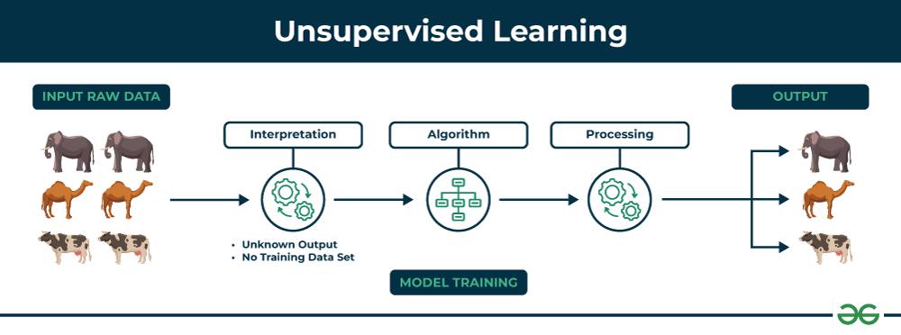

**Process:**

1. **Training Phase**:
   * Provide the model with input data xix_ixi​.
   * Use algorithms to group, reduce, or transform the data based on intrinsic similarities or statistical properties.
2. **Evaluation Phase**:
   * Performance metrics are often qualitative or based on domain-specific heuristics.

**Types of Unsupervised Learning**

Unsupervised learning is classified into two categories of algorithms:

* **Clustering**: Clustering is a type of unsupervised learning that is used to group similar data points together. [**Clustering algorithms**](https://www.geeksforgeeks.org/clustering-in-machine-learning/) work by iteratively moving data points closer to their cluster centers and further away from data points in other clusters.

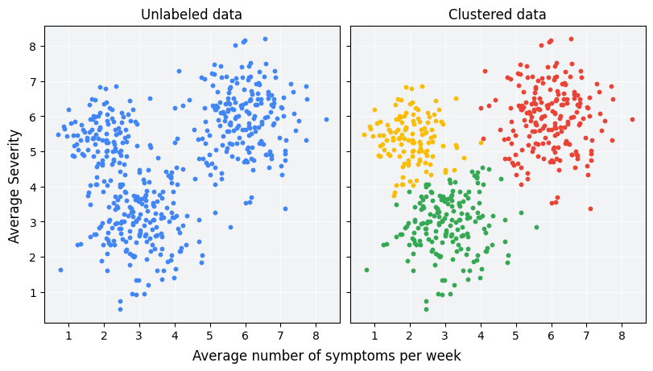

* **Association**: Association rule learning is a type of unsupervised learning that is used to identify patterns in a data. [**Association rule**](https://www.geeksforgeeks.org/association-rule/)learning algorithms work by finding relationships between different items in a dataset.

**Algorithms:**

1. **Clustering**:

**K-Means Algorithm**

[K-Means Clustering](https://www.geeksforgeeks.org/k-means-clustering-introduction/) is an[Unsupervised Machine Learning](https://www.geeksforgeeks.org/ml-types-learning-part-2/) algorithm, which groups the unlabeled dataset into different clusters. The article aims to explore the fundamentals and working of k mean clustering along with the implementation.

**Steps of the K-Means Algorithm**

1. **Choose the number of clusters kkk**:
   * Decide how many clusters the data should be divided into. This value is often determined by prior knowledge or using techniques like the Elbow Method.
2. **Initialize centroids**:
   * Randomly select kkk points from the dataset as initial cluster centroids (starting points for the clusters).
3. **Assign points to the nearest centroid**:
   * For each data point, calculate the distance to each centroid (using a distance metric like Euclidean distance).
   * Assign each point to the cluster with the nearest centroid.
4. **Update centroids**:
   * Compute the new centroid for each cluster by averaging the coordinates of all points assigned to that cluster.
5. **Repeat steps 3 and 4** until convergence:

* Reassign points to the nearest centroids based on the updated centroids.
* Update the centroids again.
* The algorithm stops when the centroids no longer change significantly or a maximum number of iterations is reached.

6 . **Output the clusters:**

* Once the algorithm converges, it outputs the kkk clusters and their centroids.

**Daigram**

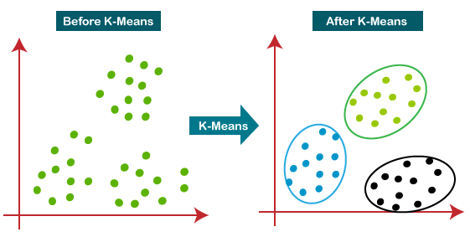

**Advantages of K-Means**

* Simple and easy to implement.
* Works well with large datasets.

**Limitations of K-Means**

* Choice of k: Requires manual selection or use of techniques like the Elbow Method.
* Sensitive to initialization: Different initial centroids can lead to different clusters.
* Assumes spherical clusters: Struggles with non-convex clusters or clusters of varying sizes and densities.
* Outlier sensitivity: Outliers can skew centroids.

**DBSCAN (Density-Based Spatial Clustering)**

Clustering analysis or simply Clustering is basically an Unsupervised learning method that divides the data points into a number of specific batches or groups, such that the data points in the same groups have similar properties and data points in different groups have different properties in some sense. It comprises many different methods based on differential evolution.

**Parameters Required For DBSCAN Algorithm**

1. **eps**: It defines the neighborhood around a data point i.e. if the distance between two points is lower or equal to ‘eps’ then they are considered neighbors. If the eps value is chosen too small then a large part of the data will be considered as an outlier. If it is chosen very large then the clusters will merge and the majority of the data points will be in the same clusters. One way to find the eps value is based on the ***k-distance graph***.
2. **MinPts**: Minimum number of neighbors (data points) within eps radius. The larger the dataset, the larger value of MinPts must be chosen. As a general rule, the minimum MinPts can be derived from the number of dimensions D in the dataset as, MinPts >= D+1. The minimum value of MinPts must be chosen at least 3.

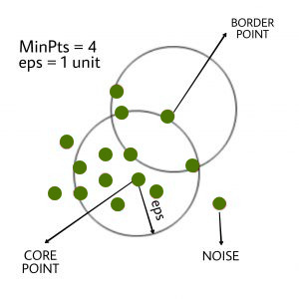

**Steps of the DBSCAN Algorithm**

1. **Select an unvisited point**:
   * Start with an unvisited point and check if it is a core point (has at least MinPts points within an ε-radius).
2. **Form a cluster**:
   * If the point is a core point, form a cluster with this point and all its directly reachable points (neighbors within ε distance).
3. **Expand the cluster**:
   * For each new point added to the cluster, check if it is a core point. If it is, expand the cluster by adding its neighbors as well.
4. **Mark visited points**:
   * Mark all points as visited after processing them.
5. **Repeat for all points**:
   * Continue the process for all unvisited points. Points that are not part of any cluster (i.e., noise points) are labeled as such.
6. **Termination**:
   * The algorithm ends when all points have been visited and assigned to a cluster or labeled as noise.

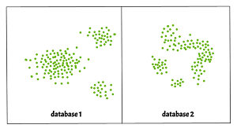

**Advantages of DBSCAN**

* **No need to specify the number of clusters**: Unlike K-Means, DBSCAN does not require the number of clusters to be predefined.
* **Ability to detect outliers**: Points that do not belong to any cluster are labeled as noise.
* **Arbitrary-shaped clusters**: DBSCAN can detect clusters of arbitrary shapes (not just spherical).
* **Works well with varying densities**: DBSCAN can handle clusters of different densities effectively, unlike K-Means which assumes uniform density.

**2.Dimensionality Reduction**:

**Principal Component Analysis (PCA) Algorithm**

Principal Component Analysis (PCA) is a dimensionality reduction techniques used to reduce the number of features (variables) in a dataset while retaining as much of the original variance as possible. PCA helps in simplifying the data, making it easier to visualize and analyze, and is commonly used for data compression, noise reduction, and feature extraction.

**Key Concepts of PCA**

1. **Principal Components**:
   * Principal components (PCs) are the new variables that are linear combinations of the original features. They are ordered by the amount of variance they capture from the data.
   * The first principal component captures the largest variance, the second captures the second largest variance, and so on.
2. **Eigenvectors and Eigenvalues**:
   * **Eigenvectors** represent the directions of the principal components.
   * **Eigenvalues** indicate the magnitude (or variance) of the data along the eigenvector direction. Larger eigenvalues mean that the corresponding eigenvector (principal component) accounts for more variance in the data.
3. **Covariance Matrix**:
   * The covariance matrix represents the relationships between the features (variables). The covariance between two features indicates how changes in one feature relate to changes in the other.
   * PCA works by analyzing the covariance matrix to determine the principal components.

**Steps in PCA**

1. **Standardize the Data**:
   * Since PCA is sensitive to the scale of the features, it is important to standardize the data (e.g., subtract the mean and divide by the standard deviation for each feature). This step is especially important when the features have different units or scales.
2. **Compute the Covariance Matrix**:
   * Calculate the covariance matrix to understand how the features vary with respect to each other. This matrix captures the relationships between the original variables.
3. **Calculate Eigenvalues and Eigenvectors**:
   * Compute the eigenvalues and eigenvectors of the covariance matrix. Eigenvectors define the direction of the principal components, and the corresponding eigenvalues represent the variance captured by each principal component.
   * **Eigenvalue decomposition**: The eigenvalues and eigenvectors can be computed using linear algebra techniques such as Singular Value Decomposition (SVD) or directly through eigenvalue decomposition.
4. **Sort the Eigenvalues and Eigenvectors**:
   * Sort the eigenvectors in descending order based on the eigenvalues. This ensures that the principal components that capture the most variance are ranked highest.
5. **Select the Top Principal Components**:
   * Choose the top k eigenvectors (principal components) based on the eigenvalues. The number k is the desired dimensionality for the reduced dataset. This step reduces the dimensionality of the dataset while retaining the most important variance.
6. **Project the Data onto the New Principal Components**:
   * Multiply the original data matrix by the selected eigenvectors (principal components). This projects the data onto a new coordinate system defined by the principal components.

Projected Data=Original Data×Eigenvectors

1. **Resulting Data**:
   * The resulting data will have fewer dimensions, with each dimension representing a principal component that captures the most variance from the original data.

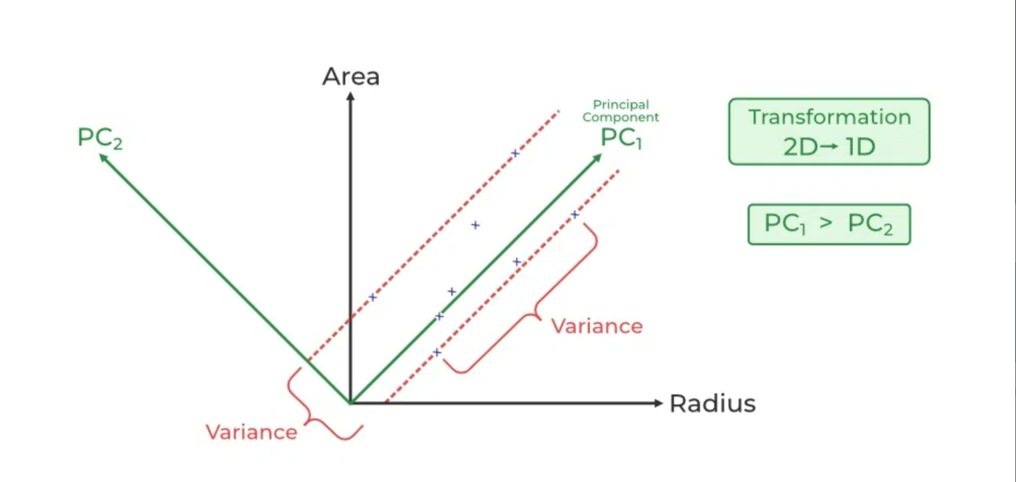

**Advantages of PCA**

* **Dimensionality Reduction**: PCA can significantly reduce the number of features while preserving most of the original data's variability.
* **Noise Reduction**: By eliminating less important components (those with small eigenvalues), PCA can reduce noise and improve model performance.
* **Improved Visualization**: PCA can be used to reduce high-dimensional data to 2 or 3 dimensions, making it easier to visualize and interpret.
* **Uncorrelated Features**: The new features (principal components) are uncorrelated, which can be beneficial for certain machine learning algorithms.

**2.Association Rule Learning:**

**priori Algorithm:**

Apriori algorithm is given by R. Agrawal and R. Srikant in 1994 for finding frequent itemsets in a dataset for boolean association rule. Name of the algorithm is Apriori because it uses prior knowledge of frequent itemset properties. We apply an iterative approach or level-wise search where k-frequent itemsets are used to find k+1 itemsets.

**Steps in the Apriori Algorithm**

1. **Set Parameters:**
   * Define the minimum support threshold and minimum confidence threshold. These thresholds determine which itemsets and rules will be considered significant.
2. **Generate Candidate Itemsets:**
   * Start with 1-itemsets (individual items) and calculate their support in the dataset.
   * Retain only those itemsets whose support is above the minimum support threshold.
3. **Iteratively Generate Larger Itemsets:**
   * For each iteration, generate candidate itemsets of size kkk (combinations of kkk items) from the frequent itemsets of size k−1k-1k−1.
   * Calculate the support for each candidate itemset.
   * Prune candidate itemsets whose support is below the minimum support threshold.
   * Repeat the process until no more frequent itemsets can be generated.
4. **Generate Association Rules:**
   * For each frequent itemset, generate all possible association rules. For an itemset X ∪ Y, generate rules like X → Y and Y → X.
   * For each rule, calculate the confidence and lift. Retain only those rules whose confidence is above the minimum confidence threshold.
5. **Return the Frequent Itemsets and Association Rules:**
   * The algorithm returns the frequent itemsets and the associated rules that meet the specified support and confidence thresholds.

**Advantages of Apriori**

* **Simplicity**: Easy to understand and implement.
* **Efficiency for Small Datasets**: Works well for small to medium-sized datasets.

**Limitations of Apriori**

* **Computationally Expensive**: Requires generating candidate itemsets, which can be computationally expensive for large datasets, especially if the data contains many items or transactions.
* **Memory Intensive**: As the number of itemsets grows, the algorithm can consume a large amount of memory.
* **Inefficient for Sparse Data**: The algorithm may become inefficient in sparse data where few items appear together frequently.

**Reinforcement Learning:**

Reinforcement Learning (RL) is a branch of machine learning focused on making decisions to maximize cumulative rewards in a given situation. Unlike supervised learning, which relies on training dataset with predefined answers, RL involves learning through experience. In RL, an agent learns to achieve a goal in an uncertain, potentially complex environment by performing actions and receiving feedback through rewards or penalties.

**Key Concepts of Reinforcement Learning**

* **Agent:** The learner or decision-maker.
* **Environment:**Everything the agent interacts with.
* **State:** A specific situation in which the agent finds itself.
* **Action:**All possible moves the agent can make.
* **Reward:**Feedback from the environment based on the action taken.

**Example: Navigating a Maze**

The problem is as follows: We have an agent and a reward, with many hurdles in between. The agent is supposed to find the best possible path to reach the reward. The following problem explains the problem more easily.

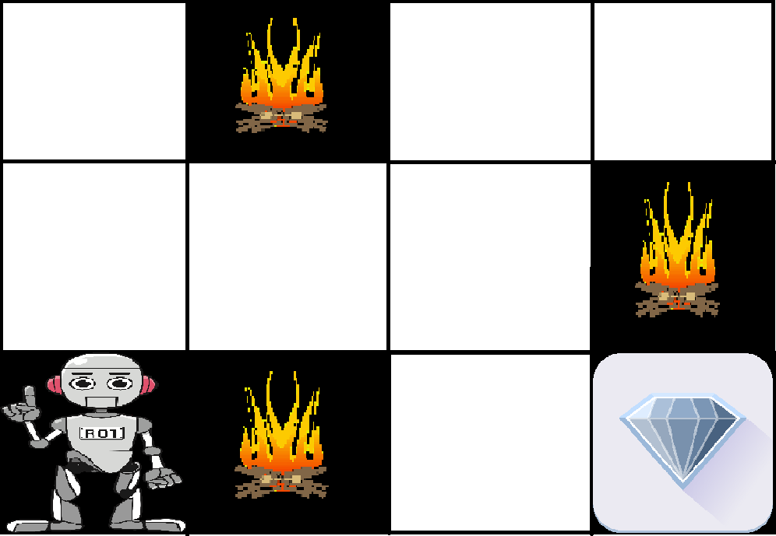

The above image shows the robot, diamond, and fire. The goal of the robot is to get the reward that is the diamond and avoid the hurdles that are fired. The robot learns by trying all the possible paths and then choosing the path which gives him the reward with the least hurdles. Each right step will give the robot a reward and each wrong step will subtract the reward of the robot. The total reward will be calculated when it reaches the final reward that is the diamond.

**Main points in Reinforcement learning –**

* Input: The input should be an initial state from which the model will start
* Output: There are many possible outputs as there are a variety of solutions to a particular problem
* Training: The training is based upon the input, The model will return a state and the user will decide to reward or punish the model based on its output.
* The model keeps continues to learn.
* The best solution is decided based on the maximum reward.

**Types of Reinforcement:**

1. **Positive:**Positive Reinforcement is defined as when an event, occurs due to a particular behavior, increases the strength and the frequency of the behavior. In other words, it has a positive effect on behavior.   
   Advantages of reinforcement learning are:   
   * Maximizes Performance
   * Sustain Change for a long period of time
   * Too much Reinforcement can lead to an overload of states which can diminish the results
2. **Negative:**Negative Reinforcement is defined as strengthening of behavior because a negative condition is stopped or avoided.   
   Advantages of reinforcement learning:   
   * Increases Behavior
   * Provide defiance to a minimum standard of performance
   * It Only provides enough to meet up the minimum behavior