

Alcohol Detection and Vehicle Locking system




INTERNET OF THINGS
Project

ALCOHOL DETECTION AND VEHICLE LOCKING SYSTEM

Komali priya - 23BCE9973
CONTENTS :
Abstract | 3
Introduction | 3-4
Methodology | 5
Flow Chart | 6
Proposed Model | 7
Block Diagram | 8
Ideology | 8-9
Components | 10-11
Working Model | 12
Results | 13-14
Output and works | 15
Conclusion | 16

Abstract:
Alcohol-related accidents and injuries have become a growing concern in recent years, leading to a significant number of premature deaths worldwide. This paper presents a novel approach to enhance alcohol detection in an automobile ignition locking system using Arduino. The proposed system incorporates a temperature sensor to measure the breath sample's temperature, ensuring its similarity to human breath. Additionally, a sensor is employed to capture a specific volume of the breath sample, enabling the determination of alcohol content. A Micro Controller is utilized to convert the sensor output into a reliable reading representing the breath alcohol content. The developed analysis serves as an integral part of an automobile ignition locking system that prevents the car from starting when the driver is intoxicated. To ensure ongoing sobriety, the system also includes rolling retests at regular intervals. By implementing this advanced alcohol detection system, the aim is to significantly reduce the occurrence of alcohol-related accidents and promote safer driving practices.

Key Words: Arduino UNO, MQ-3 Sensor, Buzzer, LED, DC Motor.

Introduction:
In today's world, drunk driving has emerged as a significant cause of road accidents. Drivers under the influence of alcohol often find themselves in an unstable condition, leading to reckless driving on highways. This not only jeopardizes their own lives but also poses a risk to other road users. The problem of dangerous driving extends beyond borders, demanding effective measures to address it. In India, laws prohibiting drinking and driving are in place, with the hope that hefty fines will discourage individuals from engaging in this behaviour. However, enforcing these laws presents challenges for police officers and road safety authorities. The inherent limitation lies in their inability to be present everywhere at the same time, undermining manual efforts to combat drunk driving. Thus, there is an urgent need for an alcohol detection system that transcends the constraints of space and time.
The Indian Ministry of Statistics reported thousands of road accidents in 2016. While the report identifies speeding violations as the primary cause, it can be inferred that a significant portion of these cases can be attributed to drivers being in an impaired state due to alcohol consumption. According to a 2008 investigation conducted by the World Health Organization (WHO), approximately 50% to 60% of traffic accidents are linked to drink-driving. Furthermore, WHO data on road traffic deaths revealed a global count of 1.25 million fatalities in 2013, with low- and middle-income countries experiencing higher fatality rates per 100,000 population (24.1% and 18.4% respectively). Disturbingly, many commercial vehicle drivers in India admitted to consuming alcohol while on duty. This highlights the prevalence of drink-driving among drivers, especially those operating commercial and heavy-duty trucks, significantly increasing the risk of accidents.
India has set a legal blood alcohol concentration (BAC) limit of 30mg/100mL. Any level above this threshold is deemed unlawful. BAC represents the amount of alcohol present in a specific volume of blood and is measured in grams of alcohol per millilitre of blood (mg/ml), as used in much of Europe. BAC levels ranging from 0.4 to 0.6 lead to dizziness, confusion, and disorientation, making it unsafe for drivers to operate a vehicle under such conditions. Additionally, a BAC level of 0.7 to 0.8 severely impairs a driver's mental, physical, and sensory functions, rendering them unable to drive. Even BAC levels between 0.2 and 0.3, although considered unsafe, may not deter some drivers from getting behind the wheel. Therefore, it is imperative to develop a system that can effectively reduce the number of road accidents caused by drunk driving.
By addressing the critical issue of alcohol detection in vehicles, we aim to contribute to the improvement of road safety and mitigate the devastating consequences associated with drunk driving.

Methodology:
The Alcohol Detection with Engine Locking system serves as an effective measure to reduce accidents caused by drunk driving. It incorporates the use of an MQ-3 sensor, which is capable of detecting the presence of alcohol in the surrounding environment. The sensor provides an output signal based on the concentration of alcohol present. When the alcohol concentration exceeds a certain threshold, the conductivity of the MQ-3 sensor increases, and this information is relayed to an Arduino microcontroller.
Upon receiving the sensor reading, the Arduino microcontroller initiates a response. If the reading surpasses the predetermined threshold level, the microcontroller activates a mechanism to stop the DC motor, thereby preventing the vehicle from moving. Additionally, as an alert to indicate the presence of a drunk driver, a red LED is programmed to blink.
To further enhance safety measures, an additional feature has been implemented. When the threshold value is exceeded, a client is created within the system. This client utilises an API provided by Twilio to send an SMS to a pre-set emergency contact number. The SMS includes the location information of the vehicle at that particular moment.
By integrating these components, the Alcohol Detection with Engine Locking system provides a robust solution to address the issue of drunk driving. It combines the alcohol sensing capability of the MQ-3 sensor, the decision-making capabilities of the Arduino microcontroller, and the alert system through LED blinking and SMS notifications. Together, these features aim to deter and prevent accidents caused by intoxicated drivers, ultimately promoting safer roads and protecting lives.

Flow Chart:

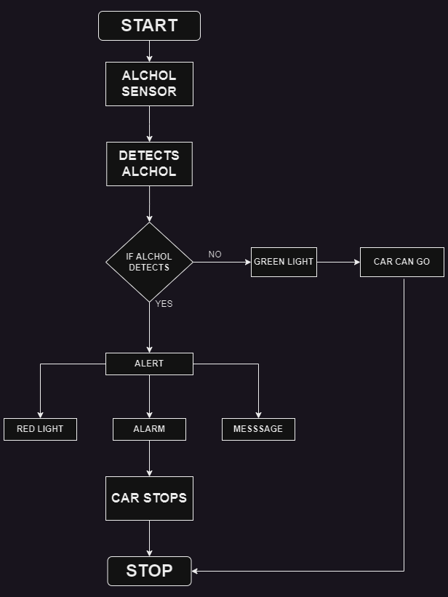
Proposed Model:
The proposed model introduces an innovative Alcohol Detection with Engine Locking system designed to effectively address the issue of drunk driving and reduce alcohol-related accidents. The core component of the system is the MQ-3 Alcohol Sensor, which is responsible for detecting alcohol presence in the surrounding environment. By analysing the concentration of alcohol, the sensor provides crucial data for determining the level of intoxication. This information is then processed by an Arduino Microcontroller, which acts as the decision-making hub of the system. Using a predefined threshold value, the microcontroller evaluates the alcohol concentration and initiates appropriate actions when the limit is exceeded. One such action is the activation of the engine locking mechanism, effectively preventing the vehicle from being driven by an intoxicated individual.
To provide a visible warning, a red LED alert system is implemented. When triggered, the LED starts blinking, serving as a clear indicator of a drunk driver's presence. Moreover, the proposed model includes an emergency SMS notification feature to ensure swift response. In the event of surpassing the threshold, the system generates a client that leverages the Twilio API to send an SMS to a designated emergency contact. This SMS includes vital information about the vehicle's location, enabling prompt intervention by authorities or concerned parties. Together, these components form a comprehensive system that actively deters drunk driving, promotes responsible behaviour, and enhances overall road safety.

Block Diagram:

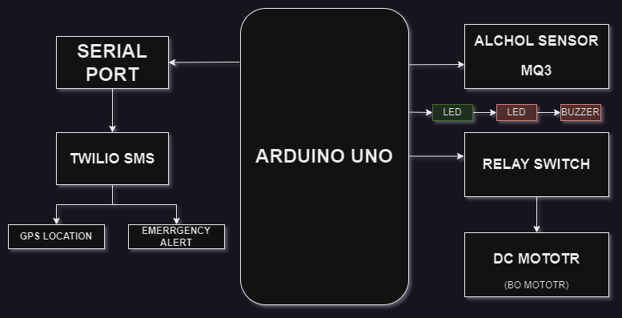

Ideology:

Intelligent Wearable Alcohol Detection System:
The proposed idea revolves around developing an intelligent wearable device that can detect alcohol levels through perspiration analysis. The device would consist of a compact sensor module integrated into a wearable wristband or patch, making it convenient and unobtrusive for users.
The sensor module would employ advanced technologies such as electrochemical sensors or optical spectroscopy to analyse the composition of sweat and detect the presence of alcohol biomarkers. These biomarkers would provide a reliable indication of alcohol consumption, even when traditional breath-based detection methods may not be suitable or feasible.
The wearable device would be connected to a mobile application via Bluetooth or a wireless connection. The application would provide real-time monitoring and display the alcohol levels detected by the sensor module. It could also include features like historical data tracking, customizable alert thresholds, and a user-friendly interface.
To ensure accuracy and reliability, the system could be calibrated individually for each user by collecting baseline data and establishing personalized alcohol detection thresholds. This calibration process would enhance the precision of the system, accounting for variations in perspiration patterns and individual metabolisms.
The intelligent wearable alcohol detection system could also incorporate additional safety features. For instance, if the detected alcohol levels exceed a predetermined threshold, the device could send notifications to a pre-selected emergency contact, ensuring prompt assistance if needed. The system could also integrate with vehicle ignition systems, preventing a drunk user from starting their car through an engine locking mechanism.
This innovative approach to alcohol detection offers several advantages, including non-invasive and continuous monitoring, discreet usage, and the potential to overcome limitations associated with traditional breath-based methods. By providing real-time feedback and proactive alerts, this intelligent wearable device has the potential to promote responsible drinking habits, deter drunk driving, and enhance overall public safety.

Components:

1. Arduino Uno:
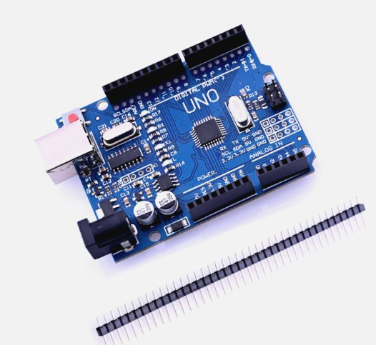
The Arduino Uno microcontroller is chosen for its versatility, ease of use, and availability of numerous input/output pins. It provides a user-friendly programming environment, making it suitable for controlling the alcohol detection system. With its robust hardware and software ecosystem, Arduino Uno offers a reliable platform for data acquisition and system control.
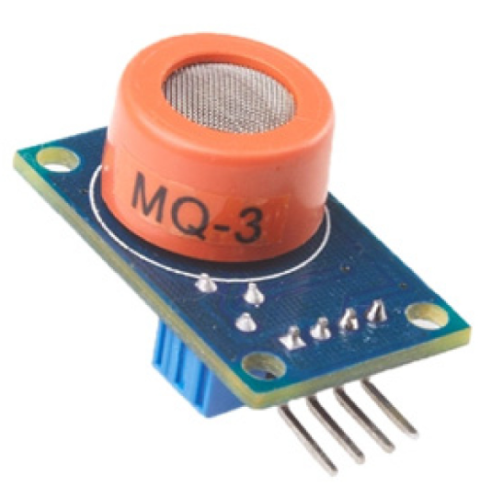

2. MQ-3 Alcohol Sensor:
The MQ-3 alcohol sensor is specifically designed to detect the presence of alcohol vapour. It has high sensitivity and selectivity towards ethanol, the main component found in alcoholic beverages. The MQ-3 sensor provides an analog output that can be easily interfaced with the Arduino Uno, enabling accurate detection of alcohol concentration in the surrounding air.

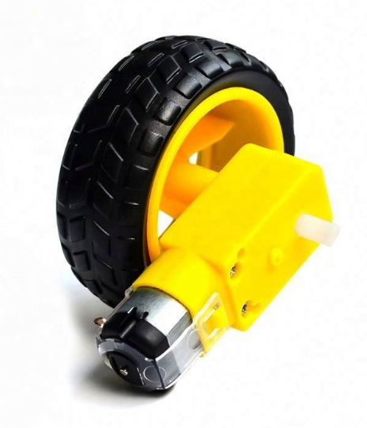
3. DC Motor:
The DC motor serves as a practical representation of a vehicle's engine. By using a DC motor in the system, the concept of engine locking can be effectively demonstrated. When the alcohol concentration exceeds the threshold, the DC motor is stopped, symbolizing the prevention of a drunk driver from starting the vehicle. This visual representation enhances user understanding of the system's functionality.

4. Relay:
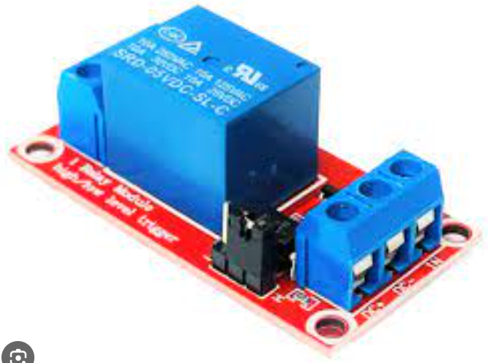
A relay is utilized to control the power supply to the DC motor. Relays offer electrical isolation between the low-voltage Arduino circuitry and the high-current DC motor. This isolation ensures the safety and protection of the components. By using a relay, the Arduino can effectively switch the power supply to the motor, allowing for precise control over the engine locking mechanism.

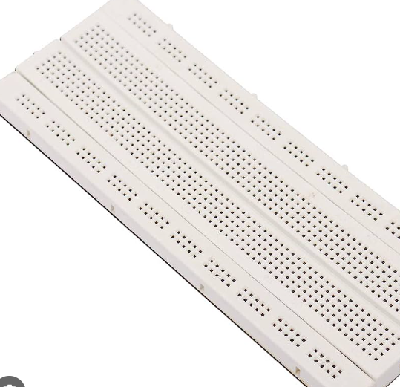
5. Breadboard:
A breadboard is chosen for its convenience in temporary circuit connections and prototyping. It allows for quick assembly and modification of the circuit without the need for soldering. Breadboards facilitate easy testing and experimentation during the development phase, enabling rapid iteration and refinement of the alcohol detection system.

6. LED:
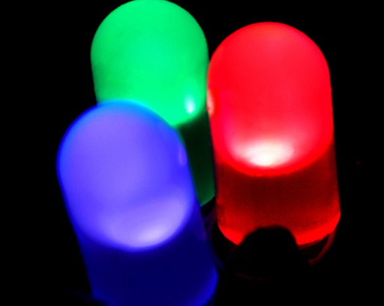
The LED serves as a visual indicator to convey information to the user and observers. When the alcohol concentration surpasses the threshold, the LED lights up, providing a clear visual warning. LEDs are chosen for their low power consumption, ease of use, and ability to emit bright and easily recognizable light, making them suitable for indicating the presence of high alcohol levels.

7. Buzzer:
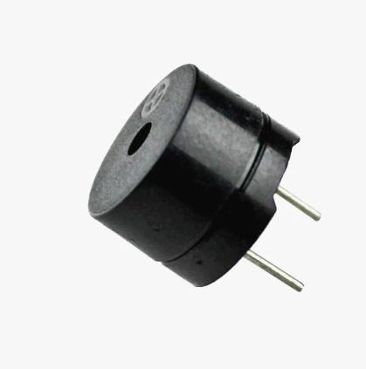
The buzzer or piezo speaker is employed as an audible alarm to enhance the warning system. When the alcohol concentration exceeds the specified threshold, the buzzer emits an alarm sound, drawing attention to the potential dangers of drunk driving. Buzzer modules are selected for their simplicity, compact size, and capability to produce loud and distinctive sounds, effectively capturing the attention of users and those nearby.
By using these specific components, the alcohol detection system can achieve accurate alcohol level detection, simulate engine locking, provide visual and audible warnings, and emphasize the importance of responsible alcohol consumption and road safety. The selection of each component is based on its functionality, compatibility with the system, ease of integration, and effectiveness in conveying important information to the user.

Working Model :
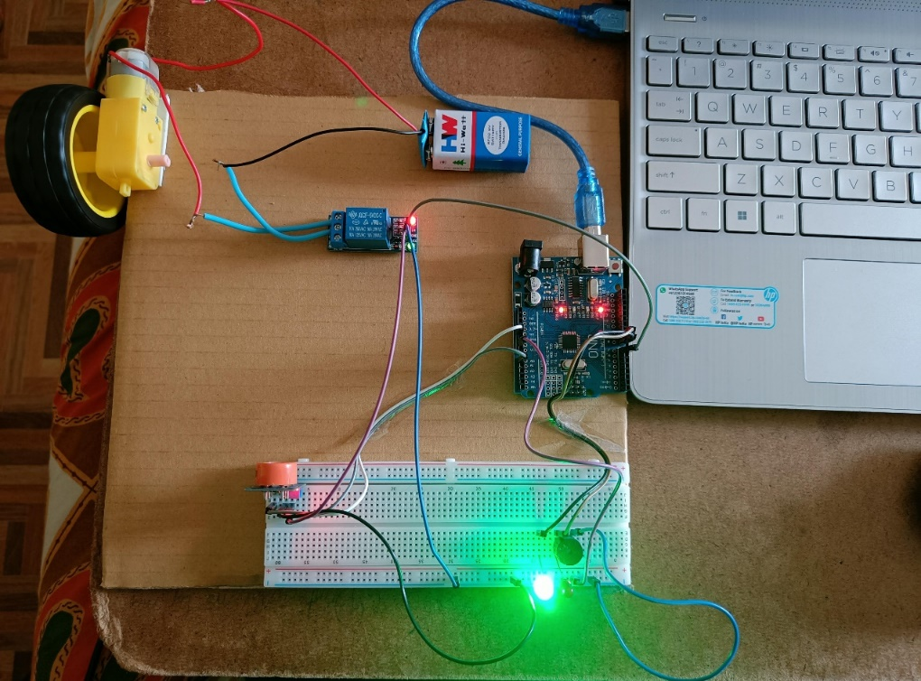

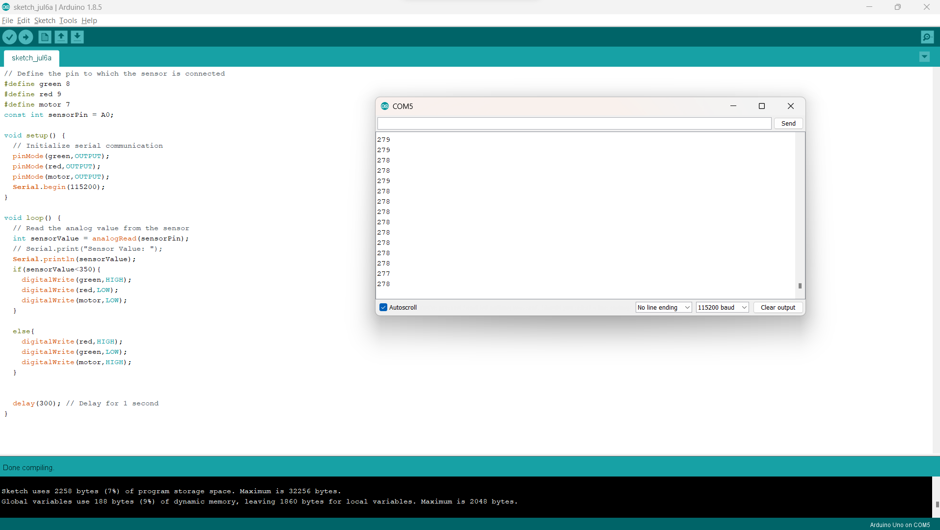
Results:

1. MQ-3 Alcohol Sensor:
- The MQ-3 alcohol sensor is designed to detect alcohol vapor in the surrounding environment.
- The result from this component is the concentration of alcohol detected, typically provided as an analog output.
- The sensor's response will vary based on the alcohol concentration, allowing the system to determine the level of intoxication.

2. Arduino Uno:
- The Arduino Uno microcontroller processes the data received from the alcohol sensor and performs the necessary computations.
- The result from the Arduino Uno is the decision to initiate specific actions based on the alcohol concentration detected.
- It can determine whether the alcohol level exceeds the predetermined threshold and subsequently activate the engine locking mechanism or trigger visual and audible warnings.

It is also helpful in serial communication

3. DC Motor:
- The DC motor's result is the physical representation of engine locking.
- When the alcohol concentration surpasses the specified threshold, the DC motor will stop, symbolising the prevention of a drunk driver from starting the vehicle.
- The result is a clear indication that the engine is locked, reinforcing the message of responsible behaviour and discouraging further attempts to operate the vehicle.

4. Relay:
- The result from the relay is the switching of the power supply to the DC motor.
- When the Arduino determines that the alcohol concentration exceeds the threshold, it activates the relay, which interrupts the power flow to the motor, leading to its cessation.
- The result is a controlled and reliable mechanism to stop the motor and enforce engine locking.

5. LED:
- The result from the LED is a visual indication of the alcohol level exceeding the threshold.
- When triggered by the Arduino, the LED lights up, providing a clear and visible warning signal.
- The result is a visual cue that alerts the user and others nearby to the presence of high alcohol levels, emphasizing the need for responsible behavior and raising awareness about the potential dangers of drunk driving.

6. Buzzer:
- The result from the buzzer or piezo speaker is an audible alarm.
- When the alcohol concentration surpasses the threshold, the Arduino activates the buzzer, generating an alarm sound.
- The result is an attention-grabbing auditory signal that serves as an additional warning, alerting the user and those in proximity to the potential risks associated with driving under the influence.

Each component contributes to the overall result of the alcohol detection system, working in conjunction to provide accurate detection of alcohol levels, simulate engine locking, and deliver visual and audible warnings.
The combined outcomes aim to promote responsible behaviour, deter drunk driving, and enhance overall road safety.

Output and works:

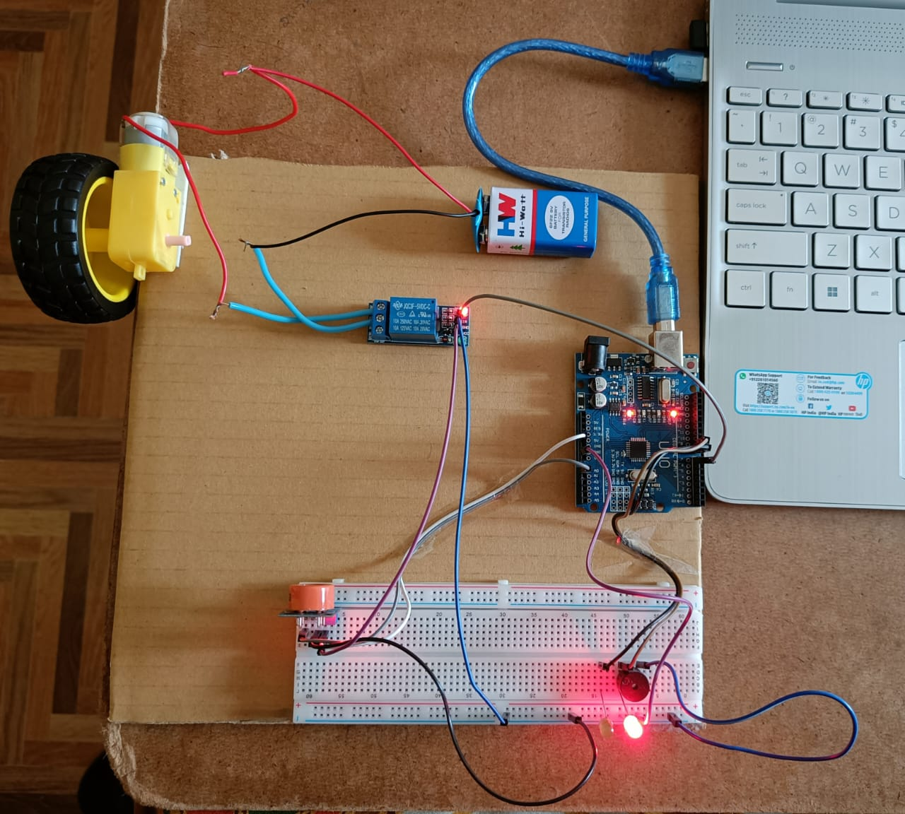
- When the alcohol is detected then the engine (dc motor) stops and the red led glows with a buzzer sound and also a message is sent to the Phone as Shown Below

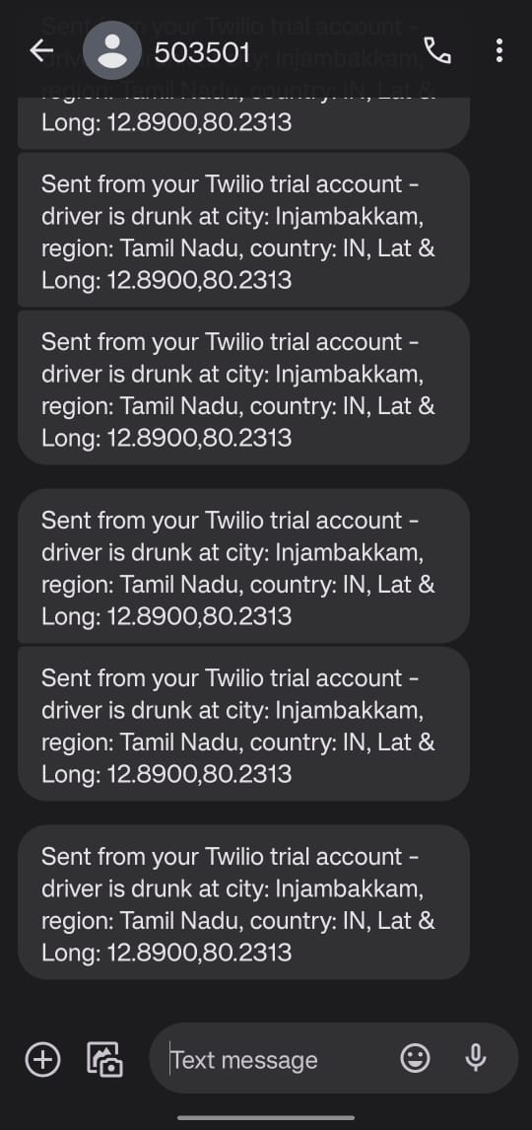

Conclusion:
The proposed alcohol detection system with its various components presents a comprehensive solution to address the critical issue of drunk driving and enhance road safety. By utilising the MQ-3 alcohol sensor, Arduino Uno microcontroller, DC motor, relay, LED, and buzzer, the system effectively detects alcohol levels, simulates engine locking, and provides visual and audible warnings.
The MQ-3 alcohol sensor offers accurate and reliable detection of alcohol vapor, providing valuable data on the alcohol concentration in the surrounding environment. The Arduino Uno microcontroller processes this data, making informed decisions based on predetermined thresholds. When the alcohol concentration exceeds the threshold, the system activates the engine locking mechanism, represented by the DC motor, preventing a drunk driver from starting the vehicle. The LED serves as a visual indicator, illuminating to signal the presence of high alcohol levels, while the buzzer emits an audible alarm, drawing attention to the potential dangers of drunk driving.
Furthermore, the integration of an emergency SMS notification feature adds an extra layer of safety. In the event that the alcohol concentration surpasses the threshold, the system generates an SMS using the Twilio API. This SMS is sent to a pre-selected emergency contact, providing vital information about the vehicle's location. This feature ensures prompt intervention and assistance in case of emergencies, enhancing overall public safety.
By combining these components and features, the alcohol detection system aims to promote responsible drinking habits, discourage drunk driving, and ultimately reduce the number of alcohol-related accidents on the roads. It serves as a proactive measure to enhance road safety and protect the lives of both drivers and other road users.
The implementation of this system has the potential to make a significant impact by actively detecting and preventing drunk driving instances. Through continuous monitoring, engine locking, visual and audible warnings, and emergency SMS notifications, the proposed alcohol detection system provides a comprehensive solution to mitigate the risks associated with alcohol-impaired driving.

References :

- https://www.ijetajournal.org/volume-2/issue-2/IJETA-V2I2P14.pdf
- http://ijariie.com/AdminUploadPdf/AUTOMATIC_ALCOHOL_DETECTION_IN_VEHICLE_ijariie12573.pdf
- Lee, Assessing the Feasibility of Vehicle-Based Sensors To Detect Alcohol Impairment. 2010, National Highway Traffic Safety Administration: Washington, DC.
- https://papers.ssrn.com/sol3/papers.cfm?abstract_id=4232102
- https://ieeexplore.ieee.org/abstract/document/8405475
- https://www.jetir.org/papers/JETIR2204460.pdf
- https://pubs.aip.org/aip/acp/article-abstract/2519/1/050019/2827998/Automatic-engine-locking-system-for-drunken
- https://pnrjournal.com/index.php/home/article/view/6911
- https://www.ijeast.com/papers/142-144,%20Tesma611,IJEAST.pdf
- https://www.irjmets.com/uploadedfiles/paper/volume2/issue_7_july_2020/2229/1628083080.pdf

