**AIM :** Design an obstacle detector

**APPRATUS :** LED, breadboard, wires, arduino, ultrasonic sensor

**CIRCUIT DIAGRAM** **:**

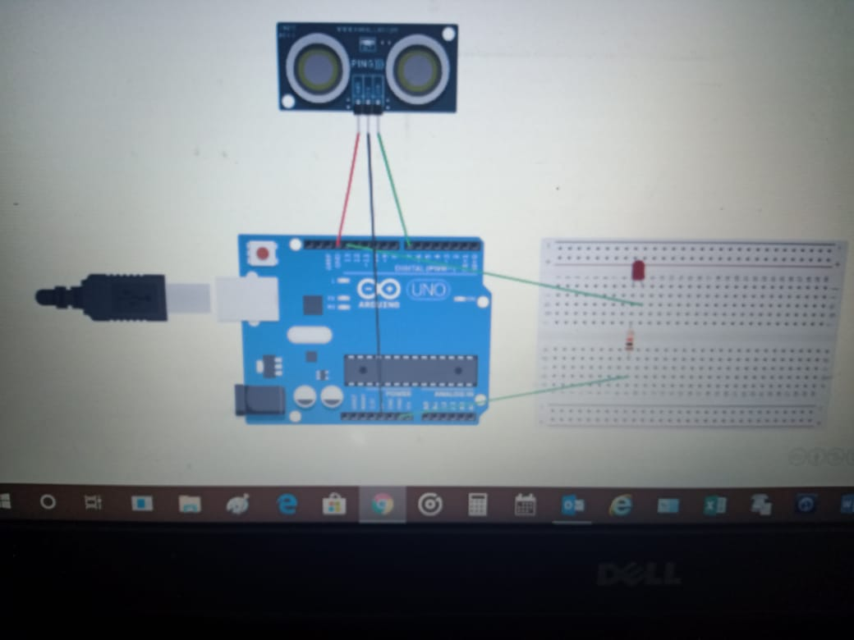

**THEORY** :

The LED has one p junction and n junction inside it, p is longer while p is shorter.

Breadbord have network of connection inside it.

Ultrasonic sensors are used for reliable position detection and precise continuous distance measurement of solids, powders and liquids.

**LERNING & OBSERVATION :**

1. Learned how to connect the connection inside the breadboard.
2. Connection of LED in the breadboard and which is n side & p side of LED.
3. Learned how to upload code on arduino and work on it.
4. Learned how to glow led automatically during night and close during day.

**PROBLEM & TROUBLESHOOTING:**

1. Connection of led in series and parallel was wrong.
2. Mistake in code uploading .

**LEARNING OUTCOMES**:

1. Connection of LED in series and parallel in breadboard.
2. How to use arduino as it was first experience for me.